GEOGRAPHY
Paper 1
MARCH/APRIL 2020

ARISE AND SHINE TRIAL 1 EXAM
MARCH/APRIL-2020

MARKING SCHEME

SECTION A
- (a) What is a Stevenson screen? (2 marks)
It is a white wooden box in which meteorological instruments are kept at a weather station.
(b) Name two forms of precipitation that commonly occur in Kenya (2 marks)
- Rain
- Hail
- Dew
- Fog/mist (Any 2 X1 = 2marks)

- (a) State three characteristics of the crust (3 marks)
- Rocks are generally brittle.
- Extends between 6 to 80km.
- Divided into two layers, continental crust/sial and sima/oceanic crust
- Sima contains silica, magnesium and iron
- Sial contains silica and aluminum
- Sial is lighter than sima/ has density of 2.65 to 2.70 g/cc
- Sima is heavier than sial/ has density of 2.7 to 3.0g/cc
- Sial rest on sima
- Sial has mainly basaltic rocks
- Sima is fairly flexible. (Any 4 X 1 = 4 marks)

(b) Give three reasons why the intensity of insolation is higher at equator than at Polar Regions. (3 marks)
- The sunrays are received at right angle hence spread over a small area within the equator
- The sun rays travelled a shorter distance with few obstacles hence less heat is lost within the equator.
- The sun is virtually overhead along the equator throughout the year. (Any 2 X 1 =2 marks)

- (a) Identify two theories used to describe the origin of Fold Mountains. (2 marks)
    - Conventional Currents Theory
    - Continental Drift Theory
    - Plate Tectonics Theory
    - Contraction Theory

(b) Give three effects of Fold Mountains on climate. (2 marks)
- The slopes of mountains facing the sun receive direct sunshine or are warmer than slopes facing away from the sun.
- Mountain slopes causes the development of local winds due to variation in pressure between the mountain and the valley.
- The windward slopes of mountains receive high rainfall due to orographic effect.
- Atmospheric pressure reduces with increasing altitude along mountain slope/increases with decreasing altitude.
- Temperature decreases with increasing altitude/increases with decreasing altitude
- Mountain tops experiences mist/fog or snow due to very low temperatures.
(Any 3 X 1 = 3 marks)
- (a) Name two types of earth movements that occur within the earth’s crust. (2 marks)
- Horizontal/lateral/orogenic movement
- Vertical/epeirogenic movement

(b) Name three tectonic plates (3 marks)
- Eurasian plate
- Australian plate
- African plate
- North American plate
- South American plate
- Pacific plate
- Antarctic plate

- (a) Define faulting (2 marks)
Faulting refers to the breaking/fracturing of crustal rocks due to tectonic forces.

(b) State three effects of faulting on human environment (3 marks)
- Faulting may lead to destruction of properties in built up areas.
- Faulting may change the drainage pattern leading to disappearance of rivers into the fault causing shortage of water for domestic
- Faulting lead to loss of life when it occurs in built up places.
- Features formed promote tourism.
- Windward sides of Block Mountains promote forestry/crop growing.
- Escarpments make expensive to construct roads/railways.
- Faulting exposes minerals making easy to extract.
(Any 3 X 1 = 3 marks)

SECTION B
Answer Question 6 and Any Other Two Questions in This Section

- Study the map of Yimbo 1:50,000 (sheet 115/1) provided and answer the following questions
- What is the map name of the extract given? (1 mark)
  - Yimbo

- Name the type of boundaries in the map extract. (2 marks)
- Regional/provincial boundary
- International boundary
- District boundary
(Any 2 X 1 = 2 marks)
- Calculate the area of Mageta island (2 marks)

Complete squares = 0
Incomplete squares =19√ (1 mark)
19 ÷ 2 = 9.5√ (1 mark)

- (i) Using a scale of 1cm represent 20M, draw a cross-section from grid reference 270850 to 330850. (3 marks)
On it, mark and name the following features:
- Forest
- Hill
- River
- Swamp
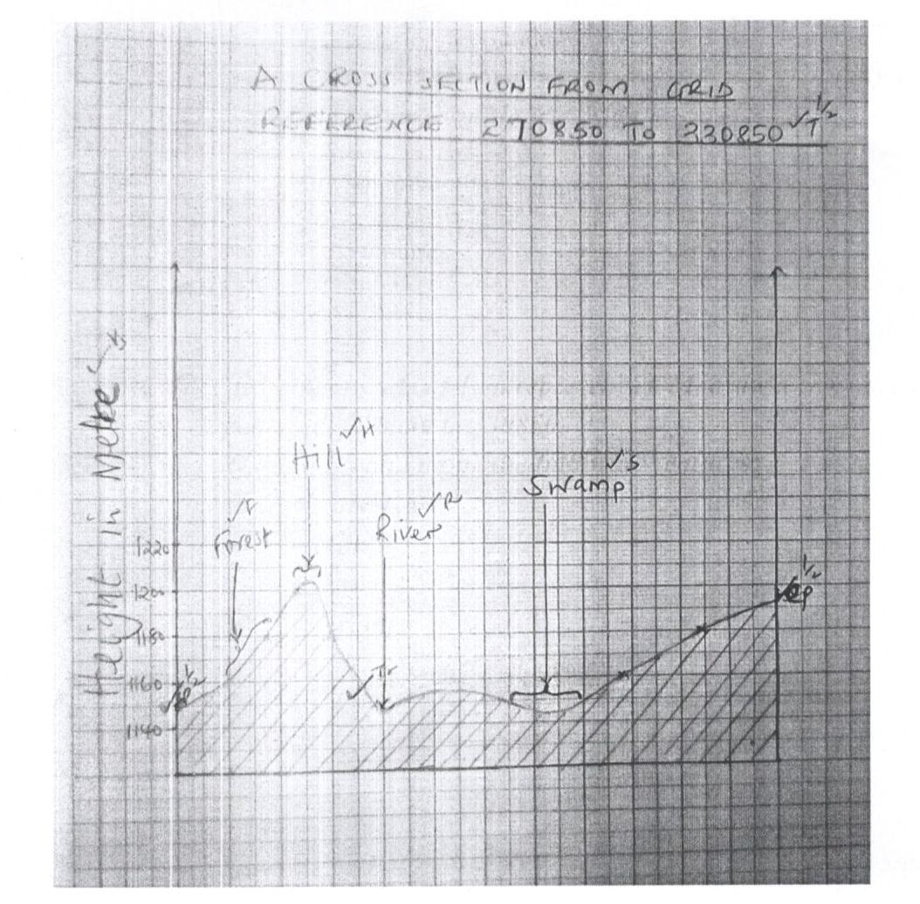
Starting point (SP) (btw 1140 – 1160) $\frac{1}{2}$mark
Ending point (EP) (btw 1180 – 1200) $\frac{1}{2}$mark

Trend 1 mark
Title $\frac{1}{2}$mark
Vertical scale $\frac{1}{2}$mark
______________________________________________
Total 3 marks

Features
- Forest 1 mark
- Hill 1 mark
- River 1 mark
- Swamp 1 mark
________________________
Total 4 marks

(ii) Calculate the vertical exaggeration of the map. (2 marks)

V.E = Vertical Scale ÷ Horizontal Scale

1:2000 ÷ 1:50,000
= 25 times (a tick for each step = 2 marks)

- Describe the long profile of River Yala. (5 marks)
- River Yala has meanders at its lower stage
- The river valley widens downstream
- The volume of water increases downstream
- River Yala has several tributaries
- Tributaries join the river at right angle/trellis drainage pattern
- River Yala flows through a swamp
- The gradient of the river is low. (Any 5 X 1 = 5 marks)

- Citing evidence from the map, explain the factors that influence trade in the area covered by the map. (6 marks)
  - Presence of market√ as evidenced by many settlements√ which buy goods/large purchasing power√
  - Availability of transport√ as evidenced by roads√ /waterways for easy movement of goods and people to the market√
  - Presence of numerous markets/shops√ e.g Usengi market√ provide room for trading activities√
  - The area is economically productive√ /presence of resources as evidenced by posho mill√ adds value to products /provide goods.

NB – Tick for evidence √e, factor √f and explanation √Ex i.e the three must be clearly mentioned for one point to score 2 marks
(Any 3 X 2 = 6 marks)

- (a) Define the following
- Aridity (2 marks)
- Aridity is the condition of rainfall deficiency in an area. (It is characterized by irregular rainfall, little vegetation cones and excessive evaporation in comparison to precipitation.

Or

- Aridity is the state of land being deficient in moisture leading to scanty vegetation or lack of it.

- Wind (2 marks)
- Wind is air in motion. The motion is created by difference in temperatures so that air moves from colder areas to warmer areas. (2 marks for full definition)

(b) (i) Explain three ways in which wind erodes weathered materials in arid areas. (6 marks)

Deflation – is the process by which wind moves dry unconsolidated materials like dust and sand from surface of the earth by filting and rolling which depends on wind velocity.
Abrasion – is frictional or mechanical weathering down of rocks by wind borne materials like coarse sand which is the erosion tool.

Attrition – since water borne materials are at constant state of movement they rub against rocks and each other produce rounded sand.
(2 X 3 = 6 marks)

(ii) Name three features which develop under arid conditions as a result of wind erosion. (3 marks)
- Deflation hollows
- Yardangs
- Zeugens
- Rocks pedestals
- Ventifacts
- Inselbergs, millet-seed, gours, desert pavements
- Mushroom block
(Any 3 X 1 = 3 marks)

(c) State four factors which influence wind transportation in desert. (4 marks)
- Speed and the force (strength) of the wind
- Nature of the load i.e either light or heavy
- Intervening obstacles e.g. dead animals, twig or rock
- Water mass and vegetation (Any 4 X 1 = 4 marks)

(d) (i) Apart from Wadis, name any three resultant features of water action in arid areas. (3 marks)
- Bajada
- Inselbergs
- Pediplains
- Playas
- Selinas
- Dry river valleys/Lagh (Any 3 X 1 = 3 marks)

(ii) Describe the formation of a Wadi. (5 marks)
- Flashfloods occur on a steep and undulating landscape. The flash flood cut rills which in turn developed into gullies.
⃰⃰ The stream enlarges the gullies rapidly to form steep dry hollows in an arid area called wadis
Tick on underlined points
NB (⃰ must be mentioned for maximum score of 5 marks)

- (a) What is a glacier? (2 marks)
- Glazier is a mass of ice having limited width and moving outwards from the point of accumulation.

(b) Describe how the following glacial erosional processes occur.
- Plucking (3 marks)
- The melt water will enter into cracks of well-joined rocks.
- Temperature slightly reduces/falls and the melt water freezes in the cracks.
- Repeated action of freezing and thawing enlarges the rock cracks and eventually causing part of the rock to fall off, pulled and carried away by the moving glacier.
- Abrasion (3 marks)
- Ice moves downwards as it carries materials over rock surface.
- The rock debris/moraine at the base and sides of the glacier is used as a tool for scratching and polishing.
- The underlying rocks will be smoothened when the debris are dragged along the rocks as the glacier moves.

(c) The diagram below shows features on a glaciated lowland.
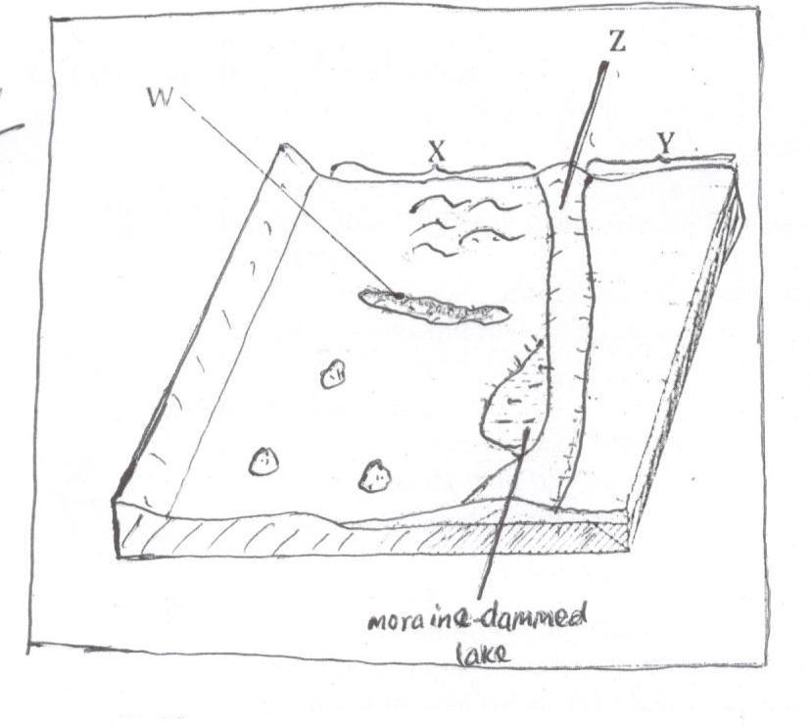
- Name the features marked W, X, Y and Z. (4 marks)
W - Esker
X - Boulder clay plain/till plain
Y - Outwash plain
Z - Terminal moraine

- Describe how a drumlin is formed. (5 marks)
- They are formed when deposition of glacial materials/clay on the plains/ boulder clay plains beneath ice due to friction between the bed rock and the boulder clay plain.
- Continual deposition leads to formation of large mounds of the deposits irregularly as long as egg-shaped hills whose upstream side being steep and smoothened and gentle downstream features called drumlins.

(d) Explain four negative effects of glaciations in low-land areas. (8 marks)
- Outwash plains may have infertile sand deposits making such area unsuitable for agriculture
- Deposits of moraine results in the formation of numerous Moraine-dammed lakes reducing land for settlement and agriculture.
- Boulder clay plains may create marshy conditions having poor drainage discourage human settlement and agriculture.
- Presence of erratic, drumlins and kettle lakes makes the landscape rugged discouraging construction of transport and communication lines.
- Some minerals may be buried deep underneath the moraine making it difficult/expensive to mine.
(Any first 4 X 2 =8 marks)
- (a) (i) Define weathering (2 marks)
- Weathering is the breaking /disintegration /decomposition of rocks in the earth/on the earth surface without movement /in situ

(ii) Explain the following processes of weathering
- Hydration (2 marks)
- Certain minerals in rocks absorb water and expand.
- This causes internal stress in the rock and eventually disintegrates.

- Oxidation (2 marks)
- Oxidation takes place in rocks with iron.
- Iron combines with oxygen forming ferric oxide/iron oxide
- The rocks then change colour and easily crumbles.

- Frost action (3 marks)
- In high mountains/temperate areas water may occupy cracks in the rocks during the day.
- At night temperatures drop below freezing point causing the water to freeze/expand, exerting pressure on the cracks.
- During the day, temperatures rise, causing the ice to melt thus releasing pressure in the cracks.
- This alternate freezing and thawing action weakens the rocks causing it to disintegrate.

(b) State three conditions that influence the process of Solifluction. (3 marks)
- The presence of a gentle slope.
- The occurrence of alternate warm and cold season.
- The presence of a permafrost/frozen ground/bedrock.
- Unconsolidated saturated weathered material.
(Any 3 X 1 = 3 marks)
(c) Describe how an exfoliation dome is formed. (5 marks)
- In arid and semi-arid areas, there is large diurnal range of temperature.
- During the day homogenous rock is intensely heated/at night the rock loses heat rapidly
- The differential heating causes the outer layer to expand/contract faster than the inner layer.
- When this expansion and contraction takes place repeatedly, stress develops in the outer layer of rocks. Cracks appear on the surface layer.
- Eventually the outer layer peels off.
- The peeling off leaves behind a rounded mass of rock known as exfoliation dome

(d) Explain four physical factors that enhance movement of material along the slope due to gravity. (8 marks)

Nature of materials
Heavy and large materials move faster on a slope as they are more likely to be overcome by gravity/thinly bedded layers have a tendency to move faster.

Angle of slope
The steeper the slope the faster the rate of movement/where rocks are dipping steeply, movement is faster.

Climatic factors/amount of water
The more saturated the soil/material/rock, the more likely it is to move as water adds weight and lubricates/alternate freezing and thawing encourages movement.

Vegetation cover
Bare surfaces are more likely to experience mass wasting because there is no vegetation to bind the materials together.

Earth movement
Earthquakes/vulcanicity/isostatic adjustments cause vibrations which may trigger widespread movement of weathered rock materials.
(Any 4 X 2 = 8 marks)

- (a) Define the term vegetation. (1 mark)
- Vegetation refers to collective plants cover growing in a particular area/is the plant cover that occurs naturally or widely on the earth surface.

(b) Explain how the following factors influence the distribution of vegetation.
- Aspect (2 marks)
- Slopes facing the sun have a variety of plants due to warm summers.
- Slopes facing away from the sun have few plants due to cool conditions or low temperatures.

- Relief (4 marks)
- Windward sides of mountains receive heavy rainfall leading to the growth of thick forests.
- Mountain tops have no or little vegetation cover due to little rainfall and very low temperatures.
- Gentle slopes have thick vegetation due to deep fertile soils.

(c) The map below shows world vegetation zone

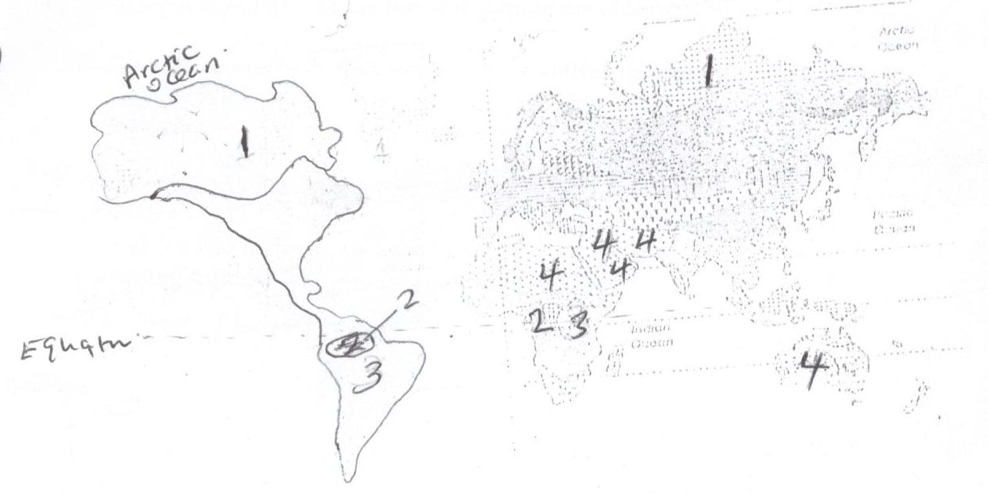

- Name vegetation type marked 1, 2, 3 and 4. (4 marks)
1 - Tundra
2 - Equatonal forests
3 - Tropical grasslands
4 - Desert vegetation

(d) Explain four ways in which trees in coniferous forests are adopted to the climatic conditions. (8 marks)
- Needle - like leaves help to reduce loss of water.
- The leaves have a tough waxy skin to protect them from cold winter
- The trees have a conical shape and flexible branches to allow snow to slide easily and to maximize damage to trees.
- Most trees are evergreen to minimize sunlight during the short growing season.
- The tree trunks are flexible to enable them sway without breaking during strong winds.
- The trees have thick barks with a lot of resin which protect them from frost.
(4 X 2 = 8 marks)
(e) A form four Geography class is planning to carry out a field study in Kakamega forest.
- State how they would use the following tools during the study.
- A tape recorder (1 mark)
- Used for recording conversations /interview In the field.

- A sketch map (1 mark)
- To show routes/direction
- To fill in information during the study.
- A camera (1 mark)
- Taking photographs of the forest/recording the observations.

- Give three methods they would use to collect the data during the study. (3 marks)
- Observing
- Oral interviewing.
- Collecting samples taking photographs
- Digging
- Smelling and feeling
- Reading from books
- Taking photographs
(Any 3 X 1 = 3 marks)

