312/1
GEOGRAPHY
Paper 1
November, 2020
Time 2 hours 45 min.

MOKASA I JOINT EXAMINATION
Kenya Certificate of Secondary Education
312/1
Paper 1
GEOGRAPHY

INSTRUCTIONS TO STUDENTS
- This paper has two sections A and B
- Answer ALL the questions in section A. In section B answer questions 6 and any other TWO questions.

SECTION A: 25 MARKS
Answer ALL questions in this section
1. (a) What is the solar system? (2 marks)
- It is an arrangement made up of the sun, planets and other heavenly bodies orbiting the sun.
(b) State three effects of the earth’s revolution. (3 marks)
- It causes varying length of day and night at different times of the year.
- It causes variation in position of the mid-day sun at different times of the
year.
- It causes occurrence of lunar /solar eclipse.
- It causes changes in seasons.
2. (a) Name two layers of the atmosphere. (2 marks)
- Troposphere
- Stratosphere
- Mesosphere.
- Thermosphere/Ionosphere

(b) The local time at Rabat, 5⁰ W is 8.00am. Find the longitude of Mogadishu if the local time is 11.00 am. (3 marks)
- Time difference: 11- 8 = 3 hours
- Difference between the longitudes.
1hr- 15º
3hours- xº
X= (3 x 15)/1
= 45º
-Location of the town
45º-5º = 40º E
3. (a) Identify the countries in which the following Fold Mountains are found.
(3 marks)
- Himalayas
- Afghanistan.
- Pakistan.
- India.
- Nepal.
- China.
- Bhutan.
- Bangladesh.
- Atlas
- Western Sahara.
- Morocco.
- Algeria.
- Tunisia.
- Rockies
- Canada.
- U.S.A.

(b) Draw a well labelled diagram showing a simple fold. (3 marks)
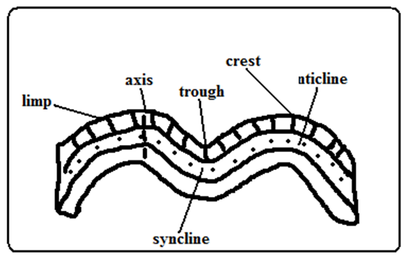
4. (a) Distinguish between Vulcanicity and Volcanicity. (2 marks)
- Vulcanicity refers to a process through which liquid, gaseous and solid materials are forced out of the earth’s interior into the earth’s crust or onto the earth’s surface while Volcanicity refers to a process through which magma reaches onto the earth’s surface.
(b) Apart from vulcanicity, give three other processes that lead to the formation of lakes. (3 marks)

- Down warping.
- Glaciation.
- Faulting.
- Folding.
- Wind erosion
- Solution weathering.
- Falling of a meteorite.
5. State four ways in which humus improves the quality of soil. (4 marks)

- It helps improve soil texture and structure.
- It provides essential soil minerals from the decomposed plant matter.
- It improves soil moisture retention capacity.
- It reduces the leaching of soil minerals.
- It facilitates aeration of the soil.
- It protects soil from erosion.
- It is a source of food to micro-organisms in the soil.
SECTION B
Answer question 6 and any other TWO questions from this section.

6. Study the map of YIMBO 1:50,000(sheet 115/1) provided answer the following questions.
(a) (i) Convert the Representative Fraction scale given on the map to a
statement scale. (2 marks)

RF Scale is 1:50,000
Change ground distance into kilometers
50,000/100,000= 0.5 km
Therefore, 1 cm represents 0.5 kilometers

(ii) Identify three Districts the area covered by the Yimbo map. (3 marks)
- Siaya District
- Busia District
- Busoga District
(b) (i) Give the exact height of Usengi hill. (1 mark)
- 1269 meters

(ii) Using evidence from the map, give two social services that are offered in the area covered by the map. (2 marks)
- Education due to the presence of schools e.g Nyagoma Mission school
- Health services due to the presence of dispensaries e.g. Usigu dispensary

(c) (i) Using a vertical scale of 1 cm represents 20m, draw a cross section from grid reference 320790 to grid reference 390790. (4 marks)

(ii) On the cross section, mark and name the following:-
- A lake (1 mark)
- Main track (motorable) (1 mark)
- A river (1 mark)
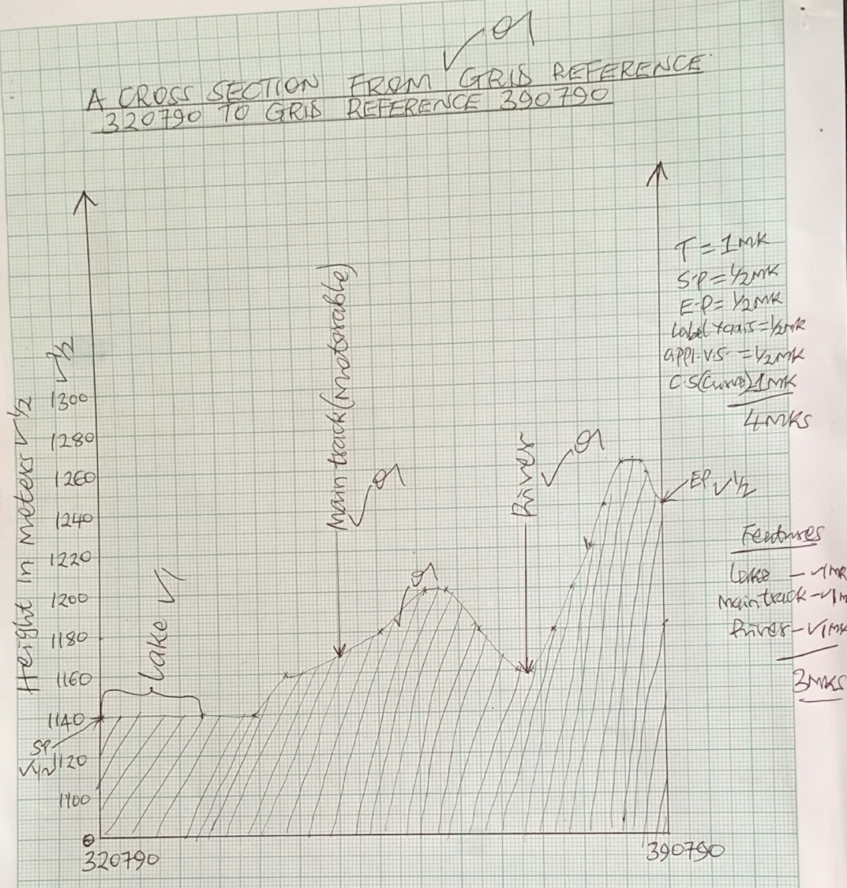
(d) (i) Describe the relief of the area covered by the map (4 marks)

- The main relief features are hills, and river valleys.
- There are many hills such as Usengi hill,Abiero hill, Serawongo hill etc.
- Usengi hill has steep slopes.
- There is a depression occupied by lake Sare
- There are river valleys such as occupied by river Yala, river Ulomaetc
- The area is generally gently sloping
- The land rises from he west towards the east any 4x1=4 mks
(ii) Explain three factors that have influenced the distribution settlement in the area covered by the map. (6 marks)
- Vegetation-there are no settlement within the thickets due to safety concerns and presence of pests such as mosquitoes.
- Drainage-there are no settlements within the poorly drained areas such as swamps due to difficulties in constructing houses and/ fear of floods.
- Relief-there are no settlements on steep areas such as Usengihill due to difficult in erecting houses
- Social amenities-there are many settlements close to schools for ease of access to Education.
- Economic activities-There are many settlements around market centers and towns for ease of access to goods and services. Any 3x2=6 marks
7. (a) (i) Distinguish between faulting and earth movements. (2 marks)
- Faulting is the cracking/fracturing of crustal rocks due to tectonic forces while earth movements is the motions/displacements of the crustal rocks due to tectonic forces.

(ii) The diagram below represents an area affected by faulting. Name the parts marked E, F and G. (3 marks)
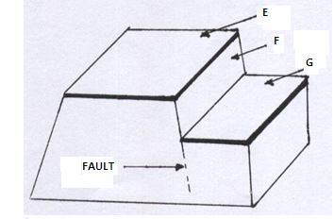
- E - Upthrow
- F –Fault scarp/ Escarpment
- G – Downthrow

(b) Describe the formation of the Rift valley by anticlinal arching. (7 marks)
- Layers of rocks in the earth’s crust are subjected to vertical tectonic forces.
- This leads to the formation of a massive anticline.
- Further upward push of the crustal rocks exert stress at the crest of the anticline.
- The upward arching of the land lead to the development of a series of cracks or faults
- Further action by upward forces may cause the outer blocks to be pushed higher than the middle block.
- The sunken middle part forms a depression/trough known as the Rift Valley

(c) Describe the origin of the continents according to plate tectonics theory.
(4 marks)
- The earth’s lithosphere is a series of rigid blocks of land called tectonic plates.
- The plates are separated from one another by distinct boundaries
- The plates float on the molten mantle
- The plates move relative to each other due to convectional currents in the mantle
- The plates either move towards each other or away from each other or past each other along the boundaries
- The plate movements trigger off vulcanicity and earthquakes
- Where the plates move away from each other it forms extension boundary, towards each other it forms compressional boundaries and past each other it forms transform boundary.

(d) (i) Apart from the Rift Valley, list three features formed as a result of faulting. (3marks)

- Fault step
- Fault scarp
- Block mountain/Horst block
- Tilt block
(ii) Explain three ways in which faulting may influence drainage of an area. (6 marks)
- Uplifting of the landscape which leads to faulting may cause rivers to reverse their direction of flow
- Vertical faulting across a river may cause a change in the local base level resulting in the formation of a waterfall.
- Basins/depressions resulting from faulting may be filled with water to form lakes.
- Some rivers flow along fault lines forming fault guided drainage patterns.
- Some rivers may disappear into the ground through a fault forming underground streams.
8. (a) (i) What is vegetation? (2 marks)

- A mass of plant cover that occupies a given area.

(ii) Distinguish between natural and derived vegetation. (2 marks)
- Natural vegetation is a plant cover which grows naturally/wildly in a given place (without interference and modification by man) while Derived Vegetation plant cover that grows naturally/wildly in an area but has been interfered with by man or his animals.

(b) The map below shows the world vegetation regions. Study and use it to answer the questions that follow.

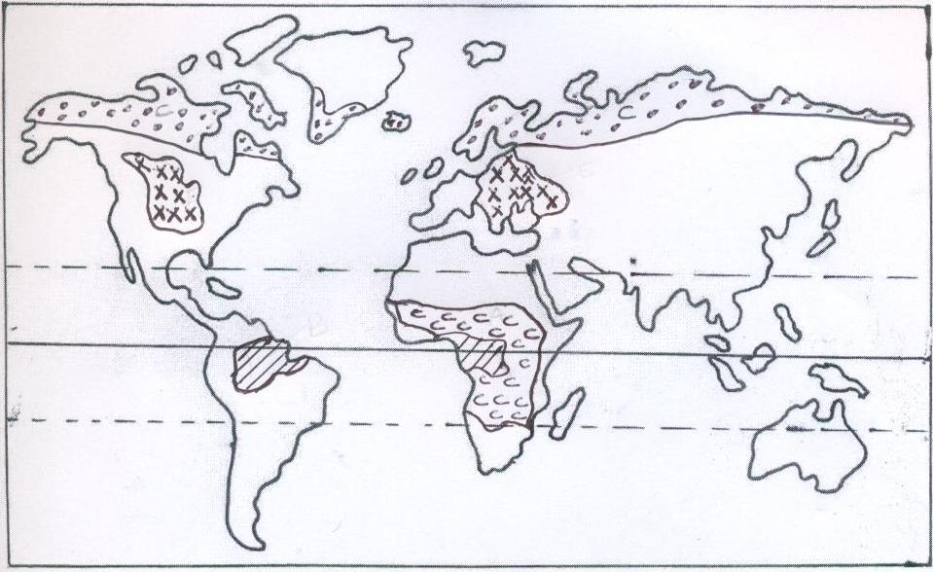
K
X
G
H
(i) Identify grassland regions marked G, H and K. (3 marks)
G - Steppes
H - Pampas
K - Veldt
(ii) Describe the characteristics of the vegetation marked X (Mediterranean). (5 marks)
- Some trees are deciduous.
- Some trees are evergreen e.g. oak
- There is woody scrub/thickets/bush/thorny bush/maquis/machia/chaparral vegetation in areas which are dry and with poor soils.
- There are many plants which are sweet smelling e.g. rosemary, lavender, oleander, broom and myrtle.
- Some plants have long tap roots to reach the water table deep below during long dry spells.
- Some trees have skinny waxy leaves to reduce loss of water through transpiration.
- Some plants have fleshy stems and leaves for storing water.
- Some plants have fleshy leaves
- Grasses dry off in summer and germinate in winter.
- Some plants have thick barks
- Some trees have small spiny leaves to reduce on loss of water through transpiration.
(c) Explain how the following factors influence growth and distribution of vegetation.
- Altitude (2 marks)
- High altitude areas with low temperature and high rainfall encourages growth of bamboo and rain forest.
- Coniferous trees are found at high altitudes because they are adapted to cool conditions.
- Lowland areas with moderate rainfall support growth of grasslands.
- There is little or no vegetation on High Mountain tops because there is very low temperature which inhibit plant growth.

- Soils (2 marks)
- Nutrient rich soils encourage growth of dense vegetation cover as they have plenty of nutrients.
- Thin and nutrient deficient soils support poorly developed and scanty vegetation cover as they have insufficient nutrients.
- Poorly drained/ coarse /or fine textured soils support growth of scanty or no vegetation.
- Medium textured soils which are well drained support growth of a variety of plants.
- Deep, well drained soils supports growth of big trees since roots can penetrate into great depths while thin soils supports shallow rooted plants.

- Human activities (2 marks)
- Clearing of natural vegetation for settlement, agriculture and mining leads to loss of natural vegetation/ leading to growth of derived vegetation
- Bush fires such as burning grasslands for the grass to sprout can cause extinction of some plant species.
- Overstocking can lead to overgrazing leading to loss of some natural plant species.
- Through afforestation and re-afforestation, man has established new vegetation cover.

(d) Your class is to undertake a field study on vegetation in the Mau forest.
(i) State two objectives for the study. (2 marks)
- To find out the different types of vegetation at different heights.
- To identify the characteristics of vegetation.
- To find out the tree species in the area.
- To find out the factors influencing vegetation growth and distribution.
- To find out the causes of forest or vegetation distribution.
- To find out the methods that can be used to conserve vegetation.

(ii) Prepare a working schedule for the study. (5 marks)
TIME | ACTIVITY
7:30 am | Assemble equipment
8:00 am | Depart for the area of study
8:20 am | Arrive at the area of study and report to forest authorities
9:00 am | Embark on data collection
12:30 pm | Re-group for lunch
2:00 pm | Continue with data collection
3:30 pm | Report back to the forest authorities
4:00 pm | Depart for school
4:20 pm | Arrive at school.

9. (a) (i) State two reasons why wind erosion is effective in hot deserts.
(2 marks)
- Presence of loose unconsolidated dry masses of mud, sand and gravel.
- Occurrence of strong tropical storms.
- Absence of vegetation leading to high wind velocity due to little frictional force.

(ii) Explain three processes of wind erosion in deserts. (6 marks)
- Abrasion which is the mechanical or frictional erosion that is caused by the materials carried by the wind.Materials carried by wind such as sand grains scratch rock surfaces across the path of wind.
- Deflation is the removal of unconsolidated materials such as sand and dust rolling and lifting or scooping and blowing away.
- Attritionit is the wearing away of the wind-borne materials e.g. sand grains carried by wind knocking against each other causing each other to become smaller and rounded in shape.

(b) (i) Apart from rock Pedestals, name three other features that result from
wind erosion. (3 marks)

- Mushroom blocks
- Zeugen
- Yardangs
- Deflation hollows
- Ventifacts

(ii) Describe the formation of rock pedestals. (5 marks)
- Wind abrasion acts upon a rock outcrop with alternating hard and soft layers.
- Soft layers are eroded more than hard layers leaving hollows and protrusions.
- Hollows are where the soft rocks were while protruding layers are where the resistant rocks are.
- There is more undercutting at the base where there is more abrasion, because abrasion is more effective within a height of 2 m.
- This results in formation of an irregular rock pillar with a broad top and a narrow base called a rock pedestal
(c) (i) What is Karst Scenery? (1 mark)
- These are unique features in a limestone region resulting from the action of water.
(ii) State three conditions that are necessary for the formation of a karst Scenery. (3 marks)
- The rock should be hard and well jointed to allow rainwater to percolate the joints and cause solution to happen e.g. limestone, chalk or dolomite.
- The climate should be hot and humid f to speed chemical weathering or availability of rain which is a solvent.
- The surface rocks should be thick limestone, dolomite or chalk rock to allow solubility of rainwater
- Water table should be far below the surface to allow for the formation of.
(d) (i) Name three surface features in the Karst region. (3 marks)
- Grikes and Clints
- Swallow/Sink Holes
- Dry Valley
- Limestone Gorge
- Dolines (dolina)
- Polje
- Uvala
- Karst Window

(ii) State two significance of the Karst scenery. (2 marks)
- Features in Karst scenery are a tourist attraction e.g. caves, gorges, stalactites, stalagmites, etc. they attract many tourists who in turn bring foreign exchange to the country.
- Limestone rock are a raw material in the manufacture of cement e.g. cement factory at Bamburi in Mombasa and Athi River.
- Limestone blocks are also used for building and construction of houses..
- Limestone regions are very good for grazing particularly sheep because of thin and dry soils.
- The rugged nature of Karst landscape discourages human settlement.

10. (a) (i) Define the term glacier. (2 marks)
- This is moving ice
(ii) Name three types of glacier. (3 marks)
- Valley glacier
- Hanging glacier
- Piedmont glacier
- Cirque glacier
- Continental glacier
(b) Describe how the following features found in glaciated landscapes are formed.
(i) U- shaped valley (5 marks)
- Ice/glacier occupies river valleys on the glaciated highlands.
- The ice occumulates
- Erosion by plucking occurs, deepening and widening the valley.
- Further deepening occurs due to abrasion as the broken rocks are removed by melt waters.
- Eventually, a glacier melts./thaws to reveal a wide valley with near vertical sides
- This is known as U-shaped valley/glacial trough..
(ii) Roche mountonee (5 marks)
- It is formed by glacial erosion on the lowlands.
- The moving ice comes into contact with a rock barrier.
- The upstream side is thus eroded by abrasion as the ice moves over the rock, creating a smooth and gentle slopes.
- The downstream side is eroded by plucking as ice gets embedded, creating a steep and rugged slope.
- This forms a feature with gentle upstream and steep down stream slope.
- This feature is called a Roche mountonee
(c) Explain three significance of upland glaciated features to human activities. (6 marks)
- Hanging valleys can be used for generation of HEP
- The pyramidal peaks and other features are attractive, promoting tourism and earning revenue.
- Pastures grow in sheltered glacial troughs providing food for animals thus promoting animal farming.
- Eroded glacial valleys on glacial uplands provide passage ways making the mountains accessible.
- Cirque lakes/tarns provide fresh water for domestic/industrial use.
- The steep slopes/aretes makes it difficult for glaciated uplands to be settled.
(d) Suppose you were to carry out a field study of glaciated lowlands.
(i) State two advantages of using oral interviews to collect information during the study. (2 marks)
- The researcher will be able to collect firsthand information.
- The data obtained is reliable.
- It allows room for more information / clarification to be sort by the researcher.
- A detailed information can be collected from a single source.

(ii) Name two depositional in glaciated lowlands that you are likely to study. (2 marks)
- Esker
- Kame
- Erratics
- Terminal moraines
- Outwash plains
- Boulder train
- Till/boulder clay plain

