MARKING SCHEME
ARISE AND SHINE TRIAL ONE EXAM
101/3
ENGLISH

1. IMAGINATIVE COMPOSITION
This question is intended to test the candidate’s ability to communicate in writing. This communication is established at different levels of intelligibility, correctness, accuracy, fluency, pleasantness and originality. Within the constraints set by each question, it is the linguistic competence shown by the candidate that should carry most of the marks. Examiners should not hesitate to use the full range of marks for each essay. It is important to determine first how each essay communicates and in which category A, B, C or D it fits.

D Class (01 – 05)
The candidate either does not communicate at all or his language is so minimal that the examiner practically has to guess what the candidate wants to say. The candidate fails to fit the English words he/she knows into meaningful sentences. The subject is glanced at or distorted. Practically no valid punctuation. All kinds of errors “Broken English.”

D – 01 – 02: chaotic, little meaning whatsoever. Question paper or some words from it simply copied.

D 03: Flow of thought almost impossible to follow. The errors are continuous.

D + 04 – 05: Although the English is often broken and essay is full of errors of all types, we can at least guess what the candidate wants to say.

C Class (06 – 10)
The candidate communicates understandably but only more or less clearly. He/she is not confident with his/her language. The subject is often underdeveloped. There may be some digressions. Unnecessary repetitions are frequent. The arrangement is weak and the flow jerky. There is no economy of language; mother tongue influence is felt.

C – 06 – 07:
The candidate obviously finds it difficult to communicate his/her ideas. He/she is hampered by his/her very limited knowledge of structure and vocabulary. This results in many gross errors of arrangement, spelling, misuse of prepositions, tenses, verb arrangement and sentence construction.

C 08:
The candidate communicates but not with consistent clarity. His/her linguistic abilities being very limited, he/she cannot avoid frequent errors in sentence structure. There is little variety or originality. Very bookish English, links are weak, incorrect, repeated at times.

C + 09 – 10
The candidate communicates clearly but in a flat and uncertain manner. Simple concepts/sentence forms are often strained. There may be an overuse of clichés, unsuitable idioms. Proverbs are misquoted or misinterpreted. The flow is jerky. There are some errors of agreement, tenses and spelling can have some merit ticks.

B Class
11 – 15: This class is characterized by greater fluency and ease of expression. The candidate demonstrates that she/he can use English as a normal way of expressing himself/herself. Sentences are varied and usually well-constructed. There may be items of merit of the one word or the one expression type. Give credit for tone.

B – 11 – 12
The candidate communicates fairly with some fluency. There may be little variety in sentence structure. Gross errors are still found occasionally, but this must not be over punished by the examiner.

B 13
Sentences are varied but rather simple and straight forward. The candidate does not strain himself/herself in an effort to impress. There is a fair range of vocabulary and idiom. Natural and effortless, some items of merit, economy of language.

B + 14 – 15
The candidate communicates his/her ideas pleasantly and without strain. There are errors and slips. Tenses, spelling and punctuation are quite good. A number of items of merit of the “whole sentence” or the “whole expression” type, merit ticks, phrasal verbs, inversions, idioms etc variety of sentences, correct vocabulary.

A Class
16 – 20: The candidate communicates not only fluently, but attractively, with originality and efficiency. He/she has ability to make us share his/her deep feelings, emotions, enthusiasm. He/she expresses himself/herself freely and without any visible constraint. The script gives evidence of maturity, good planning and often humor. Many items of merit which indicate that the candidate has complete command of language. There is no strain, just pleasantness, clear arrangement, felicity of expression, contrast, irony.

A – 16 – 17
The candidate shows competence and fluency in using the language. He may lack imagination or originality which usually provide the “spark” in such essay. Vocabulary, idiom, sentence structure, link, variety are impressive. Gross errors are very rare.

A 18
Positive ability. A few errors that are felt to be slips. The story of argument has a definite impact. No grammar problem. Variety of structures. A definite spark many margin ticks.

A + 19 – 20
The candidate communicates not only information and meaning but also the candidate’s whole self: her/his feelings, tastes, points of view, youth culture. This ability to communicate may express itself in many ways: wide range of effective vocabulary, original approach, vivid and sustained account in the case of the narrative, well developed and ordered argument in the case of a debate or discussion. Errors and slips should not deprive the candidate of the full marks he/she deserves. A very definite spark.
Table of Categories
Class | Mark Category | Each Essay
A | A+  A  A - | 19-20  18  16-17
B | B+  B  B - | 14-15  13  11-12
C | C+  C  C - | 9-10  8  6-7
D | D+  D  D - | 4-5  3  0-2
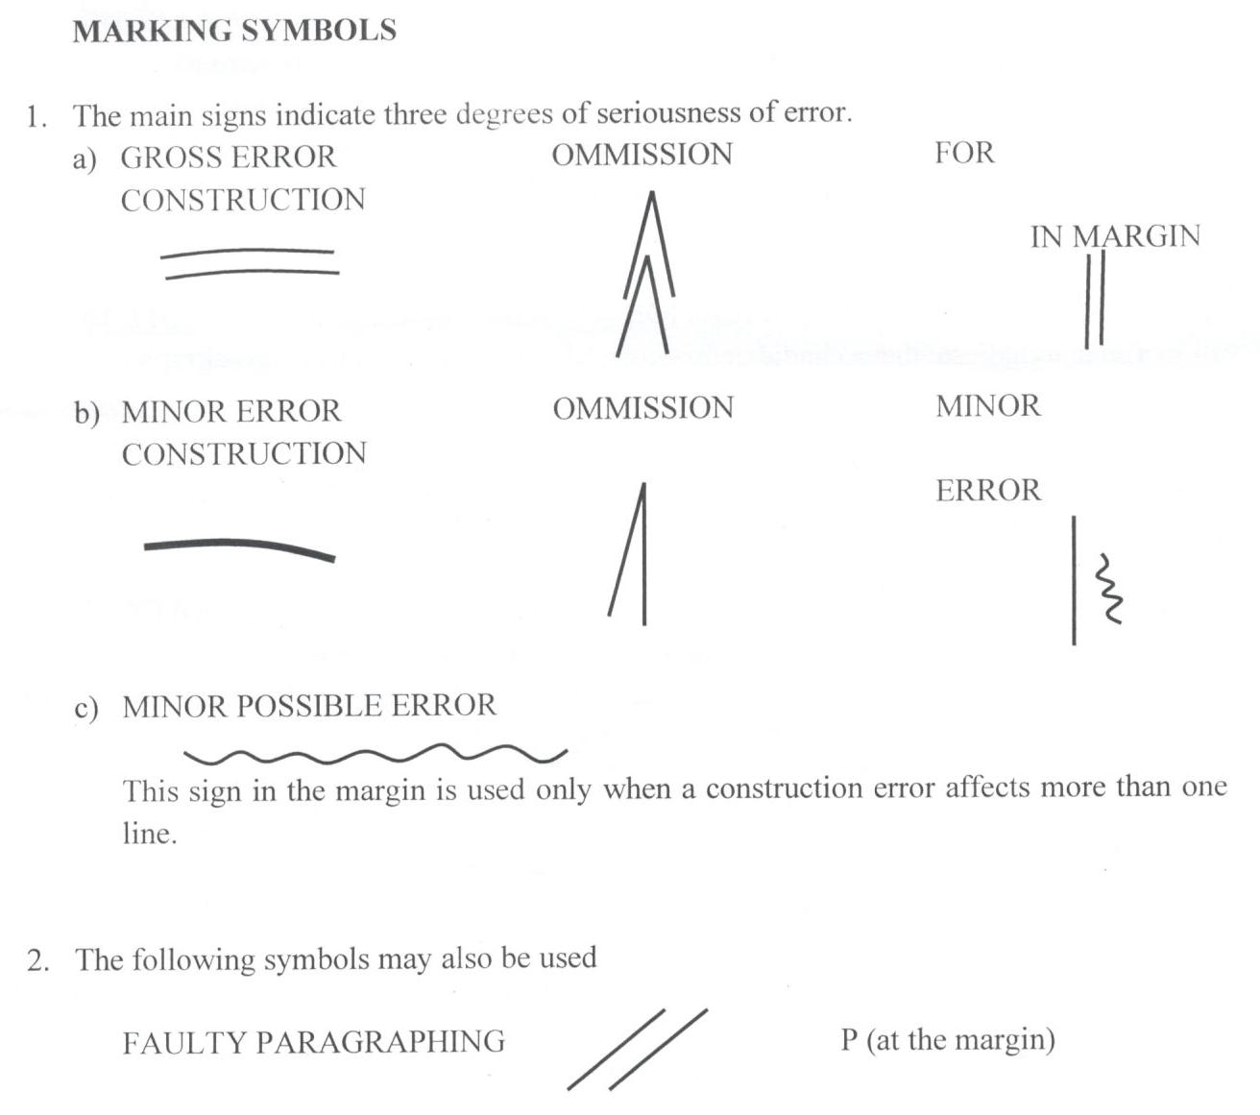
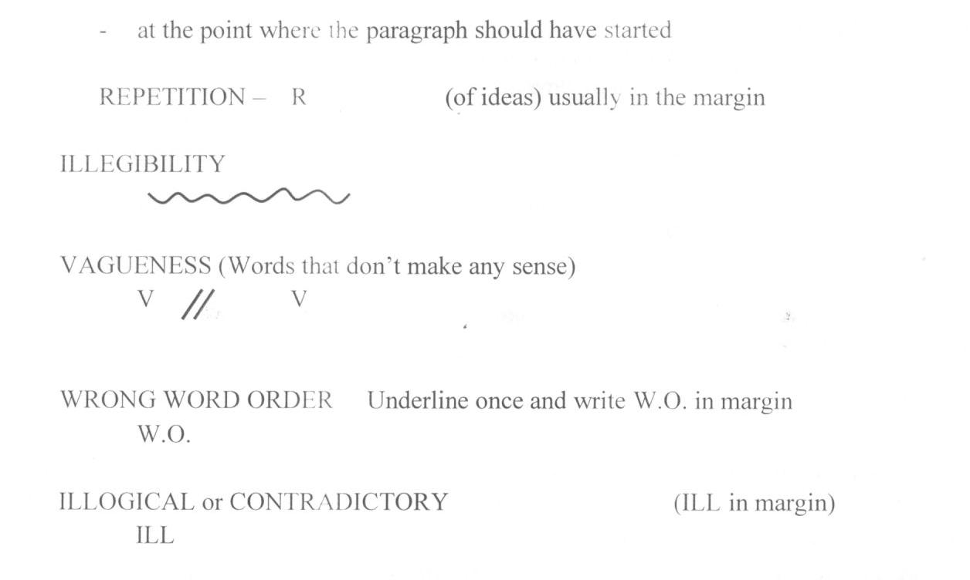
BROKEN ENGLISH – When the candidate fails to communicate (BR in)
BR

FOR PURPOSE OF IDENTIFICATION
COW to indicate that a candidate has crossed to make a correction – paragraph/page.

BRACKETS [ ] indicate a part of a D script that communicates.

- Use an asterisk to indicate an item or a sentence that the rubrics indicate should be used.
3. TO INDICATE AN ITEM OF MERIT use a tick (√) either above a word or in the margin for the whole sentence.

GROSS ERRORS
- Almost any error of agreement.
- Serious tense error.
- Errors of elementary vocabulary: spelling and misuse.
- Punctuation errors or missing punctuation which causes serious lack of communication.
- Elementary errors of idiom that affects communication.
- Misuse of common prepositions.
- Misuse of capital letters. Use of CAPS underline the first page and use CAPS on subsequent pages where the mistake persists.
- Contracted forms except in dialogue.

MARKING NORMAL SCRIPTS
- Decide on the degree of communication achieved A-D
- After underlining, decide on the mark category.
- Allocate a numerical mark to the essay.

PROBLEM SCRIPT
All problem scripts must be marked by the examiner and then sent to the team leader with comments in case of a centralized marking. The issues include:

- IRRELEVANCY
- Consistent distortion of question, evasion of question, writing on a totally different subject with a clumsy attempt at connecting the essay to the subject given, inclusion of memorized passages etc.
- The question is given an unacceptable or questionable interpretation e.g. glorifying sex, crime, violence etc.
- Essays contain long, semi-relevant digressions or lack coherence.

ACTION
The examiner marks the essay, gives a linguistic mark and comments on the nature of the irrelevancy. The essay is then passed to the team leader who judges whether the irrelevancy should be judged as a deliberate attempt to deceive or should be attributed to the candidate’s poor understanding of the subject. Deduct upto 4 marks for irrelevancy in the essay.

- CONTRAVENTION OF RUBRIC
Since the rubrics may change from year to year, the POINTS OF INTERPRETATION that are part of this MARKING SCHEME must be consulted and adhered to faithfully. Here are some general rules that usually apply.

- SCRIPTS THAT DO NOT COMMUNICATE (Broken Language)
- Decide on the category D+, D or D-
- Mark the errors on the essay and give numerical mark.
- In case of centralized marking, team leaders should look at a good number of those scripts and ensure that the mark given is fair.

- Brevity
It should be remembered that the main quality of an essay is how effectively it communicates. If an essay looks too short, the examiner should take the time to count the exact number of word. If a candidate writes a very short story, he or she has already penalized himself or herself. Essays exceeding 450 words (2 pages) deduct 2 marks AD.

Question 1 (20 marks)
- a) This should be a narrative composition (story)
- The expected answer should show awareness of the structure of a good story.
- It should have the above things not necessarily in the same way they appear in the question. If all the three are in one sentence deduct 2 marks.
- Introduces and develops the characters.
- Contain well developed and well-organized paragraphs.
- Make use of cohesive devices e.g. transitional words and phrases, pronouns and appropriate repetition
- Have appropriate choice of words and expressions
- Make use of Standard English grammar, spelling and punctuation.

b) Expect an explanatory essay
If not explanatory deduct up to 4 marks AD
The points should be explained as clearly as possible
Give credit for good use of language
Consider the following points:
- Ban on harmful traditional practices like ‘disco matanga’ among the Kilifi residents
- Guidance and counseling
- Creating awareness on the dangers of engaging in teenage sex
- Encourage parents and religious leaders to set time for educating the young on sexual relationships
- Introduction of sex education in schools.
- Heavy penalty on those found guilty of defiling minors.
- Establish a strong learning culture in schools
- Minimize on school holidays
(Accept any other relevant points)

Use the grid to award marks in question 2 and 3
CONTENT/ BODY | GRAMMAR | CONCLUSION
0-4 | 1 | 1
5-6 | 2
7-8 | 3 | 2
9-12 | 4
e.g. if a candidate scores 12 marks in the content and 2 marks in the introduction, then they get 4 marks in grammar and 2 marks in the conclusion, totaling 20marks.

Question 2 (20 marks)

A DOLL’S HOUSE by Henrik Ibsen

Introduction
All over the world, women do a lot to people around them but many a time, their roles and service to others around them go unappreciated. Women in the play, A Doll’s House by H. Ibsen do a lot that is not appreciated even by people who are close to them or no one seems to notice what they are doing.
Accept any other relevant introduction 2 marks

Points of interpretation/ Body/ Content

Wi: Christmas decoration
When the play opens, Nora is busy preparing for Christmas. She is secretly adorning the Christmas tree to unveil it as a secret to the family (p.1). During the previous Christmas, we are told that she shut herself up for three weeks making ornaments for Christmas tree. Helmer reveals: “it was the dullest three weeks I ever spent!” (p.8). his confession shows that he did not appreciate what she was doing to ensure that family has a happy Christmas.

Wii: Loan
Nora gets little money from her husband for daily family use but despite her financial obligation to Krogstad, she affords to buy clothes, gifts and toys for her children and the servants (p. 4). This is a great sacrifice on her part which goes unappreciated by her husband’s trip to Italy for his healing; she repays the loan for long using the pocket money she gets from him (p.21). She hopes that her husband would own up the guilt after discovering the secret about the loan and to prevent him from being blamed for her mistake, she is ready to kill herself once such a wonderful thing occurs. Despite all these sacrifices and selfless acts, her husband does not seem to appreciate her actions for at the end, when he discovers the secret, he refuses to forgive her and quickly makes thoughtless decisions against her. This is a great break of trust, a big betrayal to Nora who has lived all her life trying to please and care for husband.

Wiii: Selflessness
Mrs. Linde has also done a lot that easily escapes the notice of those around her. She marries a man who is not her choice but is financially stable for the sake of her bedridden mother and two brothers. She says, “My mother was alive then, and was bedridden and helpless, and I had to provide for my two younger brothers; so, I did not think I was justified in refusing his offer” (p.14)
Nora is not appreciated by Helmes for the sacrifices she makes for the family e.g. clothes or Torvald’s health improvement

Wiv: Peacemaker
Linde decides to go back to Krogstad to save his reputation and to try to protect Nora and her family from Krogstad who is determined to expose Nora’s forgery. She wants to work not for herself but for someone else for she tells Krogstad, “Nils, give me someone and something to work for” (p.88). This reveals her selfless nature, an attribute that Krogstad doubts by saying, “I don’t trust that. It is nothing but a woman’s overstrained sense of generosity that prompts you to make such an offer of yourself” (p.88). Linde also plays a great role in helping Nora Navigate the turbulent waters in her marriage and home after her secret gets threatened to be revealed to her husband. She promises to talk to Krogstad, arranges a meeting with him and even reasons that Mr. Helmer should know about the secret to save the marriage (p.90). Despite the fact that all her actions might go unnoticed, it is clear that she has played a great role towards the play’s resolution.

3:3:3:3=12 points
Conclusion
Women should be appreciated for the invaluable and integral roles they play in the society.
Accept any other valid conclusion. (2marks)

Question 3 (20 marks)

a): The Short Story.
Moran (Ed), Memories we lost and other stories.

Introduction
Lack of contentment in life can lead to greed and even in some case death. Leo Tolsoy in the story, How Much Land Does One Need? reminds us that we do not need a lot in life and we should be content with what is enough. Pahom looks for more land yet he has more than what many people have.
Accept any other introduction 2marks

Points of interpretation

Ci: Attraction

Lack of contentment can lead one to destruction as seen with Pahom. He is a farmer who owns 123 acres of land and pasture but he still wants more. He keeps thinking of how he wants more land. When a man tells him of the land of the Bashkirs and how cheaply it is sold, he is strongly attracted.

Cii: Sleep
Pahom learns from the Bashkir leader that he was to walk the whole day and return before sunset and all the land he had marked would be his for 1000 rubles. He is unable to sleep as he thinks of the large tract of land he will get if he covers a large area.

Ciii: Walking
When Pahom starts to cover ground, he sees more fertile land farther and farther away and all he thinks about is how to get all the land for himself. He keeps moving towards more land and he loses track of time. He is willing to even throw away what he has to get what he can see and unfortunately never have.

Civ: Running
Pahom removes his shirt and throws away his water bottle. He suffers because he wants to walk to more of fertile land that he can see, the more he sees, the more he runs towards it. It is almost sunset and he runs fast as he wants to beat the sunset deadline and own all the land he has marked. He is tired and his heart beats very hard. Unfortunately, he falls to the ground dead because he had lost a lot of energy. His servant buries him and says that all Pahom needed was six feet from his head to his heels.
3:3:3:3=12 points
Conclusion
Pahom dies because he is not satisfied with what he has. In his quest to acquire more fertile land, he missed out on time. In the end, it is greed that kills him, yet all he needed was some land.

Accept any other valid conclusion 2marks

3 (b) David Mulwa: Inheritance
Introduction
The citizens suffer because of bad leadership. Lacuna Kasoo is a dictator who demands to be obeyed. Those who refuse to obey him are incarcerated and killed. Those who oppose him, like Bengo, are imprisoned.
Accept any other introduction 2marks

Points of interpretation

Si: Bengo
Lacuna asks Judah Zen Melo to kill his brother Bengo because Bengo is opposing him. When Judah refuses, he is put out by Lacuna and he cannot get employment. His family suffers in his absence as Tamina his wife cannot make ends meet.

Sii: Subjects
Bad leadership causes suffering because Lacuna refuses to give licenses to farmers and they cannot grow or sell their products. He then buys the land cheaply and other people work on their farms as slaves. Lacuna employs people from his clan even when they are uneducated because he wants loyalty even if it is at the expense of efficiency. As a leader, Lacuna stashes away money in foreign accounts and the people are charged high taxes in order to repay the loans that he enjoys with his ministers and councilors.

Siii: Foreigners
Lacuna gives the imperialists a dam and the people spend a whole day getting a little amount of the precious commodity from the dam.

Siv: Lulu
Lacuna wants to marry Lulu forcefully because, as a leader, he assumes that he can do whatever he wants. He even has Lulu’s father murdered and this causes Tamina and Lulu untold suffering.
3:3:3:3=12 points
Conclusion
Bad leadership brings a lot of suffering to the citizens. They lack food and basic necessities like water, they lose their loved like Tamina and Lulu, ‘they also lose their property; this causes disillusionment among the people.
Accept any other valid conclusion 2marks

3 (c) The Novel
John Steinbeck, The Pearl

Introduction
In the face of diversity, our relations are always there for us. For instance, Juana Kino’s wife does everything in her power to protect her husband Kino and child Coyotito. She risks her life by sucking the scorpion’s poison out of the child’s shoulder for she cares for her son Coyotito.
Accept any other introduction 2marks

Points of Interpretation

Fi: Mother
First, Juana cares for her son Coyotito. When he is stung by a scorpion, she does everything within her means to save his life. First, she sucks the poison out and spits and sucks again. She suggests that they go to see the doctor. She also sticks with Kino when he was pearl fishing and prays that they find a pearl with which they can hire the doctor to treat their son Coyotito. Meanwhile she gathers brown seaweed and makes flat damp poultice which she uses as a remedy for Coyotito’s pain. Her quick thinking saves Coyotito from the adverse effect of the scorpion sting; a withered leg, a crumpled back or a blind eye. Surely, family members are always there for us.

Fii: Kino
Kino is a simple family man who loves and strives to protect his family. Kino finds solace and contentment in the song of the family. He knows the value of family since he inherited his only prized possession, a canoe, from his father and grandfather. He cannot take a chance that the doctor is lying to him about Coyotito’s health since he doesn’t want his child to suffer. When he gets the pearl Kino only thinks of how to improve his family; clothes for Juana and Coyotito, education for Coyotito and marrying Juana in church. Although the pearl causes pain, Kino only clings on it because he wants the best for his family.

Fiii: Juan Thomas
Juan Thomas cares for and values his brother Kino. He shows up when Coyotito is stung and accompanies Kino to the doctor. He advices Kino to be careful so that the dealers don’t take advantage of him. He also accompanies him to the dealers. When Kino kills a man, he offers him and his family shelter in his hut and tries to divert the attention of the neighbors and gathers supplies for the journey; a bag of beans, a gourd of rice, dried pepper, salt, a knife and an axe. Although he doesn’t manage to convince Kino to get rid of the evil pearl, he does all he can to help him escape it.
Fiv: Wife
Juana cares for her husband Kino and is always there for him. She wakes up early to prepare breakfast for her family. She is always on Kino’s side and acts like his chief advisor. She sees the potentially harmful nature of the pearl and asks Kino to get rid of it. She gets tired of Kino’s inaction and tries to throw the pearl away. Even after Kino attacks her she has no anger for him in her. She advices Kino to escape the village after he kills a man and sticks with him through thick and thin as they return to the village with their dead son. She is on his side when he flings the pearl back into the sea.

3:3:3:3=12 points
Conclusion
In conclusion, it is indeed true to say that family members are always there for us. Surely blood is thicker than water.

Accept any other valid conclusion 2marks

