GOLDEN ELITE EXAMINTIONS 2020

451/1
COMPUTER STUDIES
PAPER 1 MARKING SCHEME

    - Input – accepts in data and converts it into computer understandable form
  - Processor – manipulates data into information
  - Storage – holds data, instruction and information in the computer.
  - Output – gives the results of processing to the user
- These are microcomputers - based systems that take in data from the VRU (Keyboard, mouse and monitor) and store it in diskettes
- i. System software refers to the programs that control the performance of the computer.
ii. Utility programs, O/S, compilers and interpreters
iii. Application software
iv. Word processors, spreadsheet, RBMS
- (a) DBMS – collection of data programs (software) that help one retrieve data and perform operations on it. It involves creating, modifying, deleting and adding data files and using this data to generate reports.
(b). i. Primary key – an attribute of a relation that uniquely identifies all the other attributes
ii. Record – collection of related fields (data items)
- - Com – ports are used for serial cables
- LPT ports are used for parallel cables connection

  - Suitability of accumulating data
  - Response time
  - Cost of initial installation and operations
  - Ease of development and subsequent maintenance

  - Avoid overcrowding of either machines or users in the room
  - Ensuring that the room has enough ventilation points like windows
  - Installing air conditioners

- Audit trail – Careful study of an information system by experts to establish all weaknesses in a system that could lead to security threat.
  - Data encryption - Combination of letters and characters that deter unauthorized access
  - Log files – special files that keep a record of events on the use of computer resources
  - Password – combination of characters that deter unauthorized user from accessing data.
- It is used to look for specified words in a document and replacing them with alternative.
- There is only one way of representing a zero unlike in ones compliment

  - Large in physical size
  - Used thermionic valves
  - Consumed a lot of power
  - Constant breakdown
  - Low memory and processing speed
  - Cost was high

- Change text colour
  - Change font size
  - Change font style
  - Text alignment
- - Gas plasma
  - Electro luminiscent
  - Thin film transistors
  - Liquid crystal display
- - Identing – move text away from the left margin
  - Alignment – placing text on page relative to right, left or centre of the page
  - Footnote – additional piece of information printed at bottom of page
  - End note – notes collected under separate heading at end of chapter in a document
- i. Load application programs from external storage in to main memory. Also note the part of main memory in use and free
ii. Prepares jobs for continuous execution determining the first task to be done and last one.
iii. Reports errors that occur during execution
iv. Control use computer hardware by system software and application programs.

SECTION B
16. a. Sequence
Selection
Iteration
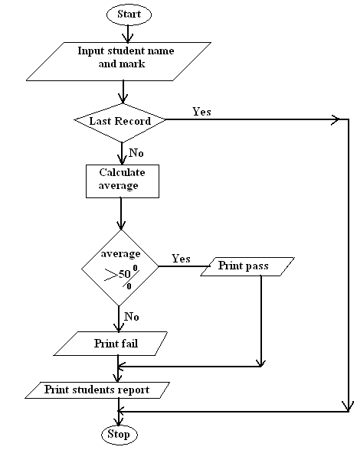
b.

c. Analog is continuous in nature. While digital is discrete in form
d. - Computers are fast
- Produce more accurate results
- Produce neat work
- Are more efficient
17. a. (i) (2⁰x1) + (2¹x1) + (2⁻¹ x 1) + (2⁻³ x 1)
2 + 1 + 0+0.25 + 0.125
= 3.375₁₀
(1x8¹) + (2x8⁰) + (1x8⁻¹) + (5x8⁻²)
8 + 2 + +
= 10 or 10.203₁₀

(10x16¹) + (3x16⁰) + (3x16⁻¹)
160 + 3 +
= 163
(ii). - Back up data
  - Control data access
  - Design interface that minimize invalid data entry
  - Use data capture service
iii. - Can reach many respondents
  - Give many responses
  - Saves time
  - Minimjze biasness
iv. Contain the deleted files
- a. -Questionnaires
Interviews
Observations
Note taking
Study available documents
Tape recording
b. i. Process of transferring information from remote computer to local storage.
ii. Text or picture in an electronic document
iii. Applications that enable a person to access the internet.
iv. Companies that offer internet services to end users.
c. Sort is to arrange data in a predefined order either ascending or descending. While filtering is a quick and efficient method of finding and working with a subject within a list.
d. i. A mail sent to many people indiscriminately.
ii. Flat circular plate covered in a magnetic which is able to store data on concentric tracks.
iii. Modem fixed on mother board
e. Windows icons mouse and pointing devices
- a. The arrangement of data in a file which determine the access method.
b. - Control of data redundancy
- Maintain data consistency
- Sharing of data
- Improved date integrity
- Economy of scale
- Improved security
c. i.Ensure that the data fields contain the correct data type
ii. Primary key cannot have empty values.
iii. A foreign key can only have the values of the relevant primary key.
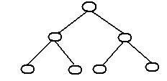
d. i. Hierarchical model – Records in the database can be related in one parent only but can have more child records.

ii. Network – any record can be related with any other record.
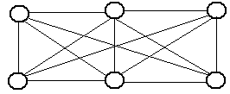

iii. Relational model – all data is logically structured within tables.
e. One to one – for any member of A there is only one member of B and for any member in B there is one member of A.

One to many – for a single member of A, there may be multiple associations with it B but for any B member there is only one member of A associated with it.

Many to many – for member in A there may be more members of B and for any member in B there may be many members of A

f. - Serial – records are placed on the disk with no particular order.
- Sequential – records are placed on disk according to a specific field
- Random – A hash function calculates the address of the page in which the record is to be stored based on one or more of the fields.

- a. - Parallel running – both old and new systems run in parallel to each other
- Direct changeover – complete replacement of the old system with the new system in one move.
ii. - It may be inconveniencing incase the new system fails/face problem.
-The users may not have gained enough confidence to run the new system.
iii.-Incase of system failure
-If testing was not thoroughly done.
- Requires training on new programs
- Requires new hardware and software (costs)
iv. -Promotes confidence as a result of same input and output
- Training is done to enable familiarization
- Reliable in terms of testing
b. Collection /group of related WebPages belonging to an organization or individual
c. - Internet software
-Telecommunication facilities
-Modem
-Internet service provider
-TCP/IP protocol
d. - Exchange programs with students in other schools
-E-learning
-Research widely

