NAME………………………………………………ADM N0……………………
CLASS………………………….CANDIDATES SIGNATURE………………

451/1
COMPUTER STUDIES
PAPER 1
DECEMBER, 2020
Time: 2 ½ Hours

LANJET JOINT EVALUATION EXAMINATION
DECEMBER, 2020
Kenya Certificate of Secondary Education
COMPUTER STUDIES
PAPER 1
TIME: 2 ½ HOURS

INSTRUCTIONS TO CANDIDATES
- Write your name and index number in the spaces provided above.
- Sign and write date of examination in the spaces provided above.
- This paper consists of TWO sections A and B.
- Answer ALL questions in section A.
- Answer question 16 and any the THREE questions from section B
- ALL answers should be written in ENGLISH on spaces provided on the question paper
- This paper consists of 11 printed pages
- Candidates should check the question paper to ascertain that all pages are printed as indicated and that no questions are missing.

FOR EXAMINERS USE ONLY
SECTION | QUESTION
A | 1 – 15
B | 16
 | 17
 | 18
 | 19
 | 20
 | TOTAL MARKS

This paper consists of 10 printed pages. Candidates should check the question paper to
ascertain that all the pages are printed as indicated and that no questions are missing.

SECTION A (40 MARKS)
Answer all the questions in space provided.
- List 5 hardware components that form a complete computer system. 2 ¹/₂mks
………………………………………………………………………………………………………………………………………………………………………………………………………………………………………………………………………………………………………………………………………………………………………………………………………………………………
- What do you understand by the term ‘Disk initializing’? 1mks
……………………………………………………………………………………………………………………………………………………………………………………………………………………………………………………………………………………………………………………………………………………………………………………………………………………………..
- Draw an illustration of:
a) Parallel cable 1mk

b) USB port 1mk

- Explain the three parts of a task bar . 3mks
………………………………………………………………………………………………………………………………………………………………………………………………………………………………………………………………………………………………………………………………………………………………………………………………………………………………
- Name three examples of flat-panel monitors available in market today. 3mks
………………………………………………………………………………………………………………………………………………………………………………………………………………………………………………………………………………………………………………………………………………………………………………………………………………………………
- (a) What is the difference between Real data type and an Integer data type as used in programming? 2 mk
………………………………………………………………………………………………………………………………………………………………………………………………………………………………………………………………………………………………………………………
(b) Differentiate between a source code and an object code. 2mks
………………………………………………………………………………………………………………………………………………………………………………………………………………………………………………………………………………………………………
- State three changeover strategies that can be used to move from the old system to a new one. 3mks
………………………………………………………………………………………………………………………………………………………………………………………………………………………………………………………………………………………………………………………
- Explain the 3 factors used to classify operating systems. 3mks
………………………………………………………………………………………………………………………………………………………………………………………………………………………………………………………………………………………………………………………
- What is the meaning of the following as used in word-processing: 2mks
  - Word wrap
……………………………………………………………………………………………………………………………………………………………………………………………………
  - Drop caps
……………………………………………………………………………………………………………………………………………………………………………………………………
- Using the long division method convert 45₁₀ into binary. 1 mks
………………………………………………………………………………………………………………………………………………………………………………………………………………

- a) Differentiate between a formula and a function as used in Excel 2 mks
………………………………………………………………………………………………………………………………………………………………………………………………………………………………………………………………………………………………………………………
b) What is the effect of the following function: COUNTIF(A10:E10, “eggs”). 1mk
……………………………………………………………………………………………………………………………………………………………………………………………………
c) Explain the meaning of legends as used in Excel. 1mk
……………………………………………………………………………………………………………………………………………………………………………………………………
- a) Name four database models. 2mks
……………………………………………………………………………………………………………………………………………………………………………………………………
b) State the work/function of the following field properties if set: 2mks
- Format.
………………………………………………………………………………………………………………………………………………………………………………………………………………
- Default value
………………………………………………………………………………………………………………………………………………………………………………………………
- (a) List any 4 examples of DTP software available in the market today. 2mks
………………………………………………………………………………………………………………………………………………………………………………………………………………………………………………………………………………………………………
(b) What is the difference between the pasteboard and printable area? 2mks
……………………………………………………………………………………………………………………………………………………………………………………………………
- In electronic mailing (e-mail), what do the following domain refer to in an e-mail address 2mks

e.g. – Oketchjunior@yahoo.co
      - Edu ……………………………………………..
      - Org ……………………………………………..
      - Gov ………………………………………………
      - Co ………………………………………………
- Define the word protocol. 1mk
……………………………………………………………………………………………………………………………………………………………………………………………………
SECTION B (60 MARKS)
Answer question 16 and any other three questions from this section
a) Design a flowchart for a simple program that can be used to categorize people according to age. If the person is above or equal18 years, output “Adult” otherwise output “Young” 8 mks

b) What is the difference between looping and selection. 2mks
………………………………………………………………………………………………………………………………………………………………………………………………………………………………………………………………………………………………………
c) Name the stage of program development cycle when: 2mks
- A user guide would be written
……………………………………………………………………………………………………………………………………………………………………………………………………
- A programmer dry-run the code.
……………………………………………………………………………………………………………………………………………………………………………………………………
- System charts would be drawn
……………………………………………………………………………………………………………………………………………………………………………………………………
- Staff training is done.
……………………………………………………………………………………………………………………………………………………………………………………………………
d) State the 3 translators used in programming. 3mks
………………………………………………………………………………………………………………………………………………………………………………………………………………………………………………………………………………………………………………………………………………………………………………………………………….
- a) (i) Give the name of the communication media depicted in the diagram below. 1mk
Name: ………………………………………
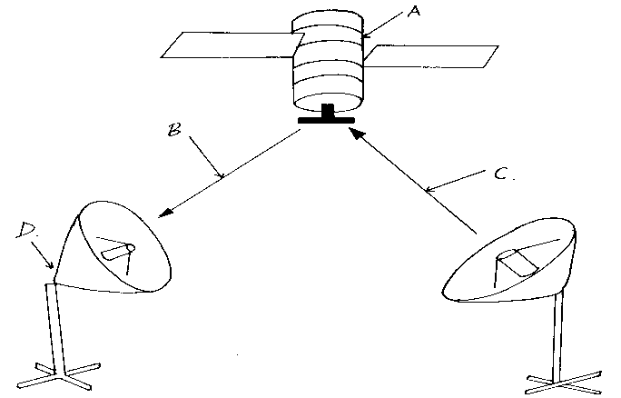
(ii) Give names to the parts indicated by A,B,C,and D. 4mks
………………………………………………………………………………………………………………………………………………………………………………………………………………………………………………………………………………………………………………………………………………………………………………………………………….
(iii) List three advantages of the communication media above. 3mks
………………………………………………………………………………………………………………………………………………………………………………………………………………………………………………………………………………………………………………………………………………………………………………………………………….
b) Explain the three major types of computer networks. 3mks
………………………………………………………………………………………………………………………………………………………………………………………………………………………………………………………………………………………………………………………………………………………………………………………………………….
c) Explain the purpose of the following on a network. 4mks
A hub
………………………………………………………………………………………………………………………………………………………………………………………………………………
- A switch
………………………………………………………………………………………………………………………………………………………………………………………………………………
- a) Describe any three mouse techniques/skills 3mks
………………………………………………………………………………………………………………………………………………………………………………………………………………………………………………………………………………………………………………………
b) List four key groupings on a computer keyboard citing two examples in each. 4mks
………………………………………………………………………………………………………………………………………………………………………………………………………………………………………………………………………………………………………………………………………………………………………………………………………….…………………
c) Name and explain the function of the following key symbols.
i) 2mks

………………………………………………………………………………………………………………………………………………………………………………………………………………
ii) 2mks

………………………………………………………………………………………………………………………………………………………………………………………………………………
iii) 2mks
………………………………………………………………………………………………………………………………………………………………………………………………………………

………………………………………………………………………………………………………………………………………………………………………………………………………………………………………………………………………………………………………………………
Esc 2mks
………………………………………………………………………………………………………………………………………………………………………………………………………………………………………………………………………………………………………………………
- i) Define the following terms:
          - Data processing. 2mks
………………………………………………………………………………………………………………………………………………………………………………………………………………

          - Data processing cycle 2mks
………………………………………………………………………………………………………………………………………………………………………………………………………………
ii) Describe any two-transcription errors. 4mks
………………………………………………………………………………………………………………………………………………………………………………………………………………………………………………………………………………………………………………………………………………………………………………………………………………………………
iii) State 3 data processing methods. 3mks
………………………………………………………………………………………………………………………………………………………………………………………………………………………………………………………………………………………………………………………
iv) Distinguish between a logical file and a physical file. 4mks
………………………………………………………………………………………………………………………………………………………………………………………………………………………………………………………………………………………………………………………………………………………………………………………………………………………………
20. a) What is desktop publishing?. 2 mk
……………………………………………………………………………………………………………………………………………………………………………………………………………………………………………………………………………………………………………………………………………………………………………………………………………………………………………………………………………………………………………
- Name the desktop publishing screen layout parts labels below.
A
B
C

E
D

F

A - ……………………………………………..
B - ……………………………………………..
C - ……………………………………………..
D - ……………………………………………
E - …………………………………………
F - …………………………………………
Give three examples of publications that can be made using desktop publishing. 3mks
………………………………………………………………………………………………………………………………………………………………………………………………………………………………………………………………………………………………………………………………………………………………………………………………………………………………
d) Describe how you can save a publication of the desktop by use of a password. 4mk
………………………………………………………………………………………………………………………………………………………………………………………………………………………………………………………………………………………………………………………………………………………………………………………………………………………………

