NAME: ……………………………………………..……. INDEX NO: ……………………
233/2
CHEMISTRY
PAPER 2
DECEMBER. 2020
TIME: 2 HOURS
LANJET F4 JOINT EXAMINATION – 2020
Kenya Certificate of Secondary Education

INSTRUCTIONS TO CANDIDATES
- Write your name and index number in the spaces provided.
- Answer all questions in the spaces provided
- KNEC mathematical tables and silent electronic calculators may be used for calculations.
- All workings must be clearly shown where necessary.
- Candidates should check the question paper to ascertain all the pages are printed as indicated and no questions are missing.
For Examiners Use Only
Questions | Maximum Score | Score
1
2
3
4
5
6
7
8
TOTAL | 80
This paper consists of 12 printed pages. Candidates should check the question paper to ascertain that all pages are printed as indicated and that no pages are missing.

1. The diagram below shows a set up used by a student in an attempt to prepare collect oxygen gas
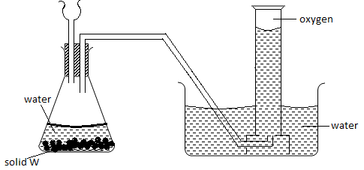

- i) Identify and correct the mistakes in the set up to enable the preparation and collection of the gas. (2mks)
………………………………………………………………………………………………………
………………………………………………………………………………………………………
ii) Identify solid w. (1mk)
………………………………………………………………………………………………
b) A piece of phosphorous was burnt in excess air. And the product dissolved in hot water to make a solution.
i) Write an equation for the burning of phosphorous in excess air. (1mk)
………………………………………………………………………………………………
ii) The solution obtained in (b) above was found to have a pH of 2.0. Give reasons for this observation. (1mks)
………………………………………………………………………………………………
………………………………………………………………………………………………
c) Explain why cooking pots made of aluminium do not corrode easily when exposed to air. (1mk)
………………………………………………………………………………………………
………………………………………………………………………………………………
………………………………………………………………………………………………
d) The reaction between sulphure (IV) Oxide and oxygen to form Sulphur (VI) Oxide is an exothermic reaction, which can be represented by the equation below;
2SO_{2(g)} + O_{2(g)} 2SO_{3(g)} H = -ve
A factory manufacturing sulphuric (VI) acid by contact process produces 350kg of sulphur(VI)oxide per day (conditions for the reaction; catalyst, 2 atmospheres pressure and temperatures between 400 – 500 ºC.)
i) What is meant by an exothermic reaction? (1mk)
………………………………………………………………………………………………
………………………………………………………………………………………………
ii) How would the yield per day of sulphur trioxide be affected if temperatures lower than 400ºC are used? Explain. (1mk)
………………………………………………………………………………………………
………………………………………………………………………………………………
iii) All the sulphur (VI) Oxide produced was absorbed in concentrated sulphuric acid to form oleum.
SO_{3(g)} + H₂SO_{4(l)} → H₂S₂O_{7(l)}
Calculate the mass of oleum that was produced per day. (S = 32.0, O= 16: H = 1.0)(3mks)

2. Study the table below and answer the questions that follow:

Compounds | Melting point ⁰C | Boiling points ⁰C
C₂H₄O₂ | 16.6 | 118
C₃H₆ | -185.0 | -47.7
C₃H₈O | -127 | 97.2
C₅H₁₂ | -130 | 36.3
C₆H₁₄ | -95.3 | 68.7
(a) (i) Which of the compounds is a solid at 10ᵒC. Explain (1mk)
………………………………………………………………………………………………
………………………………………………………………………………………………
(ii) Choose two compounds which are members of the same homologous series and explain the difference in their melting points (3mks)
……………………………………………………………………………………………….
……………………………………………………………………………………………….
……………………………………………………………………………………………….
(iii) The compound C₃H₈Ois an alcohol. How does its solubility in water differ from the solubility of C₅H₁₂ in water? Explain (2mks)
……………………………………………………………………………………………….
…………………………………………………………………………………………………
…………………………………………………………………………………………………
(b) Complete combustion of one mole of a hydrocarbon produces four moles of carbon (IV) oxide and four moles of water.
(i) Write the formula of the hydrocarbon (1mk)
………………………………………………………………………………………………
(ii) Write the equation for the complete combustion (1mk)
……………………………………………………………………………………………….
(c) (i) In a reaction, an alcohol “J” was converted to hex -1-ene. Give the structural formula of alcohol “J” (1mk)
………………………………………………………………………………………………..
(ii) Name the reagent and conditions necessary for the reaction in C (ii) above ( 1mk)
………………………………………………………………………………………………..
(d) Compound K reacts with sodium hydroxide as shown below
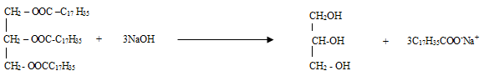

(i) What type of reaction is represented by the equation above (1mk)

……………………………………………………………………………………………….
(ii) To what class of compound does “K” belong? (1mk)
……………………………………………………………………………………………….

(e)The following equations represent two different types of reactions
(i) nC₄H_{8(g)} → [C₄H₈]_{n(g)}
(ii) C₂H_{6(g}) + Cl_{2(g)} → C₂H₅Cl_{(g)} + HCl_{(g)}
State the type of reaction represented by (i) and (ii) (1mk)
- ……………………………………………
- ……………………………………………
3. (a) Give the name of one reagent which when reacted with concentrated hydrochloric acid produces chlorine gas (1mk)
……………………………………………………………………………………………….
(b) A student set out to prepare iron (lll) chloride using apparatus shown in the diagram below
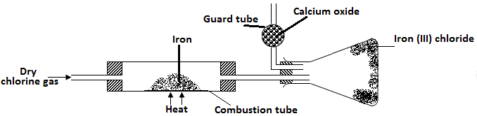
- Explain why it is necessary to pass chlorine gas through the apparatus before heating begins? (1mk)
..............................................................................................................................................................
………………………………………………………………………………………………………...
- What property of iron (III) chloride makes it possible to be collected as shown in the diagram (1mk)
…………………………………………………………………………………………………………

(iii) The total mass of iron (III) chloride formed was found to be 0.5g. Calculate the volume of chlorine gas that reacted with iron. (Fe = 56, Cl = 35.5 and molar gas volume at r.t.p is 24,000 cm³) (3mks)

(c) When hydrogen sulphide gas passed through a solution of iron (III) chloride the following observation was made;
The colour of the solution changed from reddish brown to green and yellow solid was deposited. Explain these observations (2mks)
…………………………………………………………………………………………………
…………………………………………………………………………………………………
(d) State and explain the observations that would be made if a moist blue-litmus paper was placed in a gas jar full of chlorine gas (2mks)
………………………………………………………………………………………………
……………………………………………………………………………………………….
………………………………………………………………………………………………..
(e) Study the information to answer the questions that follow. The letters do not represent the actual symbols of the elements.
Elements | Atomic number | Melting point (⁰C)
L | 11 | 97.8
M | 13 | 660
N | 14 | 1410
C | 17 | -101
R | 19 | 63.7
a) i) Write the electron arrangement for the ions formed by elements “ M” and “C” (1mk)
M ……………………………………………..
C ……………………………………………….
ii) State the type of the bond that will be formed when M and C react. (1mk)
………………………………………………………………………………………………
iii) In which group and period of the periodic table does element “R” belongs? (1mk)
………………………………………………………………………………………………
iv) Element R loses its outermost electrons more readily than “L”. Explain (1mk)
………………………………………………………………………………………………
………………………………………………………………………………………………
v) Using dots and crosses to represent electrons, show bonding in the compound formed between N and C. (2mks)

- Study the energy level diagram below and answer the questions that follow.
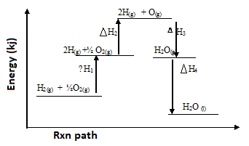

- (i) Which H values have a positive sign. (1mk)
……………………………………………………………………………………………………….
(ii) Which H values have a negative sign (1mk)
………………………………………………………………………………………………...
- What chemical changes is being represented by (2mks)
H₁ ………………………………………………………………………..
H₄ ………………………………………………………………………..

- The hydration energy of Al³⁺ and Cl⁻ are -4690 and -364kJmol⁻¹ respectively. The heat of solution of alluminium chloride is -332kJ mol-¹.

- Calculate the lattice energy of alluminium chloride (2mks)

- Draw an energy level diagram for dissolving of alluminium chloride (2mks)

- When one mole of butanol is burnt. 2676kJ are liberated
- Write a chemical reaction for combustion of butanol. (1mk)
……………………………………………………………………………………………….
- Considering the following heats of combustion
H^{θ}C (Graphite) = -393kJ mol⁻¹
H^{θ}C (H₂) _{(g)} = -286kJ mol⁻¹
H^{θ}C (Butanol) = -2676kJ mol⁻¹
Draw an energy cycle for the above energy changes (2mks)

- Calculate the heat of formation of butanol (2mks)

- (a) The equations below shows the standard reduction potential for four half cell. Study it and answer the questions that follow. Letters are not actual symbols of the element.
E^{ᶿ} Volts
F_{2(g)} + 2e- → 2F⁻_{(aq)} + 0.54
G²⁺_{(aq)} + 2e- → G_{(s)} -0.44
H⁺²_{(aq)} + 2 e- → H_{(s)} + 0.34
2J⁺_{(aq)} + 2e- → J_{2(g)} 0.00
i. Write the equation for the reaction which takes place when solid “G” is added to a solution containing H²⁺ (ions) (1mk)
………………………………………………………………………………………………
ii. Calculate the E^{ᶿ} value for the reaction in (ii) above (1mk)

(b) The diagram below shows the apparatus used to electrolyze acidified water to obtain hydrogen and oxygen gases. Study it and answer the questions that follows?
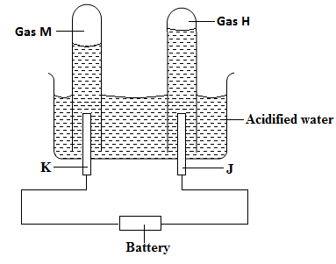

i. Identify the electrodes marked K and J (1mk)
K ……………………………………………………………
J …………………………………………………………….
ii. Write the equation that led to the production of gas (1mk)
M ……………………………………………………………………………………
H ……………………………………………………………………………………
iii. Explain why hydrochloric acid is not used to acidify the water (1mk)
………………………………………………………………………………………………
………………………………………………………………………………………………
(c) During electrolysis of aqueous copper (II) sulphate 144750 columbus of electricity were used. Calculate the mass of copper metal that was obtained (Cu= 64, 1 Faraday = 96500 Columbus) (2mks)

- The flow chart illustrates the extraction of zinc and preparation of Zinc (II) sulphate crystals. Study it and answer the questions that follow
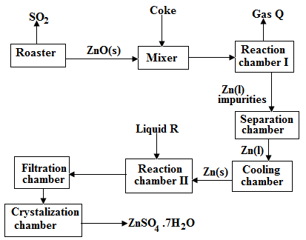

(a)(i) Name
I. Gas Q ………………………………………………………………. (1mk)
II. Liquid R …………………………………………………………….. (1mk)

(ii) Write an equation for the reaction that takes place in
Chamber I ………………………………………………………………………………… (1mk)
The Roster …………………………………………………………………………………. (1mk)
Chamber II ………………………………………………………………………………….(1mk)
(iii) Given that the zinc sulphide ore contain 45% of Zinc sulphide by mass, calculate
- The mass in grains of Zinc sulphide that would be obtained from 250 kg of the ore.(1mk)

- The volume of sulphur (IV) oxide (So₂) that would be obtained from the above mass of zincsulphideat room temperature and pressure (S = 32.0, molar gas volume = 24 dm³). (2mks)

III. The mass of zinc metalthat would be obtained in Iabove(Zn = 65.4) (1mk)

(b) In such an experiment sulphur (IV) Oxide may keep escaping to the atmosphere. Explain how this could affect the environment. (1mk)
……………………………………………………………………………………………..
……………………………………………………………………………………………..
(c) Suggest one other manufacturing plant that could be set up near Zinc extraction plant. (1mk)
……………………………………………………………………………………………….
- (a) State the difference between chemical and nuclear reactions (1mks)
……………………………………………………………………………………………….
……………………………………………………………………………………………….
(b) Below is a radioactive decay series starting from
214 206
Bi and ending at Pb. Study it and answer the questionsthat follows
83 82
214 219 210 210 210 206
Bi ^{Step I} Ti ^{Step II} Pb ^{Step III} Bi ^{Step IV} Po ^{Step V} Pb
83 84 82 83 84 82

(i) Identify the particle emitted in step I and III. (2mks)
I ………………………………………………………….
II …………………………………………………………
(ii) Write the nuclear equation for the reaction which takes place in step V (1mk)
………………………………………………………………………………………………
(c) The table below gives the percentage of radioactive isotope of Bismuth that remains after decaying at different times.
Time (mm) | 0 | 6 | 12 | 22 | 38 | 62 | 100
Percentage of Bismuth | 100 | 81 | 65 | 46 | 29 | 12 | 3

(i) On the grid provided below, plot a graph of the percentage of bismuth remaining (vertical axis) against time (3mks)

(ii) Use the graph, determine the
I. Half life of the Bismuth (1mk)
……………………………………………………………………………………………….
II. Original mass of bismuth isotope given that the mass remained after 70 minutes was 0.16g (1mks)
………………………………………………………………………………………………..
d. Give one use of radioactive isotope in medicine (1mk)
………………………………………………………………………………………………...

