NAME: ……………………………………………..……. INDEX NO: ……………………

233/1
CHEMISTRY
PAPER 1
NOV/DEC. 2020
TIME: 2 HOURS

LANJET F4 JOINT EXAMINATION – 2020
Kenya Certificate of Secondary Education

INSTRUCTIONS TO CANDIDATES
- Write your name and index number in the spaces provided.
- Answer all questions in the spaces provided
- KNEC mathematical tables and silent electronic calculators may be used for calculations.
- All workings must be clearly shown where necessary.
- Candidates should check the question paper to ascertain all the pages are printed as indicated and no questions are missing.

For Examiners Use Only
Questions | Maximum Score | Students Score
1-32 | 80

This paper consists of 12 printed pages. Candidates should check the question paper to ascertain that all pages are printed as indicated and that no pages are missing.

- State the observations made when a piece of sodium metal is dropped into a beaker containing water. (2mks)

- During a class experiment, students passed gas X over heated copper metal, the metal changed its colour to black.

(a) Identify gas X. (1mk)

(b) Name the black substance formed. (1mk)

- Aluminium is extracted from its ore by electrolysis.

(a) Name the main ore of Aluminium . (1mk)

(b) The Aluminium ore in (a) above has a very high melting point.(2015⁰C),though it is electrolyzed at a lower temperature of about 900⁰ C. Explain how the low temperature is achieved. (1mk)

(c) In the above process, graphite electrodes are used. What is the disadvantage of using this kind of electrodes (1mk)

- A student added 50cm³ of 1.0M aqueous Sulphuric (VI) acid to 50cm³ of 2.0M Potassium Hydroxide and the temperature of the resulting solution rose by 4⁰ C.

(a) Define the term Molar heat of neutralization. (1mk)

(b) Calculate the molar heat of neutralization
(C=4.2KJKg⁻¹ K⁻¹ ,Density of solution=1g/cm³) (2mks)

- Use the table below to answer the question that follow:

Element | Atomic number
A | 11
B | 13
C | 14
D | 17
E | 19

(a) Write an equation for the reaction between element A and water. (1mk)

(b) Explain the trend of atomic radii between elements A and D. (2mks)

.

- In terms of structure and bonding, explain why graphite is used as a lubricant. (2mks)

7. (a)State the Boyles Law. (1mk)

(b) A given mass of the gas occupies 20cm³ at 25⁰ C and 670mmHg pressure. Find the volume it will occupy at 10⁰ C and 335mmHg. (2mks)

8. Study the flow chart below and answer the questions that follow.
White precipitate insoluble on boiling tube
Colourless solution
Black solid
Mixture M
Step 1
Add water and filter
Add

Add water and filter
Add Barium Nitrate solution
Colourless solution
Pale blue solution
Step 4
Add dilute nitric (V) Acid
Step 3
Add ammonia solution in excess
Step 2

(a) Name
(i) Cations present in mixture M. (1mk)

(ii) Anion present in thecolourless solution. (1mk)

(b) Write an equation to show how the white precipitate in step 3 dissolves. (1mk)

(c) Name the process outlined in step 4 above. (1mk)

9.The solubility of potassium nitrate is 85g/100g of water at 50 ⁰ C and 32g/100g of water at 25 ⁰ C.
(a) Define the term solubility. (1mk)

(b) Calculate the mass of the crystals formed if a saturated solution of potassium nitrate in 50g of water at 50 ⁰ C is cooled to 25 ⁰ C. (2mks)

10.Magnesium Chloride dissolves in water to form a neutral solution while iron (III) chloride forms an acidic solution. Explain. (2mks)

11. The diagram below is a set up to prepare a certain gas X. Study it and use it to answer the questions that follow.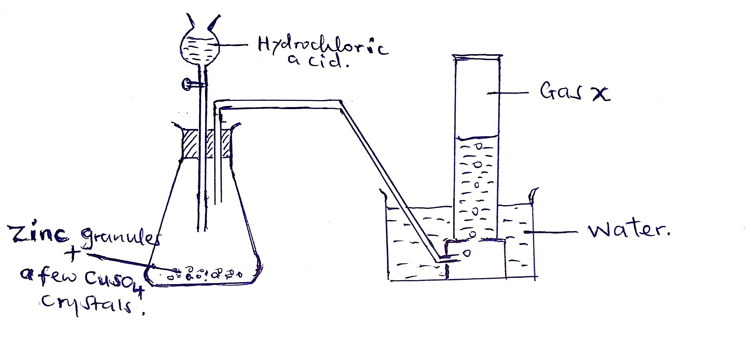
(a)Identify gas X. (1mk)

(b)Why is the gas collected over water? (1mk)
.
(c)Why are Copper (II) Sulphate crystals added to the flask where the reaction takes place?

12. (a)Give the systematic names of the following organic compounds. (2mks)
(i) CH₃CH₂CH₂CH₂OH

(ii) CH₃CH₂COOCH₂CH₃

(b)Explain why an organic compound with the formula C₄H₈burns with a more sooty flame than C₄H₁₀. (2mks)
.
13. When solid Zinc Carbonate was added to a solution of Hydrogen Chloride in methylbenzene there was no observable change. On addition of some water to the mixture there was effervescence. Explain the observation. (2mks)

14. In titration experiment,25.0 cm³ of sodium hydroxide containing 8.0 g per litre was required for complete neutralization of 0.245 g of a dibasic acid. Calculate the relative molecular mass of the acid. (3mks)

15. (a)100g of a radioactive isotope was reduced to 12.5g after 81 days. Calculate the half lifeof the radioisotope. (2mks)

` (b) ²¹²₈₀Y decays by beta emission. What is the mass number and the atomic number of the product after decay? (1 mk)

16.(a) Distinguish between ionization energy and electron affinity. ` (2mks)

17.The diagram below represents a paper chromatography for three brands of juice suspected to contain unwanted food additives.
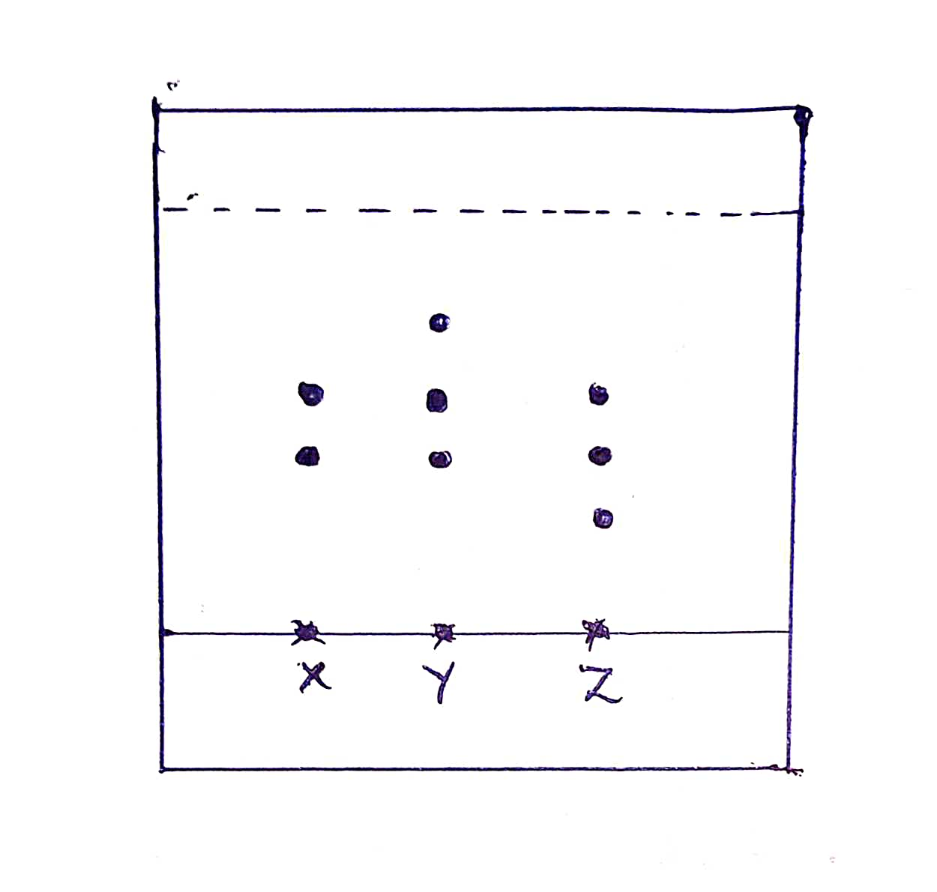
From the results, it was found that unwanted additives are present in Y and Z only.
On the chromatogram;
(a)Circle the spots which show unwanted food additives. (1mk)
(b)Name the solvent commonly used in paper chromatography. (1mk)

(c)State two applications of chromatography. (2mks)

18.(a)Show bonding in Aluminium Oxide. (1mk)

(b)Identify the type of bonds represented by p and q in the substances below.
H
H
H
H
O
p
q
O
O
H
H

q

p- (½ mk)

q- (½ mk)
19.The following diagram represents a charcoal burner. Study it and answer the questions that follow:
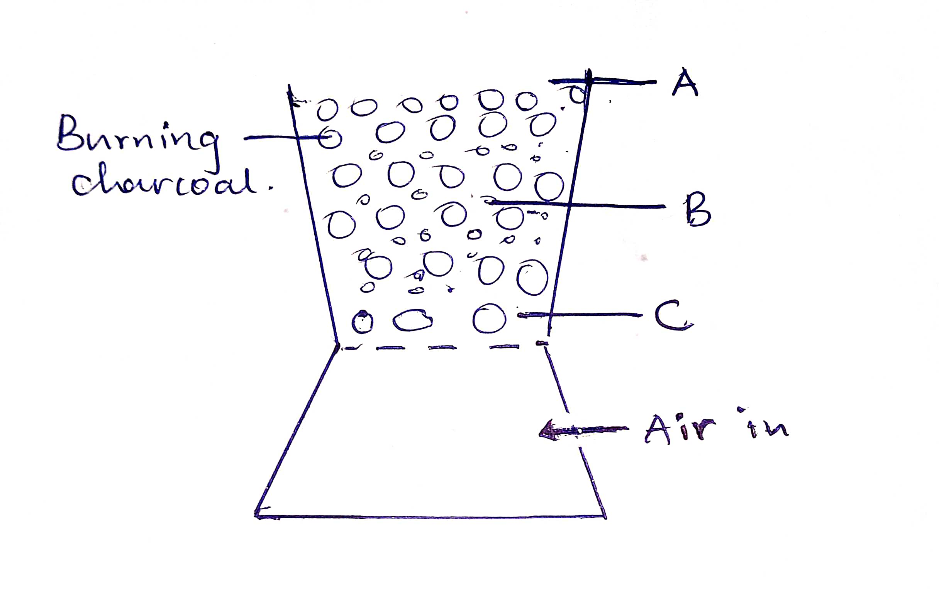
Write the equations for the reactions at A,B and C regions. (3mks)
A -
B –
C -

20. Use the scheme below to answer the question that follow.
Solid H
Carbon (IV) oxide
Solid J
(Yellow when cold)

(a)Identify process N. (1mk)
(b)Identify the solids
H- (½ mk)
J- (½ mk)
21.Ammonia gas is prepared by Harber process according to the equation below:
N₂(g)+3H₂(g) 2NH₃(g) +Heat
State and explain the effect on equilibrium when the following conditions are applied.
(a)Pressure increased. (1mk)

(b)Temperature increased. (1mk)

(c)State Le Chatelier’s principle. (1mk)

22. You are given the following half equations.
I₂(s) +2e⁻ 2I (aq) E^{Ѳ}=+0.54V
Br₂(l) +2e⁻ 2Br ⁻ (aq) E^{Ѳ}=+1.09V
(a)Write an overall equation for the cell reaction. (1mk)

(b)Calculate the E^{Ѳ} value of the cell. (1mk)

(c)Name the oxidizing agent. (1mk)

23.When a current of 0.8Ampheres was passed for 44 minutes and 20 seconds through fused iodide of metal Z, 0.7167g of Z was deposited. Determine the charge of the ion of metal Z.
(1 Faraday=96500C,RAM of Z=65) (2mks)

24.The set up below shows how small pieces of copper are heated in nitrogen (I) Oxide.
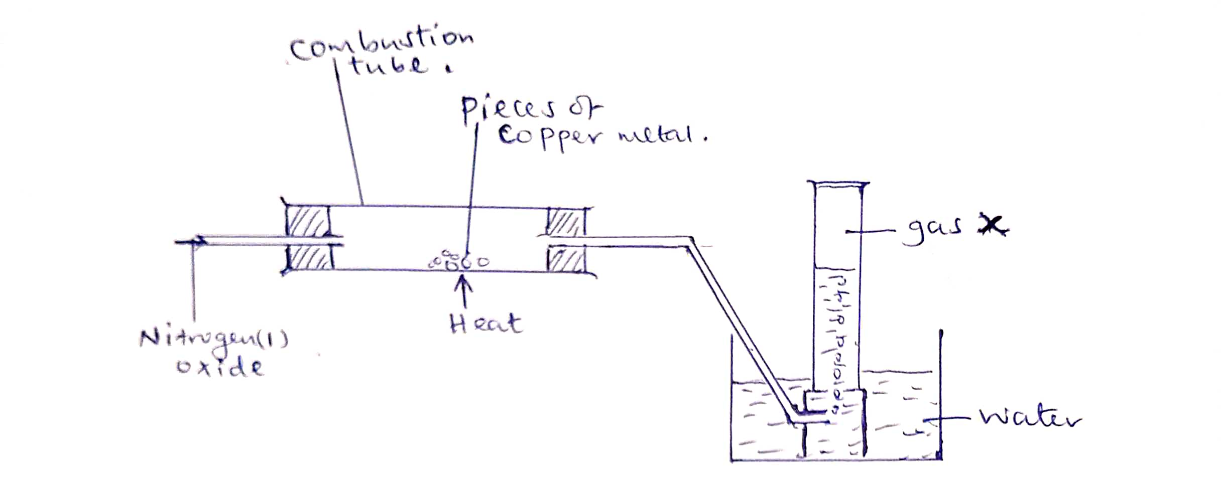
(a)Write an equation for the reaction which occurs in the glass jar. (1mk)

(b)Give one use of the Nitrogen (I) Oxide. (1mk)

25.State what would be observed if concentrated Sulphuric (VI) Acid is added to:
(a)Sugar crystals. (1mk)

(b)Hydrated Copper (II) Sulphate crystals. (1mk)

(c)What type of reaction has taken place above. (1mk)

26.Explain why commercial indicators are preferred to flower extracts as acid base indicators. (2mks)
.

27.(a)Magnesium reacts with hydrochloric acid according to the following equation.
Mg(s) +2HCl(aq) MgCl₂(aq) +H₂(g)

Identify the reducing agent. Give a reason for your answer. (2mks)

(b)Iron sheets are dipped in molten Zinc to prevent rusting .Name this process. (1mk)

28.Explain why a balloon filled with helium gas deflates faster than a balloon of the same size filled with argon gas. (2mks)

29.Complete the table below. (2mks)
Solution | PH | Nature of Solution
H | 1.0
I |  | Neutral
J |  | Weak acid
K | 13.0

30.A farmer intended to plant cabbages in his farm. he first tested the PH of the soil and found it to be 3.0.If cabbages do well in alkaline soils, explain the advice that would be given to the farmer in order to realize a high yield. (2mks)

31.Name an appropriate apparatus:
(a)That is used to prepare standard solutions in the laboratory. (1mk)

(b) That is used in heating solid substances strongly. (1mk)

(c)That can be used to separate two immiscible liquids. (1mk)

32.Some plants have seeds that contain vegetable oil.
(a)State the reagent and apparatus used to extract the oil from the seeds. (1mk)
Reagent-
Apparatus-

(b)Explain how it could be confirmed that the liquid obtained from the seeds is oil? (1mk)

(c)State an application of the method of extracting oil above. (1mk)

