MERU CENTRAL CLUSTER FORM FOUR TERM TWO EXAMINATION 2020
233/2
CHEMISTRY PAPER 2
FORM 4 DECEMBER 2020
MARKING SCHEME

I) To absorb excess Carbon (IV) oxide or gas B
To absorb unreacted Carbon (IV) oxide any one

II) Carbon (IV) oxide / CO₂
III) Any Carbonate/hydrogen Carbonate and acid
IV) (I) CO₂ (g) + C (s) 2CO (g)
(II) KOH (aq) + CO₂ (g) KHCO₃ (aq)

v) Use of Ca(OH)₂ (aq) : CO does not form white precipitate with Ca(OH)₂ while CO₂ does
CO burns with a blue flame while CO₂ does not support combustion.
VI (i) Brown fumes produced
Black substance dissolves any one

ii) HNO₃ (aq) + C(s) CO₂ (g) + 4NO₂ (g)

VII) Reducing agent in the extraction of metals from the ores
Used as fuels any one correct
Manufacture of hydrocarbons

2. a) 2.8.8, 2.8

b) i) D
ii) A
iii) C
iv) Liquid The melting point is below 661⁰c
c) B is a better electric conductor than A, because it has more delocalized electrons than A.

d) 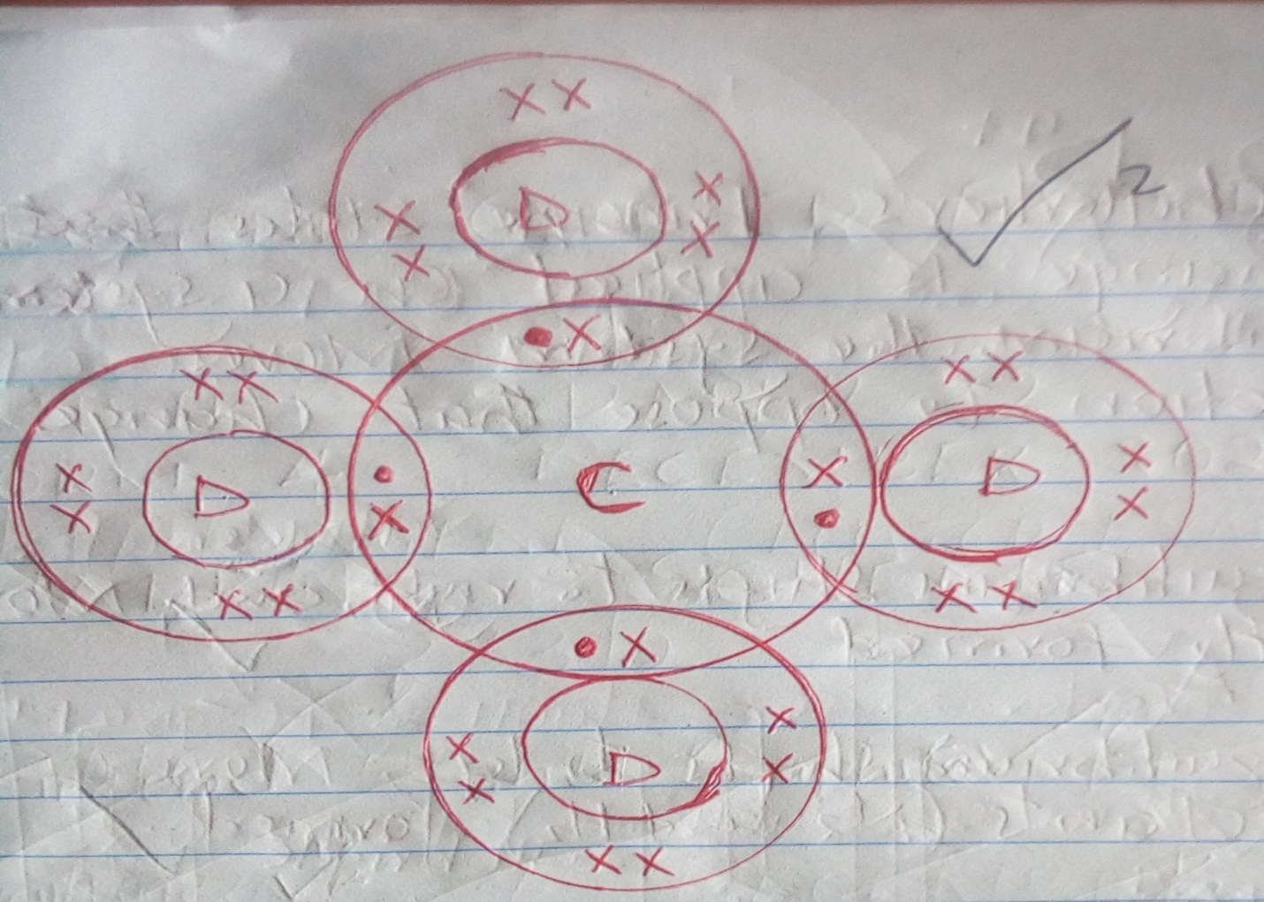
e) B has a higher melting point than A because B has more delocalized electrons than A.
Therefore B has stronger metallic bond than A thus high melting point.

f) E(s) + H₂O (g) EO(s) + H₂ (g)

g. Add water to the mixture, Stir, E Chloride dissolves while Lead (II) Sulphate does not. Filter
and wash the residue with distilled water.
Evaporate the filtrate to obtain solid E Chloride

3. a) Propane
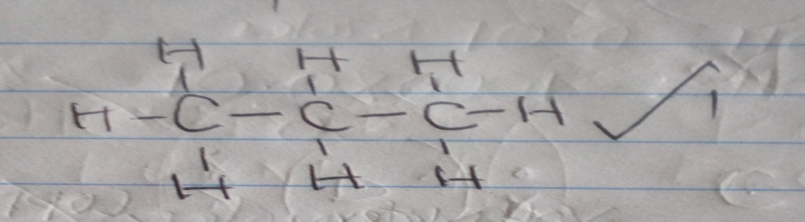

b) i) Reagent – Conc Sulphuric (VI) acid/Conc H₂SO₄
Condition – 160 – 180⁰c
ii) Reagent: Chlorine gas / C/ (g)
Condition: Ur light / sunlight
C (i) Carbon (IV) oxide
(ii) Hydrogen gas
(iii) Propan-1-oic acid
iv) 1-Bromopropane / 2 – Bromopropane
d) 2C₃H₇OH (l) + 9O₂ (g) 6CO₂ (g) + 8H₂O (l)
e) Addition polymerization / polymerization
f) (3 x 12) + (1 x 6) = 42
42n = 21,000
N = 21,000 = 500 units
42

4.
i) a) Are substances which when molten or dissolved in water conduct an electric current and
decomposes.

b) i) Magnesium metal conducts since it contains free ions

c) i) P – PbSO₄
Q – Mg (NO₃)₂

ii) Pb²⁺ (aq) +SO4²⁻ (aq) PbSO₄ (s)

iii) Precipitation / Double decomposition

iv) Pb(NO₃) (aq) + 2HCI (aq) PbCI₂ (s) + 2HNO₃ (aq)

v) Heat/warm

vi) Effect of temperature on solubility

vii) It is used as anti-acid medicine because Mg (OH) ₂ is a non-toxic base.

5. a) A solution which cannot dissolve any more solute at a particular temperature.

b (i)
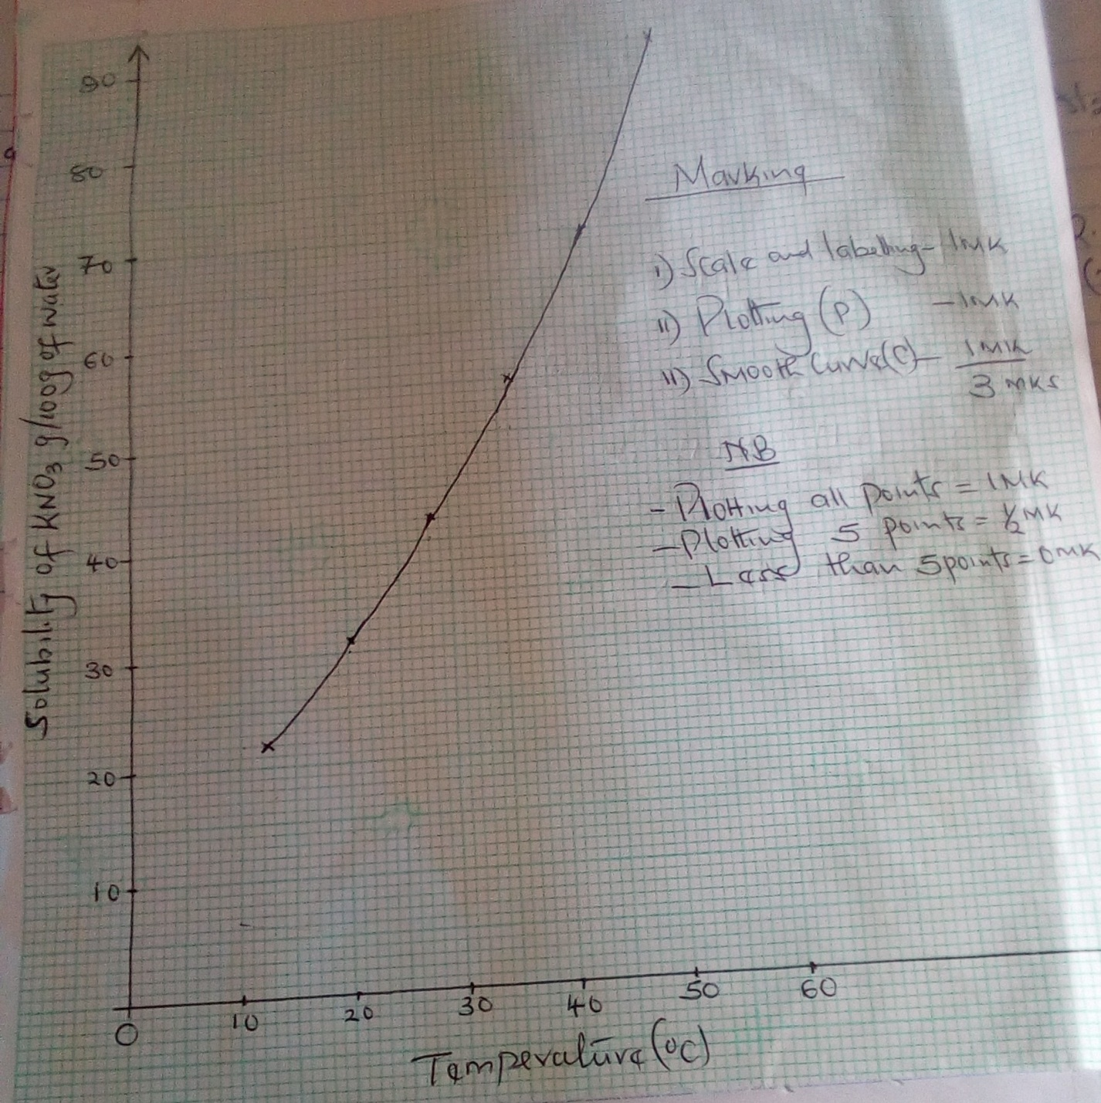

ii) (i) 25g per 100g of water

(ii) Mass dissolved = 62g
Mass of undissolved = 80 – 62 = 18g
c) R.F.M of KNO₃ =101
Moles of KNO₃in 100g water = 25 = 0.2475 moles
101
Moles in 1000g of water = 0.2475 x 1000
100
= 2.475 moles

6. a) i) Al₂O₃(s) + 6HCI (aq) 2AlCI₃ (aq) + 3 H₂O (l)
(ii) R.F.M of Al 2O₃
(27 x 2) + (16 x 3) = 102
Moles of Al₂O₃ = 153 = 1.5 moles
102
Moles of HCI = 1.5 x 6 = 9 moles
b) i) 2NaOH (aq) + H₂SO₄ (aq) Na₂SO₄ (aq) + 2H₂O (l)

(ii) (I) Mole ratio of NaOH: H₂SO₄ = 2: 1
Moles of H₂SO₄ reacted = 20 x 0.25 = 0.005 moles
1000
Moles of NaOH reacted = 2 X 0.005 = 0.01moles
(II) If 50cm³ of NaOH = 0.01 moles
1000cm³ of NaOH = 1000 X 0.01
50

= 0.2 moles

(III) Molar mass of NaOH = 40 gmol⁻¹
Mass of NaOH reacted = 40 x 0.2 = 8g
Mass of NaCI = 8.8 – 8.0 = 0.8g
% of NaCI = 0.8 x 100 = 9.090%
8.8
7. i) Galena

ii) Some of the Sulphide is converted into Lead Oxide and Sulphur (IV) oxide

iii) Carbon (II) oxide or carbon (IV) oxide

iv) PbO (l) + C (s) Pb (l) + CO (g)

v) To reduce unreacted Pbs to Pb

vi) Sulphur (IV) oxide – causes acid rain
Lead – causes lead poisoning

b) Hard water contains Mg²⁺ / Ca²⁺ ions. These ions form a protective layer of calcium Sulphate
or Magnesium Carbonate hence does not dissolve lead.
Soft water does not form these deposits.

c) Radioactive shielding
Lead acid accumulators
Making roof

