NAME…………………………………………………...… INDEX NUMBER…………….…
SCHOOL ………………………………………….. CANDIDATE SIGN ……………………..
DATE ……………………………..

233/1
CHEMISTRY
PAPER 1
TIME: 2 HOURS

MERU CENTRAL ClUSTER FORM FOUR TERM TWO EXAMINATION 2020
FORM FOUR TERM TWO EXAM 2020

INSTRUCTIONS TO CANDIDATES
- Write your name and index number in the spaces provided above
- Sign and write the date of examination in the spaces provided
- Answer all questions in the spaces provided
- KNEC mathematical tables and silent electronic calculators may be used
- All workings must be clearly shown where necessary
- Candidates should answer all questions in ENGLISH

FOR EXAMINER’S USE ONLY
QUESTION | MAXIMUM SCORE | CANDIDATES SCORE
1 - 32 | 80

1 a) What is meant by allotropy? (1mk)

b) Identify the two crystalline allotropes of carbon. (1mk)

c) Give one use of carbon black. (1mk)

2. When hydrated sample of iron (II) Sulphate FeSO₄. nH₂O was heated until there was no
further change in mass, the following data was recorded.
Mass of evaporating dish = 78.94g
Mass of evaporating dish + hydrated salt = 84.14g
Mass of evaporating dish + residue = 81.78g
Determine the empirical formula of the hydrated salt
(Relative formula Mass of FeSO₄ = 152, H₂O =18) (3mks)

3. Equal volumes of 2M monobasic acids R and S were each reacted with excess magnesium ribbon. The table below shows the volume of the gas produced after one minutes

Acid | Volume of gas (cm³)
R | 80
S | 30

- Write the ionic equation for reaction which took place (1mk)

- Explain the difference in the volumes of the gas produced (2mks)

4. The graph below shows the changes which takes place when a solid is heated.
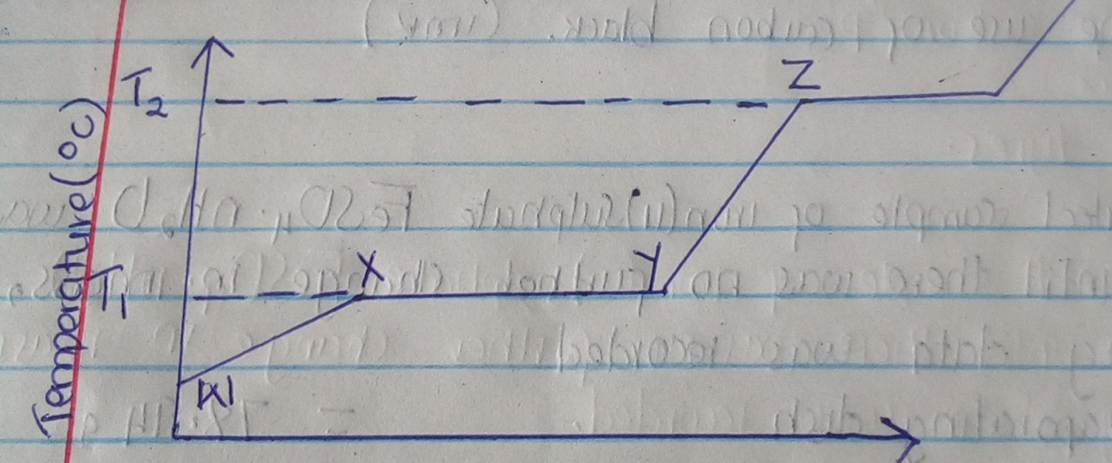
- What happened to the molecules between W and X? (1mk)

- What is the significance of temperatures T₁ and T₂ (1mk)

- Explain why the temperature does not rise between X and Y (1mk)

5. In an experiment to determine the solubility of potassium nitrate at 30⁰c, a saturated solution
was heated in an evaporating dish until there was no further change in mass. The following

data was obtained.
Mass of dish + solution = 128.9 g
Mass of dish + dry salt = 103.9 g
Mass of empty dish = 94.3 g

Determine the solubility of potassium nitrate at 30⁰c. (3mks)

6. The diagram below shows a set up that was used to prepare and collect a sample of nitric acid.
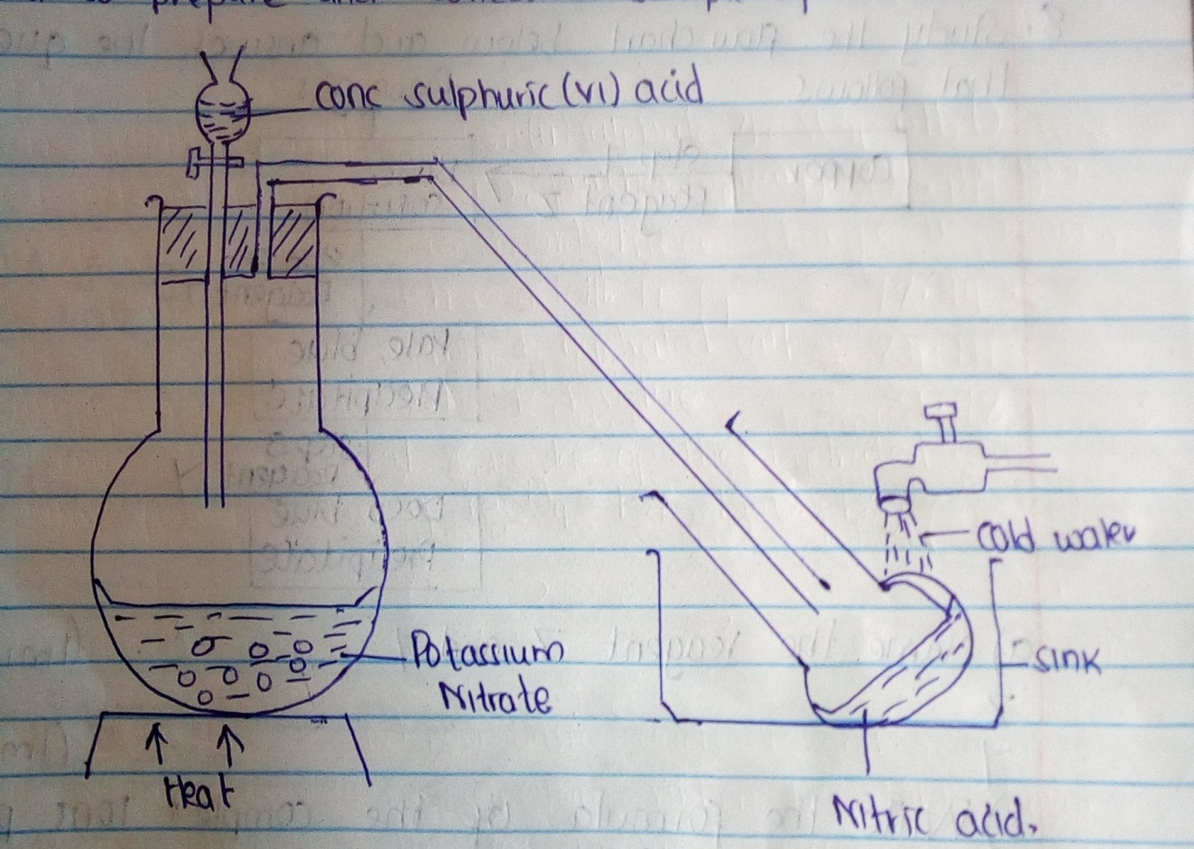

- Give a reason why it is possible to separate nitric acid from Sulphuric acid in the set up. (1mk)

- Name another substance that can be used instead of potassium nitrate. (1mk)

7. Starting with lead oxide, nitric acid, sodium sulphate, water and all necessary apparatus,
describe how you would prepare a dry sample of lead (II) sulphate (3mks)

8. Study the flow chart below and answer the questions that follows:

Brown gas
Copper
Step 1
Blue
solution

Reagent Z
Pale blue
Precipitate
Step 2
Reagent y

Step 3
Reagent Y
Deep blue
Precipitate

- Name the reagent Z and Y
Z (1mk)

Y (1mk)

- Write the formula of the complex ions presented in the deep blue solution (1mk)

9. The equations below shows the molar enthalpies of combustion of carbon, hydrogen and
methane.

C(s) + O₂(g) CO₂ (g) H_{c} = -393 KJmol⁻¹
H₂ (g) + ½ O₂ (g) H₂O (l) H_{c} = -285 KJmol ⁻¹
CH₄ (g) + O₂ (g) CO₂ (g) H_{c} = -890KJmol ⁻¹
Use the energy cycle diagram to calculate the heat of formation of methane (3mks)

10. NO₂ and N₂O₄ gases exist in equilibrium at 20⁰c
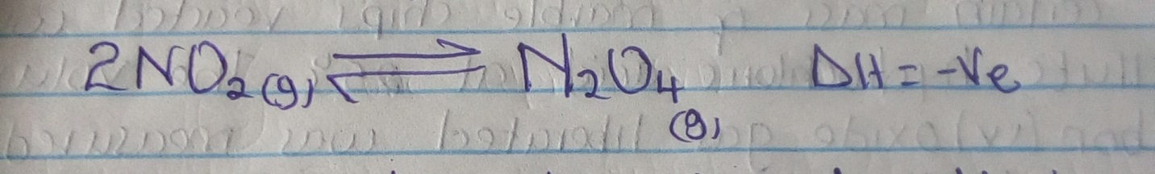

State and explain the observation that would be made when
- A syringe containing the mixture 20⁰c is heated to 40⁰c (1mk)

- The gaseous mixture in a syringe is compressed. (1mk)

11. The diagram below shows a Bunsen burner when in use
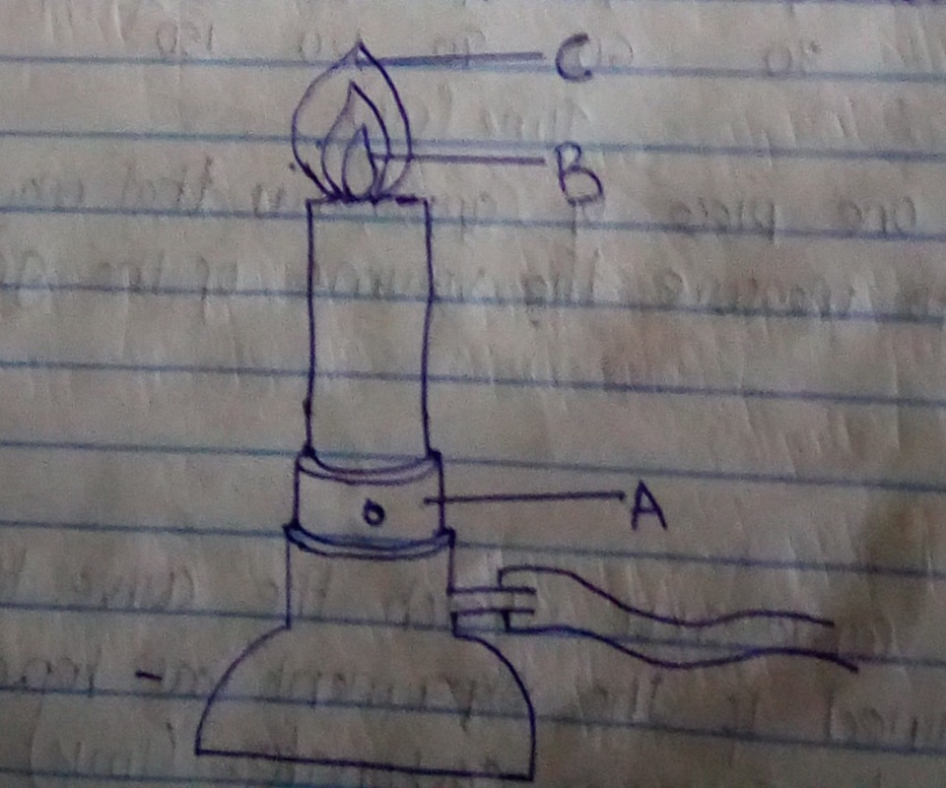

- Name the regions labelled B and C (1mk)
B

C

- What is the function of the part labelled A? (1mk)

12. A certain mass of marble chips reacted with excess dilute hydrochloric acid at 25⁰c. The volume of carbon (iv) oxide gas liberated was measured after 30 seconds. The results were presented as shown in the graph below.
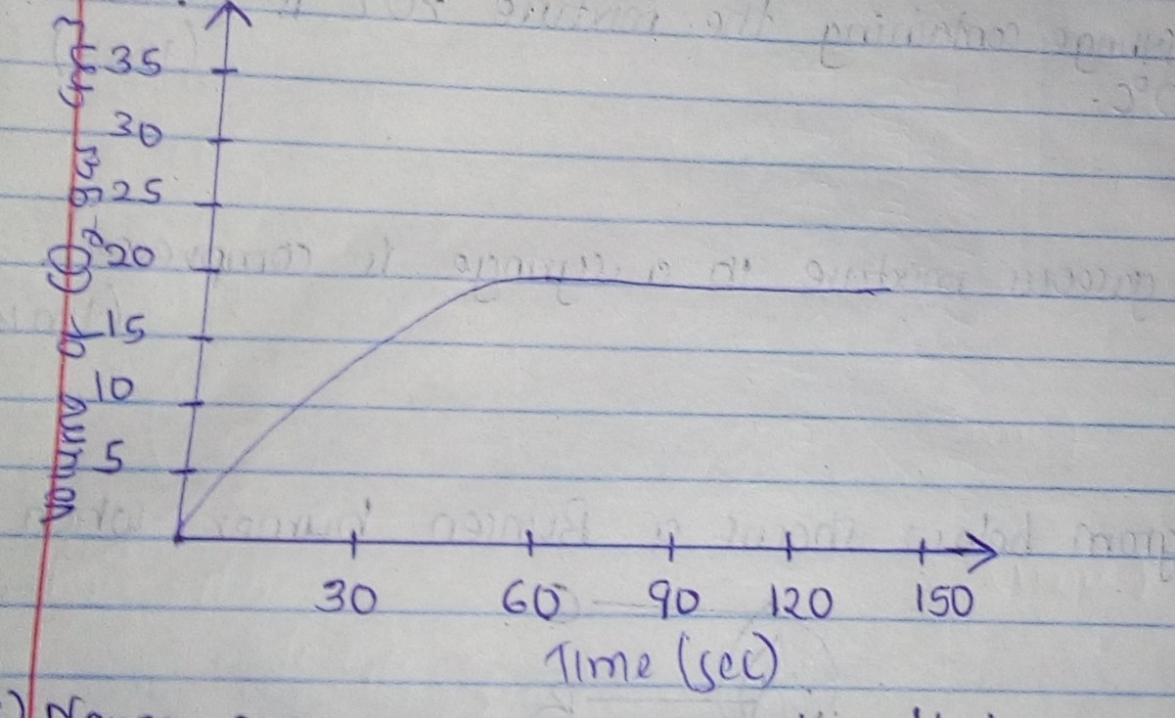

- Name one piece of apparatus that may have been used to measure the volume of the gas liberated. (1mk)

- On the same axis sketch the curve that would be obtained if the experiment was repeated using powdered calcium carbonate. (1mk)

13. When hydrogen Sulphide gas was bubbled into an aqueous solution of iron (iii) chloride, a
yellow precipitate was deposited.
- State another observation that would be made (1mk)

- Write an equation of the reaction that took place. (1mk)

14. The table below shows the atomic number of elements M, P, Q and R.

Element | P | Q | R | M
Atomic No | 13 | 7 | 12 | 13
Mass No | 26 | 15 | 24 | 27

- Which two letters represent the same element? Give reasons (1mk)

- Give the number of neutrons of an atom of element Q (1mk)

15. The diagram below show the set up that was used to prepare and collect
Sulphur (iv) oxide gas.
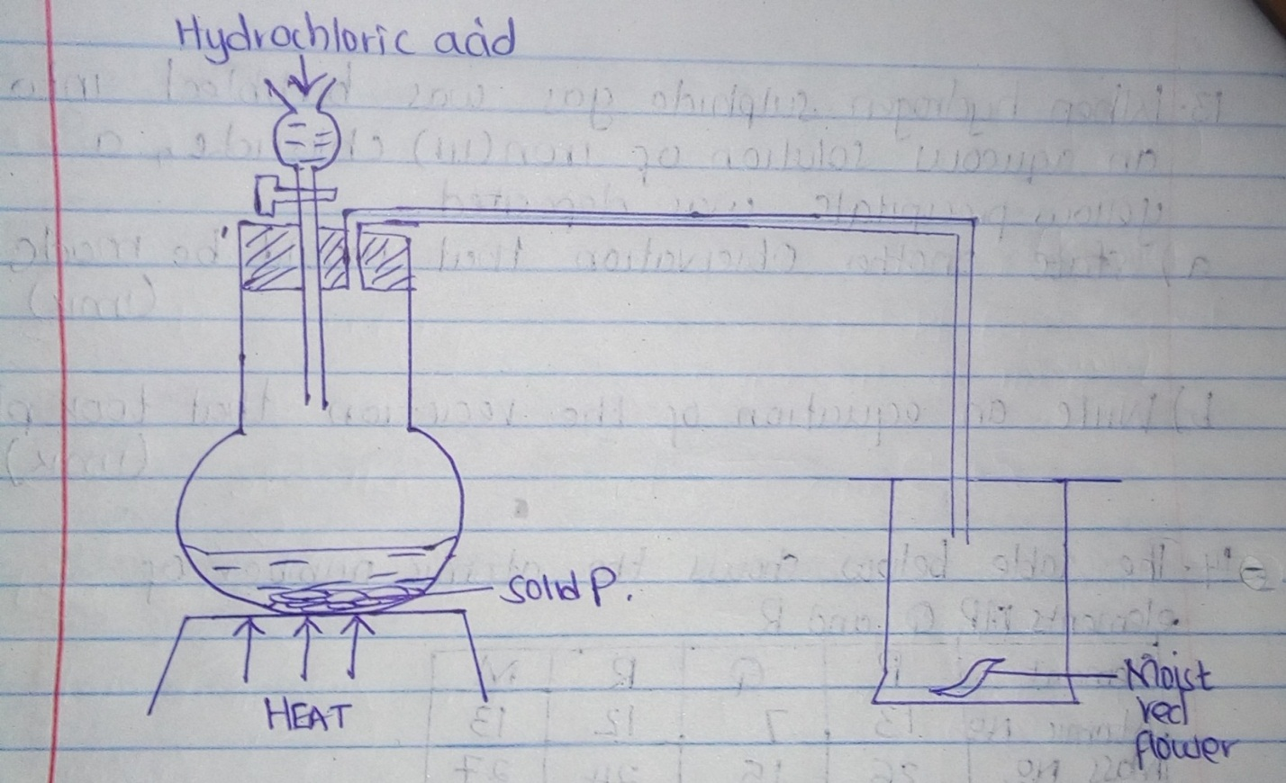

- Identify the solid P (1mk)

- i) Why is it possible to collect Sulphur (iv) oxide as shown? (1mk)

ii) What happened to the red flower? (1mk)

16 a) State Charles’ law (1mk)

b) The volume o f a sample of nitrogen gas at temperature of 298k and 600mmHg pressure
was 0.048m³, calculate the temperature at which the volume of the gas would be 0.032m³
if pressure remains the same. (2mks)

17. Element T consists of two isotopes ⁶²T and ⁶⁴T in the ratio 7:3 respectively. Calculate the
Relative atomic mass of element T (3mks)

18. Name the process which takes place when
a) Solid carbon (iv) oxide changes directly into gas (1mk)

b) Butanol reacts with hexanoic acid in the presence of Sulphuric (iv) acid. (1mk)

19. Study the standard electrode potentials for the half-cells give below and answer the questions
that follows ( the letters do not represent the actual symbols of the elements)
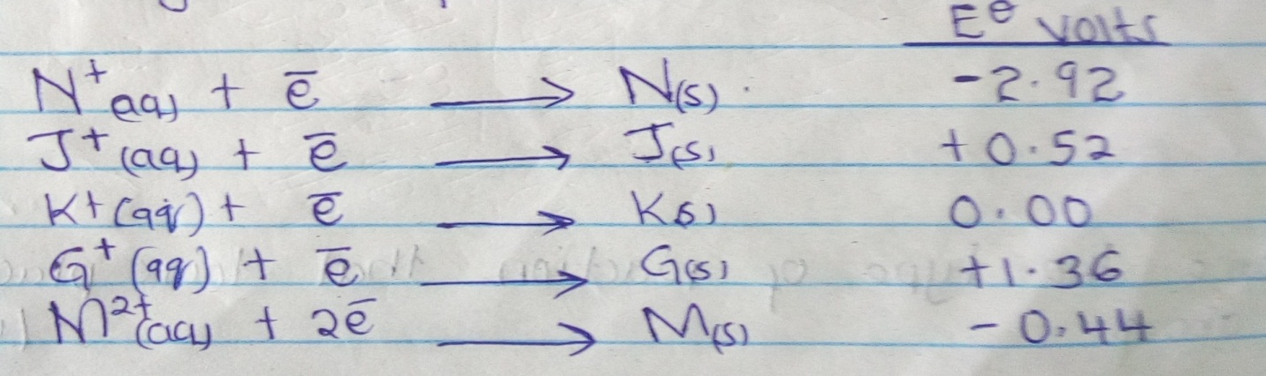

- Identify
- The strongest reducing agent (½ mks)

- The strongest oxidizing agent (½mks)

- Calculate the e.m.f of the cell (2mks)
N_{(s)/}N⁺_{(aq)} // G⁺_{(aq)} / G_{(s)}

20. Study the table below and answer the questions that follow

Bond type | Bond energy  KJ/mol
C - C | 346
C = C | 610
C - H | 413
C - Br | 280
Br - Br | 193

- Calculate the enthalpy of the following reaction. (2mks)

C₂ H_{4(g)} + Br₂ (g) C₂H₄ Br₂ (g)

- Name the type of reaction that took place in a) above (1mk)

21. Briefly explain how you would obtain pure sample of lead (ii) chloride from a mixture of
lead (ii) chloride and silver chloride (3mks)

22. Explain the following observations: very little carbon (iv) oxide is evolved when lead
carbonate reacts with dilute hydrochloric acid (2mks)

23. The table below gives some properties of compounds P, Q, R and S

Compound | B.P⁰C | M.P⁰C | Conductivity in water
P | 77 | -23 | Does not conduct
Q | 74 | -19 | Does not conduct
R | -161 | -85 | Conduct
S | 2407 | 714 | Conduct

- Which one of the compounds in the table is ionic?
Explain (1mk)

- Give the compound that is liquid at room temperature. (1mk)

24. When butan – 1 – 0L is oxidized by acidic potassium dichromate, a weak organic acid is
formed. Draw and name the structure formula of the acid obtained from the above
reaction. (2mks)

25. When a hydrocarbon fuel burns, one of the main products is acidic gas R
i) Identify gas R (1mk)

ii) What two effects does gas R have when its concentration in the atmosphere exceeds its
acceptable level. (2mks)

Escaping
26. Air was passed through several reagents as shown in the flow chart below. gases
Excess heated magnesium powder
Excess hot
Copper turnings
Concentrated potassium
Hydroxide solution
Air

- Write an equation for the reaction that took place in the chamber with the magnesium powder (1mk)

- Name one gas that escapes from the chamber containing magnesium powder. Give a reason for your answer. (1mk)

27. When a current of 6.42 Amperes was passed through an electrolyte Y ²⁺ for 10 minutes,
2.74g of Y were deposited. (1mk)
- Calculate the quantity of the electricity passed in the experiment.

- Determine the relative atomic mass of (1 faraday = 96,500 coulombs) (2mks)

28. Explain why aluminium metal is not extracted from aluminium chloride (2mks)

29. Part of the structure of a polymer is given below.
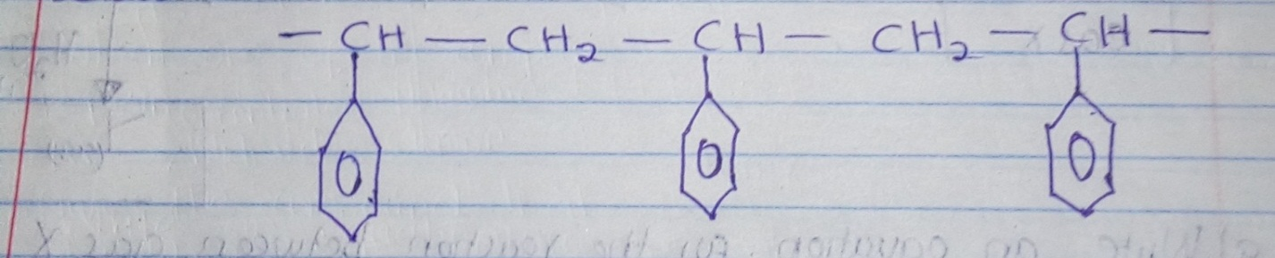

- Identify the polymer. (1mk)

- State one disadvantage of continued use of this polymer (1mk)

30. The table below gives the rate of decay for a radioactive element M

Number of days | Mass (g)
0 | 12.8
280 | 0.8

Determine the half – life of the radioactive element M (2mks)

31. Study the flow chart below and answer the questions that follows.
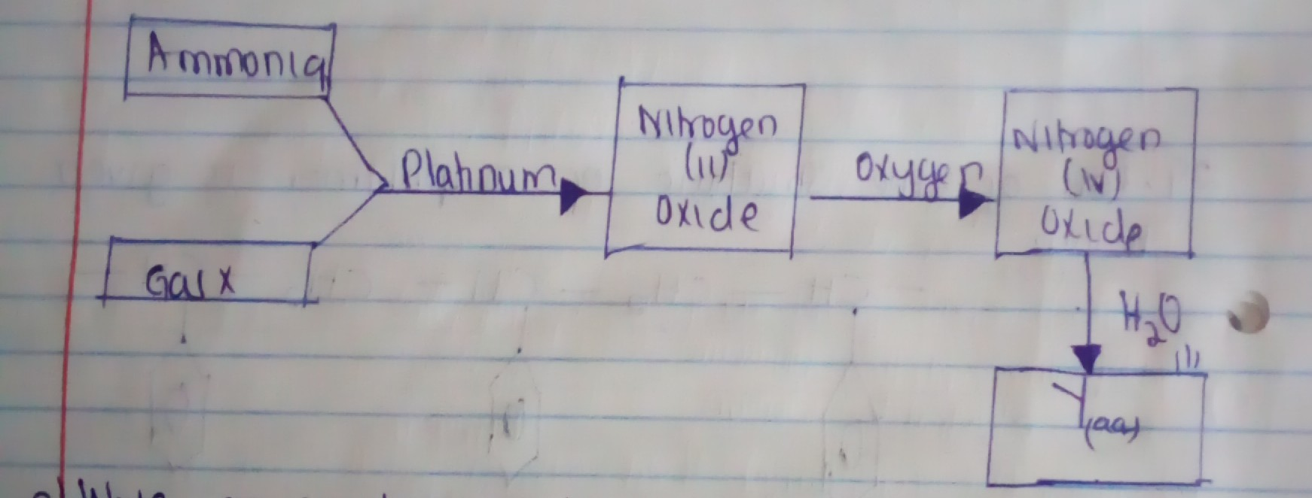

- Write an equation for the reaction between gas X and ammonia (1mk)

- Write the formulae of the substance present in the mixture Y(aq) (2mks)

32. When the air hole is fully opened, the Bunsen burner produces a non-luminous flame
Explain (1mk)

