MARKING SCHEME
233/1
Chemistry THEORY
PAPER 1
MARCH 2020
MAGS 2 CYCLE 7
Kenya Certificate of Secondary Education (K.C.S.E)

This paper consists of 10 printed pages. Candidates should check
the questions to ensure that all pages are printed as
indicated and no question(s) are missing

- Study the information given below and use it to answer the questions that follow;
Red dye is more soluble than green dye, green is more soluble than yellow whereas blue dye is the least soluble.
i) Represent the three dyes on a round paper chromatography. (2marks)

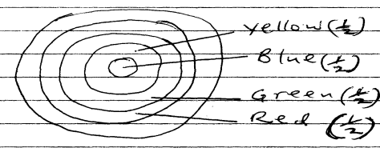

ii) Name one industrial application of chromatography. (1mark)
Detecting/identifying poisonous substances present in food substances// purifying natural pigments (1)

- a) What is a fuel? (1mark)
A substance that produces a substantial amount of energy when burnt. (1)

b) Calculate the heat value of ethanol if its molar enthalpy of combustion is-1360kjmol-1
(C=12.0, O=16.0, H=1.0) (2marks)
RFM of C₂H₅OH. = 12 x 2 + 1 x 6 + 16 = 46 ( ½ )
Heat value = ( ½ )
= 29.5652kJ(1) penalize ½ mk for wrong/missing units

- Study the set up below and use it to answer the questions that follow.
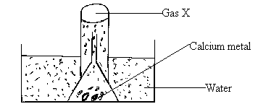
a) What physical property of calcium metal is demonstrated in the diagram above? (1mark)
Denser than water (1
b) What would be observed if water was replaced with dilute Sulphuric (VI) acid? (2marks)
Effervescence/gas bubbles ( ½ ) which stops immediately ( ½ )// white precipitate with evolution of gas bubbles/effervescences
Calcium reacts with sulphuric acid to form an insoluble calcium sulphate and hydrogen gas (1)
4. A hydrocarbon decolorizes chlorine gas in presence of ultra violet light but does not decolorize acidified potassium manganate (VII) solution.
i) Name the homologous series to which the hydrocarbon belongs. (1mark)
Alkanes (1)
ii) Draw the structural formula and name the fourth member of the homologous series to which the hydrocarbon belongs? (2marks)
H H H H

H C C C C H (1) Butane (1)

H H H H 5. Explain why a solution of hydrogen chloride in water turns blue litmus paper red but a solution of hydrogen chloride in methylbenzene has no effect on litmus papers. (2marks)
HCL_{(g)} ionizes (1) in water to form acidic solution ( ½ ) while in methylbenzene, HCl_{(g)} gas remains molecular (1) hence neutral ( ½ )

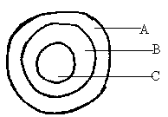
6. The diagram below represents a cross section of the apparatus used to extract sulphur from its deposits. Study it and answer the questions that follow.

a) State the role of the substance that is passed through;
i) A – Superheated water is used to melt sulphur deposits (1) (1mark)
ii) C – Hot air used to force the mixture of molten sulphur (1mark)
b)Give one reason why the method shown in the diagram is suitable for extraction of sulphur. (1mark)
The soil structure is weak and can cave incase of open mining (1)
7. Explain how you would obtain magnesium carbonate from a mixture of magnesium carbonate and sodium carbonate. (2mark
Add water to the mixture (1) filter (1) wash the residue with distilled water ( ½ ) Dry between filter papers (½)

8. 20g of potassium carbonate were dissolved in 50cm3 of water in a conical flask. Lemon juice was then added drop wise while shaking until there was no further observable change.
a) Explain the observation that was made in the conical flask when the reaction was in progress. (1mark)

Lemon reacted with the carbonate to produce carbon (IV) oxide gas (effervesnces ) (1)
b) What observation would be made if lemon juice had been added to copper turnings in a conical flask?
Give a reason. (2marks)
No observable change/effervescence/gas bubbles (1); lemon juice is not an oxidizing agent
9. Explain why a burning magnesium continues to burn in a gas jar full of carbon (IV) oxide while a burning candle would be extinguished. (2marks)
The intense heat of reaction (1) of magnesium decomposes CO_{2(g)} into carbon and oxygen.(1)
The oxygen formed further combine with magnesium to form magnesium oxide (1)
10. 8.4g of carbon (IV) oxide and 3.42g of water are formed when a hydrocarbon is burnt completely in oxygen. Determine the empirical formula of the hydrocarbon.
(H=1.0; C=12.0; O=16.0) (3marks)
C_{x}H_{y} + O_{2(g)} XCO_{2(g)} + H₂O_{(l)} (1)
Mass moles 8.4 3.42

Moles
0.1909 : 0.19( ½ )
Mole ration :
X = 1; = 1 y=2 ( ½ )
E.F = CH₂ (1)
11. The melting point of nitrogen is -1960C while that of sodium is 980C, in terms of structure and bonding explain the differences in the melting points of nitrogen and sodium. (2marks)
Nitrogen has a simple molecular structure ( ½ ) with weak van der waals/ intermolecular forces (½ ) which are easily overcome by heat ( ½ ) while sodium metal has a metallic structure (½) with stronger metallic bonds (1)// which require a lot of heat to break.
12. a) What is an amphoteric substance? (1mark)
A substance that displays both acidic and basic properties(1)

b) Identify the reagent that acts as a base in the equation below. Give a reason for your answer.
H2O2(aq) + H2O(I) H3+O(aq) + HO2(aq) (2marks)
H₂O_{2(aq)}(1) has accepted protons/H⁺(1)

13. In the industrial manufacture of ammonia gas by Haber process, Nitrogen and hydrogen gases are reacted together.
a) State any two conditions necessary for ammonia to be formed in the Haber process. (1mark)
Temperature of 450⁰C - 500⁰C
Pressure of 200 atmospheres
Iron catalyst Any 2 correct @ ½ mk each
b) Nitrogen and hydrogen must be purified before they are reacted. Give a reason. (1mark)
Impurities will poison the iron catalyst (1)
c) Other than manufacture of fertilizers state one use of ammonia. (1mark)
Make nitric acid; Refrigerates; softening water; make hydrazine (rocket fuel) Any 1 correct @ 1mk
14. Describe how you would prepare crystals of potassium sulphate starting with 100cm3 of 0.5M potassium hydroxide. (3marks)

React the 100cm³ of potassium hydroxide with 50cm³ of 0.5M H₂SO_{4(aq)} (or 100ml of 0.25 H₂SO₄) (1)
Evaporate/heat ( ½ )the resulting solution to saturation ( ½ ) leave in air the saturated solution to form crystals/cool in air for crystals top form ( ½ ) Dry the crystals by pressing a filter paper on them ( ½ )

15. Distinguish between atomic mass and relative atomic mass. (2marks) Atomic mass- refers to the total number of protons and neutrons in an atom of an element (1)
Relative atomic mass – the average mass of an atom of the element compared with an atom of carbon – 12 (1)
// RAM = Average mass of one atom of an element
of the mass of one atom of C-12

16. Study the diagram below and answer the questions that follow:
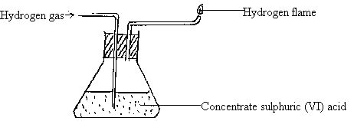
a) Name one chemical and one physical property of hydrogen being demonstrated in the set-up above.

i) Chemical property. (1mark)
Burns in air/Reacts with air when burnt ( ½ )

ii) Write a chemical equation for the reaction taking place. (1mark)
2H_{2(g)} + O2_{(g)} 2H₂0_{(g)}
b) Name any other substance that can be used in place of concentrated sulphuric (VI) acid. (1mark)
Anhydrous calcium chloride/calcium oxide lamps (1)
c) Give a reason why it is necessary to burn the hydrogen gas as shown in the set-up. (1mark)
Explodes in air/when mixed with air (1)
17. The diagram below shows a simple distillation to separate water and ethanol.
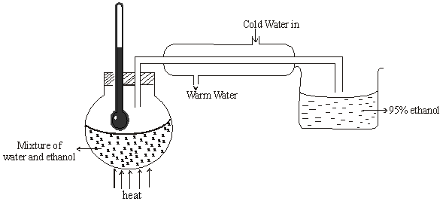

- State one of the conditions for the above process to take place. (1mark).
Two liquids must be miscible ^{√1mk} or two liquids must have different boiling points.
- Ethanol collected is 95% pure. Secondary distillation is carried out in which calcium metal is placed in ethanol to react with water. Give a reason why the following cannot be used. (2marks)
  - Sodium
React with both water and ethanol ^{√1mk}
  - Copper
Copper cannot react with water ^{√1mk}
18. The table below shows tests carried out on a sample of water and the results obtained.
 | Test | Results
I | Addition of sodium hydroxide solution | White precipitate which dissolves in excess
II | Addition of excess aqueous ammonia | Colourless solution obtained
III | Addition of dilute hydrochloric acid and barium chloride | White precipitate

- Identify the anion present in the water. (1mark)
SO₄^{2-√1mk}

- Write an ionic equation for the reaction in III (1mark)
Ba²⁺_{(aq)} + SO₄²⁻_{(aq)} BaSO_{4(s)} ^{√1mk}
- Write the formula of the complex ion formed in II (1mark)
Zn(NH₃)₄ ²⁺ ^{√1mk}

19. 1.9g of Magnesium chloride was dissolved in water. Silver nitrate solution was added till excess. Calculate the mass of silver nitrate that was added for complete reaction. (3marks)
(MgCl₂= 95, N=14, O=16, Ag = 108)

20. In an experiment 40cm³ of 0.5M nitric acid was reacted with excess Sodium Carbonate and the volume of Carbon (IV) Oxide produced recorded with time. In another experiment, the same volume and concentration of ethanoic acid was reacted with excess Sodium Carbonate and the volume of Carbon (IV) Oxide produced recorded with time.
a) Why was Sodium Carbonate used in excess? (1marks)

To ensure all the acid has reacted 1

b) On the graph below sketch and label the curves of the volumes of Carbon (IV) Oxide produced against time. (2marks)

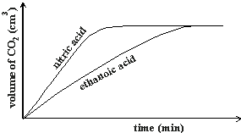

21. The figure below is an energy level diagram for the reaction.

2A_{(g)} + 2B_{(g)} 2AB_{(g)}

Energy (kJ)
Reaction progress
2AB_{(g)}

2A_{(g)} + 2B_{(g)}

Explain how the following conditions would affect the yield of AB.

- Increase in pressure. (2marks)
The yield of AB ^{√ 1 mk} is increased.
The forward reaction is accompanied by a decrease in volume ^{√ ½ mk}. Equilibrium shifts to the right following the forward reaction. ^{√ ½ mk}
- Decrease in temperature. (2marks)

The yield of AB ^{√ 1 mk} is increased.
- The forward reaction is exothermic. ^{√ ½ mk}
- Decrease in temperature favours the forward reaction, equilibrium shifting to the right. ^{√ ½ mk}

22. A white solid K was heated. It produced a brown gas A and another gas B which relights a glowing
splint. The residue left was yellow even after cooling.
- Identify gases A and B. (2marks)
A – nitrogen (IV) oxide ^{√ 1 mk} / NO_{2(g)}
B – Oxygen / O_{2(g)}^{√ 1 mk}
- Write a balanced chemical equation for the decomposition of solid K. (1mark)
2Pb(NO₃)_{2(s)} 2PbO_{(s)}+ 4NO_{2(g)} ^{√ 1 mk}
23. The scheme below shows some reaction sequence starting with solid M.
Solid M
Solid N
White ppt
Colourless Solution Q
+ Gas which burns with a ‘pop’ sound
Few drops of NH_{3(aq)}
Excess NH_{3(aq)}
H₂SO_{4(aq)}

- Name solid M. (1mark)
Zinc Metal ^{√ 1 mk}
- Write the following of a complex ion present in solution Q. (1mark)
Zn(NH₃)₄²⁺ ^{√ 1 mk}
Write an ionic equation of the reaction between barium nitrate and solution N. (1mark)
Ba²⁺_{(aq)} + SO₄² ⁻_{(aq)} BaSO_{4(s)} ^{√ 1 mk}

24. (a) What is meant by a saturated solution? (1mark)
a solution in which no more solute can be dissolved in the solvent.
(b) In an experiment to determine the solubility of solid Y in water at 30⁰C the following results were
obtained.
Mass of evaporating dish = 26.2g
Mass of evaporating + saturated solution = 42.4g
Mass of evaporating dish + dry solid Y = 30.4g
Using the information, determine the solubility of solid Y at 30⁰C in grams per 100g of water. (2marks)
Mass of solid Y = 30.4 - 26.2g
= 4.2g^{√ ½ mk}
Mass of water in the solution = 42.4 – 30.4g
= 12g ^{√ ½ mk}
12g of water dissolves 4.2g
Thus 100g of water dissolves = 100 x 4.2g ^{√ ½ mk}
12
= 35g / 100g H₂O ^{√ ½ mk}
26. Compare the electrical conductivity of dilute Sulphuric (VI) acid and concentrated Sulphuric (VI) acid. Explain your answer. (2marks)
Dilute sulphuric (VI) acid ^{√ 1 mk} has a higher electrical conductivity than concentrated sulphuric (VI) acid.
Reason;
Dilute sulphuric (VI) acid has more ions in solution than conc. Sulphuric (VI) acid. ^{√ 1 mk}
27. Draw a well labelled diagram of a setup used to prepare and collect dry Sulphur IV oxide. (3marks) 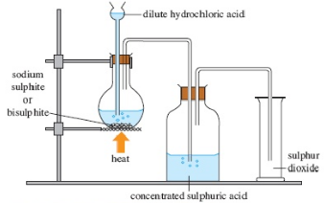

28. The molar heat of formation of carbon (II) oxide is -105kJmol⁻¹, molar heat of combustion of carbon
is -393kJmol⁻¹.
By using an energy cycle diagram, determine the molar heat of combustion of carbon (II) oxide. (3marks)
ΔH^{θ}f (CO) + ΔH^{θ}c(CO)= ΔH^{θ}c(C)
-105 + ΔH^{θ}c(C) = -393 ^{√ 1 mk}
ΔH_{c}^{θ} = -393 - 105 ^{√ 1 mk}
= -188KJmol^{-1√ 1 mk}
29. In an experiment, a small amount of charcoal was added into a test tube and 5cm³ of concentrated
nitric (V) acid added, then warmed.
- State the observation that was made. (1mark)
Brown fumes ^{√ 1 mk} of nitrogen (iv) oxide
- (ii) Explain the observation made in (i) above. (1mark)
Nitric (v) acid is a strong oxidizing agent and thus oxidizes carbon to carbon (iv) oxide ^{√ ½ mk} and itself reduced to nitrogen (iv) oxide ^{√ ½ mk}
- (iii) Write an equation for the reaction that took place. (1mark) C_{(s)} +HNO_{3(l)} 4NO_{2(g)} + CO_{2(g)}+ 2H₂O_{(l)} ^{√ 1 mk}

