MARKING SCHEME

CHEMISTRY PAPER 2
ARISE AND SHINE TRIAL 1 EXAM
March/April-2020

1.(a)(i) Fractional distillation √1 Any two
(ii) Molecular mass 1mk each
- density
- Boiling points

(b)(i). C₃H₆ √1

(ii). Shake a sample with bromine water √1,C₃H⁸ do not decolourize√1 C₃H₆ decolourize √1 OR use acidified potassium permanganate C₃H₈ do not decolourize C₃H₆ decolourize (Reject chlorine)
Or
Burn a sample of C₃H₈-burns with a non-luminous flame C₃H₆-burns with a luminous flame
Or
Use acidified potassium dichromate-C₃H₈ do not decolourize
-C₃H₆decolourize
(d)(i). Ethanol √1/C₂H₅OH /CH₃CH₂OH √1
(ii). slightly soluble in water/insoluble in water

(d). Name-polythene/polyethen √1
Disadvantage-it is non-biodegradable poisonous gases when burn√ (Any one)

2.(a). Name the method that can be used to obtain pure iron (III) chloride from a mixture of iron (III) chloride and sodium chloride (1mark)
Sublimation √1

(b). A student was provided with a mixture of sunflower flour, common salt and a red dye. The characteristics of the three substances in the mixture are given in the able below.
Substance | Solubility in water | Solubility in ethanol
Sunflower flour | Insoluble | Insoluble
Common salt | Soluble | Insoluble
Solid red dye | soluble | soluble

The student was provided with ethanol and any other materials needed. Describe how the student can be separate the mixture into its three components. (3 marks)
Add ethanol √½
Filter √½
Evaporate √½
Add water √½
Filter √½
Evaporate ½

(c) The diagram shows part of the periodic table. The letters do not represent the actual symbols of the elements. Use the diagram to answer the questions that follow.

 |  |  |  |  |  |  |  | Q
R |  |  |  |  | K√1 | V | W
 | Z |  |  |  |  |  | X
Y |  |  | N

(i). - W has a shorter atomic radius than X √1
- W accepts electrons more readily than X√1
- W has less energy levels than X
- W has less screening effects than X Any two

(ii). – R has a higher m.p than √T.R has a giant metallic structure while T has a molecular structure/R has metallic bonds while R has eak√1 van der waals forces

(iii). –ZW₂ √1 penalize use of equation
(iv).

(v).
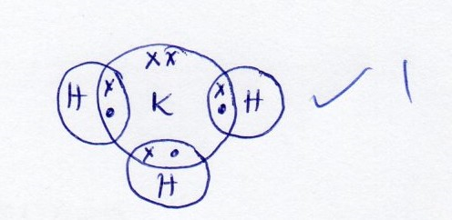

- Q/He √1
- N/A √1

3(a). Purify to remove impurities ½ √,bubble through ½ √ NaOH/KOH to remove CO₂,rduce the ½ √temp,to remove water vapor compress to liquefy the residual air, then fractional distillation to obtain oxygen at -180ºC
- concentrated sulphuric (vi) acid √1
- SO₂(aq) + H₂SO_{4(l)} H₂S₂O_{7(l}) √1
c). (i). Platinum √1
(ii). It is cheap/cheaper √½
Not easily poisoned/action stopped by impurities ½
(d). Turns from blue to white. Forms white powder sulphuric (VI)√1 acid dehydrates copper (II) sulphate crystals/remove water of crystallization.

e). It is less volatile √1
(f). Manufacture of sulphate fertilizer/superphosphate fertilizer/production of Ray on making dyes/used in car batteries/As an electroly manufacture of sosaples detergents/cleaning of metals manufacture of pain HCL/HNO₃,Oleum. As a drying agent, as adehydrating agent/manufacture of nylon AL₂SO₄/ALCOH₃/sulphate drugs, pigments
Any four ½ each

4(a). Energy change that occurs when one mole of a substance is completely burnt in oxygen √1
(b). The energy changes in converting reactants to √1
Products is the same regardless of the path in which the chemical changed occurs
∆H$θ$C(Graphite) = - 393kJ mol-1
∆HC(H$θ$₂(g)) = -286kJ mol-1
∆H$θf \left(C3H8\left(g\right)\right)= -104kJ mol-1$

(a). 3C_{(s)} + H_{2(g)} C₃H_{8(g) √}1

(II)
3C_{(s)+}4H_{2(g)} AH₃ C₃H₈
1√ + AH₂
+ 2O₂ AH
∆H₁ 3O₂ 3CO₂ +4H₂O 5O₂ + AH

(iii). ∆H₄ = ∆H₁ + ∆H₂-∆H₃ √1 ∆H₄=-879-1144+1√104
=(-393x3) + (4x-286)+-(-104) ∆H₄=-1919kJmol⁻¹
Penalize ½ for wrong missing unit

(d). - Availability
- Safety Any one

e). Dil HNO₃ andHCl√1 ionize fully in water while ethanoic acid partially ionizes√1

5.(a). It is a solution which cannot dissolve any more solute at a particular temperature √1
(b)(i) I-24g/100g of water √1
II- mass dissolved=62g ½
- mass of undissolved =80-62=18g√¹/₂
c). RFM of KNO₃ = 39+14+16x3
=101 √½
Mole of KNO₃ at 18ºc = 24 √½ =0.2376√ ½ moles
101
Molarity = no of moles x1000 = 0.2376 √¹/₂ x 1000√¹/₂
Volume 100
=2.376MKNO₃ √¹/₂
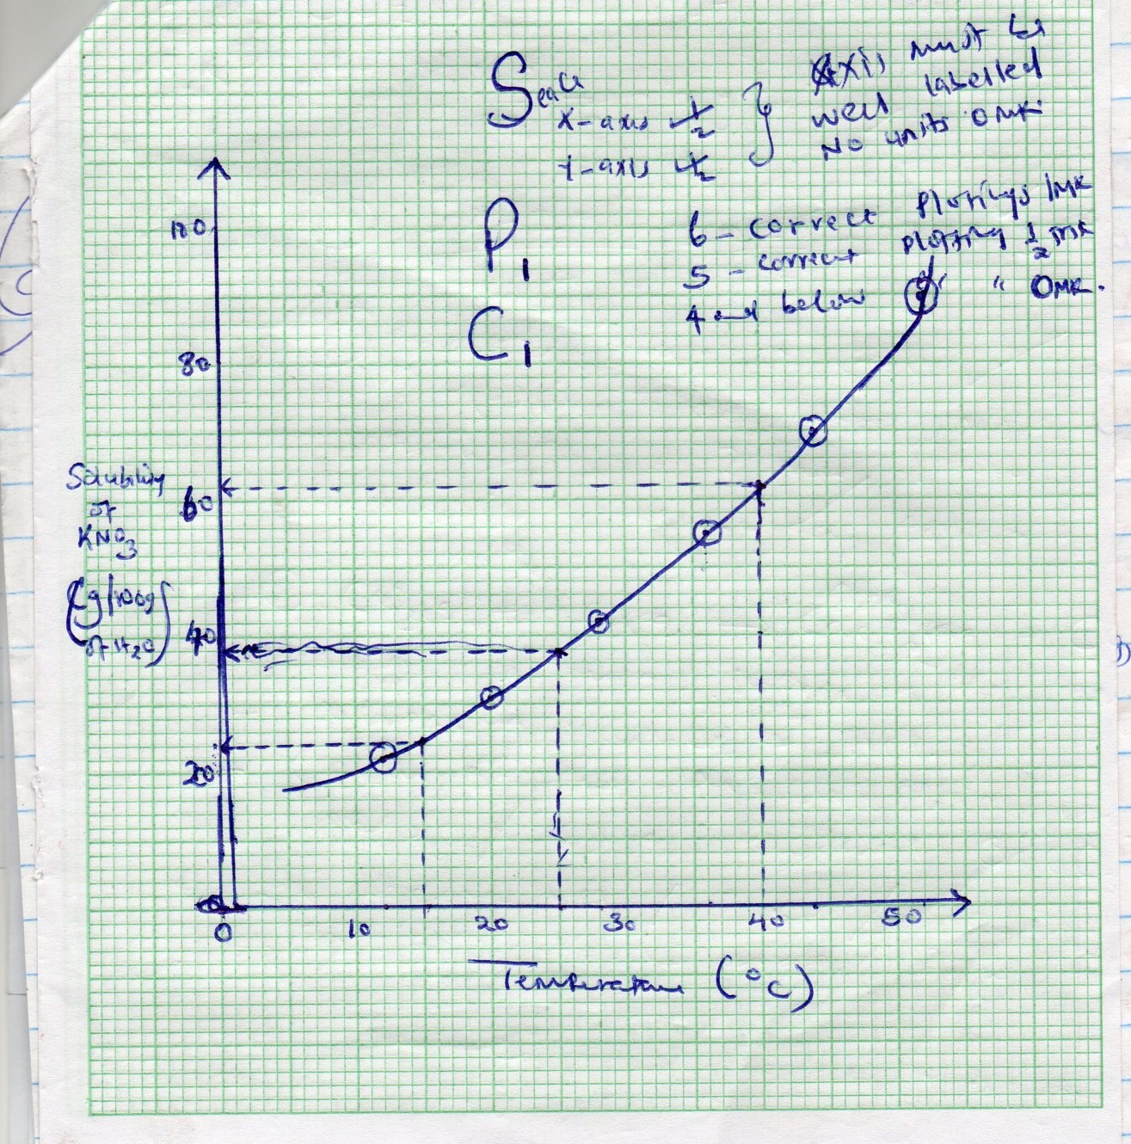
6(a)(i) - preservative √½
- Add taste/flavor√ ½

(ii). Effervescence occur √1
- CO₂ was dissolved under pressure √1
(iii). - H₂CO₃ √1 penalize fully for an equation

(b)(i). 2zn(NO₃)_{2(s}) 2ZnO(s) + 4NO_{2(g)} + O_{2(g)} penalize √½ for wrong /missing state
Symbols
(ii). 5.76 x =0.03 √½
188.5
Moles of NO₂ = 4 x0.03 = 0.06√ ½
2
Moles of oxygen = 0.03 – 0.15√ ½
2
Total moles = (0.06 + 0.015) √½ = 0.075
Volume of gases = 0.075 √½ x 24 = 1.8dm³ penalize √½ for wrong or missing units

c)(i). White solid √1 turns yellow on heating
the yellow √1 solid turns grey because zinc oxide is reduce to √1 zinc

(ii). ZnO_{(s)} + CO_{(g)} Zn_{(s}) + CO_{2(g)} –penalize √½ for missing/wrong state symbols
Penalize fully if equation is not balanced

7(a)(i) O²⁻ √1
(ii). CuCO₃ √1, ZnSO₄ √1

(b) Ba²⁺_{(aq)} + SO₄²_{-(aq)} BaSO_{4(s)} penalize a chemical
Penalize √½ for missing wrong st. symbols
c). - solution change from blue to colourless/fede√1
- a brown solid is formed √1 mg dissolves
- discharged of Cu²⁺ because Mg displaced √1Cu²⁺ from the solution
- Apparatus become worn √½ is exothermic/heat given out
d)(i) Add excess PbO to √½ the HNO₃ and filter √½ add soluble sulphate /sulphuric acid to the filtrate. Filter to obtain PbSO_{4(s)} then dry the residue between filter papers

e)(i) determine mpt – if its pure mpt is sharp

