Name: _____________________________ Adm. No_____________Index No: _________

School:__________________________________Candidate’s Sign______________________

Date: ____________________________________
233/1
CHEMISTRY
Paper 1
THEORY

March /April 2020
Time: 2 Hours

ARISE AND SHINE TRIAL ONE EXAM
MARCH/APRIL - 2020
Instructions to candidates:

- Write your name, Admission Number, index number and school in the spaces provided above
- Sign and write the date of examination in the spaces above
- Answer ALL the questions in the spaces provided below each question.
- Mathematical tables and silent electronic calculators may be used.
- All working MUST be clearly shown where necessary
- This paper consists of 10 printed pages.

FOR EXAMINER’S USE ONLY

QUESTIONS | MAXIMUM SCORE | CANDIDATE’S SCORE
1 -28 | 80
TOTAL SCORE | 80

1. (a). Under what condition does the Bunsen burner produce luminous flame? (1 mark)
______________________________________________________________________________

(b). Luminous flame is yellow and sooty. Explain. (2 marks)
____________________________________________________________________________________________________________________________________________________________
______________________________________________________________________________
2. (a). Distinguish between isotopes and allotropes (2 marks)
____________________________________________________________________________________________________________________________________________________________
(b). Name one allotrope of Sulphur that is stable at temperature above 96ºC (1 mark)
______________________________________________________________________________
3. Sodium metal burns with a yellow flame in excess oxygen forming yellow solid. The yellow solid react with water to form gas F.
(a). Name the yellow solid (1 mark)
____________________________________________________________________________________________________________________________________________________________
(b). Identify gas F (1 mark)
____________________________________________________________________________________________________________________________________________________________
(c). Write an equation for the reaction of the yellow solid with water. (1 mark)
____________________________________________________________________________________________________________________________________________________________
4. (a). State Boyle’s law. (1 mark)
____________________________________________________________________________________________________________________________________________________________
(b). Explain why the pressure of a fixed mass of a gas increases with increase in temperature in a fixed volume container. (2 marks)
____________________________________________________________________________________________________________________________________________________________
5. The set up in figure 1 can be used to prepare ethyne gas. Use it to answer the questions that follow.

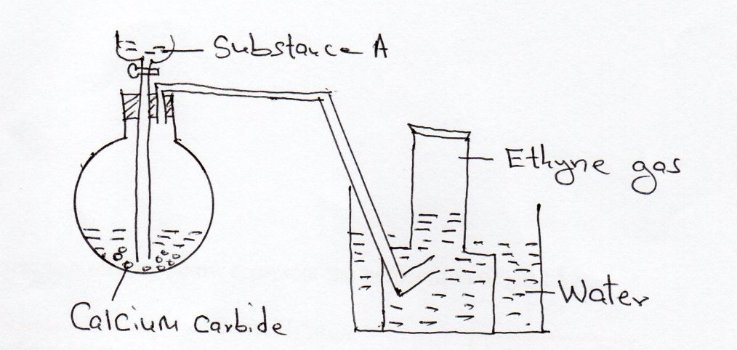

[a]. Name substance A (1 mark)
______________________________________________________________________________

[b]. Write an equation for the reaction which occurred in the flask (1 mark)
____________________________________________________________________________________________________________________________________________________________
(c). Draw and name the structure of the compound formed when one mole of ethyne reacts with one mole of chlorine gas. (1 mark)

6. Starting with zinc carbonate solid describe how zinc hydroxide can be prepared in the laboratory. (3 marks)
______________________________________________________________________________________________________________________________________________________________________________________________________________________________________________________________________________________________________________________________________________________________________________________________________
7. 24.0cm³ of 0.18M hydrochloric acid was added to 0.38g of sodium carbonate solid. Calculate the mass of sodium carbonate that did not react. (0=16, Na=23 C=12) (3 marks)
______________________________________________________________________________________________________________________________________________________________________________________________________________________________________________________________________________________________________________________________________________________________________________________________________
8. The reaction scheme below represent the preparation of gas M.
Conc.H₂So_{4(l)}
Solid sodium chloride
Colourless Gas M
Green solid K

Iron fillings

Heat

[a]. Identify gas M and solid K
Gas M________________________________________________________ (¹/₂ mark)
Green solid K __________________________________________________ (^{1/}₂ mark)
[b]. Describe a chemical test for gas M (2 marks)
____________________________________________________________________________________________________________________________________________________________
______________________________________________________________________________
9. (a). 0.95g of Magnesium Chloride was dissolved in 250cm³ of water. Calculate the molar concentration of Chloride ions in the solution. (Mg=24 Cl=35.5) (3 marks)
____________________________________________________________________________________________________________________________________________________________
______________________________________________________________________________
10. (a). What is an acid-base indictor? (1 mark)
____________________________________________________________________________________________________________________________________________________________
(b). Describe how the pH of a soil sample can be determined in the laboratory. (2 marks)
____________________________________________________________________________________________________________________________________________________________
11. In an experiment, Hydrogen sulphide gas was bubbled into a solution of iron (III) chloride. State and explain the observations made. (3 marks)
____________________________________________________________________________________________________________________________________________________________
____________________________________________________________________________________________________________________________________________________________
____________________________________________________________________________________________________________________________________________________________
______________________________________________________________________________
12. The diagram below represents part of the periodic table. Use it to answer the questions that follow. The letters are not the actual symbols of the elements. (2 marks)
M |  |  |  |  |  | Q
T | V |  | W

(a). Write the Electronic arrangement for the stable ion formed by M. (1 mark)
_____________________________________________________________________________
______________________________________________________________________________
(b). Write an equation for the reaction between T and Q. (1 mark)
_____________________________________________________________________________
______________________________________________________________________________
(c). Compare the melting point of element T and V. (1 mark)
_____________________________________________________________________________
______________________________________________________________________________

13. Study the set-up below and answer the questions that follow.
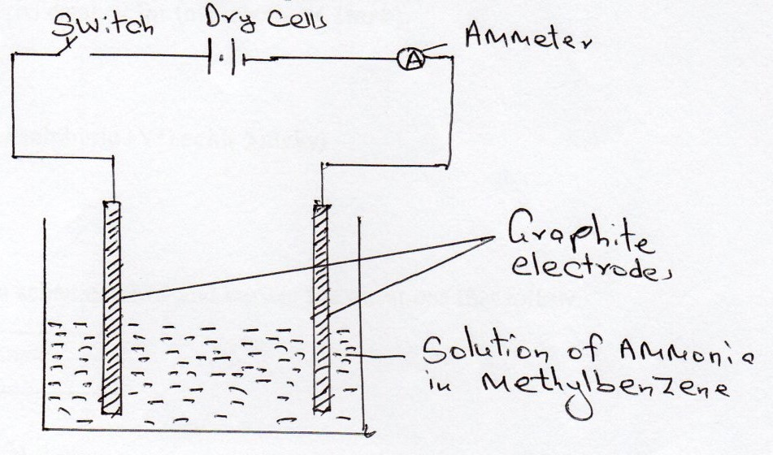
State and explain the observation made when the switch is closed. (2 marks)

14. (a). Define molar heat of combustion. (1 mark)
____________________________________________________________________________________________________________________________________________________________
(b). X g of element Q was completely burned in air. The heat evolved was used to heat 250cm³ of water. The temperature of water rose from 32ºC to 50ºC. Molar heat of combustion of element Q is -360 kJmol⁻ .Calculate the value of X. (Density of water is 1gcm⁻³ and specific heat capacity of water is 4.2kJ mol⁻³ R.A.M of Q=24) (2 marks)
_____________________________________________________________________________
______________________________________________________________________________
_____________________________________________________________________________
______________________________________________________________________________
15. A sample of water is suspected to contain chloride ions. Describe an experiment that can be carried out to determine the presence of chloride ions. (3 marks)
_____________________________________________________________________________
______________________________________________________________________________
_____________________________________________________________________________
______________________________________________________________________________
16. In contact process, Sulphur (IV) oxide reacts with oxygen to form Sulphur (VI) oxide in presence of a catalyst.
(a). Name the preferred catalyst for this reaction. (1 mark)
_____________________________________________________________________________
_____________________________________________________________________________

(b). Give two uses of sulphuric (VI) acid (2 marks)
_____________________________________________________________________________
_____________________________________________________________________________
_____________________________________________________________________________

17. Study the reaction scheme below and answer the questions that follow. [1 mark]
A
Ethanol
Sodium propanoate

Soda lime
Heat
Process II Process I
B
H_{2(g})/Ni H₂SO₄(I)/180ºC

a). Identify substances (1 mark)
A-
B-
[b]. Name process I (1 mark)
____________________________________________________________________________________________________________________________________________________________

(c). Name the substance produced when Sodium Propanoate react with Soda lime. (1 mark)
_____________________________________________________________________________
_____________________________________________________________________________

18. The solubility curve of potassium nitrate is shown below.
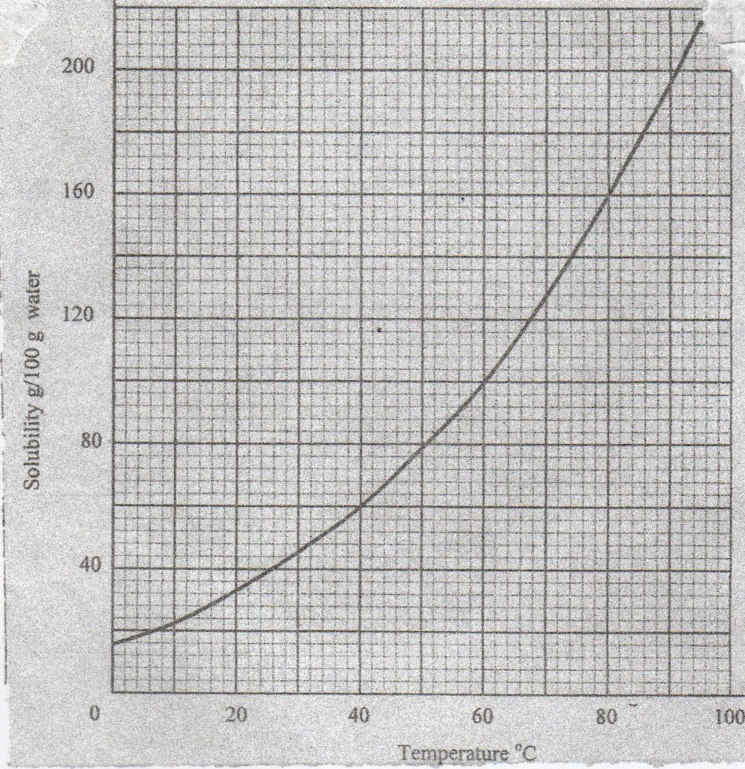
[a]. Determine the solubility of potassium nitrate at 40ºC (1 mark)
_____________________________________________________________________________
_____________________________________________________________________________
[b]. Determine the molar concentration of saturated potassium nitrate at 40ºC
(K = 39.0, O =16.0 N=14.0 and density of water 1g/cm³ (2 marks)
____________________________________________________________________________________________________________________________________________________________
____________________________________________________________________________________________________________________________________________________________
19. Sample of urine from three participants W, X and P at an international sports meeting were spotted onto a chromatography paper alongside two from illegal drugs,A₁ B₂. A Chromatogram was run using methanol. The figure below shows the chromatogram.

A1 B2 W X P

(a). Identify the athlete who had used an illegal drug. (1 mark)
______________________________________________________________________________
(b). Which drug is more soluble in methanol. Give a reason. (2 marks)
___________________________________________________________________________________________________________________________________________________________
20. State and explain the change in mass that occur when the following substances are separately heated in open crucibles.
(a). Magnesium ribbon (1 mark)
____________________________________________________________________________________________________________________________________________________________
(b). Sodium carbonate (1 mark)
______________________________________________________________________________
______________________________________________________________________________
21. With the help of a well labeled diagram, draw a set-up of an arrangement of assembled apparatus that can be used to prepare dry hydrogen gas, including the appropriate reagents.
(3 marks)

22. Dry carbon (II) oxide gas was passed over heated lead (II) oxide.
(a). Write an equation for the reaction. (1 mark)
_____________________________________________________________________________
_____________________________________________________________________________
(b). Give one industrial application of the above reaction. (1 mark)
_____________________________________________________________________________
23. A student burnt magnesium ribbon in a gas jar full of Sulphur (IV) oxide gas
(i). State two observations made in the gas jar. (2 marks)
_____________________________________________________________________________
_____________________________________________________________________________
(ii). Write an equation for the reaction that took place. (1 mark)
_____________________________________________________________________________
_____________________________________________________________________________
24. Air was passed through reagent as shown below.

Hot
Copper
Excess hot
Magnesium
Sodium hydroxide solution
Air C
A B
(i).State the role of sodium hydroxide solution. (1 mark)
_____________________________________________________________________________
(ii). Name one component in C. Explain. (1 mark)
____________________________________________________________________________________________________________________________________________________________
25. Analysis of a compound showed that it had the following composition. 69.42% Carbon, 4.13% Hydrogen and the rest Oxygen
Determine the empirical formula of the compounds. (3 marks)
(C=12.0, H=1.0 , O=16.0
__________________________________________________________________________________________________________________________________________________________________________________________________________________________________________
______________________________________________________________________________
26. Study the reaction scheme below and answer the questions that follow. (1 mark)

Water
Brown
Black solid Q
Gas A
Deep Blue solution
Blue solution

Ammonia
H2SO_{4(aq)} Heat

Excess Ammonia
Solution
(a).Identify
i. Black solid Q (1 mark)
_________________________________________________________________________
ii. Gas A (1 mark)
_________________________________________________________________________

(b). Write an equation for the reaction between ammonia and black solid Q. (1 mark)
____________________________________________________________________________________________________________________________________________________________
(c). Write the formula of the complex ion in deep blue solution. (1 mark)
_____________________________________________________________________________
______________________________________________________________________________
27. Element S has an atomic number of 14 and R has an atomic number of 17
(a). Write the formula of the ion of element S. (1 mark)
______________________________________________________________________________
(b). Using dot (.) and cross (x) diagrams show how S an R combine to form a compound.
(2 marks)
_____________________________________________________________________________
____________________________________________________________________________________________________________________________________________________________
28. Explain why the following substances conduct an electric current.

(a). Aluminium metal (1mark)
______________________________________________________________________________
(b). Molten magnesium chloride (1 mark)
______________________________________________________________________________

