NAME_______________________________________________________ADM.NO._________________

233/1
2020 FORM 4 TERM 1 ENTRY EXAMS
CHEMISTRY
PAPER 1
TIME: 2 Hours

Instructions to Candidates
- Write your name and admission number in the spaces provided.
- Answer ALL the questions in the spaces provided.
- Mathematical tables and silent electronic calculators may be used.
- All working MUST be clearly shown where necessary.
- All questions should be answered in English.

For Examiner’s Use only

Question | Maximum Score | Candidate’s Score
1 – 28 | 80

- a) What role do the following parts play during fractional distillation of water and ethanol?
    - The fractionating column. (1mark)

    - The glass beads (1mark)

b)State one application of fractional distillation. (1mark)

- Study the table below and answer the questions that follow:-
Ion | Electron Arrangement
R²⁺ | 2.8.8
S²⁻ | 2.8

  - Write the electron arrangement of each atom.
R ………………………………………………………..…………. (½ mark)

S …………………………………………………………………… (½ mark)

  - Write the formula of the oxide of R and Chloride of S
Oxide of R (1mark)

Chloride of S (1mark)

- When 5.35g of Sodium Nitrate were heated in an open crucible, the mass of oxygen produced was 0.83g. given that the equation for the reaction is:-
2NaNO_{3(s)} 2NaNO_{2(s)} + O_{2(g)}
Calculate the percentage of Sodium Nitrate that was converted to sodium nitrite. (3marks)
(Na=23, O=16, N = 14)

- Equal volumes of water put in 100cm³ glass beaker and heated for 5 minutes using Bunsen flames. It was observed that water in beaker A registered higher temperature than beaker B.
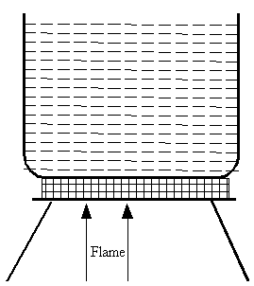

Beaker A Beaker B

- Name the kind of flame used in beaker; A (1mark)
- State the condition under which flame that heated B was produced. (1mark)

- Silver chloride can be prepared in the laboratory by the reaction between potassium chloride and silver nitrate.
  - What name is given to this method of reaction? (1mark)

  - Write an ionic equation for the reaction that occurs. (1mark)

- During heating of hydrated copper (II) sulphate crystals, the following readings were obtained:-
Mass of evaporating dish = 300g
Mass of evaporating dish + hydrated salt = 305g
Mass of evaporating dish + dehydrated salt = 303.2g
Calculate the empirical formula of hydrated copper (II) sulphate.
(Cu = 64.5, S = 32.0, O= 16.0, H = 1) (3marks)

- A seed catalogue that the preferred soil pH range for the growth of different varieties of a crop are as shown in the table.
Type of plant | Preferred pH
A | 4.5 – 6.0
B | 5.0 – 7.5
C | 5.5 – 6.5
D | 6.0 – 6.5
  - Which seed variety will grow over the largest pH range. (1mark)

  - What soil pH range will a gardener be able to grow all these crops (1mark)

  - The soil in a garden has a pH of 4.5, which substance can be added to the soil in order to grow plant type D? explain (2marks)

- Using dot (.) and cross (x) diagram, show bonding in the compound Ammonium ion (NH⁺₄).
(N= 14, H = 1) (2marks)

  - State Graham’s Law of diffusion. (1mark)

b) 200cm³ of oxygen gas take 250seconds to diffuse through a porous plug. Under similar conditions, an equal volume of an unknown gas take 277 seconds to diffuse through the same porous plug. Calculate the relative molecular mass of the unknown gas. (3marks)

c) Give two products formed when a candle burns. (1mark)

d) From the above products; which elements make up a candle? (1mark)

- Explain how the following substances conduct an electric current.
  - Magnesium metal. (1mark)

  - Molten magnesium chloride (1mark)

- The molar mass of a gaseous compound XO₂ is 64 gmol⁻¹. A sample of this gas occupied 11.2dm³ at s.t.p.molar gas volume =22.4dm³.find
  - The number of moles of this gas. (2marks)

  - The amount in grams that occupied the above volume. (2marks)

- Classify the following processes as either chemical or physical. (3marks)
- Heating copper (II) sulphate crystals
- Obtaining kerosene from crude oil
- Souring of milk
- The diagram below represents a charcoal burner. Study it and answer the questions that follow;
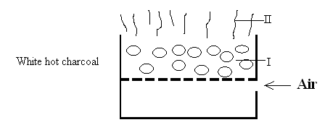
Write equations for the reactions taking place in part I and II.
I (1mark)
II (1mark)
- When a mixture of iron filings and sulphur are heated, a red glow spreads through the mixture and a dark grey solid was formed.
  - Identify the dark grey solid formed. (1mark)

  - Write a chemical equation in which the dark grey solid is formed. (1mark)

  - What observation can be made when dark grey solid reacts with dilute hydrochloric acid. (1mark)

- The table below shows isotopes and their percentage abundances.
Isotope | A | B | C
Isotope mass | 54 | 56 | 57
Percentage abundances | 6.0 | 92.0 | 2.0
Calculate the relative atomic mass of the element with the above isotopes. (3marks)

- Metal R does not react with an oxide of metal S. Metal T reacts with an oxide of metal S. metal Q reacts with an oxide of T. Arrange the metals in increasing order of reactivity. (2marks)

- An experiment was set up as shown below.
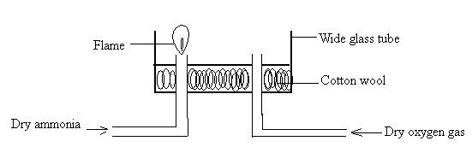
- A student passed dry ammonia gas into the glass tube and tried to ignite the gas before allowing oxygen gas. What observation was made? (1mark)

- Write the equation for the reaction above (1mark)

- (a) Complete the table below to show pairs of substances used to prepare oxygen. (2marks)
Hydrogen peroxide
ii) | Sodium peroxide
(b)State the importance of oxygen in cutting metals. (1mark)

- The diagram below illustrates an experiment set up to investigate the effect of heat on copper (II) carbonate. Study it and answer the questions that follow.
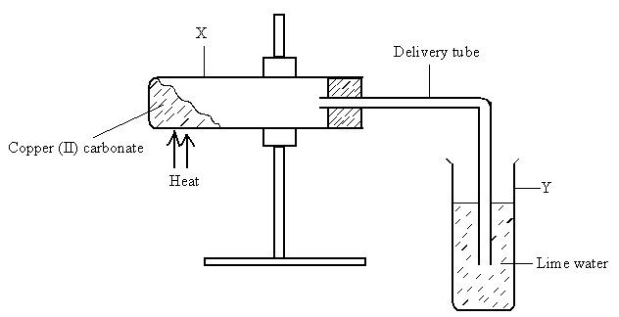
- Give the expected observation in each test tube.
X ........................................................................................................................................ (1mark)

Y ....................................................................................................................................... (1mark)
- Write an equation for the change that occurs in tube X (1mark)

  - State one way in which the strength of a base or an acid can be determined in the laboratory. (1mark)

  - Give the basicity of the following acids:-
    - Sulphuric (VI) acid. (1mark)

    - Phosphoric acid (1mark)

- An element X is represented as $1840X$ (X = is not the actual symbol of the element)
  - What is the composition of the nucleus for this element? (2marks)

  - Give the electronic arrangement of the element. (1mark)

- Chlorine gas was bubbled through a solution of potassium iodide in boiling tube.
  - State the observation made. (1mark)

  - Name the oxidizing agent in this reaction. Explain. (2marks)

- Name the process which take place when:-
  - Iodine changes directly from solid to gas (1mark)

  - Fe²⁺ changes to Fe³⁺ (1mark)

  - White sugar changes to black solid when mixed with excess concentrated sulphuric acid. (1mark)

- GSTRU and P belong to the same period in the periodic table. The ions formed by the atoms are as below:-
Q²⁺, U⁻, T²⁻, R³⁺, P⁺, S³⁻

- Arrange the elements in order of decreasing atomic size. (1mark)

- Suggest a reason why elements P and Q cannot react with each to form a compound. (1mark)

- A piece of burning magnesium ribbon was plunged into a gas jar containing sulphur (IV) oxide.
  - What observation was made? (1mark)

  - Write an equation for the reaction taking place. (1mark)

  - What property of sulphur (IV) oxide is investigated above. (1mark)

  - What is paper chromatography? (1mark)

  - Give two applications of chromatography? (2marks)

- The structure of two molecules of water can be represented as shown below.
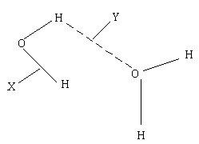

Name the type of bonds X and Y (2marks)
X ………………………………………………………………………..
Y ………………………………………………………………………..
- In an experiment 3.36g of iron fillings were added to excess copper (II) sulphate. Calculate the mass of copper that was deposited. (CU= 63.5, Fe = 56) (3mks )

