NAME………………………………………………………. INDEX NO…………………/…………
SCHOOL……………………………………………… CANDIDATES SIGNATURE……………… ADMISSION NUMBER……………………. CLASS………………………

231/3
BIOLOGY
(PRACTICALS)
Paper 3
November, 2020
1³/₄ Hours
MOKASA EXAMINATIONS 2020
Kenya Certificate of Secondary Education (K.C.S.E)

INSTRUCTIONS TO CANDIDATES

- Write your name and Index Number in the spaces provided above.
- Sign and write date of examination in the spaces provided above.
- Answer ALL questions in the spaces provided in the question paper.
- You are not allowed to start working with the apparatus for the first 15 minutes of the 1³/₄ Hours allowed for this paper. This time is to enable you to read the question paper and make sure you have all the chemicals and apparatus that you may need.
- All workings must be clearly shown where necessary.
- Mathematical tables and silent electronic calculators may be used.

For Examiners use only.
Section | Question | Maximum Score | Candidates Score
 | 1 | 14
 | 2 | 12
 | 3 | 14
 | Total score | 40

This paper consists of 7 Printed pages.
Candidates should check the question paper to ensure that all the
Papers are printed as indicated and no questions are missing

1. You are provided with specimen labeled A. Obtain a cube measuring 1cm by 1cm from the specimen.

(a) Crush the cube using mortar and pestle, place the crushed parts in measuring cylinder, add 2 ml of hydrogen peroxide and quickly determine the volume of foam after 20 seconds and fill the table below. (1 mark)
Specimen | Volume of foam
Crushed cube A
Explain why the reaction in (a) above occurs in living cells. (2 marks)
………………………………………………………………………………………………………………………………………………………………………………………………………………………………………………………………………………………………………………………………………………………………………………………………………………………………………………………………
………………………………………………………………………………………………………………
(b) You are provided with a solution labeled B, unboiled C1 and boiled C2. Place 2ml of the solution B into two test tubes and carry out a food test using the reagents provided. Record your observation in the table below. (2 marks)
FOOD SUBSTANCE | PROCEDURE | OBSERVATION | CONCLUSION

Place 2ml of solution B into four test tubes labeled F, G, H and K. Carry out the following steps.
(i) To test tube labeled F and its contents add 3ml solution C1 and 3 ml distilled water.
(ii) To test tube labeled G and its contents, add 3ml solution C1 and 3 ml dilute hydrochloric acid.
(iii) To test tube labeled H and its contents, add 3 ml solution C 1 and 3 ml sodium hydroxide solution.
(iv) To test tube labeled K and its contents, add 3 ml solution C2.
(v) Place the test tubes in a water bath at 37 ⁰C for 20 minutes.
(vi) Carry out a Benedict’s test and fill the table below. (4 marks)

Test tube | PROCEDURE | OBSERVATION | CONCLUSION
F
G
H

K

(a) Account for the observation in:
(i) Test tube G. (2 marks)
………………………………………………………………………………………………………………………………………………………………………………………………………………………………………………………………………………………………………………………………………………………………………………………………………………………………………………………………………………………………………………………………………………………………………………
(ii) Test tube H. (1 mark)
………………………………………………………………………………………………………………………………………………………………………………………………………………………………………………………………………………………………………………………………………………………………………………………………………………………………………………………………
(iii) Test tube K. (2 marks)
………………………………………………………………………………………………………………………………………………………………………………………………………………………………………………………………………………………………………………………………………………………………………………………………………………………………………………………………………………………………………………………………………………………………………………

2. Use the illustration below to answer questions
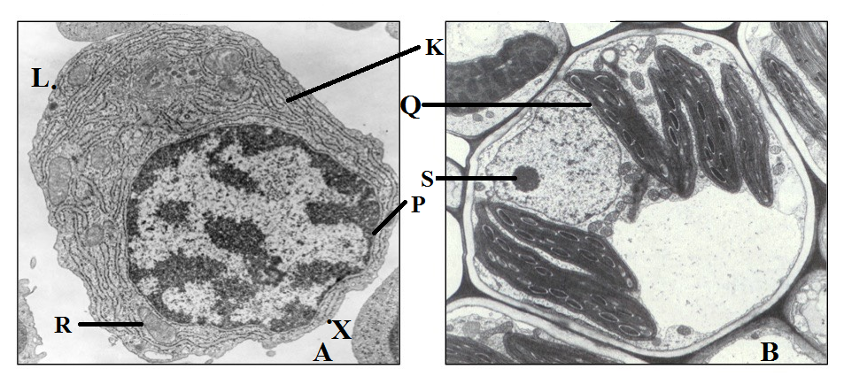

(a) Identify the organism from which the cell labelled B was obtained from while giving a reason.
(ii) B. (1 mark)
…………………………………………………………………………………………………………….
Reason. (1 mark)
……………………………………………………………………………………………………………
(b) Give the functions of the parts labeled:
(i) R. (1 mark)
……………………………………………………………………………………………………………..
(ii) S. (1 mark)
……………………………………………………………………………………………………………..
(b) Name the parts labeled:
(iii) Q. (1 mark)
……………………………………………………………………………………………………………..

(iii) P. (1 mark)
……………………………………………………………………………………………………………..
(iv) K. (1 mark)
……………………………………………………………………………………………………………..
(d) Calculate the actual length of cell A in micrometers if its magnification Is X1000 000.Use the points marked L and X. (3 marks)
………………………………………………………………………………………………………………………………………………………………………………………………………………………………………………………………………………………………………………………………………………………………………………………………………………………………………………………………………………………………………………………………………………………………………………………………………………………………………………………………………………………………
(e) Explain why cell A and B are believed to have a common ancestry. (2 marks)
………………………………………………………………………………………………………………………………………………………………………………………………………………………………………………………………………………………………………………………………………………………………………………………………………………………………………………………………

3. Use the photographs below to answer questions
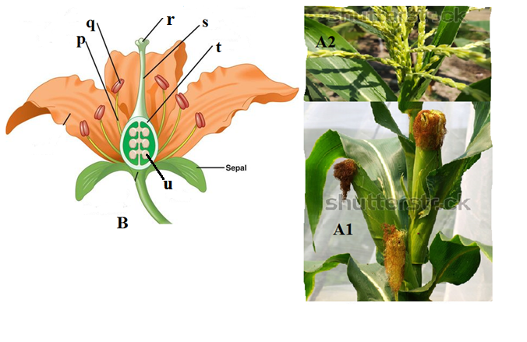
(a) (i) Name the type of flowers shown in A1 and A2.
(i) A1. (1 mark)
……………………………………………………………………………………………………………..
(ii) A2 (1 mark)
……………………………………………………………………………………………………………..
(ii) Describe the feature in flowering plants depicted in (a)(i) above. (1 mark)
…………………………………………………………………………………………………………….
(iii) Explain how flower labeled A1 is modified for pollination. 1 mark)
………………………………………………………………………………………………………………………………………………………………………………………………………………………………………………………………………………………………………………………………………………

(b) Give the functions of the parts labeled p, r and s in specimen labeled B.
(i) p. (1 mark)
……………………………………………………………………………………………………………..
(ii) r. (1 mark)
……………………………………………………………………………………………………………..
(iii) s. (1 mark)
………………………………………………………………………………………………………………
(c) State the structural descriptions of flower B. (2marks)
………………………………………………………………………………………………………………………………………………………………………………………………………………………………………………………………………………………………………………………………………………………………………………………………………………………………………………………………
(d) Explain what would happen to the following parts after pollination.
(ii) t. (1 mark)
……………………………………………………………………………………………………………..
(iii) u. (1 mark)
………………………………………………………………………………………………………………
(e) You are provided with a specimen labeled K in a petri dish, observe the specimen using a hand lens and answer questions that follow.
(i) Make well labeled diagram to show the reproductive structure of the organism. (3 marks)

(ii) Give the type of asexual reproduction exhibited by the organism. (1 mark)
……………………………………………………………………………………………………………..

