NAME………………………………………………………. INDEX NO…………………/…………
SCHOOL……………………………………………… CANDIDATES SIGNATURE……………… ADMISSION NUMBER……………………. CLASS………………………

231/3
BIOLOGY
(PRACTICALS)
Paper 3
MARCH 2020
1³/₄ Hours
MOKASA EXAMINATIONS 2020
Kenya Certificate of Secondary Education (K.C.S.E)

INSTRUCTIONS TO CANDIDATES

- Write your name and Index Number in the spaces provided above.
- Sign and write date of examination in the spaces provided above.
- Answer ALL questions in the spaces provided in the question paper.
- You are not allowed to start working with the apparatus for the first 15 minutes of the 1³/₄ Hours allowed for this paper. This time is to enable you to read the question paper and make sure you have all the chemicals and apparatus that you may need.
- All workings must be clearly shown where necessary.
- Mathematical tables and silent electronic calculators may be used.

For Examiners use only.
Section | Question | Maximum Score | Candidates Score
 | 1 | 14
 | 2 | 12
 | 3 | 14
 | Total score | 40

This paper consists of 7 Printed pages.
Candidates should check the question paper to ensure that all the
Papers are printed as indicated and no questions are missing

1. 1. You are provided with specimen labeled A. Obtain a cube measuring 1cm by 1cm from the specimen.

(a) Crush the cube using mortar and pestle, place the crushed parts in measuring cylinder, add 2 ml of hydrogen peroxide and quickly determine the volume of foam after 10 seconds and fill the table below. (1 mark)
Specimen | Volume of foam
Crushed cube A | Not more than 10 ml depending on concentration;1
Explain why the reaction in (a) above occurs in living cells. (2 marks)
Cellular respiration produce toxic hydrogen peroxide; enzyme catalase breaks down toxic hydrogen peroxide to harmless products; water and oxygen.
(b) You are provided with a solution labeled B, unboiled C1 and boiled C2 in a boiling tube. Place 2ml of the solution into two test tubes and carry out a food test using the reagents provided. Record your observation in the table below. (2 marks)
FOOD SUBSTANCE | PROCEDURE | OBSERVATION | CONCLUSION
Starch; | To 2ml of food substance in a test tube add 2 drops of iodine solution; | Blue black; | Presence of starch;  (award mark if all steps are correct)
Reducing sugars; ¹/₂ | To 2ml of food substance, add equal amount of Benedict’s solution and boil mixture in water bath. | Turns from blue to green to yellow to orange to brown; | Presence of reducing sugars;  (award mark if all steps are correct)

Place 2ml of solution B into four test tubes labeled F, G, H and K. Carry out the following steps.
(i) To test tube labeled F and its contents add 3ml solution C1 and 3 ml distilled water.
(ii) To test tube labeled G and its contents, add 3ml solution C1 and 3 ml dilute hydrochloric acid.
(iii) To test tube labeled H and its contents, add 3 ml solution C 1 and 3 ml sodium hydroxide solution.
(iv) To test tube labeled K and its contents, add 3 ml solution C2.
(v) Place the test tubes in a water bath at 37 ⁰C for 20 minutes.
(vi) Carry out a Benedict’s test and fill the table below. (4 marks)

Test tube | PROCEDURE | OBSERVATION | CONCLUSION
F | To 3ml of food substance, add equal amount of Benedict’s solution and boil mixture in water bath | Turns from blue to green to yellow to orange to brown; ¹/₂ | Presence of reducing sugars; ¹/₂
G | To 2ml of food substance, add equal amount of Benedict’s solution and boil mixture in water bath | Blue colour of Benedicts’s solution is retained. ¹/₂ | Absence of reducing sugars; ¹/₂
H | To 2ml of food substance, add equal amount of Benedict’s solution and boil mixture in water bath | Turns from blue to green to yellow to orange to brown; ¹/₂ | Presence of reducing sugars; ¹/₂
K | To 2ml of food substance, add equal amount of Benedict’s solution and boil mixture in water bath | Blue colour of Benedicts’s solution is retained. ¹/₂ | Absence of reducing sugars; ¹/₂

(a) Account for the observation in:
(i) Test tube G. (2 marks)
Presence of reducing sugars, Enzyme is denatured by hydrochloric acid;starch not broken down to reducing sugars;
(ii) Test tube H. (1 mark)
Presence of reducing sugars, enzyme works best in alkaline condition; starch is broken down to reducing sugars.
(iii) Test tube K. (2 marks)
Absence of reducing sugars;enzyme is denatured;starch is not broken down to starch;

2. Use the illustration below to answer questions
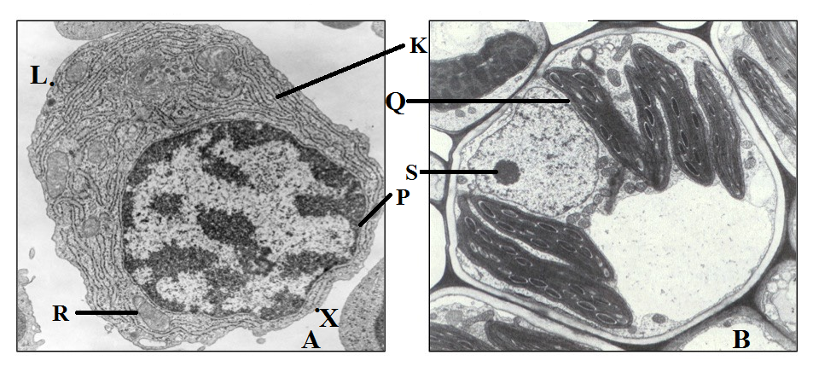

(a) Identify the organism from which the cell labelled B was obtained from while giving a reason.
(ii) B. (1 mark)
Plant;
Reason. (1 mark)
Cellulose cell wall;
Has chloroplast;
Nucleus at periphery;

(b) Give the functions of the parts labeled:
(i) R. (1 mark)
Site for respiration that yields energy for the cell;
(ii) S. (1 mark)
Synthesis of ribosomes;
(b) Name the parts labeled:

(iii) Q. (1 mark)
Chloroplast;
(iii) P. (1 mark)
Nucleus/cell membrane;
(iv) K. (1 mark)
Smooth endoplasmic reticulum;
(d) Calculate the actual length of cell A in micrometers if its magnification Is X1000 000.Use the points marked L and X. (3 marks)
Actual length = drawing length; dawing length=7.6 +1 cm ,=760 mm=760 000 um;
Magnification

760,000 ;
1000,000

=0.76 um;
(e) Explain why cell A and B are believed to have a common ancestry. (2 marks)
Both have a nucleus;
Both have a nucleolus;
Both have a mitochondrion;
Both have endoplasmic reticulum; any 2

3. Use the photographs below to answer questions
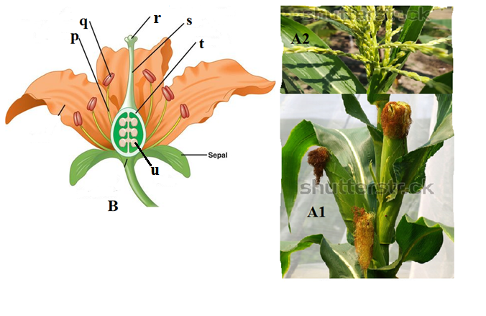
(a) (i) Name the type of flowers shown in A1 and A2.
(i) A1. (1 mark)
Staminate;
(ii) A2 (1 mark)
Pistillate;
(ii) Describe the feature in flowering plants depicted in (a)(i) above. (1 mark)
Monoecism;
(iii) Explain how flower labeled A1 is modified for pollination. 1 mark)
Numerous to increase the surface area for attachment of pollen grains;
Hang outside to trap pollen grains;
(b) Give the functions of the parts labeled p, r and s in specimen labeled B.
(i) p. (1 mark)
Hold anthers in position;
(ii) r. (1 mark)
Receive pollen grains;
(iii) s. (1 mark)
Support the stigma; allow transfer of male gametes;any 1
(c) State the structural descriptions of flower B. (2marks)
Superior ovary;
Polypetalous;
polysepalous;
brightly coloured petals;
pedicillate; any 1
(d) Explain what would happen to the following parts after pollination.
(ii) t. (1 mark)
Becomes pericarp;
(iii) u. (1 mark)
Becomes the seed;
(e) You are provided with a specimen labeled K in a petri dish, observe the specimen using a hand lens and answer questions that follow.
(i) Make well labeled diagram to show the reproductive structure of the organism. (3 marks)
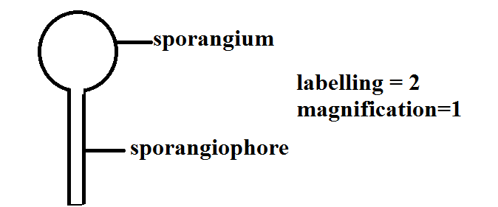

(ii) Give the type of asexual reproduction exhibited by the organism. (1 mark)
Sporulation ;

