Name: ___________________________________________ Index No: ____________________ School: __________________________________ Candidate’s Sign_____________________
Date: ________________________

565/1
BUSINESS STUDIES
Paper 1
March/April, 2020
Time: 2 Hours

ARISE AND SHINE TRIAL ONE EXAM
MARCH/APRIL - 2020

565/1
BUSINESS STUDIES
PAPER 1

Instructions to Candidates:
- Write your name, index number and school in the spaces provided above.
- Sign and write the examination date.
- Answer all the questions in the spaces provided.
- Ensure all the pages are printed.

QUESTIONS
- Outline four elements that may compromise the internal environment of a business. (4marks)
____________________________________________________________________________________________________________________________________________________________________________________________________________________________________________________________________________________________________________
- List four characteristics of money. (4marks)
____________________________________________________________________________________________________________________________________________________________________________________________________________________________________________________________________________________________________________
- Give four assumptions that are associated with perfect competition. (4marks)
____________________________________________________________________________________________________________________________________________________________________________________________________________________________________________________________________________________________________________
- State four ways in which a warehouse is of importance to a manufacturer. (4marks)
____________________________________________________________________________________________________________________________________________________________________________________________________________________________________________________________________________________________________________
- Outline four factors that an entrepreneur should consider before setting up a manufacturing business. (4marks)
____________________________________________________________________________________________________________________________________________________________________________________________________________________________________________________________________________________________________________
- Given the statement in the table below; indicate the type of entry to be made in the relevant ledger accounts. (4marks)
Statement | Types of Entry
- An increase in revenue
- A decrease in an asset
- An increase in an expense
- A decrease in liability

- Below are some entries in the cash book of Romano Traders for the month of July 2010:
Date 2010 | Details | Cash(sh) | Bank (sh) |  | Date | Details | Cash (sh) | Bank (sh)
July 1 | Bal b/d | 15,000 |  |  | July 1 |  |  | 10,000
July 6 | Cash |  | 20,000 |  | July 6 | Bank | 20,000
July 20 | Sales |  | 15,000 |  | July 15
July 28 | Debtors | 20,000 |  |  | July 29 | Stock |  | 10,000
 |  |  |  |  | July 31 | Bal c/d | 10,000

State the meaning of the following entries: - (4marks)
- July 1, 2010 balance b/d, bank column, sh. 10,000
______________________________________________________________________________________________________________________________________________________
- July 6, 2010 cash sh. 20,000 and bank sh. 20,000
______________________________________________________________________________________________________________________________________________________
- July 28,2010 debtors sh. 20,000
______________________________________________________________________________________________________________________________________________________
- July 31, 2010 balance c/d sh. 10,000
______________________________________________________________________________________________________________________________________________________
- State four merits of promoting products through personal selling. (4marks)
____________________________________________________________________________________________________________________________________________________________________________________________________________________________________________________________________________________________________________
- The aggressive campaign for citizens to plan their families seems to be causing a decline in the country’s population growth. Outline four possible effects on this. (4marks)
____________________________________________________________________________________________________________________________________________________________________________________________________________________________________________________________________________________________________________
- State four functions of commercial attaches. (4marks)
____________________________________________________________________________________________________________________________________________________________________________________________________________________________________________________________________________________________________________
- Wanjau started a business with sh. 60,000 as at 1st January 2010. During the year profits and additional investments were sh. 50,000 and sh. 60,000 respectively. At the end of the year, Wanjau remembered that she had taken goods for her personal use and that as at 31st December 2010, her capital was sh. 19,500.
Determine the value of goods that Wanjau had taken for her personal use. (4marks)

- The figure below shows a shift in demand curve from D_{O}D_{O} to D₁D₁. State four factors that may have caused the shift. (4marks)
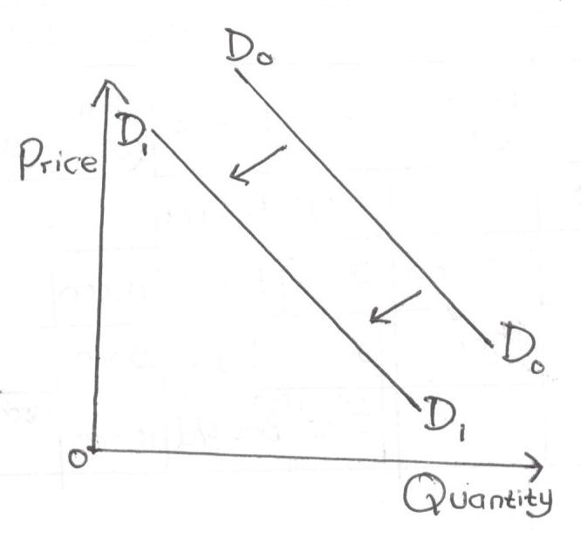
____________________________________________________________________________________________________________________________________________________________________________________________________________________________________________________________________________________________________________
- Juma Munyacia sells all his goods at 25% above cost. His books gave the following information as at 31st December 2004.
Sh
Stock 1st January 2004 98,720
Stock 31st December 2004 126,000
Sales for the year 600,000

Calculate the profit made by Munyacia (4marks)

- State four types of source documents. (4marks)
____________________________________________________________________________________________________________________________________________________________________________________________________________________________________________________________________________________________________________
- Prepare the balance sheet of Baraka traders from the following list of balances extracted from his books as at 31st December 2005. (4marks)

Sh
Machine 150,000
Motor vehicles 200,000
Stock 40,000
Creditors 25,000
Loan from KCB 100,000
Bank 20,000
Furniture 7,000
Capital 292,000

- Outline four factors that promote the level of national income in a country. (4marks)
____________________________________________________________________________________________________________________________________________________________________________________________________________________________________________________________________________________________________________
- Highlight four adverse effects of production activities on the environment and community health. (4marks)
____________________________________________________________________________________________________________________________________________________________________________________________________________________________________________________________________________________________________________
- Mention four circumstances under which an insurance company may re-insure. (4marks)
_______________________________________________________________________________________________________________________________________________________________________________________________________________________________________________________________________________________________________________________________________________________________________________________
___________________________________________________________________________
- State four elements of communication process. (4marks)
____________________________________________________________________________________________________________________________________________________________________________________________________________________________________________________________________________________________________________
- In the absence of a written partnership agreement, the provision of the partnership Act will apply. State four such provisions. (4marks)
____________________________________________________________________________________________________________________________________________________________________________________________________________________________________________________________________________________________________________
___________________________________________________________________________
- Highlight four features of open-air market trading. (4marks)
____________________________________________________________________________________________________________________________________________________________________________________________________________________________________________________________________________________________________________
___________________________________________________________________________
- State four emotional qualities of an office worker. (4marks)
____________________________________________________________________________________________________________________________________________________________________________________________________________________________________________________________________________________________________________
- State four features of indirect production. (4marks)
____________________________________________________________________________________________________________________________________________________________________________________________________________________________________________________________________________________________________________
- Outline four factors that may limit the use of containers as a method of transporting goods. (4marks)
____________________________________________________________________________________________________________________________________________________________________________________________________________________________________________________________________________________________________________
- Describe four characteristics of services. (4marks)
____________________________________________________________________________________________________________________________________________________________________________________________________________________________________________________________________________________________________________

