NAME __________________________ CLASS______ADM. NO. __________

School……………………………………………………………………………….
231/3
BIOLOGY
PAPER 3
NOV. 2020

MERU CENTRAL EXAMINATIONS
BIOLOGY
PAPER 3

INSTRUCTIONS TO CANDIDATES

- Write your name and index number in the spaces provided above.
- Sign and write the date of examination in the spaces provided above.
- You are required to spend the first 15 minutes of the 1 ¾ hours allowed for this paper reading the whole paper carefully before commencing your work.
- Answers must be written in the spaces provided in the question paper.

For Examiner’s Use only:-

Question | Maximum Score | Candidate’s Score
1 | 14
2 | 13
3 | 13
TOTAL | 40

This paper consists of 7 printed pages. Candidates should check to ascertain that all pages are printed as indicated and that no questions are missing.

- Below are photographs of two specimens, J and K. Both of them belong to the same phylum and class. Observe them carefully before you answer the questions that follow.
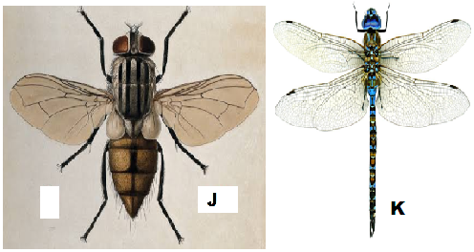
- Name the class to which J and K belong and support your answer with two reasons.
Class ………………………………………………………………………………….1mk
Reasons 2mks
- …………………………………………………………………………………
- …………………………………………………………………………………
- Suggest why the circulatory fluid in J and K has no haemoglobin. 2mks
…………………………………………………………………………………………
………………………………………………………………………………………….
- Observe their wings and suggest the type of evolution that could have taken place to give rise to J and K, and then give a reason for your answer.
Type of evolution …………………………………………………………………1mk
Reason ……………………………………………………………………………………
…………………………………………………………………………………2mks
- Below is a diagram showing the life cycle of specimen J.
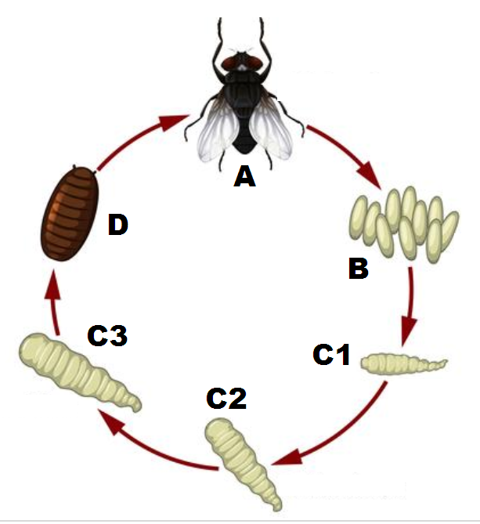
- Identify the stage labeled D. ……………………………………………………..1mk
- Name the hormone responsible for the change from D to A. 1mk
………………………………………
- Explain the differences in the change from C2 to C3 and from C3 to D. 4mks
………………………………………………………………………………………….
………………………………………………………………………………………….
………………………………………………………………………………………….
………………………………………………………………………………………….

Q2. Study the organisms below and answer questions in spaces provided .
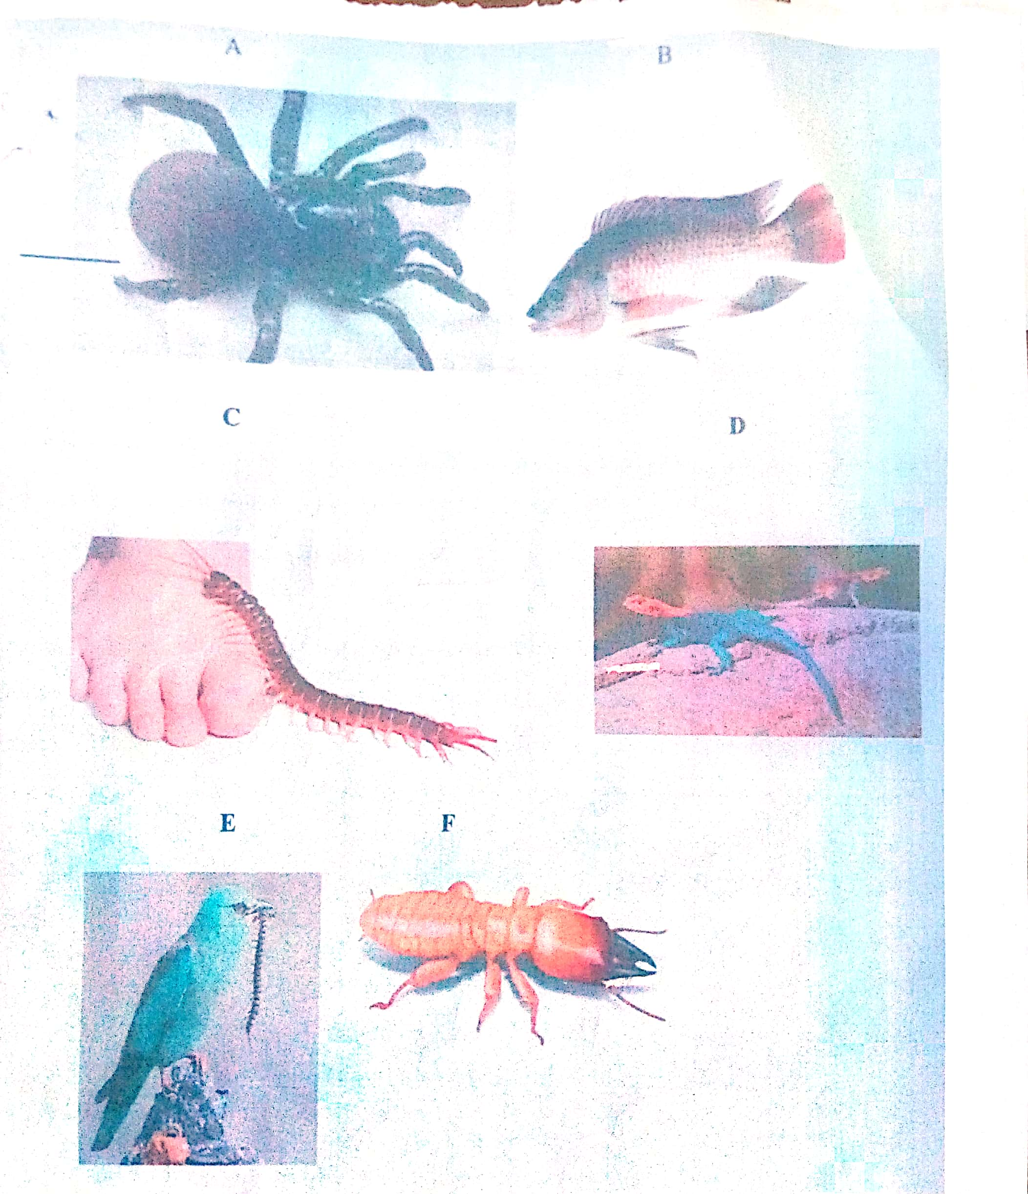

- Complete and use the key below to identify the organism. 2mks

1a. Organism with endoskeleton ………………………………………… go to 2
1b. ______________________ ………………………………………………… go to 3

2a. Has scales on the body………………………………………………… go to 4
2b. Has no scales on the body…………………………………… mammalian.

3a. Has cephalothorax ………………………………………………… Arachnida.
3b. Has no cephalothorax………………………………………………go to 5

4a. __________________________________............................... pisces
4b. Has no fins …………………………………………………….. Go to 7

5a. Has three pairs of legs …………………………………………… Insects.
5b. Has more than three pairs of legs …………………………… go to 6

6a. Two pairs of legs per segment ……………………………………Diplopoda
6b. One pair of legs per segment………………………………………chilopoda.

7a. Has feathers ……………………………………………………………… Aves
7b. Has no feathers …………………………………………………………go to 8

8a. Has a tail…………………………………………………………………Reptilia
8b. Has no tail……………………………………………………………Amphibia.

b). Identify the organisms above using the completed key above. 6mks
Specimen | Steps followed | Identity
A
B
C
D
E
F

c). Name the phylum in which specimens C, E and F belong to ……………………………………………..1mk

d). Give three reasons for your answer in (c). 3mks
………………………………………………………………………………………………………………………………………………………………………………………………………………………………………………………………………………………………………………………………………………………………………………………………………………………………………………………………………………………………

e).Name one feature that is common in organisms B, D and E. 1mk
………………………………………………………………………………………
Q3.You are provided with a specimen labeled T which is a fruit. Use it to answer the questions that follow.
- Make a transverse section of the specimen T. Draw and label at least 3 parts. 6mks

- With reasons, state the identity of fruit T.
Type of fruit………………………………………………………………………..1mk
Reason …………………………………………………………………………………1mk
- Suggest the possible agent of dispersal and give two reasons
Agent …………………………………………………………………………………1mk

Reason ……………………………………………………………………………………………………………………………………………………………………………………
2mk
- What is the placentation of T? …………………………………………………….1mk
- Specimen T was green in colour before it was treated with a plant hormone.
Suggest the plant hormone.
………………………………………………………………………………………1mk
END

