MERU CENTRAL PP3 marking scheme
- Below are photographs of two specimens, J and K. Both of them belong to the same phylum and class. Observe them carefully before you answer the questions that follow.
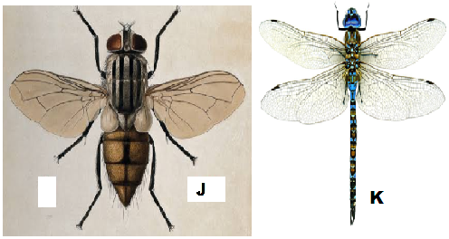
- Name the class to which J and K belong and support your answer with two reasons.
Class Insecta; 1mk Rej. insect
Reasons 2mks
- Six legs; three body parts; two antennae; two compound eyes;
- Suggest why the circulatory fluid in J and K has no haemoglobin. 2mks
Haemoglobin used to transport oxygen/ carbon (IV) oxide in the body; oxygen is taken directly to tissues/ carbon (IV) oxide taken directly from tissues by tracheoles;

divergent evolution; 1mk
Reason one pair of wings in J reduced to halters/ are vestigial; but both are functional in K 2mks

- pupa stage; 1mk
- 1mk
Ecdysone; accept Moulting hormone
- 4mks
C2 to C3 – moulting hormone / Ecdysone induce moulting; but presence of juvenile hormone prevent formation of pupa;

C3 to D – moulting hormone / Ecdysone induce moulting; but abscence of juvenile hormone lead to formation of pupa;
2a. 1b – organism with exoskeleton
4a. – has fins
b.
Specimen | Steps followed | Identity
A | 1a, 3a | Arachnida
B | 1a, 2a, 4a | Pisces
C | 1b,3b, 5b, 6b | Chilopoda
D | 1a, 2a, 4b, 7b, 8a | Reptilian
E | 1a, 2a, 4b, 7a, | Ave
F | 1b, 3b, 5a | Insect

c. Arthropoda
rej: Anthropoda or arthropoda
d. They all have exoskeleton
- They have segmented bodies
- They all have jointed appendages/limbs
e. Scales

3.
- 5mks
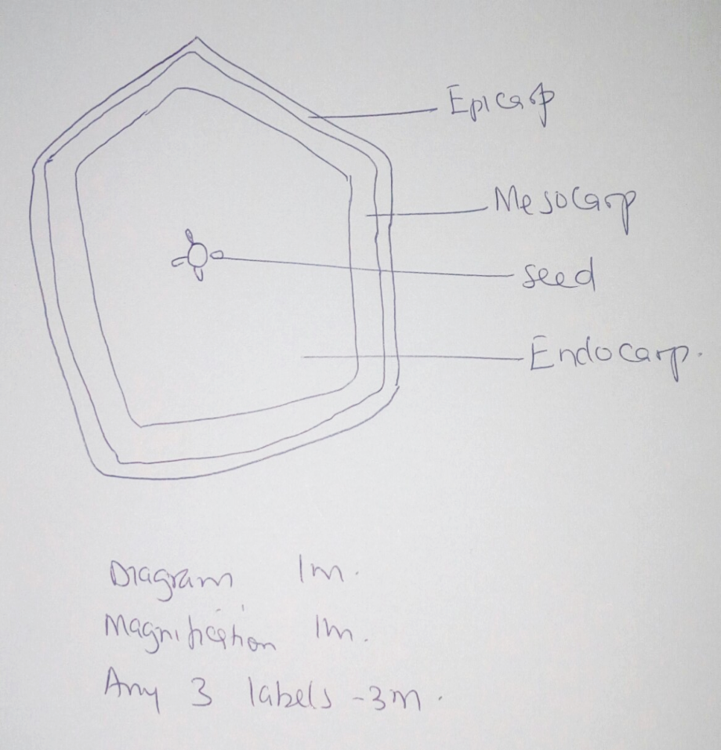
Magnification between X1 and X5
b) Type of fruit Berry 1mk
Reason has many seeds 1mk

Agent Animal 1mk
Reason brightly coloured; scented; fleshy; large; first 2mk
- Axile; 1mk
- Ethylene/ ethyne; 1mk

