MAGS 2 CYCLE 7 MARCH 2020

BIOLOGY PAPER 2
(THEORY)
MARCH 2020
TIME: 2 HOURS

NAME:.....................................................................CLASS:..............ADM NO:.....................

SIGNATURE....................................................................DATE...............................................

INSTRUCTIONS TO CANDIDATES:-
- Write your name and admission number in the spaces provided above.
- This paper consists of two sections; A and B.
- Answer all the questions in section A in the spaces provided.
- In section B, answer question 6 (compulsory) and either question 7 or 8 in the spaces provided after question 8.

For Examiner’s Use Only:

Section | Question | Maximum score | Candidates score
A | 1  2  3  4  5 | 8  8  8  8  8
B | 6  7 or  8 | 20  20  20
TOTAL SCORE |  | 80

This paper consists of 8 printed pages. Candidates should check to ascertain that all the pages are printed as indicated and that no questions are missing.

SECTION A
- An investigation was carried out to study the effects of the concentration of sucrose solutions on pieces of tulip stem 44mm in length. The pieces were placed in different concentrations of sucrose solutions and measured after two hours of immersion. The results are shown in the table below.
Sucrose concentration (moles per litre) | 0.2 | 0.3 | 0.4 | 0.5 | 0.6 | 0.7 | 0.8
Length after 2 hours (mm) | 50 | 48 | 46 | 44 | 42 | 42 | 42

  - Explain the effect of the 0.2 moles per litre sucrose solution on the length of the pieces of the tulip stem. (3mks).

  - Use information from the table to predict the concentration of a sucrose solution isotonic to the cells in the tulip stem. (1mk).

  - (i) Give the term which would be used to describe the cells in the tulip stem after immersion in a solution with a sucrose concentration of 0.7 moles per litre. (1mk)

ii. Draw the appearance of a cell from the tulip stem after immersion in a solution with a sucrose concentration of 0.7 moles per litre. (2mks).

  - State one role of the process being investigated in plants. (1mk)

- The diagram below illustrates circulation in certain organs of the mammalian body.
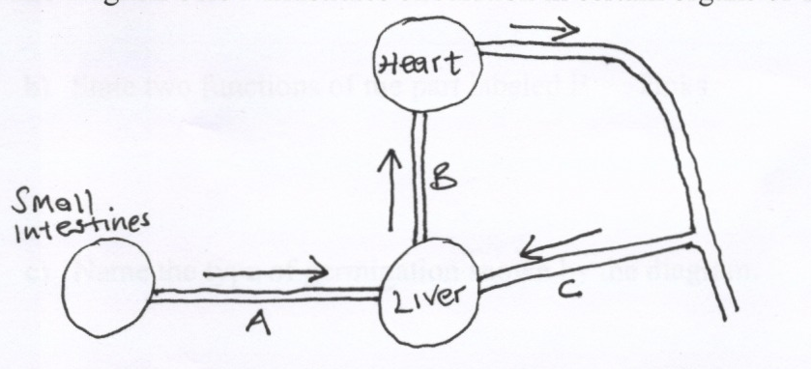

Heart

B
Small Intestines

C
Liver
A

a) Identify the blood vessels represented by A, B and C. (3mks)
A…………………………………………….
B…………………………………………….
C…………………………………………….

b) Explain why blood from the small intestines goes to the liver before it goes to any
other organ of the body. (2mks)
………………………………………………………………………………………………………
……………………………………………………………………………………………………………………………………………………………………………………………………………………………………………….
c) Compare the blood in vessels B and C. (1mk)
………………………………………………………………………………………………………
………………………………………………………………………………………………………
d) Outline how a glucose molecule in vessel A finally reaches the heart. (2mks)

………………………………………………………………………………………………………………………………………………………………………………………………………………………………………………
……………………………………………………………………………………………………………….
3. Polydactyl is a genetic disorder in which people inherit an extra digit. Polydactyl is caused by a dominant allele (B). The table below describes the different genotypes for polydactyl.
- Complete the table below by giving the correct genotype, alleles of each genotype and the expected number of fingers per hand. (4mks)
Genotype | Alleles | Expected number of digits per hand.
Homozygous dominant |  | Six
 | bb
Heterozygous. | Bb

- The table below shows results of marriages between various parents. Complete the table by writing the probability of each marriage producing a child with polydactyl. One has been done for you. (2mks)
Parental genotypes. | Probability of child with polydactyl
Bb X BB
Bb X bb | 0.5
Bb X Bb

c) State the two types of variation (2mks)

- Cuban pond weed (Elodea cubiensis) is a common water plant that produces tiny air bubbles of oxygen during photosynthesis. The number of bubbles produced per minute indicates the rate of photosynthesis. The graph shows how the rate of photosynthesis in the pond weed relates to light intensity.
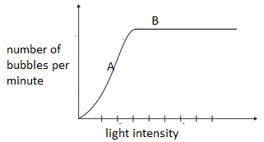
a). write the equation to account for the air bubbles. (1mk)

b). Name the factor that affects photosynthesis at point A. Explain. (2mks)

c). Explain why the rate of photosynthesis does not increase any further at high light intensity.(point B) (2mks)

d). Explain the role of the following in photosynthesis.
i) Chlorophyll. (1mk)

ii) Water. (1mk)

e). Name one product of the light stage of photosynthesis used in the dark stage of photosynthesis. (1mk)
5. Study the diagram below and answer the questions that follow.
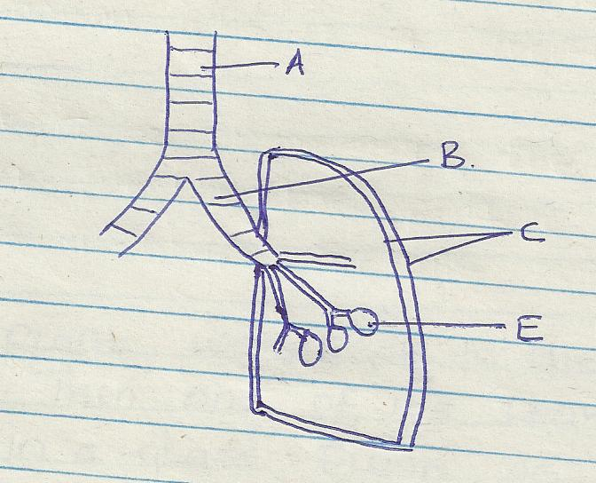

a) Name the part labeled A and B (2marks)

b) State the function of the part labeled C (2marks)

c) How is he part labeled E adapted to its function (2marks)

d) Identify the structure that perform the same function as one illustrated above in (2marks)
i) Amoeba

ii) Fish
SECTION B (40 Marks)
Answer question 6 (compulsory) and either questions 7 or 8 in the spaces provided after questions 8
- The pressure in the flow of blood in a mammal was determined at two different vessels; A and B. The data was taken within a period of 1 minute and was presented as follows.
Time in seconds | Blood pressure in
 | Vessel A | Vessel B
0 | 160 | 320
10 | 165 | 360
20 | 170 | 320
30 | 180 | 400
40 | 170 | 360
50 | 160 | 320
60 | 160 | 360
- Plot the graph of blood pressure in both vessels against time on the same axis. (7 marks)

- Describe the trend of each curve. (2 marks)
………………………………………………………………………………………………………………………………………………………………………………………………………………………………………………………………………………………………………………………………………………………
- (I) From the graph, suggest the possible identity for:
- Blood vessel A. (1 mark)
……………………………………………………………………………….
- Blood vessel B. (1 mark)
………………………………………………………………………………………..
- Give reasons for your answer in (c) i) and ii) above. (2 marks)
……………………………………………………………………………………………………………………………………………………………………………………………………………………………………………………………………………………………………………………………………..
- Explain a factor that would result to an increase in blood pressure in both the blood vessels above. (2 marks)
………………………………………………………………………………………………………………………………………………………………………………………………………………………………………………………………………………………………………………………………………………………
- State two structural differences between the two vessels mentioned in (c) above. (2 marks)
………………………………………………………………………………………………………………………………………………………………………………………………………………………………………………………………………………………………………………………………………………………………………………………………………………………………………………………………………….
- i) Name two diseases of circulatory system in humans. (2 marks)
……………………………………………………………………………………………………………………………………………………………………………………………………
ii) Other than transport of substances give one other function of blood. (1 mark)
………………………………………………………………………………………………………………………7. State and explain various areas where knowledge about genetics is applied. (20mks)
8. a) Describe the process of fertilization in flowering plant. (15mks)
b) State the changes that take place in a flower after fertilization. (5mks)
………………………………………………………………………………………………………………………………………………………………………………………………………………………………………………………………………………………………………………………………………………………………………………………………………………………………………………………………………………………………………………………………………………………………………………………………………………………………………………………………………………………………………………………………………………………………………………………………………………………………………………………………………………………………………………………………………………………………………………………………………………………………………………………………………………………………………………………………………………………………………………………………………………………………………………………………………………………………………………………………………………………………………………………………………………………………………………………………………………………………………………………………………………………………………………………………………………………………………………………………………………………………………………………………………………………………………………………………………………………………………………………………………………………………………………………………………………………………………………………………………………………………………………………………………………………………………………………………………………………………………………………………………………………………………………………………………………………………………………………………………………………………………………………………………………………………………………………………………………………………………………………………………………………………………………………………………………………………………………………………………………………………………………………………………………………………………………………………………………………………………………………………………………………………………………………………………………………………………………………………………………………………………………………………………………………………………………………………………………………………………………………………………………………………………………………………………………………………………………………………………………………………………………………………………………………………………………………………………………………………………………………………………………………………………………………………………………………………………………………………………………………………………………………………………………………………………………………………………………………………………………………………………………………………………………………………………………………………………………………………………………………………………………………………………………………………………………………………………………………………………………………………………………………………………………………………………………………………………………………………………………………………………………………………………………………………………………………………………………………………………………………………………………………………………………………………………………………………………………………………………………………………………………………………………………………………………………………………………………………………………………………………………………………………………………………………………………………………………………………………

