LANJET CLUSTER JOINT MOCK EXAM - 2020
BIOLOGY PP2
DECEMBER, 2020
MARKING SCHEME

- (a) Homozygous recessive plants do not have chlorophyll/cannot photosynthesize;
(b) Parental phenotype Normal green Pale green
Plants plants
Parental genotypes NN x Nn ;

N
N
N
n
Gametes ;

F₁ offspring NN Nn NN Nn ;
genotypes

Punnet’s Square
Parental genotype NN x Nn;

♂  ♀ | N | N;
N | NN | NN;
n | Nn | Nn
c) Parental genotype Nn x Nn
N
n
N
n
Gametes

Offsprings NN Nn Nn nn;

Have chlorophyll survive lack chlorophyll die early

$\frac{3}{4 }$ x 100 = 75% ; Grow to maturity
(d) Due to incomplete dominance of the gene for normal colour;

2. a) Epidermal tissue
b) Cell A – epidermal cell
Cell B – Guard cell
c)
Cell A | Cell B
Lack chloroplasts | Contain chloroplasts
Rectangular shaped | Bean shaped
No thickening on either walls | Thickened on inner walls

d)During the day, guard cells (cell B) carry out photosynthesis forming glucose. Glucose formed increases osmotic pressure of guard cells making them to draw water from adjacent cells of epidermis by osmosis
Guard cells swell and expand leading to opening of stoma (c)

3. a)(i) Tube A and B – liver cells have very high metabolic rates hence higher concentration of enzyme catalase.
- The resultant gas is oxygen.1mk
- However, boiling denatures the enzyme catalase in the liver cells hence no action on hydrogen peroxide.1mk
(ii) Tube A & C –1mk liver cells have higher metabolic rate than muscle cells hence higher concentration of enxyme catalase.1mk
- Tube D & E - cells of bean seeds have lower metabolic rates than soaked beans hence a lower concentration of enzymes catalase 1mk
Dry conditions inactivate enzymes in the cells of dry bean seeds 1mk
- F & G – crushing increases S.A of contact between enzymes catalase in a potato cells and hydrogen peroxide hence faster reaction than in the potato cubes.1mk
Catalase
(b) Hydrogen peroxide Water + Oxygen1mk
4. (a) | Light microscope
(b) | Q – objective lenses, Rj. Lense  K – Eye piece lens;  R – stage;
(c) | P- condenser – concentrate light from the source and directs it to the specimen  N – fine adjustment knob;  -Raises or lowers the body tube through small distance to bring the image into sharp focus;  S – Base  - For support  Mg =$\frac{length of the drawing}{length of the actual object}$(1mark)

5. a) Development of seed into a seedling
b) P – Coleoptile
Q – Plumule
R – Root hair Rej. Root hairs
c) Hypogeal germination
d) i) Used during respiration to provide energy required for cell division and growth.
ii) Converts insoluble food forms into soluble form
Plays role in breakdown and oxidation of food substances
iii) Activates enzymes
Softens the seed coat
Hydrolyses and dissolves food materials
Provides medium for enzymes to act
Medium of transport of soluble food to growing parts
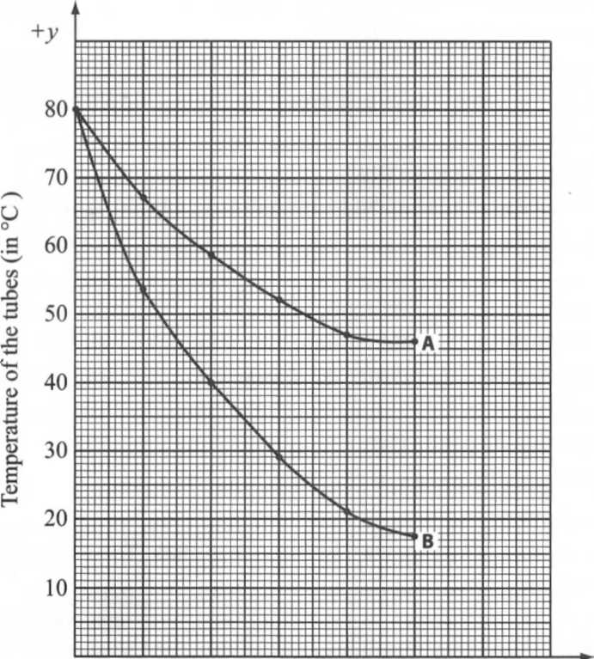
0 5 10 15 20 25
Time (in minutes)
6.

A – axis (1 mk) ×2
Plotting (1 mk)×2
Curve (1 mk)×2
Identification (1 mk)

(a)$\frac{80-18}{25}= \frac{62}{25}=2.48℃/minute$2mks
(c) Control experiment1mk
(d) The rate was faster in tube A because it’s surface was being wiped with cotton wool having methylated spirit.1mk The methylated spirit absorbed latent heat of vaporization from tube releasing it to the air, 1mktherefore encourages the cooling of the tube content.1mk
(e) Conduction1mk
Radiation1mk
(f) would have low rate of heat loss1mk
(g) (i) Feathers1mk
(ii) Fur1mk
(h) (i) Receptors in the skin1mk
(ii) Hypothalamus1mk

- (a)
Nervous system | Hormonal system
Nerve impulse evoke response | Chemical substance/ hormone evoke a response;
Impulse transmitted through nerves | Chemical substance /hormone transmitted through blood;
Response immediate | Response slow;
Effects rapid and short-lived | Effects long-lasting;
Location of the response confined to effectors | Location of the response wide-spread;
[5 marks]
- Immediately after menstruation; the pituitary gland is stimulated to secrete follicle stimulating hormone (FSH); which stimulates the ovary leading to start of development of a new Graafian follicle; its high concentration stimulates follicle cells of the ovary; to secrete oestogen hormone; Oestrogen hormone brings about healing and repair of uterine wall; and its high concentration stimulates pituitary gland; to secrete Luteinising hormone (LH); LH brings about ovulation; causes the reorganization of remnants of Graafian follicle into corpus luteum; and stimulates this corpus luteum to secrete progesterone hormone; high concentration of LH inhibits secretion of oestrogen; Progesterone hormone leads to proliferation of uterine in readiness for implantation; When conception occurs, the progesterone hormone maintains pregnancy up to birth; and inhibits production of FSH; If no conception, progesterone level falls drastically leading to menstruation; [max 15 marks]
- Mammal intestines are long to allow food more time for digestion and absorption.
-They are coiled to increase surface area for digestion and absorption and have villi and microvilli to increase the surface area for absorption.
-The walls have glands that secrete enzymes for digestion.
-They have goblet cells that secrete mucus which protect the intestinal wall from being digested and reduce friction as food moves down.
-The alimentary canal has a circular and longitudinal muscles contraction and relaxation leads to peristalsis. This facilitates faster digestion.
-The intestine is well supplied with blood vessels to supply oxygen and remove digested food material hence maintain high diffusion gradient.
-It has a narrow lumen to bring food into close contact with the walls to enhance absorption.
-It has a thin epithelium to facilitate faster diffusion of digestion food material.
-Mammalian intestine has lacteals in villi for absorption and transportation of lipids.
-At the stomach, there are pyloric sphincter and cardiac sphincter muscles which prevent food from moving out of the stomach during churning.
(1*2=20MKS)

