NAME:……………………………………… INDEX NO. ……………….…

SIGNATURE: …………………...... DATE: ...........................................

231/1
BIOLOGY
Theory
Paper 1
DECEMBER, 2020
Time: 2 Hours

LANJET JOINT EVALUATION EXAMINATION
Kenya Certificate of Secondary Education (K.C.S.E)
231/1
Biology
Paper 1
DECEMBER, 2020

Instructions to Candidates
- Write your name, admission number, class and signature in the spaces provided at the top of the page.
- Answer all the questions in the spaces provided in this paper.

FOR EXAMINER’S USE ONLY

Question | Maximum score | Candidate’s score
1-29 | 80

This paper consists of 8 printed pages. Candidates should check the question paper to ascertain that all pages are printed as indicated and that no pages are missing.

1. Which organelle would be numerous in the following cells? (2 mks)
(a) Liver cells
………………………………………………………………………………

(b) Palisade cells
………………………………………………………………………………...

2. State the functions of the following cell structures during cell division. (2 mks)
(i) Centriole –
…………………………………………………………………………………

(ii) Centromere –
…………………………………………………………………………………

3. In an investigation, the pancreatic duct of a mammal was blocked. It was found that the blood sugar regulation remained normal while, food digestion was impaired. Explain these observations. (2 mks)
……………………………………………………………………………………………………..………………………………………………………………………………………………………………………………………………………………………………………

4. State two structural differences between ribonucleic acid 9RNA) and deoxyribonucleic acid
(DNA). (3 mks)
………………………………………………………………………………………
…………………………………………………………………………………….…

5. Explain why glucose does not appear in urine of a healthy person even though it is filtered in
the Bowman’s capsule of a mammal. (2 mks)
……………………………………………………………………………………………………..………………………………………………………………………………………………………………………………………………………………………………………

6. A student set up an experiment as shown in the diagram below .
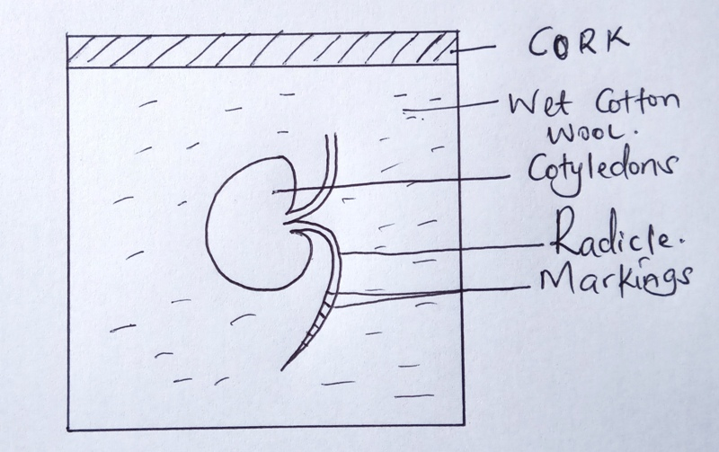
(a) (i) What was being investigated in the experiment? (1 mk)

………………………………………………………………………………

(ii) Why was it necessary to have wet cotton wool in the container? (1 mk)

………………………………………………………………………………

(b) What is the role of the following in germinating seed? (2 mks)
(i) Oxygen –
………………………………………………………………………………

(ii) Cotyledon –
………………………………………………………………………………

7. Give a reason why it is only mutation in genes of gametes that influence evolution.
(1 mk)
………………………………………………………………………………
………………………………………………………………………………

8. A person was able to read a book clearly at arm’s length, but not at normal distance.
(a) State the eye defect the person suffered from. (1 mk)

………………………………………………………………………………

(b) Why was he unable to read the book clearly at normal distance? (1 mk)
………………………………………………………………………………

(c) How can the defect be corrected? (1 mk)
………………………………………………………………………………
………………………………………………………………………………
9. Some form three students took a germinating maize grain and placed it in a starch paste in a petri dish and put the petri dish in a water bath maintained at 30ºC . After 48 hours, the starch paste was irrigated with iodine solution. The area around the maize grain changed to the colour of iodine solution while the rest turned blue-black.
(a) Account for the observation. (2 mks)
………………………………………………………………………………
………………………………………………………………………………

(b) Why was the petri dish put in a water bath maintained at 30ºC? (1 mk)

………………………………………………………………………………
10. State two functions of muscles found in the alimentary canal of a mammal? (2 mks)
………………………………………………………………………………
………………………………………………………………………………

11. State the stage in a cell division in which the following events occur:
(i) Replication of the genetic material. (1 mk)

………………………………………………………………………………
(ii) Exchange of genetic material. (1 mk)

………………………………………………………………………………
12. Explain what happens when a marine amoeba is transferred to fresh water environment.

………………………………………………………………………………
………………………………………………………………………………
………………………………………………………………………………
………………………………………………………………………………
13. In blood test, a few drops of anti-B serum were added to two samples of blood. It was
noted that agglutination occurred. What were the possible blood groups of the two blood samples? (2 mks)

………………………………………………………………………………
………………………………………………………………………………
14. The diagram below represents a simple endocrine feedback mechanism in a human male.
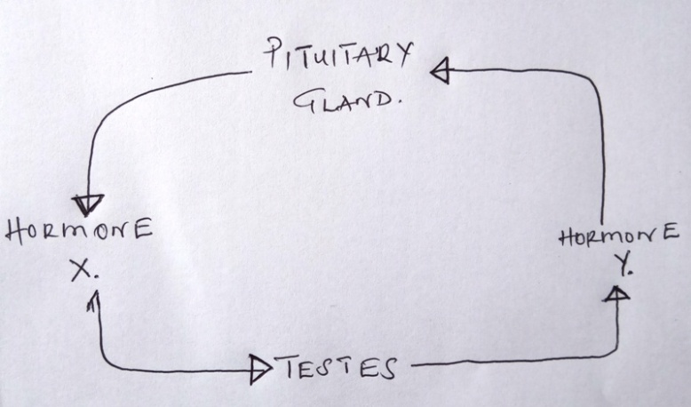
(a) Name the hormone labeled X. (1 mk)
………………………………………………………………………………
(b) State two differences that may be observed between a normal male and one who is incapable of producing hormone labeled Y. (2 mks)

………………………………………………………………………………
………………………………………………………………………………
15. A small amount of chemical M was put on one side of maize coleoptiles. After some days, it was noted that the coleoptiles curved away from the side to which the chemical was applied .
(a) Suggest the possible identity of chemical substance M. (1 mk)

………………………………………………………………………………

(b) Explain how this chemical might have caused the coleoptiles to curve. (2 mks)

………………………………………………………………………………
………………………………………………………………………………
16. In which part of the spinal cord is the cell body of the motor neurone found? (1 mk)
………………………………………………………………………………
………………………………………………………………………………
(b) Below are two features which make aneurone a specialized cell. State their role.
(i) Axion –
………………………………………………………………………………

(ii) Dendrites –
………………………………………………………………………………
17. (a) What is a natural selection? (1 mk)
………………………………………………………………………………
………………………………………………………………………………
(b) Distinguish between convergent and divergent evolution. (2 mks)
………………………………………………………………………………
………………………………………………………………………………
………………………………………………………………………………
………………………………………………………………………………
18. The diagram below shows part of a mammalian respiratory system.
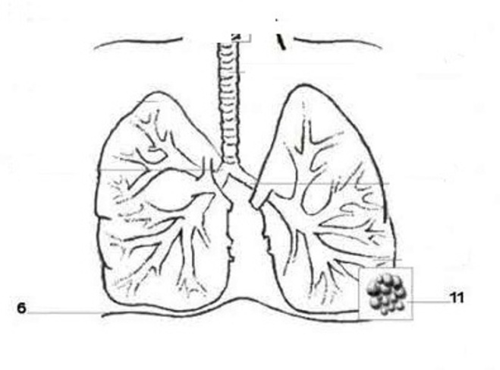
T
S
(a) Explain two ways in which the part labeled T is adapted to its functions. (2 mks)
………………………………………………………………………………
………………………………………………………………………………
………………………………………………………………………………
(b) How does the part labeled S facilitates inhalation ? (1 mk)

19. (a) Explain why the body temperature of a healthy human being must rise up to 39ºC on humid day. (2 mks)

………………………………………………………………………………
………………………………………………………………………………
………………………………………………………………………………
(b) In an experiment, a piece of brain was removed from a rat. It was found that the rat had large fluctuation of body temperature. Suggest the part of the brain that had been removed. (1 mk)

………………………………………………………………………………
20. Name the distinguishing features of class mammalian. (3 mks)

………………………………………………………………………………
………………………………………………………………………………
………………………………………………………………………………
21. State three types of asexual reproduction and give its examples. (3 mks)

………………………………………………………………………………
………………………………………………………………………………
………………………………………………………………………………
22. The figure below shows a tendril of a plant growing around a trunk.
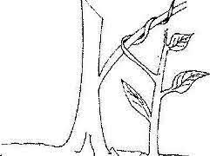

(a) Identify the types of response which causes the twisting growth. (1 mk)

………………………………………………………………………………
………………………………………………………………………………
(b) Explain how the twisting process is accomplished. (3 mks)

………………………………………………………………………………
………………………………………………………………………………
………………………………………………………………………………
24. Active yeast cells were added to a dilute sugar solution in a container. The mixture was kept in warm room. After a few hours bubbles of gas were observed escaping from the mixture.
(a) Write an equation to represent the chemical reaction above. (1 mk)
………………………………………………………………………………
………………………………………………………………………………
(b) What is the economic importance of this type of chemical reaction above? (1 mk)
………………………………………………………………………………
………………………………………………………………………………
(c) Why is that the total energy being released at the end of respiration (oxidation) being released in a small quantity. (1 mk)
………………………………………………………………………………
………………………………………………………………………………
25. Describe three roles or active transport in living organisms. (3 mks)
………………………………………………………………………………
………………………………………………………………………………
………………………………………………………………………………
26. The diagram below shows a feeding relationship in a certain ecosystem.
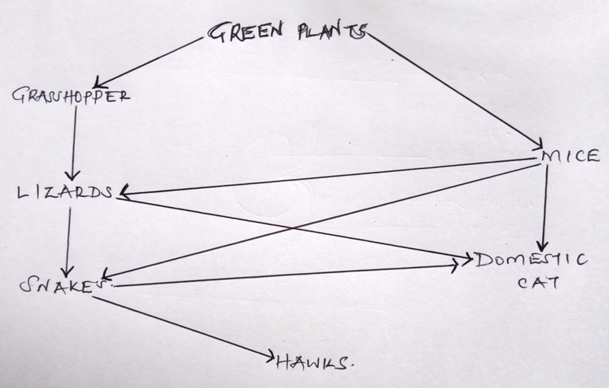

(a) Construct two food chains ending with a tertiary consumer in each case. (2 mks)

(b) Suggest three ways in which the ecosystem would be affected if there was prolonged drought. (3 mks)
………………………………………………………………………………
………………………………………………………………………………
………………………………………………………………………………
27. Explain how the following parts of a mammalian reproductive system are adapted to their functions:
(i) Testis (1 mk)
………………………………………………………………………………
(ii) Uterus (1 mk)
………………………………………………………………………………
(b) Explain why removal of the ovary after four months of pregnancy does not terminate pregnancy. ( 1 mk)
………………………………………………………………………………
………………………………………………………………………………
………………………………………………………………………………
28. (a) What is meant by double fertilization in flowering plants. (2 mks)

………………………………………………………………………………
………………………………………………………………………………
(b) State two advantages of cross pollination in a flowering plant. ( 2mks)
………………………………………………………………………………
………………………………………………………………………………

29. Name the division in kingdom plantae with the following spore producing bodies
(i) Capsule
………………………………………………………………………………

