NAME:……………………………………… INDEX NO. ……………….…

SIGNATURE: …………………...... DATE: ...........................................

231/1
BIOLOGY
THEORY
PAPER 1
DECEMBER, 2020
Time: 2 Hours

LANJET JOINT EVALUATION EXAMINATION
Kenya Certificate of Secondary Education (K.C.S.E)
231/1
Biology
Paper 1
DECEMBER, 2020

MARKING SCHEME

1. Which organelle would be numerous in the following cells? (2 mks)
(a) Liver cells
Golgi bodies/apparatus
………………………………………………………………………………

(b) Palisade cells Chloroplast
………………………………………………………………………………...

2. State the functions of the following cell structures during cell division. (2 mks)
(i) Centriole – produce spindle fibres
…………………………………………………………………………………

(ii) Centromere – Holds chromatids together
…………………………………………………………………………………
Provide point of attachment to spindle fibres .
…………………………………………………………………………………
3. In an investigation, the pancreatic duct of a mammal was blocked. It was found that the blood sugar regulation remained normal while, food digestion was impaired. Explain these observations. (2 mks)
Pancreatic juice containing digestive enzymes is blocked, from reaching food through
………………………………………………………………………………………………
The pancreatic duct, insulin and glucagon which regulates sugar is released directly to …..…………………………………………………………………………………………
the Bloodstream and reaches the liver where it regulates sugar in the body
……………………………………………………………………………………………

4. State two structural differences between ribonucleic acid (RNA) and deoxyribonucleic acid
(DNA). (3 mks)

RNA | DNA
(i) Has ribose sugars | (i) Has deoxyribose sugars
(ii) Has uracil as one of its bases | (ii) Has thymine instead of uracil
(iii) Single strand | (iii) Double strand

5. Explain why glucose does not appear in urine of a healthy person even though it is filtered in
the Bowman’s capsule of a mammal. (2 mks)
All glucose is actively reabsorbed at the proximal convoluted tubule track to the
………………………………………………………………………………………………
Blood in the body system

6. A student set up an experiment as shown in the diagram below .

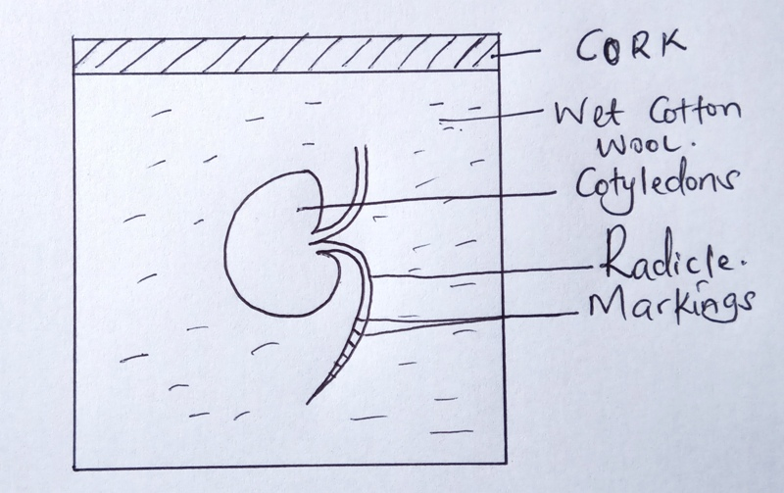
(a) (i) What was being investigated in the experiment? (1 mk)

They are investigating the region of cell elongation/rapid growth in root/
………………………………………………………………………………
or radicle

(ii) Why was it necessary to have wet cotton wool in the container?(1 mk)

To supply moisture for hydrolyzing enzymes for rapid growth.
………………………………………………………………………………

(b) What is the role of the following in germinating seed? (2 mks)
(i) Oxygen –
For oxidation of food to provide energy for germination. ………………………………………………………………………………

(ii) Cotyledon – Food storage necessary during germination for energy of
………………………………………………………………………………
plumule and radicle growth at early stages of germination

7. Give a reason why it is only mutation in genes of gametes that influence evolution.
(1 mk)
Gametes always form new offsprings and therefore any mutation in
………………………………………………………………………………
gametes affects offsprings

8. A person was able to read a book clearly at arm’s length, but not at normal distance.
(a) State the eye defect the person suffered from. (1 mk)
Long sightdness/Hypermetropia
………………………………………………………………………………

(b) Why was he unable to read the book clearly at normal distance?(1 mk)
- Image is focused behind retina due to short eyeball ………………………………………………………………………………
- Lens unable to focus because they are flat/weak.

(c) How can the defect be corrected? (1 mk)
By wearing convex/Biconvex/Conveying lens
………………………………………………………………………………
9. Some form three students took a germinating maize grain and placed it in a starch paste in a petri dish and put the petri dish in a water bath maintained at 30ºC . After 48 hours, the starch paste was irrigated with iodine solution. The area around the maize grain changed to the colour of iodine solution while the rest turned blue-black.
(a) Account for the observation. (2 mks)
Enzyme diastase from maize grain hydrolysed/digested
………………………………………………………………………………
starch from complex to simple sugars
………………………………………………………………………………

(b) Why was the petri dish put in a water bath maintained at 30ºC?(1 mk)
To maintain optimum temperature required by enzymes in
………………………………………………………………………………
Maize grain to digest starch.

10. State two functions of muscles found in the alimentary canal of a mammal?(2 mks)
It controls food movement in alimentary canal.
………………………………………………………………………………
It is used as a valve to close or open various parts of the canal.
………………………………………………………………………………

11. State the stage in a cell division in which the following events occur:
(i) Replication of the genetic material. (1 mk)
Interphase
………………………………………………………………………………

(ii) Exchange of genetic material. (1 mk)
Prophase I
………………………………………………………………………………

12. Explain what happens when a marine amoeba is transferred to fresh water
environment.
Water would be drawn into amoeba by osmosis;
Water collects into the contractile vacuoles;
More contractile vacuoles form to discharge water into the surrounding through the cell membrane thus marine amoeba will survive.

13. In blood test, a few drops of anti-B serum were added to two samples of blood. It was
noted that agglutination occurred. What were the possible blood groups of the two
blood samples? (2 mks)
Blood group AB
Blood group B

14. The diagram below represents a simple endocrine feedback mechanism in a human
male.

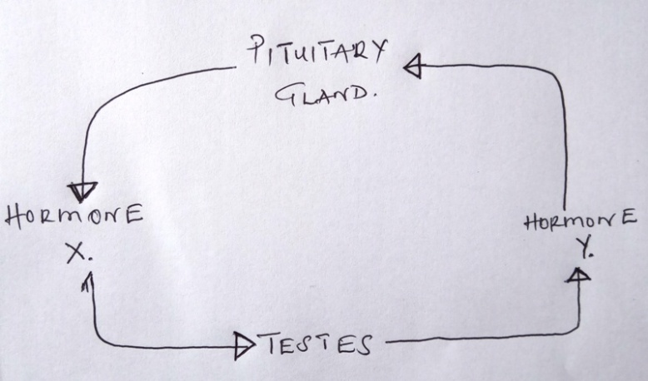
(a) Name the hormone labeled X. (1 mk)
- Follicle stimulating Hormone/Gonadotrophic Hormone/Lutenizing Hormone.
………………………………………………………………………………

(b) State two differences that may be observed between a normal male and one
who is incapable of producing hormone labeled Y. (2 mks)

Male Incapable of producing Hormone Y | Normal male
(i) Lack beards | Has beards
(ii) high pitched voice | (ii) Deep voice
(iii) No spermatogenesis | (iii) Has spermatogenesis
(iv) Less muscular | (iv) More mscular

15. A small amount of chemical M was put on one side of maize coleoptiles. After some days, it was noted that the coleoptiles curved away from the side to which the chemical was applied .
(a) Suggest the possible identity of chemical substance M. (1 mk)
Auxine/Gibberellins
………………………………………………………………………………

(b) Explain how this chemical might have caused the coleoptiles to curve. (2 mks)
Caused rapid cell elongation, causing more/faster growth on cells;
………………………………………………………………………………
exhibit the cell division in coleoptile on the side applied.

16. In which part of the spinal cord is the cell body of the motor neurone found?(1 mk)
Grey matter
………………………………………………………………………………
(b) Below are two features which make a neurone a specialized cell. State their
role.
(i) Axion – It is long to conduct a nerve impulse ………………………………………………………………………………

(ii) Dendrites – It allows synaptic connections with other neurons. ………………………………………………………………………………

17. (a) What is a natural selection? (1 mk)
This is where an organisms with favourable genes survive and transmit these genus to the offspring’s; while those with unfavourable genes perish.

(b) Distinguish between convergent and divergent evolution. (2 mks)

Convergent evolution | Divergent evolution
Where organisms posses structures with different embryonic origin, but atre modified to perform the same function. | This is where organisms posses structures with same embryonic origin but are modified to perform different functions.

18. The diagram below shows part of a mammalian respiratory system.

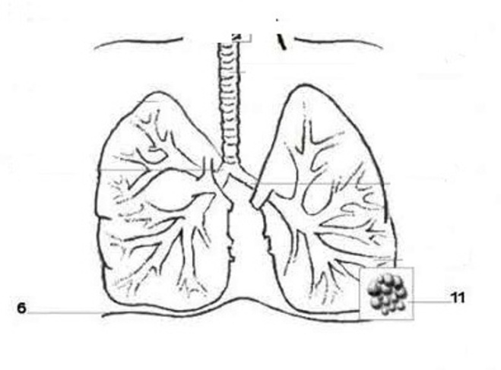
S
T

(a) Explain two ways in which the part labeled T is adapted to its functions.
(2 mks)
- It is moist to dissolve respiratory gases
- It is highly vascularized for increasing concentration gradient for respiratory gases
- It has thin surface for quick diffusion of respiratory gases.

(b) How does the part labeled S facilitates breathing in? (1 mk)
- Contract and flattens; increases the volume of the thoracic cavity
……………………………………………………………………………..

19. (a) Explain why the body temperature of a healthy human being must rise up to 39ºC
on humid day. (2 mks)
- Heat from the body is not lost to the surrounding through sweating because evaporation of heat will be low as air is already saturated with moisture. During humid, the metabolic rate/reaction will be high in the body thus increasing the heat supply, this will raise heat content in the body.

(b) In an experiment, a piece of brain was removed from a rat. It was found that the
rat had large fluctuation of body temperature. Suggest the part of the brain that
had been removed. (1 mk)

Hypothalamus
………………………………………………………………………………

20. Name the distinguishing features of class mammalian. (3 mks)
- They have mammary glands for their young ones
………………………………………………………………………………
- Their bodies are covered with fur or hairs
………………………………………………………………………………
- They posses pinna which is made up of thin skin of cartilages
………………………………………………………………………………

21. State three types of asexual reproduction and give its examples. (3 mks)
- Budding in yeast
………………………………………………………………………………
- Spore formation – Rhizopus (spp)
………………………………………………………………………………
- Binary Fission – In Amoeba
………………………………………………………………………………

22. The figure below shows a stem of a plant growing around a trunk.

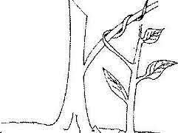
(a) Identify the types of response which causes the twisting growth. (1 mk)
Thigmotropism/haptotropism
………………………………………………………………………………
(b) Explain how the twisting process is accomplished. (3 mks)
The part of the stem in contact with hard object has a lower auxin
………………………………………………………………………………
Concentration than the outer part; contact causes lateral migration to the
………………………………………………………………………………
outer side of the stem. Since high auxine concentration promotes faster
………………………………………………………………………………
growth in shoots, high concentration in outer part causes faster growth, which
…………………………………………………………………………………
results in bending of stem.
…………………………………………………………………………………

23. Explain how plants compensate for their inability to locomote. (1 mk)
- Pollen grains transferred to the stigma by pollination
………………………………………………………………………………
- Green plants are able to manufacture their food by photosynthesis
………………………………………………………………………………
- Seeds and fruits moves by dispersal
- …………………………………………………………………………..
- Deep rooted absorb water and mineral salts from soil.
- ……………………………………………………………………………
- Some plants have thick cell walls for turgidity.
- …………………………………………………………………………

24. Active yeast cells were added to a dilute sugar solution in a container. The mixture
was kept in warm room. After a few hours bubbles of gas were observed escaping
from the mixture.
(a) Write an equation to represent the chemical reaction above. (1 mk)
Glucose Ethanol + Carbon(iv) oxide + Energy/210Kj
………………………………………………………………………………
C₆H₁₂O₆ 2C₂H₅OH + 2CO₂ + Energy/210Kj
………………………………………………………………………………
(Equation must be balanced)
(b) What is the economic importance of this type of chemical reaction above?

Produces ethanol used for – Sewage treatment
- Baking bread
- Brew making
(c) Why is that the total energy being released at the end of respiration (oxidation)
being released in a small quantity. (1 mk)

When it is being released in large quantity it can burn the cells to avoid
………………………………………………………………………………
destroying the cells. It must be released at low quantity.
………………………………………………………………………………

25. Describe three roles or active transport in living organisms. (3 mks)
(i) Absorption of dissolved food substances from small intestines to the liver.
………………………………………………………………………………
by micro – villi.
………………………………………………………………………………
(ii) Reabsorption of amino acid, mineral ions and glucose from the filtrate in the
………………………………………………………………………………
tubule to the blood.
………………………………………………………………………………
(iii) Absorption of mineral salts from the soil by plant roots.
………………………………………………………………………………

26. The diagram below shows a feeding relationship in a certain ecosystem.

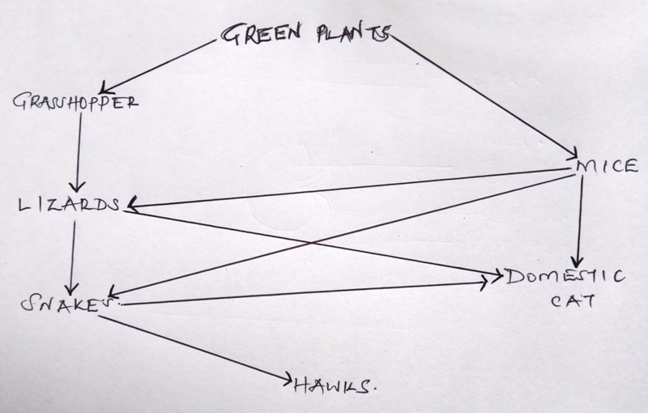 (a) Construct the food chains ending with a tertiary consumer in each case.(2 mks)
(i) Green plants Grasshopper Lizards Domestic cats
(ii) Green plants Mice Snakes Hawks
(iii) Green plants Mice Snakes Domestic cats

(b) Suggest three ways in which the ecosystem would be affected if there was
prolonged drought. (3 mks)
- Most plants will die/dry
………………………………………………………………………………
- Some animals may starve to death …………………………………………………………………………
- Some organisms may migrate.
………………………………………………………………………………

27. Explain how the following parts of a mammalian reproductive system are adapted to
their functions:
(i) Testis (1 mk)
Have seminiferous tubules for spermatogenesis
………………………………………………………………………………
They are glandular to secrete hormones testosterone which is the male
………………………………………………………………………………
androgens
……………………………………………………………………………….
(ii) Uterus (1 mk)
- It is hollow to accommodate developing foetus.
………………………………………………………………………………
- It is muscular to allow contraction to expel out foetus.
……………………………………………………………………………….

(b) Explain why removal of the ovary after four months of pregnancy does not
terminate pregnancy. ( 1 mk)
- After four months the placenta will be fully developed, the ovaries will
………………………………………………………………………………
stop producing progesterone and the placenta will take the part of
………………………………………………………………………………
producing progesterone’s for maintaining the pregnancy.
………………………………………………………………………………

28. (a) What is meant by double fertilization in flowering plants. (2 mks)
Is a process whereby one male nucleus fuses with the egg cell nucleus to
………………………………………………………………………………
form a (diploid) zygote, while the other male nucleus fuses with the polar
………………………………………………………………………………
nuclei to form a triploid) nuclei (primary) endosperm.
………………………………………………………………………………

(b) State two advantages of cross pollination in a flowering plant. ( 2mks)
- High yields (hybrid vigour)
………………………………………………………………………………
- Early maturity
………………………………………………………………………………
- High resistance to drought/pests/diseases
………………………………………………………………………………

29. Name the division in kingdom plantae with the following spore producing bodies
(i) Capsule
Bryophyta
………………………………………………………………………………

`

