NAME _________________________________________ SCHOOL ____________________
INDEX NO_______________________CANDIDATE’S SIGNATURE __________________
DATE ______________________
231/3

BIOLOGY
PRACTICAL

Paper 3
Time: 1 ¾ hours.
March/April, 2020

ARISE AND SHINE TRIAL 1 EXAM
MARCH/APRIL - 2020

INSTRUCTIONS TO THE CANDIDATES
- Answer ALL questions in the spaces provided.
- You are required to spend the first 15 minutes of the 1 ¾ hours allowed for this paper reading the whole question paper carefully before commencing your work.
- Answers MUST be written in the spaces provided in the question paper.
- Additional pages MUST not be inserted.
- Candidates will be penalized for recording irrelevant information and wrong spelling especially technical terms.

For Examiner’s Use Only
Question | Maximum Score | Candidate’s Score
1 | 14
2 | 12
3 | 14
Total Score | 40

- You are provided with the following:
- Solution A
- Benedict’s solution labelled as solution B
- Solution C
- 0.1% NaCl solution
- 1.4% NaCl solution
- Iodine solution labeled as solution D

- Label the test tubes as P, Q and R; in each test tube place 3mls of solution C into each test tube:

- Carry out iodine test on portion of the solution from test tubes P, Q and R and record the observation in the table below. (3 marks)

Test tube | Observation
P
Q
R

- To test tube Q, add 3 drops of 0.1 % sodium chloride solution and 2ml of solution A. Place test tube P, Q and R in a water bath and maintain at 37ºC for 30 minutes. Using a drop of the solution from each test tube, repeat the procedure in (a) above and spare the rest for the next question. Record your observation in the table below (2 marks)

Test tube | Observation at the end of the experiment
Q
R
- Put 2cm³of solution from test tube P in a clean test tube and add 2cm³of Benedict’s (solution B) shake then heat the mixture to boil in a hot water bath. Record your final observation in the table below. (2 marks)

Test tube | Observation after experiment
Q
R

- Why was test tube P included in the experiment? (1 mark)

- Account for the observations made in test tube Q and R at the end of the experiment (4 marks)
- Test tube Q

- Test tube R

- Suggest the identity of solution A (1 mark)

- Why was the water bath maintained at 37ºC? (1 mark)

- a) Study the photographs below for specimen R and S.
S
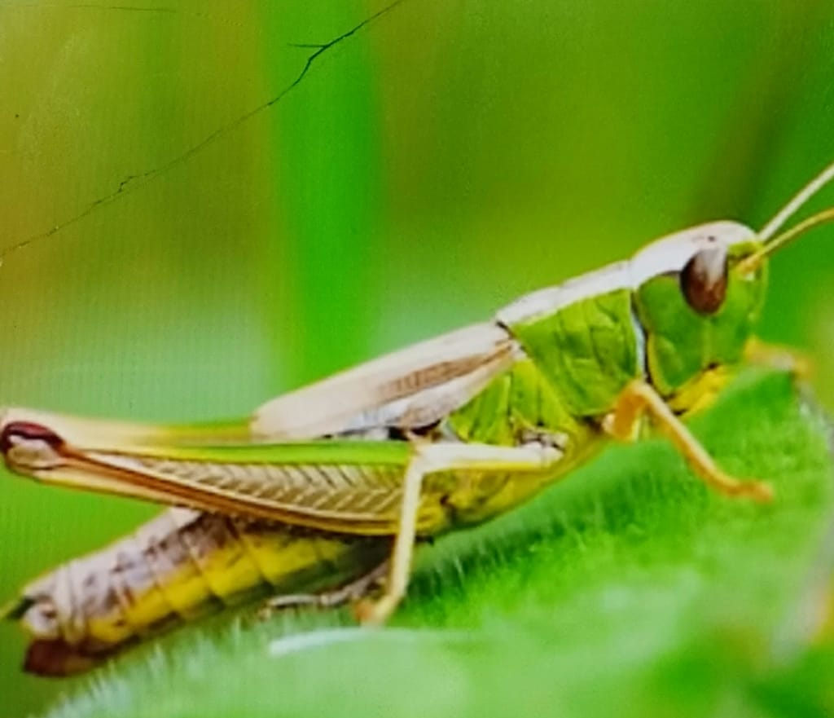

R
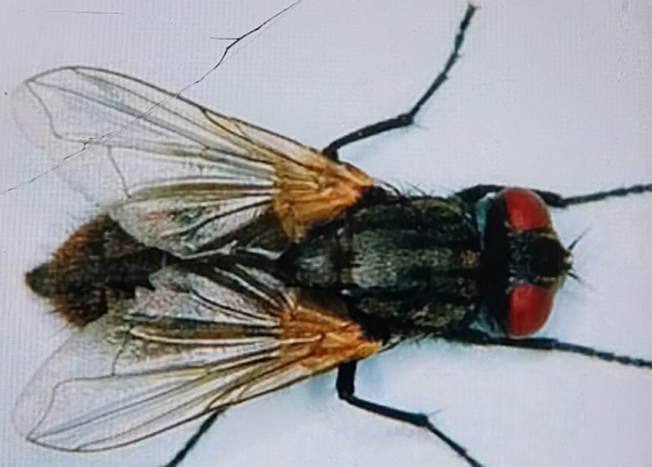

- State four observable differences between the specimen R and S (4 marks)
Specimen R | Specimen S

- Suggest the advantages of the adaptations on the limbs of specimen S (2marks)

b) Name the phylum and class to which the specimen belongs. (2 marks)
Phylum --------------------------------------------------------------------------------------
Class -----------------------------------------------------------------------------------------
c) i) Give the type of metamorphosis in S (1 mark)

ii) Draw the life cycle of the type of metamorphosis in the organism mentioned in C (i) above (3 marks)

- (a) You are provided with specimen Q, using a cork borer, remove eight strips of 2cm length from specimen Q. Place two into solution labeled Y and another two strips into solution labeled Z. Leave the set up to stand for 20 minutes.
NB Preserve the other two for use later in question 3(b) (i)

- State the observation after 20 minutes when the strips are touched. (6 marks)

 | Initial length | Final length | Change in length | Flexibility | Texture
Strips in solution Y | 2cm
Strips in solution Z | 2cm

- Account for the observations in (c) (i) above (4 marks)

(b) (i) using a mortar and a pestle crush one of the remaining strip, place the extract in a test tube and add solution C. State your observation. (1 mark)

(ii) Repeat the procedure in (b) (i) with distilled water instead of hydrogen peroxide. State your observation. (1 mark)

(c) Explain why:
- It was necessary to crush specimens in the experiment. (1 mark)

- Hydrogen peroxide should not accumulate in living tissue. (1 mark)

