231/3

BIOLOGY
PRACTICAL
Paper 3

MARKING SCHEME
ARISE AND SHINE TRIAL 1 EXAM
MARCH/APRIL- 2020

Test tube | Observation
P | Blue - black / black / blue
Q | Blue - black / black / blue
R | Blue - black / black / blue
- .
Test tube | Observation
Q | Yellow / brown / color of iodine solution retained / persist
R | Yellow / brown / color of iodine solution retained / persist
- .
Test tube | Observation
Q | Green / yellow
R | Orange / brown

- Control experiment

- (i) Q – Small / little / traces of reducing sugars; due to lower concentration of sodium ion /Na⁺ / enzyme co-factors

(ii) R – High / large amount of reducing sugar; due to higher /optimum concentration of sodium ion / Na⁺ / enzyme co-factor.

- Enzyme / diastase / amylase / ptyalin

- To provide optimum temperature for reaction of enzyme amylase / distance.

- (a) (i)
R | S
- No spikes on legs  - Hind legs not muscular  - One pair of wings  - Piercing and sucking mouth part | - Spikes on legs  - Hind less muscular  - Two pairs of wings  - Biting and chewing mouth part
(ii) Spikes for protection from predators
- Strong muscular limbs for strong leaping when taking off during flight

(b) Phylum – anthropoda
Class – insecta rei. wrong spelling

(c) (i) incomplete metamorphosis √

(ii)
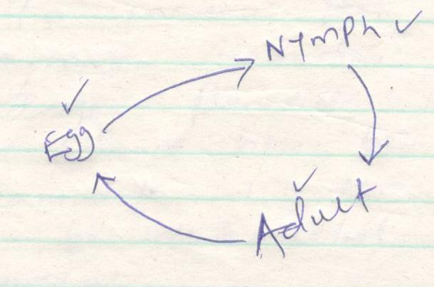
Eggs hatch to nymph, nymph changes to adult

- (i)
 | Average length | Final length | Change in length | Texture | Flexibility
Strips in solution Y | 2cm | 2.2 cm | +0.2 cm | Hard | Rigid
Strips in solution Z | 2cm | 1.8cm | -0.2 cm | Soft | Flexible

(ii) Solution Y was hypotonic to the cell sap therefore the cell gains water by osmosis (endosmosis) (and developed turgor pressure) hence strips became firm, hard and increase in length. (2marks)

Solution Z was hypotonic to the cell sap therefore the cells lose water by osmosis and became flaccid, shrunk and this leads to decrease in length (2marks)

(b) (i) Many bubbles / rapid effervescence (due to enzymatic activity) (1mark)

(ii) No bubbles / no observable reaction

(c) (i) To increase the surface area for enzymatic reaction (1mark)
(ii) Hydrogen peroxide is poisonous and so should not be allowed to accumulate in the cells and has to be detoxicated as soon as it is formed.

