GOLDEN ELITE EXAMINTIONS 2020
231/2
BIOLOGY
PAPER 2

MARKING SCHEME

- (a)
- Protandry: condition in which stamen/anthers of a flower mature before the carpels/pistils/stigma;(1 mark)
- Self sterility; pollen grains from anthers of a flower fail to germinate on the stigma of the same flower ; (1 mark)
(b) (i) Q- Antipodal cells/embryo sac wall;
R - Polar nucleus/nuclei;
S - Egg call/ovum 3 marks
- Secrete enzymes that digest the stigma/style/ovary tissue;
Offer passage for male nuclei to the ovum; 2 marks
(c) Award if correctly shown in the diagram; 1 mark
2. (a) Excess amino acids are deaminated/amino group is removed/amino group is converted in to ammonia; ammonia combines with carbon(iv) oxide(in the ornithine cycle) to form urea; carbohydrate group is converted into glucose for respiration/glycogen for storage;
2NH₃+CO →CO (NH₃)₂ +H₂O 3 marks
(b) Glomerulus; Bowman’s capsule; proximal convoluted tubule; distal convoluted tubule; 3 marks
(c) (i) Production of large amounts of dilute urine/diuresis; 1mark
(ii) Diabetes inspidus; 1mark
3. (a) (i) Using a living organism to regulate/control/reduce/check the population of another organism;
1mark
- Catscontrolling mice; beetles controlling water hyacinth; fish in ponds controlling mosquito larvae;
Majimoto ants controlling scales; goats controlling weeds in plantations; any 1 (1mark)
(b) (i) eutrophication is enrichment of water bodies with nitrates/phosphates/ammonium ions/sulphates/nutrients; due to discharge of sewage/domestic effluents/kitchen wastes containing detergents/run off water containing fertilizers; leading to rapid growth of surface plants/algae bloom/aquatic plants/phyloplanktons;
Acc symbols for ions (aq) must be present.
Rej kitchen wastes alone
Reg domestic wastes 3 marks
- (Proliferation of plants) block light from reaching plants underneath which will not photosynthesise; the plant die and decompose leading to depletion of oxygen/lack of oxygen ;( as a result) animals also die/suffocate (to death); Reg organisms die 3 marks
(c) Nitrogen (IV) oxide; sulphur (IV) oxide;
Acc Nitrogen Dioxide and sulphur dioxide
Reg oxides of sulphur and nitrogen
4. (a) - Broad and flat to absorb maximum light;
- Have chloroplasts which contain chlorophyll for trapping light;
- Transparent cuticle to allow light to pass through;
- Palisade cells are near the upper surface for optimum absorption of light; 2 marks
(b) X - Carbon (IV) oxide;
Y – Oxygen;
(c) (i) Xylem;
(ii) Phloem;
(d) Starch is insoluble in water; hence osmotically inactive; this reduces the effect on absorption of water
5. (a) Iodine solution was poured on the agar; 1 mark
(b) Millet seeds produced amylase; that converts starch to maltose2 marks
(c) To activate the enzymes; 1 mark
(d) To increase surface area for exposure of enzymes; 1 mark
(e) Starch would not be digested since the enzymes would be denatured by boiling;
(f) Placing millet seeds that have not been soaked; in water on the agar/boiled millet seeds on the agar;
2 marks
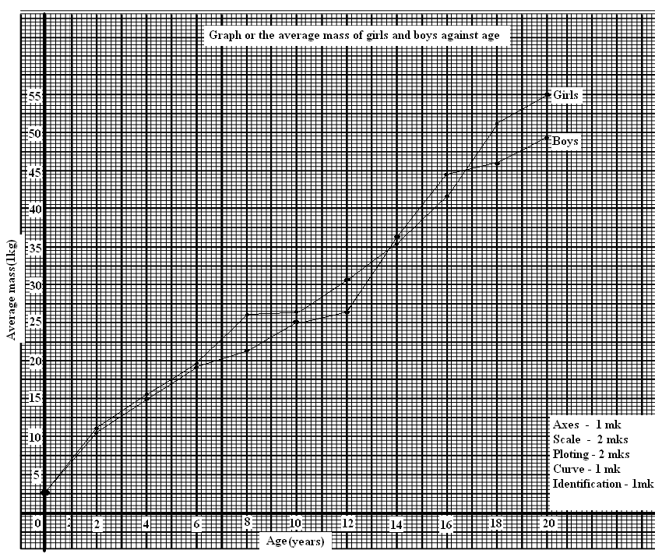
6. (a)

(b) (i) 26 kgs± 0.5;
(ii) Girls 15 yrs - 39
Girls 13 yrs - 33
6
6 ÷ 2; = 3.0 kg/year;
(c) Girls at adolescence grow faster; there is an increase in the size of hips and breasts;
(d) Girls generally grow faster than boys /boys grow slowly compared to girls; but later after puberty they grow more steadily.
(e) Girls above ten years begin the menstruation cycle; they need more iron to replace the blood lost during menstruation;
(f) Height of the body; volume of the body;
7. Mouth;
  - With teeth for chewing to increase the surface area for digestion and easy swallowing
  - Has salivary gland which secrete saliva to soften and lubricate food for easy swallowing
- Has muscular tongue to turn food sideways for proper mixing with saliva and chewing
- Rolls food in to boluses and pushes them down the gullet
- Saliva has saliva amylase to initiate digestion of starch;
Oesophagus;
- Has circular and longitudinal muscles to propel food in to the stomach by peristalsis
Stomach;
- Has cardiac sphincter muscles to allow/regulate food into the stomach
- Pyloric sphincter to retain food for digestion in the stomach
- With gastric glands that secrete mucus to protect wall of the stomach from digestive enzymes; enzymes pepsin and rennin to digest proteins;hydrochloric acid to kill bacteria in food;and provide optmum PH for protein digestion,activation of pepsnogen
- With muscular walls whose contaction churn/mix chyne with digestive enzymes.
Duodenum
- With brunners glands in its walls to produce alkaline fluid and mucus
- Has crypts of lieberkuhnwhose cells produce digestive enzymes
- Is connected to the pancrease and the liver which supply pancreatic juice and bile respectively
- Bile emulsifies fats and neutralizes the acid from the stomach. Pancreatic juice contains digestive enzymes/pancreatic lipase, pancreatic amylase and Trypsin that acts on lipids, starch/amylase and proteins respectively.
Ileum
- Long to allow complete digestion and absorption of food
- With villi and microvilli to increase surface area for digestion and absorption
- Folded to increase surface area for digestion and absorption
- Narrow to keep digested food in contact with epithelium to reduce distance over which food diffuses
- With moist inner surface to enhance absorption of nutrients
- With epithelical cells continuously replaced
- Has lacteals for fat transportation
- Has muscular walls for peristaltic movement of food
Colon
- Folded to increase surface area for absorption of water and mineral salts
- With muscular walls for peristaltic movement of undigested food
Rectum;
- Secretes large amounts of mucus for lubrication to aid defecation
Anus
- With muscular sphincter to control defecation
8. Causes of air pollution
- Sulphur and nitrogen dioxide ;; from industries
- Carbon (iv) oxide ( from combustion of fuels in industries and motor vehicles);
- Dust and smoke (from quarries and factories)
- Radio active radiations(from atomic and nuclear plants)
- Agricultural chemicals used as sprays;
- Noise from factories and vehicles; mark any five
Effects on organisms
- Sulphur dioxide/nitrogen dioxide/dust/smoke/carbon iv oxide and agricultural sprays cause respiratory diseases; and irritate respiratory systems;
- Nitrogen dioxide /sulphur dioxide combine with atmospheric moisture to form acidic rainfall which is corrosive; poisonsplants; lower metabolic activities/photosynthesis; acidic soils destroy vegetation.
- Dust/ smoke reduce amount of light reaching on the plant lowering photosynthesis;
- Carbon II oxide is a respiratory poison/combine with haemoglobin reducing oxygen carrying capacity of red blood cells;
- Carbon iv oxide causes green house effect by forming a layer around the earth’s atmosphere/insulate the earth causing global warming/ change of climatic patterns;
- Radioactive radiation causes mutation and cancer;
Control methods
- Erect factories and power generating station from residential areas;
- Build factories with chimneys to discharge waste gases up the ground;
- Educate people on dangers of air pollution;
- Filtration of waste gases to remove poisonous pollutants before being discharged into the air;
- Use of alternative less polluting fuels like hydroelectric power/lead free fuels;
- Use smokeless fuels in houses and factories;
- Banning manufacture and use of chemical weapons;
- Impose heavy fines on air pollutors; (like factories)

