NAME _________________________________________SCHOOL ______________________
INDEX NO______________________ CANDIDATE’S SIGNATURE __________________
DATE ______________________________
231/2

BIOLOGY

Paper 2
Time: hours.

ARISE AND SHINE TRIAL 1 EXAM
MARCH/APRIL - 2020

Instructions to the candidates
- Write your name and index in the spaces provided above.
- Sign and write the date of examination.
- This paper consists of TWO sections A and B
- Answer ALL questions in section A in the spaces provided.
- In section B answer question 6 (compulsory) and either question 7 or 8 in the spaces provided after question 8.
- Candidates should check the question paper to ascertain that all the pages are printed as indicated and that no questions are missing.

For Examiner’s Use Only

Section | Question | Maximum score | Candidate’s Score
A | 1  2  3  4  5 | 8  8  8  8  8
B | 6  7  8 | 20  20  20
 | TOTAL | 80

SECTION A – (40 MARKS)
Answer ALL Questions in This Section In The Spaces Provided.

- The diagram below shows the mammalian digestive system. Study it carefully and answer the questions that follow.
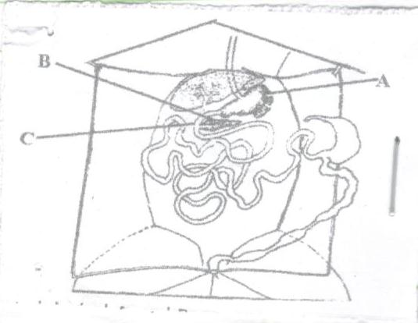
- i) Name the parts labeled A and B (2marks)
……………………………………………………………………………………………………………………………………………………………………………………………….
ii) How is the structure labeled A in the diagram adapted to carry out its function. (2marks)
………………………………………………………………………………………………
……………………………………………………………………………………………….
- i) Name the hormone secreted by the walls of the part labeled C (1mark)
……………………………………………………………………………………………….
ii) Explain the role of the hormone in b) (i) above in digestion. (3marks)
……………………………………………………………………………………………………………………………………………………………………………………………………………………………………………………………………………………………….
……………………………………………………………………………………………….
- In human beings a download pointed frontal hairline (“window peak”) is a heritable trait from an expression of recessive gene in a somatic cell. Use ‘W’ for a dominant gene.
- Determine the F1 generation if a homozygous peak male is married to a homozygous frontal hairlined female parent. (4marks)

- State two causes of variations. (2marks)
………………………………………………………………………………………………………………………………………………………………………………………………
- Name two sex linked genetic disorders that can affect both human females and males. (2marks)
………………………………………………………………………………………………………………………………………………………………………………………………
- A student set up an experiment using soaked and dry seeds as shown below
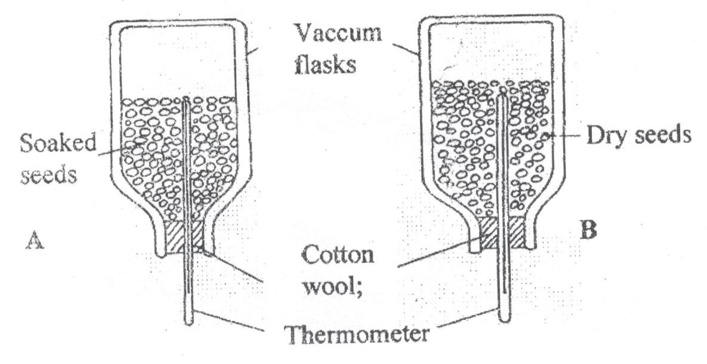
- State the objective of this experiment (1mark)
………………………………………………………………………………………………………………………………………………………………………………………………
- State the observations made in each of the flasks after 24 hours (2marks)
………………………………………………………………………………………………………………………………………………………………………………………………………………………………………………………………………………………………
- Account for the observation made in (b) above (2marks)
………………………………………………………………………………………………………………………………………………………………………………………………
- Suggest why vacuum flasks were used in this experiment. (1mark)
………………………………………………………………………………………………………………………………………………………………………………………………
- What alteration would you make in the set up to make the results more reliable (1mark)
………………………………………………………………………………………………………………………………………………………………………………………………
- Why should the seeds be washed with antiseptic 10% formalin? (1mark)
………………………………………………………………………………………………………………………………………………………………………………………………………………………………………………………………………………………………
- Shown below is a section through the mammalian nephron.
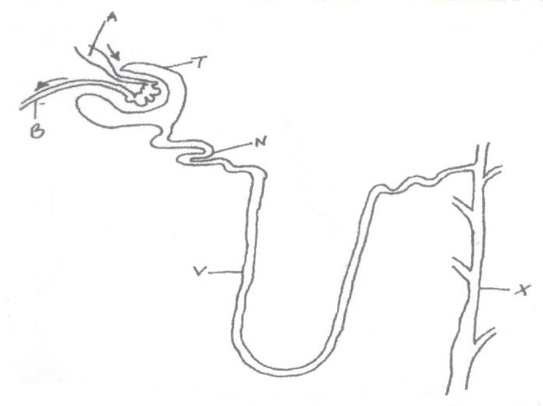

- Name the structures labeled A and N. (2marks)
……………………….………………………………………………………………………
- Name all the structures in a nephron which are normally present in the cortex region of a kidney (1mark)
………………………………………………………………………………………………………………………………………………………………………………………………
- Which region in a kidney deals with conservation of body water? (1mark)
………………………………………………………………………………………………
- Name one hormone that has an effect on part labeled X (1mark)
………………………………………………………………………………………………
- How is part labeled N adapted to its function. (3marks)
………………………………………………………………………………………………………………………………………………………………………………………………………………………………………………………………………………………………

- The diagram below represents a food web in a certain ecosystem.
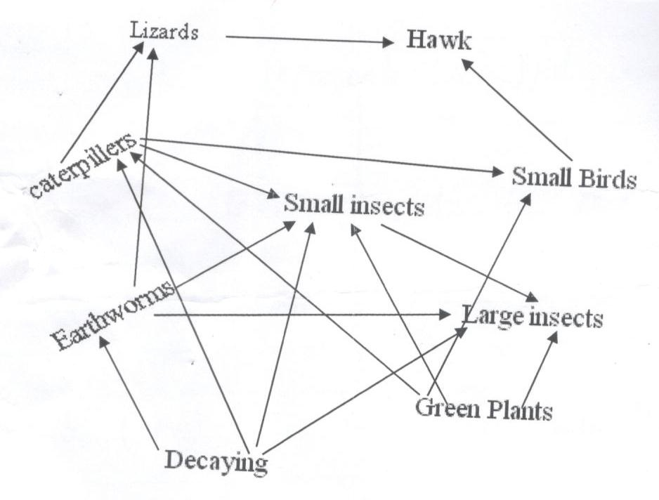
- Name the trophic level occupied by each of the following:
- Caterpillars (1mark)
………………………………………………………………………………………………
- Small insects (1mark)
………………………………………………………………………………………………
- From the food web, construct two food chains which end with lizards as tertiary consumer. (2marks)

- i) Which organisms have the least biomass in this ecosystem (1mark)
………………………………………………………………………………………………………………………………………………………………………………………………
ii) Explain the answer in (i) above. (3marks)

………………………………………………………………………………………………………………………………………………………………………………………………………………………………………………………………………………………………
………………………………………………………………………………………………………………………………………………………………………………………………
………………………………………………………………………………………………

SECTION B - (40 MARKS)
Answer Question 6 (Compulsory) and Either Question 7 Or 8 in The Spaces Provided After Question 8

- The relationship between oxygen concentration, sugar consumption and potassium ion uptake in isolated wheat roots was determined. The results obtained were tabulated as shown below. The loss of sugar and potassium uptake or gain are in arbitrary units.

 |  | Percentage oxygen in aerotun stream
 |  | 0 | 5 | 10 | 15 | 20 | 30 | 100
Sugar loss |  | 15 | 20 | 43 | 45 | 45 | 44 | 43
Potassium ion gain |  | 5 | 55 | 70 | 75 | 75 | 72 | 70

- Plot graphs of sugar loss and potassium ions gain against oxygen concentration on the same axes.

- i) Identify the process by which potassium ions is taken by the roots . (1mark)

………………………………………………………………………………………………………………………………………………………………………………………………
ii) Give reasons for your answer in b (i) above (3 marks)
………………………………………………………………………………………………………………………………………………………………………………………………………………………………………………………………………………………………
………………………………………………………………………………………………
- Account for sugar loss and potassium ions gain.
- 0% oxygen concentration (2 marks)
………………………………………………………………………………………………………………………………………………………………………………………………………………………………………………………………………………………………………………………………………………………………………………………………
………………………………………………………………………………………………

- Between 5% and 20% oxygen concentration (2 marks)
………………………………………………………………………………………………………………………………………………………………………………………………………………………………………………………………………………………………………………………………………………………………………………………………
………………………………………………………………………………………………
- Suggest two factors necessary for the above process apart from oxygen (2 marks)
………………………………………………………………………………………………
………………………………………………………………………………………………………………………………………………………………………………………………
- State two ways by which the process above can be stopped. (2 marks)
………………………………………………………………………………………………………………………………………………………………………………………………………………………………………………………………………………………………
- Name two main areas in a mammalian body where the above process occurs. (2 marks)
………………………………………………………………………………………………………………………………………………………………………………………………
7. Explain the various ways in which seeds and fruits are adapted to dispersal. (20 marks)
8. (a) Describe how the digestion of a protein is achieved in the following portions of the alimentary canal.
- Stomach (4 marks)
- Duodenum (4 marks)
(b) (i) Describe the process of absorption at the root hair to the xylem of the root. (8 marks)
(ii) Describe how temperature and light intensity affect the rate of transpiration. (4 marks)
………………………………………………………………………………………………………………………………………………………………………………………………………………………………………………………………………………………………
………………………………………………………………………………………………………………………………………………………………………………………………
………………………………………………………………………………………………………………………………………………………………………………………………
………………………………………………………………………………………………………………………………………………………………………………………………
………………………………………………………………………………………………………………………………………………………………………………………………
………………………………………………………………………………………………………………………………………………………………………………………………
………………………………………………………………………………………………………………………………………………………………………………………………
………………………………………………………………………………………………………………………………………………………………………………………………
………………………………………………………………………………………………………………………………………………………………………………………………
………………………………………………………………………………………………………………………………………………………………………………………………
………………………………………………………………………………………………………………………………………………………………………………………………
………………………………………………………………………………………………………………………………………………………………………………………………
………………………………………………………………………………………………………………………………………………………………………………………………
………………………………………………………………………………………………………………………………………………………………………………………………
………………………………………………………………………………………………………………………………………………………………………………………………
………………………………………………………………………………………………………………………………………………………………………………………………
………………………………………………………………………………………………………………………………………………………………………………………………
………………………………………………………………………………………………………………………………………………………………………………………………
………………………………………………………………………………………………………………………………………………………………………………………………
………………………………………………………………………………………………………………………………………………………………………………………………
………………………………………………………………………………………………………………………………………………………………………………………………
………………………………………………………………………………………………………………………………………………………………………………………………
………………………………………………………………………………………………………………………………………………………………………………………………
………………………………………………………………………………………………………………………………………………………………………………………………
………………………………………………………………………………………………………………………………………………………………………………………………
………………………………………………………………………………………………………………………………………………………………………………………………
………………………………………………………………………………………………………………………………………………………………………………………………
………………………………………………………………………………………………………………………………………………………………………………………………
………………………………………………………………………………………………………………………………………………………………………………………………
………………………………………………………………………………………………………………………………………………………………………………………………
………………………………………………………………………………………………………………………………………………………………………………………………
………………………………………………………………………………………………………………………………………………………………………………………………
………………………………………………………………………………………………………………………………………………………………………………………………
………………………………………………………………………………………………………………………………………………………………………………………………
………………………………………………………………………………………………………………………………………………………………………………………………
………………………………………………………………………………………………………………………………………………………………………………………………
………………………………………………………………………………………………………………………………………………………………………………………………
………………………………………………………………………………………………………………………………………………………………………………………………
………………………………………………………………………………………………………………………………………………………………………………………………
………………………………………………………………………………………………………………………………………………………………………………………………
………………………………………………………………………………………………………………………………………………………………………………………………
………………………………………………………………………………………………………………………………………………………………………………………………
………………………………………………………………………………………………………………………………………………………………………………………………
………………………………………………………………………………………………………………………………………………………………………………………………
………………………………………………………………………………………………………………………………………………………………………………………………
………………………………………………………………………………………………………………………………………………………………………………………………
………………………………………………………………………………………………………………………………………………………………………………………………
………………………………………………………………………………………………………………………………………………………………………………………………
………………………………………………………………………………………………………………………………………………………………………………………………
………………………………………………………………………………………………………………………………………………………………………………………………
………………………………………………………………………………………………………………………………………………………………………………………………
………………………………………………………………………………………………………………………………………………………………………………………………
………………………………………………………………………………………………………………………………………………………………………………………………
………………………………………………………………………………………………………………………………………………………………………………………………

