MARKING SCHEME
ARISE AND SHINE TRIAL 1 EXAM
MARCH /APRIL - 2020
BIOLOGY - PAPER 2

- a) i) A - stomach;
B - Pancreas;

ii) (Stomach wall) is made of thick circular and longitudinal layers of muscles; which contract and relax producing movements that mix contents of stomach/churning;

b) i) Cholecystokinin
ii) Cholecystokinin – it stimulates the secretion of bile from the gall bladder; bile contains bile salts / sodium glycocholate and sodium taurocholate; emulsify fats into tiny fat droplets; (3marks)

- a)
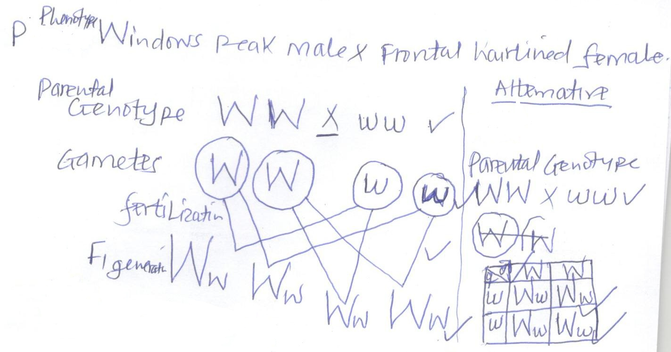
- Rej. If P genotype lack X
- Rej. If gametes are not completely circled; fusion lines must be continuous.

b) – crossing over during prophase I
- Fertilization
- Mutation
c) - Colour blindness
- Hemophilia
- (a) To show that soaked seeds produce heat when they respire;

(b) In flask A there was increase in thermometer reading; and in flask B there was no noticeable increase in thermometer reading /thermometer remained constant;

(c) In flask (A) soaked seed respire aerobically to produce heat energy which raised the temperature /thermometer reading;

(d) Vacuum flasks do not allow heat to enter or leave;

(e) Flasks should be filled with seeds to ensure that the bulb is covered;

(f) To kill bacteria / micro-organisms which would otherwise respire, giving wrong results.

- a) A – afferent arteriole
N – Proximal convoluted tubule (2marks)

b) Bowman’s capsule, proximal convoluted tubule, distal convoluted tubule. (2marks)
c) Loop of Henle (1 mark)
d) Antidiuretic hormone /vasopressin
e) i) cell lining tubule have numerous mitochondria which provide energy for reabsorption .
ii) Tubule lining have micro villi to increase surface area; for reabsorption.
iii) Tubule long / highly coiled to increase surface area;
iv) coiling of tubule reduce speed of flow of filtrate to allow more time for efficient reabsorption;
v) Tubule is well supplied with blood capillaries for efficient transportation / reabsorption.
(Any 3 = 3 marks)

- a) i) Primary consumer;
ii) Primary consumer / secondary consumer;

b) Green plants Caterpillars small insects lizards
Green plants small birds hawk lizards

- Scale - 1
Axes labeling - 1
Plotting – 2
Curves (smooth –1)
Labeling of curves – 1
6

b) i) Active transport;

ii) Oxygen is necessary for respiration and when it is low; the rate of uptake of potassium ion is very low; since active transport need energy;

c) i) Potassium ion intake is low when oxygen is 0%
- Because there is no energy for the process. Sugar as substance not broken down to release energy for active transport due to lack of oxygen.

ii) Potassium ion uptake is increasing to the max due to optimum amount of energy
- Sugar loss is also increasing because it is used as substrate. Due to oxygen concentration.
d) Presence of carriers; optimum pH for respiratory availability of glucose; optimum temperature for respiratory enzyme; presence of coenzymes or cofactors;
e) Treating the roots with metabolic poison;
- Subjecting the roots to extremely low temperatures or extremely high temperature.
f) Selective re absorption of glucose mineral ions in the kidneys;
- Transmission of nervous impulses;
- Explain the various ways in which seeds and fruits are adapted to dispersal. (20 marks)

- Wind – dispersed seeds / fruits are light and small; to be carried by air currents / wind;
- Some seeds /fruits have developed hair like structures ; feather like projections ; wing like structures to increase their surface area; to be blow or carried away about by wind NB mark surface area once
- Open capsules; borne on long stalks; which are swayed by the wind scattering the seeds; acc perforated for for open water.
- Dispersed seeds / fruits are also light to float on water;
- Some fruits like coconut have fibrous spongy mesocarps ; to trap air; making them buoyant /to float on water
- Others like the water lily whose seed coats trap air bubbles; making them float on water;
- Have water proof seed Testa /pericarp / remain afloat without soaking /sinking ; (immediately they are released from parent plants)
- Dispersed fruits (rej seeds) have developed hooks; to stick on the fur of passing animals acc. Hook like structures.
- In some cases, fruits are succulent /fleshy/ juicy; brightly colored; scented/sweet aroma; large /borne on clusters; to attract animals and birds.
- The seed coats of some seeds are hard; have mucoid secretions; and resistant to the digestive enzymes; hence passed out through the gut undigested;
- Self-dispersal /explosive mechanisms fruits have shutters /lines of weakness; which split or open when dry scattering the seeds.

- a) i) stomach
Pepsin; acts on proteins to polypeptides; renin acts on milk protein caseinigens to casein; this occurs in acidic medium.

ii) Trypsin; in pancreatic juice; hydrolyzes polypeptides molecules; in alkaline conditions provided by bile juice.

b) i) the root hair cell sap is hypertonic to the soil water; water from the soil moves into the root hair cell sap by osmosis; this makes the cell sap hypotonic/ dilute; compared to hypertonic adjacent cortex cells; water moves into the cortex cells by osmosis; till it reaches the casparian layer; which pumps water into the xylem of the root; this is called the root pressure;

ii) Increase in temperature causes evaporation of water into the intercellular airspace of the leaf; this makes water vapor from the adjacent cells to move into the stoma; creating diffusion gradient deficit between the atmosphere and intercellular space increased transpiration;

Increase in light intensity; increase rate of photosynthesis; leading to opening of the stomata which leads to increased transpiration.

