FORM 4
231/2
BIOLOGY PAPER 2
MARKING SCHEME
1. a) Incomplete dominance
b) Presence of a different colour from the two there is blending of colours and none of the two Red and White is dominant.
c) i) Parental phenotype pink × pink
Parental genotype RW × RW

W
R
W
R

WW
RW
RW
RR

1 white
2 pink
1Red

ii) $\frac{2}{4}$ x 1600 = 800plants
$¼$ x 1600 = 400 plants

2. a) Tertiary consumer / quaternary consumer
b) i) Land plants Insects Lizards Snakes Hawks
ii) Land plants Insects Lizards Hawks
c) - There will be an increase in the number of birds
- There will be an increase in the number insects
- There will be an increase in the number of lizards
d) Insects

3. a) Positive feedback mechanism
b) - Excess glucose converted glycogen and stored in liver cells.
- Glucose oxidized to release energy
- Some glucose converted to fats and stored in a dispose tissue
c) i) Pancrease
Liver
ii) - To avoid fluctuation in osmotic pressure which can affect function
- For glucose to be enough for respiration
d) Maintaining of constant internal osmatic pressure.

4. a) Capture – recapture
b) - line – transect method
- belt – transect method
- Quadrat
c) P = 1st capture x second capture
Marked recaptured

= 50 x 90
25
= 180 fish
d) - no immigration or emigration of organisms
- There is free mixing of organisms within the period of study
- The population does not vary within the period of study due to death or birth.
- The markings do not come off or affect the behavior of the organism
- The time period is enough for the organisms to mix uniformly.

5. a) i)
Skeletal muscles Smooth muscles
  - Are striated - Non striated
  - Has elongated cells - has spindle – shaped cells
  - Multi nucleated - uninucleated
(2x1 = 2marks)
ii) Biceps / muscle B relax / flex while
Triceps / muscles A contract/ extend the arm stretches.

b) i) It is made up of several fused sacral vertebrae to form arigid structure making it firm and strong.
ii) Strong and firm to support body weight and spread it to the legs through the pelvic gridle
iii)
- Fused vertebrae to form rigid structures which are strong and firm to bear body weight.
- First anterior sacral vertebrae have wing like transverse process fused to the pelvic girdle.
- Large broad centrum to offer support to body weight
- Reduced neural spine for muscle attachment
- Narrow neural canal for passage of spinal cord.
Mark first Two correct answers.

6. a)
Scale on X and Y axis = 2marks
Labeling of axis = 1mark
Plotting of points = 1mark
Curve be drawn using free hand = 1mark

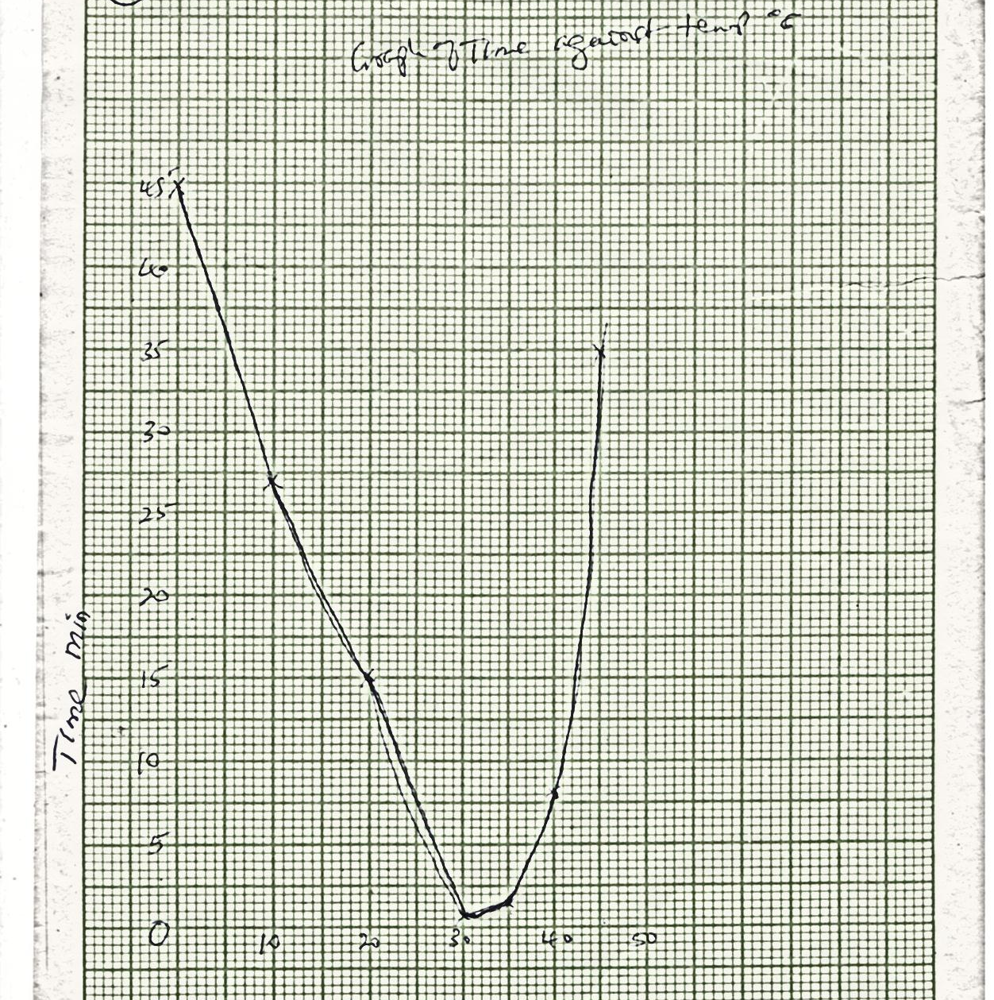

b) 37⁰c ± 0.5
c) i) at 50c – The time taken is long; temperature too low / way below optimum; enzymes are inactive.
ii) The time taken is long since most enzymes are denatured since temperature is above optimum.
d) Substrate concentration; presence of inhibitors PH range; presence of co-enzyme and co-factors (award any Two correct answers).
e) Consider the point where aline from 15⁰c meets the curve, determine the time in minutes divide the time in minutes by the temperature at that point. All the above be shown on the curve
Time in minutes at 15⁰c = 20.5
20.5min / 15⁰c = 1.367 or 1.4
f) Enzyme salivary amylase works in slightly alkaline medium; acidic PH in stomach denatures enzymes
g) Pancreatic Juice
Salivary amylase enzyme
h) HCl neutralizes bicarbonate / pancreatic salts / acid chime from the stomach denatures the pancreatic enzymes.
7.
a) The ear pinna is made up of skin and cartilage and is funnel shaped; it receives and collects sound waves into the auditory meatus; Auditory meatus / ear tube – a cana that is lined with hairs and wax; it allows passage of sound waves to the middle ear; the wax traps dust particles entering into the ear; it also maintains flexibility of the ear drum; the ear drum / tympanic membrane: with a thin tough membrane that covers the external opening of the middle ear; it vibrates when it is hit by sound waves and transforms sound waves into vibrations; passes vibrations into the ear ossicles: Ear ossicles: has stapes, malleur and incus: three ossicles form a system of levers which amplifies and transmits the vibrations to the oval window; oval window: a thin flexible membrane opening into the cochlea. It receives vibrations from the ossicles and passes them to the inner ear;
The cochlea is a spirally shaped tube filled with endolymph and perilymph; it has sensory cell for hearing; the semicircular canals; consists of three cavities containing endolymph; maintains body balance and posture in relation to movement of the head;
The vestubes – consists of utriculus and sacculus which contain sensory cells; mainstrain body balance and posture in relation to gravity;
Eustachian tube; tube connecting the middle ear with the pharynx; equalizes air pressure between the middle ear and the outer ear thus preventing distortion of the eardrum;
Any correct first 10 points.
b) i)
- Homologous structures e.g. pentadactyl limb in different vertebrates have bones arranged in similar pattern / basic plan but have been modified to perform different functions e.g. digging in males / grasping in monkey; these indicates organisms have common ancestry;
- Analogous structures e.g. wings of birds and insects; these structures have different embryonic origin but are modified to perform similar functions;
- Vestigial structures; some structures become reduced in size over long time and become functionless these are the vestigial structures e.g. caecum and appendix / coccyx in humans; presence of these structures indicates vertebrates have a common ancestry;
ii) Geographical distribution
- Present day continents are though to have been one large landmass / joined together; this allowed free migration of animals in the land mass;
- Continental drift led to isolation; led to different patterns of evolution; such that animals occupying the same climatic zones in different continents are different. E.g. Liamas of South America and camels of Africa; lions of Africa and Tiger of Asia / malsuoials are unique to Australia;
8.
a) Pollution is the release of chemical/substance / forms of energy into the environment by human activities in amounts which are harmful to human health or other organisms.
b) i) Causes of Water Pollution
- Poisonous chemicals like mercury, lead, and silver discharged into water bodies.
- Heated water from industrial plants
- Toxic chemicals used in agriculture such as insecticides, fungicides, nitrogenous and phosphorous fertilizers
- Untreated sewage a.-id domestic refuse discharged into water.
- Oil from tankers and ship
- Soil eroded by running water
ii) Effect to plants and animals
- Toxic chemicals kill organisms, some are non-biodegradable therefore accumulate along food chain/undergo bio magnifications.
- Mercury limit transport of oxygen by occupying space occupied by hemoglobin in red blood cells
- Heated water expels dissolved oxygen causing suffocation of aquatic organisms.
- Nitrogenous wastes and sewage promote rapid growth of aquatic weeds which result into eutrophication
- Sewage contains pathogenic micro - organisms like Escherichia coli which contaminate drinking water and cause animal diseases.
- Oil floating on water reduce the amount of dissolved air which cause death.
- Eroded soil make water turbid, hindering photosynthesis in aquatic weeds and unfit for consumption
iii) Methods of controlling water pollution.
- Recycling industrial wastes before releasing into water ways.
- Use of biological methods instead of chemical methods.
- Encourage the use unleaded petrol
- Public should be educated on correct amounts of organic fertilizers and pesticides to be used.
- Building of gabions, terraces, mulching and growing of soil cover crops to reduce soil erosion.
- Impose fines on ships and industries discharging oil and chemicals into water.
- Proper treatment and disposal of sewage. There should be separate systems for disposal of sewage and drinking water

