NAME________________________________________INDEX NO ___________________
SCHOOL__________________________ CANDIDATE’S SIGN ____________________ DATE _____________________

231/1

BIOLOGY
Paper 1
Time: 2 Hours.

ARISE AND SHINE TRIAL 1 EXAM
MARCH/APRIL - 2020

Instructions
- Write your name, Index Number and School in the spaces provided above.
- Sign and write the date of the examination in the spaces provided above.
- Answer all the questions in the spaces provided.
- Additional pages must not be inserted.
- Check the question paper to ascertain that all the pages are printed and that no questions are missing.

FOR EXAMINER’S USE ONLY
Question | Maximum Score | Candidate’s Score
1-27 | 80

- State the function of the diaphragm in a light microscope. (1mark)
………………………………………………………………………………………………………………………………………………………………………………………………
- State the function of the following cell organelles
- Centriole (1mark)
………………………………………………………………………………………………………………………………………………………………………………………………
- Golgi bodies (1mark)
………………………………………………………………………………………………………………………………………………………………………………………………
- Study the graph below.
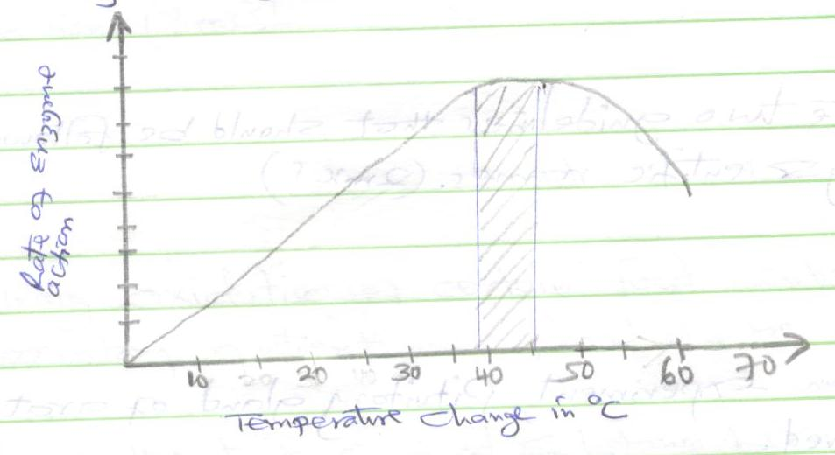
Account for the rate of reaction at:
- 10^{O} C (2marks)
………………………………………………………………………………………………………………………………………………………………………………………………………………………………………………………………………………………………
- 50^{O} C (2marks)
………………………………………………………………………………………………………………………………………………………………………………………………………………………………………………………………………………………………
- Strips were cut lengthwise from the stem of a herbaceous plant and placed in a salt solution for 30 minutes as shown below. 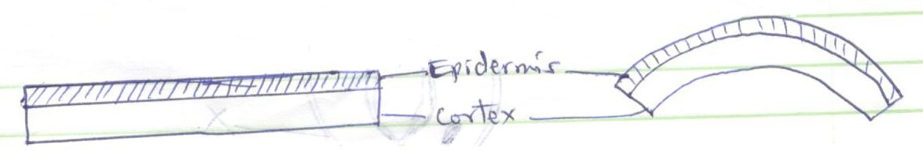
Account for the results obtained when the strip was placed in the salt solution. (4marks)
………………………………………………………………………………………………………………………………………………………………………………………………………………………………………………………………………………………………………………………………………………………………………………………………
………………………………………………………………………………………………
- (i) Name the main products of the dark stage of photosynthesis. (1mark)
………………………………………………………………………………………………………………………………………………………………………………………………
(ii) State the importance of chlorophyll in photosynthesis. (1mark)
………………………………………………………………………………………………………………………………………………………………………………………………
- State the two guidelines that should be followed when typing scientific names. (2marks)
………………………………………………………………………………………………
………………………………………………………………………………………………
- In an experiment, Pituitary gland of a rat was removed.
- State the effect this will have on the quantity of urine produced by the rat. (1 mark)
………………………………………………………………………………………………………………………………………………………………………………………………
- Give a reason for your answer in (a) above. (1mark)
………………………………………………………………………………………………………………………………………………………………………………………………
- The diagram below shows part of a plant.
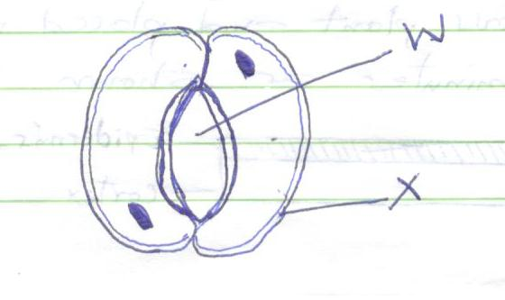
- Name the cell labelled X and part labelled W. (2marks)
X …………………………………………………………………………………
W …………………….…………………………………………..……………….
- State two adaptations of cell labeled X to its function (2marks)
………………………………………………………………………………………………………………………………………………………………………………………………
- Explain why a baby loses more heat per unit weight than an adult when exposed to the same environmental conditions. (2marks)
………………………………………………………………………………………………………………………………………………………………………………………………………………………………………………………………………………………………………………………………………………………………………………………………
- During oxidation of certain food substances, the respiratory quotient was found to be 0.718.
- Name the type of food substance being oxidized. (1mark)
………………………………………………………………………………………………
- State two advantages of using the food substances named. (2marks)
………………………………………………………………………………………………………………………………………………………………………………………………
- Name two structures used for gaseous exchange in plants. (2marks)
………………………………………………………………………………………………………………………………………………………………………………………………
- The diagram below shows the exchange of gases in alveolus.
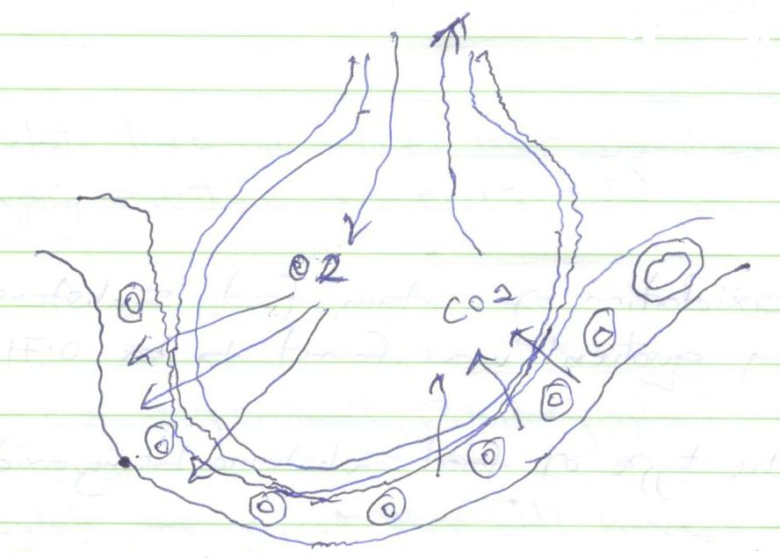
- State how the alveoli are adapted for their function. (3marks)
………………………………………………………………………………………………………………………………………………………………………………………………………………………………………………………………………………………………………………………………………………………………………………………………
- Name the cell labeled A (1mark)
………………………………………………………………………………………………
- During germination and early growth, the weight of the endosperm decreases while that of the embryo increases. Explain (2marks)
………………………………………………………………………………………………………………………………………………………………………………………………………………………………………………………………………………………………………………………………………………………………………………………………
- a) What is the importance of metamorphosis? (1mark)
………………………………………………………………………………………………………………………………………………………………………………………………
- Give an example of insect that undergoes :
- complete metamorphosis (1mark)
………………………………………………………………………………………………
- incomplete metamorphosis (1mark)
………………………………………………………………………………………………
- Define the following terms used in ecology
- biosphere (1mark)
………………………………………………………………………………………………………………………………………………………………………………………………
- population (1mark)
………………………………………………………………………………………………………………………………………………………………………………………………
- synecology (1mark)
………………………………………………………………………………………………………………………………………………………………………………………………
- carrying capacity (1 mark)
………………………………………………………………………………………………………………………………………………………………………………………………
- The paddles of whales and the fins of fish adapt these organisms to aquatic habitats.
- Name the evolutionary process that may have given rise to these structures. (1mark)
………………………………………………………………………………………………

- What is the name given to such structures? (1 mark)
………………………………………………………………………………………………………………………………………………………………………………………………
- Give two examples of vestigial organs in man. (1 mark)
………………………………………………………………………………………………………………………………………………………………………………………………
- a.) Define polyploidy (1 mark)
………………………………………………………………………………………………………………………………………………………………………………………………
b.) Name three disorders resulting from gene mutations. (3marks)
………………………………………………………………………………………………………………………………………………………………………………………………………………………………………………………………………………………………
- State the importance of sexual reproduction. (2marks)
………………………………………………………………………………………………………………………………………………………………………………………………………………………………………………………………………………………………
- The diagram below shows part of a food relationship in an ecosystem.

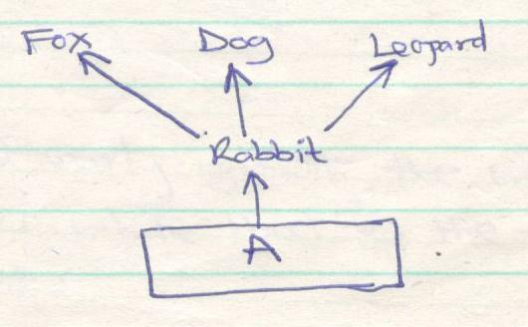
- Name the food relationship shown in the diagram. (1mark)
………………………………………………………………………………………………
- Name the trophic level occupied by organism A. (1mark)
………………………………………………………………………………………………
- What is the main source of energy in the ecosystem shown in the diagram above? (1mark)
………………………………………………………………………………………………
- Name three supportive tissues in plants. (3marks)
- …………………………………………………………………………………..
- ………………………………………………………………………………….
- …………………………………………………………………………………
- A form one student trying to estimate the size of onion cells observed the following on the microscope’s field of view.

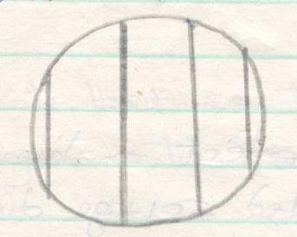
- Explain the resolving power of a microscope. (1mark)
………………………………………………………………………………………………………………………………………………………………………………………………
………………………………………………………………………………………………
- If the student counted 20 cells across the field of view calculate the size of one cell in micrometers. (2marks)

- Below is a nucleic acid strand.

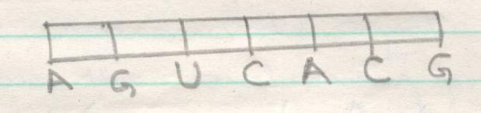
- Name the nucleic acid. (1 mark)
………………………………………………………………………………………………
- Explain the reason of your answer in (a) above. (1mark)
………………………………………………………………………………………………………………………………………………………………………………………………
………………………………………………………………………………………………

- a) Explain three ways in which a red blood cell is adapted to its function .(3marks)
………………………………………………………………………………………………………………………………………………………………………………………………
………………………………………………………………………………………………………………………………………………………………………………………………
………………………………………………………………………………………………
………………………………………………………………………………………………
b) In which form is carbon (IV) oxide transported. (1mark)
………………………………………………………………………………………………
- Explain the likely effect on humans and other organisms of untreated sewage discharge into water body that supplies water for domestic use. (3marks)
………………………………………………………………………………………………………………………………………………………………………………………………………………………………………………………………………………………………
………………………………………………………………………………………………
………………………………………………………………………………………………
………………………………………………………………………………………………
- Below are cross sections of two fruits. Study them and answer the questions that follow.
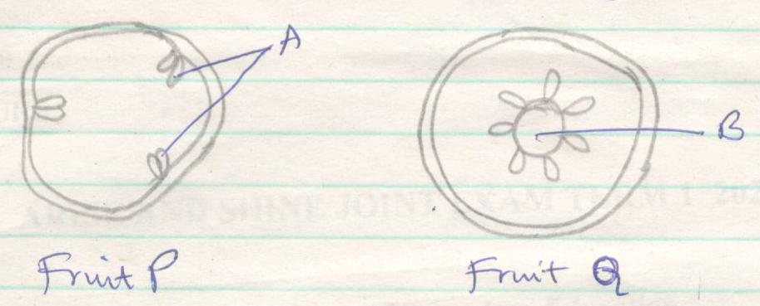
- Name the parts labeled
A…………………………………………………………………………… (1 mark)
B…………………………………………………………………………… (1 mark)

- Name the type of placentation in fruit. (2marks)
P……………………………………………………………...………………………….
Q…………………………………………………………………...……………………

- a) Differentiate between hypogeal germination and epigeal germination. (2marks)
………………………………………………………………………………………………………………………………………………………………………………………………
………………………………………………………………………………………………
………………………………………………………………………………………………
b) Explain two causes of dormancy in seed. (2 marks)
………………………………………………………………………………………………………………………………………………………………………………………………
………………………………………………………………………………………………
………………………………………………………………………………………………
- Identify two divisions in the kingdom plantae that show alternation of generations. (2marks)
………………………………………………………………………………………………………………………………………………………………………………………………
………………………………………………………………………………………………
………………………………………………………………………………………………

