NAME …………………………….. INDEX NO. ……..…CLASS …
2020 FORM 4 TERM 1 ENTRY EXAMS

231/2
BIOLOGY
Paper 2

Instructions to candidates
- Write your name and admission number in the spaces provided above
- Sign and write the date of examination in the spaces provided above
- This paper consists of two sections; A and B
- Answer all the questions in section A in the spaces provided
- In section B answer question 6 (compulsory) and either question 7 or 8 in the spaces provided after question 8.
- This paper consists of 12 printed pages
- Candidates should check the question paper to ascertain that all the pages are printed as indicated and that no questions are missing.

Section | Questions | Maximum  Score | Candidate’s Score
A | 1 | 8
 | 2 | 8
 | 3 | 8
 | 4 | 8
 | 5 | 8
B | 6 | 20
 | 7 | 20
 | 8 | 20
 | Total Score | 80

SECTION A
1. The diagram below represents a feeding relationship in an ecosystem.
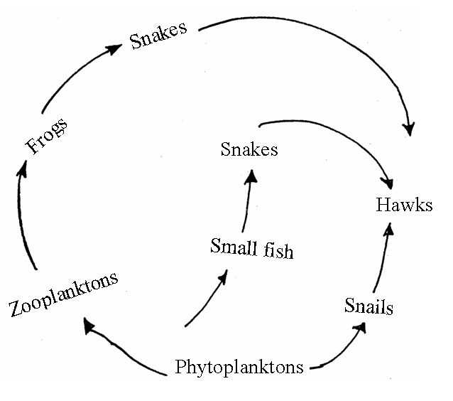
(a) Name the type of ecosystem represented by the above food web. (1mk)
………………………………………………………………………………………
(b) Name the organisms in the food web that
(i) Are producers (1mk)
………………………………………………………………………………………………
(ii) Occupies the highest trophic level (1mk)
………………………………………………………………………………………………
c) (i) Write a food chain that ends with the hawk as quaternary consumer. (1mk)
…………………………………………………………………………………………
ii) State two short term effects on the above ecosystem if all the small fish were killed .
………………………………………………………………………………………………
…………………………………………………………………………………… (2mks)

d) How does oil spills lead to death of fish. (1mk)
………………………………………………………………………………………………
e) Name one other cause of water pollution apart from oil spills. (1mk)
………………………………………………………………………………………………………
………………………………………………………………………………………………………
2. Study the flow chart below of a process that takes place in both plants and animals.
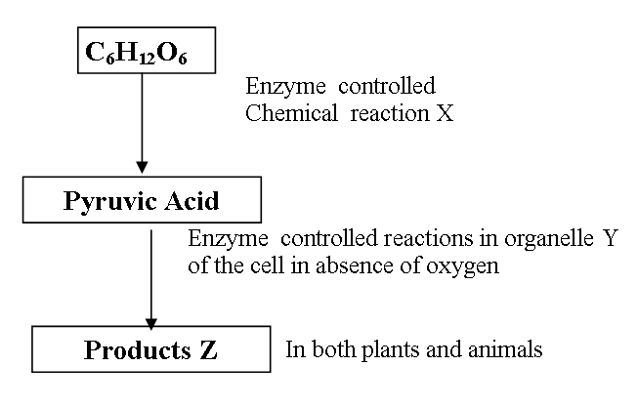
a) Name the above process. (1mk)
………………………………………………………………………………………………
b) (i) In the above process name the chemical reaction represented by X. (1mk)
………………………………………………………………………………………………
(ii) Name the part of the cell where the enzyme controlled reactions in b (i) above takes place. (1mk)
………………………………………………………………………………………………
(c) Name the products Z in
i) Plants (1mk)
………………………………………………………………………………………………
ii) Animals (1mk)
……………………………………………………………………………………………………....
(d) What would be the fate of pyruvic acid if oxygen supply is availed in the mitochondria of an animal cell (2mks)
……………………………………………………………………………………………………....
............................................................................................................................................................
e) What is meant by the term oxygen debt? (1mk)
………………………………………………………………………………………………………
………………………………………………………………………………………………………
- The diagram below represents human foetus in a uterus.
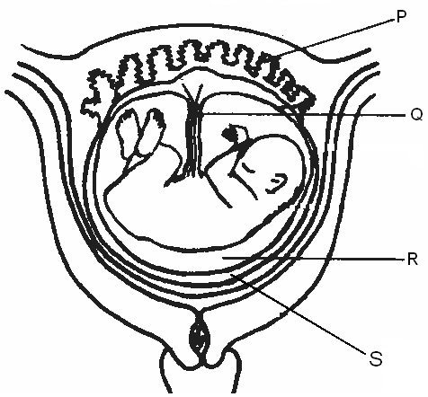

(a)Name the part labeled S. (1 mk)
………………………………………………………………………………………………
(b) (i) Name the types of blood vessels found in the structure labeled Q. (2mks)
………………………………………………………………………………………………

………………………………………………………………………………………………
(ii) State the differences in composition of blood in the vessels named in (b)(i) above (2mks) ………………………………………………………………………………………………
…………………………………………………………………………………………………
…………………………………………………………………………………………………
…………………………………………………………………………………………………
(c) Name two features that enable the structure labeled P carry out its function. ( 2mks) …………………………………………………………………………………………………

………………………………………………………………………………………………………

………………………………………………………………………………………………………
(d) State the role of the part labeled R. (1mk)
………………………………………………………………………………………………………
………………………………………………………………………………………………………

- The table below shows the concentration of sodium and iodine ions in pond water and in the cell sap of water lettuce plant.

 | Sodium ion concentration | Iodine ion concentration
Pond water | 180 | 0.4
Cell sap | 90 | 500

  - Giving reasons, name the process through which each of the ions is taken up by the plant.
- Sodium ion. (2mks) ………………………………………………………………………………………

………………………………………………………………………………………

- Iodine ion. (2 mks)
………………………………………………………………………………………

……………………………

(b) The lettuce plant was then treated with a chemical substance that inhibits the synthesis of ATP. Giving reasons, state which ion uptake was affected by the treatment. (2 mks)
………………………………………………………………………………………………………
………………………………………………………………………………………………………
………………………………………………………………………………………………………
(c) Explain why fresh water fish cannot survive in marine habitat. (2 mks)
………………………………………………………………………………………………………
………………………………………………………………………………………………………
………………………………………………………………………………………………………
5. The equation bellows shows a chemical reaction that takes place in green plants under certain conditions
Carbon (IV) Oxide + Water Glucose + X
(a) Name the; (2mks)
(i) Substance represent by X ……………………………………………………………………………………………….
(ii) Process represented by the equation
………………………………………………………………………………………………
(b) Other than the reactants, state two conditions necessary for this reaction to occur. (2mks)
………………………………………………………………………………………………
………………………………………………………………………………………………
c) Name three types of cells in which the process occurs (3mks)
………………………………………………………………………………………………………
………………………………………………………………………………………………………
………………………………………………………………………………………………………
d)State one factor that affect the process named in a)(ii) above (1mark)

SECTION B
6. A group of students carried out a study of the population growth of flour weevils. They put16grams and 64 grams of maize flour into two equal boxes K and L respectively. They then introduced equal numbers of weevils into the boxes. The boxes were kept under similar environmental conditions. The weevils were counted at intervals and the results recorded in the table below.
No. of days after introduction of weevils | Approximate No. of weevils present
 | K | L
0 | 20 | 20
5 | 20 | 20
40 | 200 | 300
60 | 550 | 800
80 | 560 | 1300
100 | 650 | 1750
120 | 640 | 1750
135 | 650 | 1740
150 | 645 | 1748

(a) Using a suitable scale, draw two graphs on the same axes from the results in the table. Plot approximate number of weevils present on the Y – axis. (8mks)

(b) What were the approximate numbers of weevils present in the two boxes on the 70th day.
(2mks)
Number in K……………………………………………………………………………………….
Number in L…………………………………………………………………………………
(c) (i) On the what day was the population of weevils in K 580. (1mk)
………………………………………………………………………………………………
……………………………………………………………………………………………..
(ii) Between which days was the population difference greatest. (1mk)
……………………………………………………………………………………………
……………………………………………………………………………………………
(d) Account for the shape of graph L between day 5 and day 100. (4mks)
………………………………………………………………………………………………
………………………………………………………………………………………………
………………………………………………………………………………………………
………………………………………………………………………………………………
(e) State factors that would make the human species assume the graph curve between
day 100 and day 150. (4mks)
…………………………………………………………………………………………………….
……………………………………………………………………………………………………..
…………………………………………………………………………………………………….
……………………………………………………………………………………………………..

7. Describe how the human male reproductive system is adapted to perform its function. (20mks)
8. a)Define transpiration (1mark)
b)Give THREE types transpiration (3mark)
c)Describe EIGHT factors that affect the rate of transpiration (16marks)
………………………………………………………………………………………………………
………………………………………………………………………………………………………
………………………………………………………………………………………………………
………………………………………………………………………………………………………
………………………………………………………………………………………………………
………………………………………………………………………………………………………
………………………………………………………………………………………………………
………………………………………………………………………………………………………
………………………………………………………………………………………………………
………………………………………………………………………………………………………
………………………………………………………………………………………………………
………………………………………………………………………………………………………
………………………………………………………………………………………………………
………………………………………………………………………………………………………
………………………………………………………………………………………………………
………………………………………………………………………………………………………
………………………………………………………………………………………………………
………………………………………………………………………………………………………
………………………………………………………………………………………………………
………………………………………………………………………………………………………
………………………………………………………………………………………………………
………………………………………………………………………………………………………
………………………………………………………………………………………………………
………………………………………………………………………………………………………
………………………………………………………………………………………………………
………………………………………………………………………………………………………
………………………………………………………………………………………………………
………………………………………………………………………………………………………
………………………………………………………………………………………………………
………………………………………………………………………………………………………
………………………………………………………………………………………………………
………………………………………………………………………………………………………
………………………………………………………………………………………………………
………………………………………………………………………………………………………
………………………………………………………………………………………………………
………………………………………………………………………………………………………
………………………………………………………………………………………………………
………………………………………………………………………………………………………
………………………………………………………………………………………………………
………………………………………………………………………………………………………
………………………………………………………………………………………………………
………………………………………………………………………………………………………
………………………………………………………………………………………………………
………………………………………………………………………………………………………
………………………………………………………………………………………………………
………………………………………………………………………………………………………
………………………………………………………………………………………………………

