Marking scheme
BIO PP2 2020 FORM 4 TERM 1 ENTRY EXAMS

1. Aquatic;
(b) (i) Phytoplanktons;
(ii) Hawks;
(c) (i) Phytoplanktons Zooplanktons Frogs Snakes Hawks;
(Reject if arrow is not indicated)
(ii) Snakes would decrease due to less food;
Zooplanktons would increase due to fewer predators;
(d) - Oil clogs fish gills;
- Oil cuts off dissolved oxygen in water leading to suffocation;
(Accept any one right)
(e) - Domestic wastes and sewage;
- Silting;
- Industrial effluents;
- Agro – chemicals;
(Accept any one right)
2. (a) Anaerobic respiration;
(Reject respiration alone)
(b) (i) Glycolysis;
(ii) Cytoplasm;
(c) (i) Alcohol/ ethanol, carbon IV oxide and energy;
(Reject if only one product is given) + Energy
(ii) Lactic acid, energy
(d) Pyruvic acid will be further oxidized by oxygen (in a series of enzymatic reactions/ Kreb’s
Cycle) into carbon IV oxide, water and energy;
(Reject if all products are not mentioned)
(e) The amount of oxygen required to get rid of the lactic acid that accumulates in the body
tissues when supply of oxygen is less than demand
3. a) chorion
(b) (i) umbilical vein; umbilical artery
(ii) More food nutrients and more oxygen in veins;; less food nutrients more excretory products in the arteries.
(c) Highly vascularised/large surface area
Presence of secretory cells;
(d) cushions/absorbs shock
4.(a) (i) Diffusion; because its uptake occurs according to the concentration gradient.
(ii) active transport; because its uptake occurs against concentration gradient;
(b) Iodine; its uptake depends on energy derived from ATP;
(c) This is because the fresh water fish would lose water molecules to the marine habitat since the marine environment is hypertonic

5. (a) (i) Oxygen
ii) Photosynthesis (2mks)
b) - Presence of light ;
- Presence of chlorophyll;
- Presence of suitable temperature ; Mark 1st (2mks)
c) - Palisade cells;
- Guard cells;
- Spongy mesophyl l cells;
d) -Avoilability of water
-Carbon (iv)oxide concentration
-Temperature
-Availability of water
6.
Axes -2
Curve- 2
Curve labelling-2
Scale -2
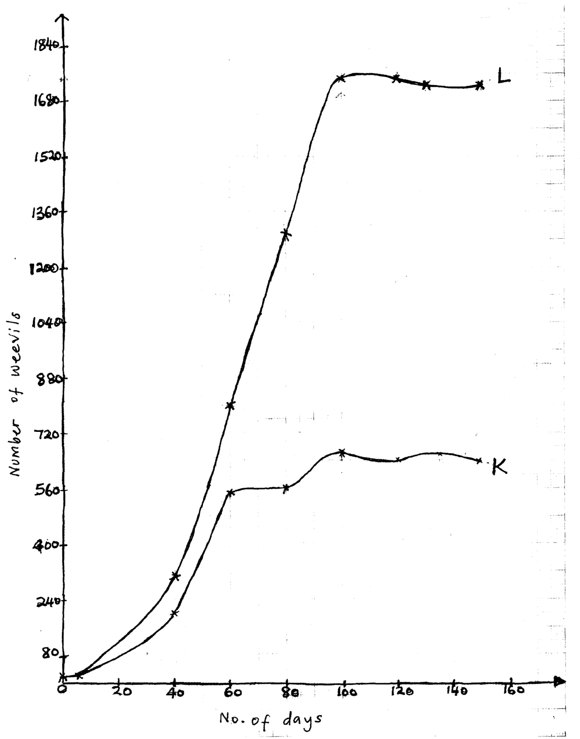

b) K- 555
L - 1020
c) (i) 86th Day
(ii) 100 - 120
d) Increase in population ; because there is adequate food ; the number of reproducing individuals is increasing ; wastes products have not accumulated to toxic levels;
e) - Diseases
- Lack of food
- Death rate equal to birth rate

7. - -The testes found outside the body; to provide a cooler environment for sperm production;
- Scrotal sacs suspend the testes outside the body cavity -
- Seminiferous tubules consist of actively diving cells; which give rise to sperms;
- -interstitial cells secrete the male hormones(androgens)
- Epididymis which is highly coiled and long; to store sperms;
- Sperm duct / vas deferens ; connect the epididymis to the urethra; is muscular: its contraction pushes sperms out allowing ejaculation
- Seminal vesicle; provides an alkaline fluid which contains nutrients for spermatozoa.
- Prostate gland ;alkaline secretion to neutralize the vaginal; fluids, also activates the sperms;
- Cowper’s gland; neutralizes the acidity along the urethra;
- Urethra used for the expulsion of urine to the exterior as well as sperms ./ allows passage of sperms during ejaculation
-Penis made up of spongy tissue; muscles and blood vessels filled with blood to enable vessels filled with blood to enable it penetrate during coitus;

8a)The process by which plants lose water inform of water vapour to the atmosphere
b)-Lenticular transpiration
--Stomata transpiration
-Cuticular transpiration
(c)Environmental factors
i)Temperature-High temperature raises internal temperature of the leaf which in turn increases latent heat of vaporization enhancing evaporation from the leaf. Low temperature lowers the internal temperature of the leaf which in turn lowers evaporation
ii)Humidity- in low humidity saturation deficit between the leaf and the atmosphere is high thus water vapour diffuses faster increasing the rate of transpiration. In high humidity saturation deficit is low thus water diffuses slowly reducing the rate of transpiration
iii)Wind .wind carries away water vapour as fast as diffuses from the leaf hence water vapour does not accumulate around the leaf and this raises diffusion gradient between the inside and outside the leave hence increasing the rate of transpiration and vice vasa.
iv)Light intencity.Light intensity increases the rate of photosynthesis forming sugar which is osmotic ally active causing stomata to open hence water diffuses out of the leaf at higher rate increasing the rate of photosynthesis and vice vasa
v) Atmospheric pressure. Low atmospheric pressure reduces the weight of gases acting on the leaf causing a lot of evaporation from the leaf hence high rate of transpiration. High atmospheric pressure increases the weight of gases acting on the leaf hence minimal evaporation from the leaf leading to reduced rate of evaporation
Structural factors
i)Cuticle. Plants whose leaves are covered with thick cuticle have reduced rate of transpiration while plant with thin layer of cuticle have high rate of transpiration
ii)Leaf size and shape. Plant with broad leaves exposes a large surface area for water loss compared to plant with small or needle like leaves
iii)Hairy leaves.Plants whose leaves are covered with hairs have reduced rate of transpiration since the hairs trap a layer of moist air on the surface of the lowering the diffusion gradient thus reducing the rate of transpiration
iv) Stomata. Plants with leaves with stomata on the upper surface ,high number of stomata, large sized aperture have increased rate of transpiration and vice vasa
v) Glossy leaf surfaces. Glossy leaf surfaces reflect light landing on the leaf surface thus reducing the internal heating of the leaf hence low transpiration rate

