NAME ………………………………... ………… ADM NO…………… CLASS……………
SCHOOL ………………………………………… SIGN………………… DATE………..……
443/2
AGRICULTURE
PAPER 2
DECEMBER, 2020
TIME: 2 HOURS

LANET CLUSTER JOINT EXAMINATION (LANJET) -2020
443/2
AGRICULTURE
PAPER 2
DECEMBER, 2020
TIME: 2 HOURS

INSTRUCTIONS TO CANDIDATES
- Write your name, index number and class in the spaces provided above.
- This paper consists of THREE SECTIONS, A, B and C.
- Answer all questions in sections A and B and two questions in section C.
- All your answers must be written in the spaces provided in this question paper.
FOR EXAMINERS USE ONLY
SECTION | QUESTIONS | MAXIMUM SCORE | CANDIDATES SCORE
A | 1-17 | 30
B | 18-21 | 20
C | 22-24 | 40
TOTAL |  | 90

This paper consists of 12 printed pages. Candidates should check the question paper to ascertain that all pages are printed as indicated and that no pages are missing

SECTION A: (30 MARKS)
Answer all the questions from this section.

- State the use of each of the following tools . (1¹/₂mks)
(i) Strip cup:
………………………………………………………………………………………………………

(ii) Sickle:
………………………………………………………………………………………………………

(iii) Stock and die:
………………………………………………………………………………………………………

- Name two reasons why rabbits hutches should be raised above the ground. (1mks)

.........................................................................................................................................................
………………………………………………………………………………………………………………….

- Name two predisposing factors of coccidiosis,. (1mks)

.........................................................................................................................................................
………………………………………………………………………………………………………………….

- Define the following terms as used in livestock production.
(i) Crutching (1mk)
.........................................................................................................................................................
………………………………………………………………………………………………………………….
(ii) Farrowing: (1mk)
.........................................................................................................................................................
………………………………………………………………………………………………………………….
- Name the infective stage of the liver flake in livestock. (1mk)

.........................................................................................................................................................

- State four disadvantages of using human power instead of tractors as a source of power in a farm.
(2mks)
.........................................................................................................................................................
………………………………………………………………………………………………………………….
.........................................................................................................................................................
………………………………………………………………………………………………………………….

- Name two tractors drawn implements attached to the tractor at one- point hitch. (1mks)

.........................................................................................................................................................
……………………………………………………………………………………………………

- Distinguish between pen mating and flock mating in poultry. (2mks)

.........................................................................................................................................................
………………………………………………………………………………………………………………….

- Give two ways in which proper breeding and selection helps to control livestock diseases. (1mk)

.........................................................................................................................................................
………………………………………………………………………………………………………………….

- (a) Name two types of feed additives. (1mk)

.........................................................................................................................................................
………………………………………………………………………………………………………………….

(b) Give two reasons why it is important to include additives in commercial feeds. (1mk)

.........................................................................................................................................................
………………………………………………………………………………………………………………….

- (a) Name four pig breeds commonly reared in Kenya. (2mks)

.........................................................................................................................................................
………………………………………………………………………………………………………………….
.........................................................................................................................................................
………………………………………………………………………………………………………………….

(b) Name four characteristics of dairy cattle breeds. (2mks)

.........................................................................................................................................................
………………………………………………………………………………………………………………….
.........................................................................................................................................................
………………………………………………………………………………………………………………….

- Outline four qualities of eggs used for incubation. (2mks)

.........................................................................................................................................................
………………………………………………………………………………………………………………….
.........................................................................................................................................................
………………………………………………………………………………………………………………….

- (a) Name two hormones that control milk let down in dairy cow. (1mk)

.........................................................................................................................................................
………………………………………………………………………………………………………………….

(b) State four factors that influence milk let – down. (2mks)

.........................................................................................................................................................
………………………………………………………………………………………………………………….
.........................................................................................................................................................
………………………………………………………………………………………………………………….

- State four reasons why bees may swarm from a hive . (2mks)

.........................................................................................................................................................
………………………………………………………………………………………………………………….
.........................................................................................................................................................
………………………………………………………………………………………………………………….

- Name three sources of water in the body of livestock. (1¹/₂mks)

.........................................................................................................................................................
………………………………………………………………………………………………………………….
.........................................................................................................................................................
………………………………………………………………………………………………………………….

- Name four cattle diseases whose outbreak calls for quarantine. (2mks)

.........................................................................................................................................................
………………………………………………………………………………………………………………….

.........................................................................................................................................................
………………………………………………………………………………………………………………….

- State two functions of ventilation in a pig house. (1mk)

.........................................................................................................................................................
………………………………………………………………………………………………………………….

SECTION B: (20MARKS)

Answer all the questions from this section.

- The diagram below shows a farm implement used by small scale farmers for several operations in the farm. Study it carefully and then answer the questions that follow.

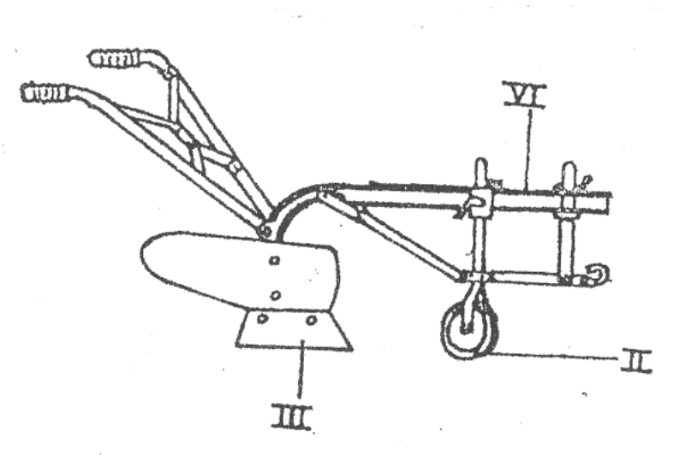
A
B
C

(a) Identify the implement. (1mk)
.........................................................................................................................................................

(b) State the function of the part labeled A, B and C. (3mks)
A ........................................................................................................................
B ……………………………………………………………………………….
C ………………………………………………………………………………

( c) Apart from land preparation, state any other one operations that can be done using the above
implement. (1mk)

.........................................................................................................................................................

- The illustration below shows an engine cylinder.

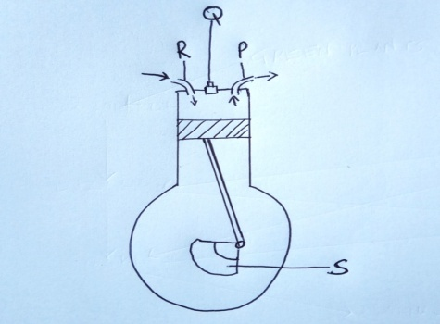
(i) Identify the parts labeled P, Q, R and S (2mks)

P …………………………………………………………………

Q ………………………………………………………………..

R ……………………………………………………………….

S ………………………………………………………………...

(ii) Give the function of the part labeled Q above. (1mk)

.........................................................................................................................................................

(iii) Give two disadvantages of four-stroke engines. (2mks)

.........................................................................................................................................................
………………………………………………………………………………………………………………….

- The activity illustrated below indicates a task undertaken in farm animals.

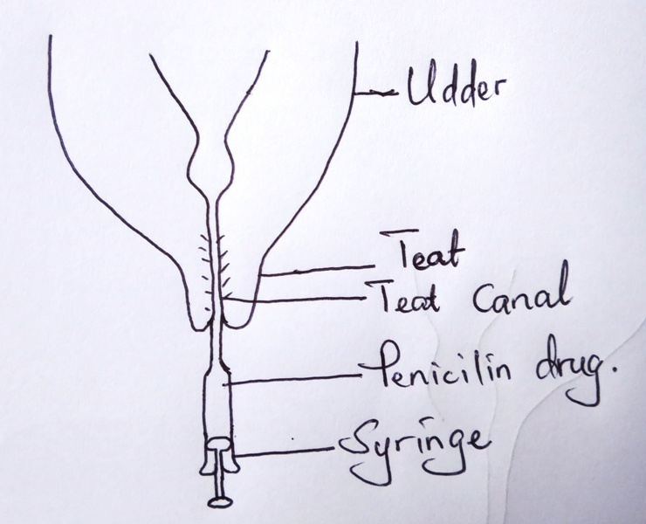
(i) Name the above activity. (1mk)
.........................................................................................................................................................
(ii) State the importance of the above activity. (1mk)

.........................................................................................................................................................
(iii) Name the disease controlled by the above practice. (1mk)

.........................................................................................................................................................

(iv) Name two other diseases that only attack female cattle. (2mks)

.........................................................................................................................................................
………………………………………………………………………………………………………………….

- Below is a diagram showing parts of a fence. Use it to answer the questions that follow.

K

H

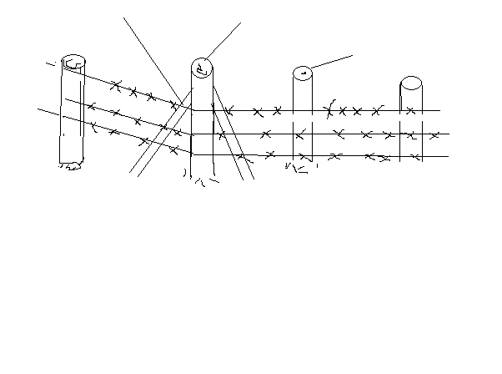
J
J
(a) Identify the type of fence above. (1mk)

………………………………………………………………………………………………………………….

(b) Name the parts labeled H and J. (2mks)

H ………………………………………………………

J ……………………………………………………….

(c) What is the role of the part labeled K? (1mk)

.........................................................................................................................................................
………………………………………………………………………………………………………………….

(d) On the diagram, draw a dropper in the right position. (1mk)

SECTION C: (40MARKS)

Answer any two questions from this section on the spaces provided after the last question.

- (a) Discuss bloat under the following sub-headings.
((i) Species of animals effected. (3mks)
(ii) Causes of the disease. (4mks)
(iii) Symptoms
(iv) Control. (2mks)
(b) Discuss various types of tools required to construct a barbed wire fence. (5mks)

- (a) Describe various cultural uses of livestock. (8mks)
(b) Describe various livestock rearing practices. (12mks)

- (a) State four functions of vitamins in livestock nutrition. (4mks)
(b) Tabulate the differences between digestion in ruminants and non-ruminants. (6mks)
(c ) Discuss the components of the cooling system of a tractor. (10mks)

………………………………………………………………………………………………………………………………………………………………………………………………………………………………………………………………………………………………………………………………………………………………………………………………………………………………………………………………………………………………………………………………………………………………………………………………………………………………………………………………………………………………………………………………………………………………………………………………………………………………………………………………………………………………………………………………………………………………………………………………………………………………………………
………………………………………………………………………………………………………………………………………………………………………………………………………………………………………………………………………………………………………………………………………………………………………………………………………………………………………………………………………………………………………………………………………………………………………………………………………………………………………………………………………………………………………………………………………………………………………………………………………………………………………………………………………………………………………………………………………………………………………………………………………………………………………………
………………………………………………………………………………………………………………………………………………………………………………………………………………………………………………………………………………………………………………………………………………………………………………………………………………………………………………………………………………………………………………………………………………………………………………………………………………………………………………………………………………………………………………………………………………………………………………………………………………………………………………………………………………………………………………………………………………………………………………………………………………………………………………
………………………………………………………………………………………………………………………………………………………………………………………………………………………………………………………………………………………………………………………………………………………………………………………………………………………………………………………………………………………………………………………………………………………………………………………………………………………………………………………………………………………………………………………………………………………………………………………………………………………………………………………………………………………………………………………………………………………………………………………………………………………………………………
………………………………………………………………………………………………………………………………………………………………………………………………………………………………………………………………………………………………………………………………………………………………………………………………………………………………………………………………………………………………………………………………………………………………………………………………………………………………………………………………………………………………………………………………………………………………………………………………………………………………………………………………………………………………………………………………………………………………………………………………………………………………………………
………………………………………………………………………………………………………………………………………………………………………………………………………………………………………………………………………………………………………………………………………………………………………………………………………………………………………………………………………………………………………………………………………………………………………………………………………………………………………………………………………………………………………………………………………………………………………………………………………………………………………………………………………………………………………………………………………………………………………………………………………………………………………………
………………………………………………………………………………………………………………………………………………………………………………………………………………………………………………………………………………………………………………………………………………………………………………………………………………………………………………………………………………………………………………………………………………………………………………………………………………………………………………………………………………………………………………………………………………………………………………………………………………………………………………………………………………………………………………………………………………………………………………………………………………………………………………
………………………………………………………………………………………………………………………………………………………………………………………………………………………………………………………………………………………………………………………………………………………………………………………………………………………………………………………………………………………………………………………………………………………………………………………………………………………………………………………………………………………………………………………………………………………………………………………………………………………………………………………………………………………………………………………………………………………………………………………………………………………………………………
………………………………………………………………………………………………………………………………………………………………………………………………………………………………………………………………………………………………………………………………………………………………………………………………………………………………………………………………………………………………………………………………………………………………………………………………………………………………………………………………………………………………………………………………………………………………………………………………………………………………………………………………………………………………………………………………………………………………………………………………………………………………………………
………………………………………………………………………………………………………………………………………………………………………………………………………………………………………………………………………………………………………………………………………………………………………………………………………………………………………………………………………………………………………………………………………………………………………………………………………………………………………………………………………………………………………………………………………………………………………………………………………………………………………………………………………………………………………………………………………………………………………………………………………………………………………………
………………………………………………………………………………………………………………………………………………………………………………………………………………………………………………………………………………………………………………………………………………………………………………………………………………………………………………………………………………………………………………………………………………………………………………………………………………………………………………………………………………………………………………………………………………………………………………………………………………………………………………………………………………………………………………………………………………………………………………………………………………………………………………
………………………………………………………………………………………………………………………………………………………………………………………………………………………………………………………………………………………………………………………………………………………………………………………………………………………………………………………………………………………………………………………………………………………………………………………………………………………………………………………………………………………………………………………………………………………………………………………………………………………………………………………………………………………………………………………………………………………………………………………………………………………………………………
………………………………………………………………………………………………………………
………………………………………………………………………………………………………………………………………………………………………………………………………………………………………………………………………………………………………………………………………………………………………………………………………………………………………………………………………………………………………………………………………………………………………………………………………………………………………………………………………………………………………………………………………………………………………………………………………………………………………………………………………………………………………………………………………………………………………………………………………………………………………………
………………………………………………………………………………………………………………………………………………………………………………………………………………………………………………………………………………………………………………………………………………………………………………………………………………………………………………………………………………………………………………………………………………………………………………………………………………………………………………………………………………………………………………………………………………………………………………………………………………………………………………………………………………………………………………………………………………………………………………………………………………………………………………
………………………………………………………………………………………………………………………………………………………………………………………………………………………………………………………………………………………………………………………………………………………………………………………………………………………………………………………………
……………………………………………………………………………………………………………………………………………………………………………………………………………………………………………………………………………………………………………………………………………

