NAME: ……………………………………….SCHOOL: …………..………………..

443/2
AGRICULTURE
PAPER 2
DECEMBER, 2020
TIME: 2 HOURS

LANET CLUSTER JOINT EXAMINATION (LANJET) -2020
443/2
AGRICULTURE
PAPER 2
DECEMBER, 2020
TIME: 2 HOURS

MARKING SCHEME

SECTION A: (30 MARKS)
- State the use of each of the following tools . (1¹/₂mks)
(i) Strip cup:
Test for mastitis in milk

(ii) Sickle:
Harvesting rice and other grains/cutting pyrethrum stalks/harvesting fodder e.g grasses.

(iii) Stock and die:
Cutting threads on pipes

- Name two reasons why rabbit’s hutches should be raised above the ground. (1mks)

- To ensure security from predators e.g dogs
- To allow droppings to fall down
- To hasten the drying of the beddings

- Name two predisposing factors of coccidiosis,. (1mks)
- Dampness/wetness
- Dirty/filthy conditions
- overcrowding

- Define the following terms as used in livestock production.
(i) Crutching (1mk)
- cutting wool around the eternal reproductive organs of a female sheep.

(ii) Farrowing: (1mk)

- Act of giving birth/parturition in pigs. (1mk)

- Name the infective stage of the liver flake in livestock. (1mk)

- Metacercarcia

- State four disadvantages of using human power instead of tractors as a source of power in a farm.
(2mks)
- Can only do light tasks compared to tractor
- Produces low quality work
- Takes long to perform tasks
- Human sometimes get sick
- Human power is unreliable

- Name two tractors drawn implements attached to the tractor at one- point hitch. (1mks)
- Trailer
- Heavy harrows
- Manure spreaders
- Planters
- Sprayers
- Rollers

- Distinguish between pen mating and flock mating in poultry. (2mks)
- Pen mating: use of only one cock to mate a flock of hens
- Flock mating: Two or more cocks are used to mate hens

- Give two ways in which proper breeding and selection helps to control livestock diseases. (1mk)
- Ensures healthy breeding stock to prevent breeding diseases
- Selection of disease-resistant animals helps in controlling diseases.

- (a) Name two types of feed additives. (1mk)
- Hormones
- Medicants
- Antibiotics
- Mineral licks
- Sweeteners e.g molasses

(b) Give two reasons why it is important to include additives in commercial feeds. (1mk)
- -stimulate growth
- Improves feed conversion efficiency
- Guard against diseases
- Make feed palatable

- (a) Name four pig breeds commonly reared in Kenya. (2mks)
- Large white
- Land race
- Sadlebacks
- Berkshire
- Duroc jessey
- Middle white

(b) Name four characteristics of dairy cattle breeds. (2mks)
- wedged shaped
- Straight top line
- Well set apart hindquarters
- Large well developed udder
- Large well spaced teats
- Prominent milk veins
- Poorly/lean bodies
- Large stomach capacity
- Thin neck

- Outline four qualities of eggs used for incubation. (2mks)
- Should be fertilized
- Should be clean
- Should not be more than 8-10days old
- Should be medium sized
- Should have smooth shells
- Should have not cracks
- Should have no abnormalities

- (a) Name two hormones that control milk let down in dairy cow. (1mk)
- Oxytocin
- Adrenaline

(b) State four factors that influence milk let – down. (2mks)
- Presence of the calf
- Presence of the milkman
- Rattling of milking equipment
- Familiar sounds e.g whistling
- Washing of udder with warm water
- Feeding
- Sight of the milk parlour
- Consistent milking time

- State four reasons why bees may swarm from a hive . (2mks)
- Shortage of food and water
- Outbreak of diseases and parasites
- Damage of brood combs
- Lack of adequate ventilation
- Dampness and bad smell
- Sick/infertile queen/death
- Overcrowding

- Name three sources of water in the body of livestock. (1¹/₂mks)
- From drinking water. (free water0
- From food taken 9bound water0
- From metabolism (metabolic water)

- Name four cattle diseases whose outbreak calls for quarantine. (2mks)
- Foot and mouth
- Anthrax
- Rinderpest
- Lumpy skin disease
- Rabies

- State two functions of ventilation in a pig house. (1mk)
- Allows efficient air circulation
- Moderates temp
- Prevents humid conditions in the house

SECTION B: (20MARKS)
- The diagram below shows a farm implement used by small scale farmers for several operations in the farm. Study it carefully and then answer the questions that follow.
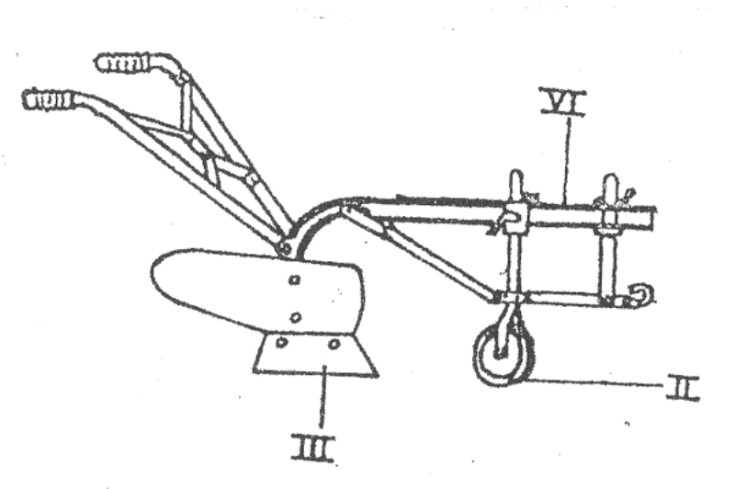
A
B
C
(a) Identify the implement. (1mk)
- ox - plough

(b) State the function of the part labeled A, B and C. (3mks)
A- Attachment of other parts of the plough

B - Controls depth of ploughing
C- Makes horizontal cutting and initiate turning of furrow slice

( c) Apart from land preparation, state any other one operations that can be done using the above
implement. (1mk)
    - Opening furrows for planting

- The illustration below shows an engine cylinder.

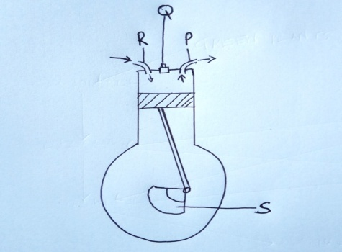
(i) Identify the parts labeled P, Q, R and S (2mks)

P. - Outlet valve
R - Inlet valve
Q- Spark plug
S - Crank shaft

(ii) Give the function of the part labeled Q above. (1mk)

  - Produces a spark that ignites the fuel air mixture

(iii) Give two disadvantages of four-stroke engines. (2mks)
  - Expensive to buy
  - Limited in certain areas
  - Requires skilled personnel
  - Expensive to maintain

- The activity illustrated below indicates a task undertaken in farm animals.

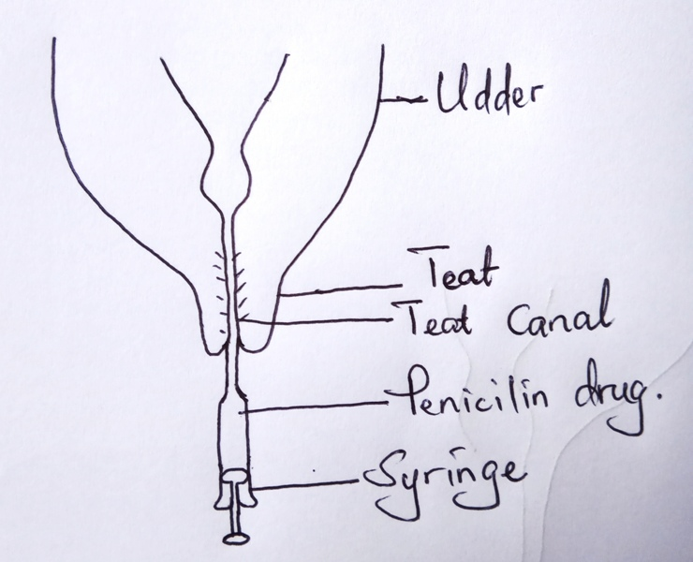

(i) Name the above activity. (1mk)
- Dry cow therapy

(ii) State the importance of the above activity. (1mk)

Prevent mastitis infection during dry period

(iii) Name the disease controlled by the above practice. (1mk)

Mastitis

(iv) Name two other diseases that only attack female cattle. (2mks)

  - Milk fever
  - Vaginitis

- Below in a diagram showing parts of a fence. Use it to answer the questions that follow.

H
K
K
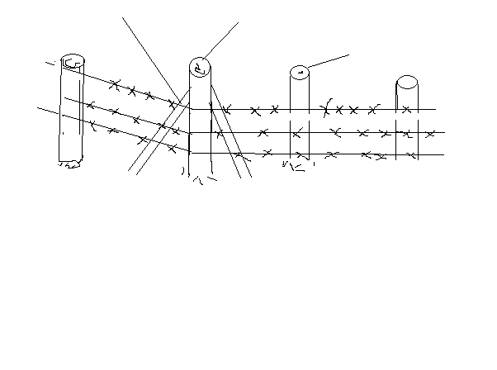
J
J

(a) Identify the type of fence above. (1mk)
Barbed wire fence rej. Wire fence

(b) Name the parts labeled H and J. (2mks)
H- king/corner post
J – Standard post

(c) What is the role of the part labeled K? (1mk)
Add support to the King post

(d) On the diagram, draw a dropper in the right position. (1mk)
- NB: The dropper should be between two standards interwoven btw the wire
strands and not touching the ground

SECTION C: (40MARKS)

- (a) Discuss bloat under the following sub-headings.
((i) Species of animals effected. cattle, sheep, goats (3mks)
(ii) Causes of the disease.
  - Obstruction of the esophagus
  - Abnormal pressure on the esophagus due to swelling
  - Indigestion
  - Feeding animal on lush pastures
- (4mks)
(iii) Symptoms
  - Distension of left side of abdomen
  - Difficulty in breathing
  - Profuse salivation
  - Animal lies down an is unable to stand
  - Grunting and kicking at the belly
  - Death within hours

(iv) Control. (2mks)
  - Provide dry roughages
  - Feed animals on wilted grass and pasture legumes

(b) Discuss various types of tools required to construct a barbed wire fence. (5mks)
  - Tape measure: to determine distances between posts.
  - Sharpened sticks: to mark points for holes
  - Hole digger: To dig holes where posts are to be placed.
  - A pair of pliers. To cut the wire/tighter/splice the wire
  - Claw hammer: to drive in and remove fencing staples/nails
  - Wire strainer: To stretch/ strengthen the wire strands
  - Ramming stick: For firming concrete around the fencing posts.

- (a) Describe various cultural uses of livestock. (8mks)
- Status symbols: one is regarded wealthy on owning large herds of cattle, sheep or goats.
- Medium of exchange: livestock were used during barter trade
- Social ceremonies: Ceremonies like marriage and funerals had live or slaughtered animals.
- Recreational purpose. Some activities like cock fighting, bull fighting, made people utilize their time constructively.

(b) Describe various livestock rearing practices. (12mks)
- Feeding – enhances maintenance and productivity of the animal. Also important in preventing diseases in animals
- Parasite and disease control. Ensures animals remain healthy and productive
- Breeding practices: Ensures multiplication of healthy animals
- Identification: Facilitates record keeping and other aspects of livestock management
- Debeaking: important in poultry to control vices e.g cannibalism and egg eating
- Tooth clipping: Removal of canine teeth in piglet 24 hours after birth
- Culling: removal of unproductive animals from a breeding herd.

- (a) State four functions of vitamins in livestock nutrition. (4mks)
- Promote growth
- Help in blood clotting
- Help in bone formation
- Help in muscular activity
- Prevents disease in animals
- Act as organic catalysts in various metabolic and physiological reactions.

(b) Tabulate the differences between digestion in ruminants and non-ruminants. (6mks)

Ruminants | Non - ruminants
(i) chew cud | - Do not chew cud
(ii) Have four stomach chamber (poly | - Have one stomach chamber (mono-gastric
(iii) Regurgitate food | - Cannot regurgitate food once swallowed
(iv) Digest cellulose | - Cannot digest cellulose
(v) Have no ptyalin in saliva | - Have ptyalin in saliva
(vi) Most digestion and absorption takes place in the rumen | - Most digestion and absorption takes place in the small intestines
(vii) have alkaline saliva due to presence of ammonia | - Have neutral saliva
(Reject if the difference is not correct for both)

(c ) Discuss the components of the cooling system of a tractor. (10mks)
- Radiator- Cools water by convectional current using radiator tubes
- Water pump: maintains circulation of water in the system
- Fan: Blow air into the radiator
- Thermostat: Regulates temperature by connecting and disconnecting circuit.
- Temperature gauge: Located on dash board and indicate engine temperature for the driver.

