NAME………………………………………………………..IDEX NO…………………………………………………………………………..
SCHOOL………………………………………………………..SIGN………………DATE…………………………………………………….
443/1

AGRICULTURE

PAPER 1

TIME: 2 HOURS

DECEMBER, 2020

MERU CENTRAL CLUSTER EXAMINATION (2020)
Kenya certificate of secondary education (k.c.s.e)

INSTRUCTIONS TO CANDIDATES

- Write your name, school and index number, in the spaces provided above.

- Sign and write the date of the examination in the spaces provided above.

- This paper consists of three sections: A, B and C.

- Answer all the questions in section A and B and any two questions from section C.

- All answers must be written in the spaces provided in this booklet

.

For Examiner’s Use Only
SECTION | QUESTIONS |  | MAXIMUM SCORE |  | CANDIDATES SCORE
A | 1−15 |  | 30
B | 16−19 |  | 20
 |  |  | 20
C
 |  |  | 20
 | Total score |  | 90

SECTION A (30 MRKS)
1.Differentiate between olericulture and pomoculture as used in crop production .(1mrk) ................................................................................................................................................................................................................................................................................................................................................................................................................................................................................................................................................................................................
2.Give four method of farming (2mrks)
................................................................................................................................................................................................................................................................................................................................................................................................................................................................................................................................................................................................................................................
3.Give two examples for each of the following types of cost incurred in broiler production .
- Variable cost ( 2 marks)
................................................................................................................................................................................................................................................................................................................................................................................................................................................
- fixed cost (2 marks)
.................................................................................................................................................................................................................................................................................................................................................................................................................................................................................................................................
4.Give four advantages of crop rotation .(2mrk)
....................................................................................................................................................................................................................................................................................................................................................................................................................................................................................
........................................................................................................................................................................................................................................................................................................................
5.State four factors that that should be considered when classifying crop pest (2mrks)
....................................................................................................................................................................................................................................................................................................................................................................................................................................................................................

6. a) Name four pieces of information contained in a land title deed (2mks
....................................................................................................................................................................................................................................................................................................................................................................................................................................................................................
........................................................................................................................................................................................................................................................................................................................

b) Name two forms of collective land tenure system. (1mk

....................................................................................................................................................................................................................................................................................................................................................................................................................................................................................
7. List four post – harvest practices that are carried out in maize production (2mks

...............................................................................................................................................................................................................................................................................................................................................................................................................................................................................................................................................................................................................................................
8. What is opportunity cost? (1/2 mk)
....................................................................................................................................................................................................................................................................................................................................................................................................................................................................................
9.Outline four ways of improving lab our productivity (2mks
................................................................................................................................................................................................................................................................................................................................................................................................................................................................................................................................................................................................................................................
10. State four factors that can affect the efficiency of pesticides (2mks
................................................................................................................................................................................................................................................................................................................................................................................................................................................................................................................................................................................................................................................
11 List four sites on which agro forestry trees can be established on a farm. (2mks
....................................................................................................................................................................................................................................................................................................................................................................................................................................................................................

12.Give four advantages of using seeds over vegetative materials. (2 mks)
…………………………………………………………………………………………………………………………………………………………………………………………………………….
………………………………………………………………………………………………

13.State four features that should be considered when choosing water pipes for use on the farm. (2 mks)
…………………………………………………………………………………………………….
……………………………………………………………………………………………………………………………………………………………………………………………………………..
……………………………………………………………………………………………………..
14.Give three reasons why primary cultivation should be done early before the onset of the rains(1 ½ )
....................................................................................................................................................................................................................................................................................................................................................................................................................................................................................
........................................................................................................................................................................................................................................................................................................................
15. Give four suitable characteristics of plants used as green manure. (2mks)

....................................................................................................................................................................................................................................................................................................................................................................................................................................................................................
........................................................................................................................................................................................................................................................................................................................

SECTION B: (20 marks)
Answer all the questions in the section in the spaces provided.

16. The diagram below shows a pest and the damaged crop study it and answer the questions that follow.

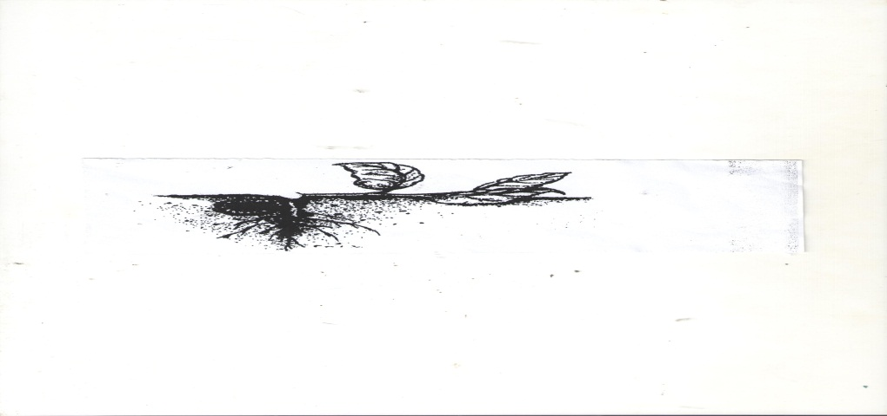

a) Identify the pest illustrated above (1mk

........................................................................................................................................................................................................................................................................................................................
b) Explain two ways of controlling the pest (2mks

....................................................................................................................................................................................................................................................................................................................................................................................................................................................................................
........................................................................................................................................................................................................................................................................................................................
c) State two ways in which the pest economically important. (2mks)

....................................................................................................................................................................................................................................................................................................................................................................................................................................................................................
17. a) Distinguish between straight and compound fertilizers. (1mk

....................................................................................................................................................................................................................................................................................................................................................................................................................................................................................
........................................................................................................................................................................................................................................................................................................................

b) A farmer applied 200kg of C A N (20%N) per hectare maize crop. Calculate the amount of
Nitrogen applied on his 5 hectare crop. Show your working (4mks

....................................................................................................................................................................................................................................................................................................................................................................................................................................................................................
........................................................................................................................................................................................................................................................................................................................

18The diagram below shows a maize cob attacked by a certain disease. Study it and then answer the following questions.

- Identify the disease (1 Mk)
………………………………………………………………………………………………
………………………………………………………………………………………………

- Name two causal organism of the disease. (1 Mk)
………………………………………………………………………………………………
………………………………………………………………………………………………

- State three cultural methods of controlling the disease. (3 Mks)
………………………………………………………………………………………………
………………………………………………………………………………………………
………………………………………………………………………………………………

19. Below is a graphical representation of a law in agricultural economics. Study the graph carefully
and answer the questions that follow.

1400

1200

1000 Phase I Phase II Phase III

800

600

400

200

0 20 40 60 90 100
Fertilizer input (50kg bags)

a) State the law illustrated by the graph (2mk

....................................................................................................................................................................................................................................................................................................................................................................................................................................................................................
............................................................................................................................................................

b) Explain how each additional unit of fertilizer input relates to the total output of maize in
phases II and III .( 2 mks)

Phase II

....................................................................................................................................................................................................................................................................................................................................................................................................................................................................................

Phase III (1mk

....................................................................................................................................................................................................................................................................................................................................................................................................................................................................................

c) State the importance of the law identified in ( I ) above to the maize farmer (1mk

....................................................................................................................................................................................................................................................................................................................................................................................................................................................................................

SECTION C ( 40MARKS)
Answer any two questions in this section in the spaces provided
20a) Explain five factors that should be considered in farm planning. (10 Mks)

....................................................................................................................................................................................................................................................................................................................................................................................................................................................................................
........................................................................................................................................................................................................................................................................................................................
....................................................................................................................................................................................................................................................................................................................................................................................................................................................................................
........................................................................................................................................................................................................................................................................................................................
....................................................................................................................................................................................................................................................................................................................................................................................................................................................................................
........................................................................................................................................................................................................................................................................................................................

....................................................................................................................................................................................................................................................................................................................................................................................................................................................................................
........................................................................................................................................................................................................................................................................................................................
....................................................................................................................................................................................................................................................................................................................................................................................................................................................................................
........................................................................................................................................................................................................................................................................................................................
....................................................................................................................................................................................................................................................................................................................................................................................................................................................................................
........................................................................................................................................................................................................................................................................................................................
....................................................................................................................................................................................................................................................................................................................................................................................................................................................................................
........................................................................................................................................................................................................................................................................................................................
........................................................................................................................................................................................................................................................................................................................
....................................................................................................................................................................................................................................................................................................................................................................................................................................................................................
........................................................................................................................................................................................................................................................................................................................

b) Describe transplanting of tomatoes seedling. (10 Mks)
....................................................................................................................................................................................................................................................................................................................................................................................................................................................................................
........................................................................................................................................................................................................................................................................................................................
....................................................................................................................................................................................................................................................................................................................................................................................................................................................................................
........................................................................................................................................................................................................................................................................................................................
....................................................................................................................................................................................................................................................................................................................................................................................................................................................................................
........................................................................................................................................................................................................................................................................................................................
....................................................................................................................................................................................................................................................................................................................................................................................................................................................................................
........................................................................................................................................................................................................................................................................................................................
....................................................................................................................................................................................................................................................................................................................................................................................................................................................................................
........................................................................................................................................................................................................................................................................................................................
....................................................................................................................................................................................................................................................................................................................................................................................................................................................................................
........................................................................................................................................................................................................................................................................................................................

21Describe paddy rice production under the following sub-headings.
- Land preparation (2 Mks)
........................................................................................................................................................................................................................................................................................................................
....................................................................................................................................................................................................................................................................................................................................................................................................................................................................................
........................................................................................................................................................................................................................................................................................................................
- Water control (2 Mks)

........................................................................................................................................................................................................................................................................................................................
....................................................................................................................................................................................................................................................................................................................................................................................................................................................................................
........................................................................................................................................................................................................................................................................................................................

- Fertilizer application (2 Mks)

........................................................................................................................................................................................................................................................................................................................
....................................................................................................................................................................................................................................................................................................................................................................................................................................................................................
........................................................................................................................................................................................................................................................................................................................

- Weed control (2 Mks)
........................................................................................................................................................................................................................................................................................................................
....................................................................................................................................................................................................................................................................................................................................................................................................................................................................................
........................................................................................................................................................................................................................................................................................................................
b) Explain how each of the properties of rainfall and light influence crop production.
i) Rainfall (8 Mks)
........................................................................................................................................................................................................................................................................................................................
....................................................................................................................................................................................................................................................................................................................................................................................................................................................................................
........................................................................................................................................................................................................................................................................................................................
....................................................................................................................................................................................................................................................................................................................................................................................................................................................................................
........................................................................................................................................................................................................................................................................................................................
....................................................................................................................................................................................................................................................................................................................................................................................................................................................................................
ii) Light
........................................................................................................................................................................................................................................................................................................................
....................................................................................................................................................................................................................................................................................................................................................................................................................................................................................
........................................................................................................................................................................................................................................................................................................................
....................................................................................................................................................................................................................................................................................................................................................................................................................................................................................
........................................................................................................................................................................................................................................................................................................................
...................................................................................................................................................................................................................................................................................................................................................................................................................................................................................

c) Explain four factors that should be considered when sitting a vegetable nursery. (4mks)
........................................................................................................................................................................................................................................................................................................................
....................................................................................................................................................................................................................................................................................................................................................................................................................................................................................
........................................................................................................................................................................................................................................................................................................................
....................................................................................................................................................................................................................................................................................................................................................................................................................................................................................
........................................................................................................................................................................................................................................................................................................................
....................................................................................................................................................................................................................................................................................................................................................................................................................................................................................

22a) Describe six advantages of rotational grazing (6mrks)
................................................................................................................................................................................................................................................................................................................................................................................................................................................................................................................................................................................................................................................
...................................................................................................................................................................................................................................................................................................................................................................................................................................................................................
...................................................................................................................................................................................................................................................................................................................................................................................................................................................................................
...............................................................................................................................................................................................................................................................................................................................................................................................................................................................................................................................................................................................................................................

b)Explain eight ways in which soil fertility can be maintained (8mrks)
................................................................................................................................................................................................................................................................................................................................................................................................................................................................................................................................................................................................................................................
...............................................................................................................................................................................................................................................................................................................................................................................................................................................................................................................................................................................................................................................
....................................................................................................................................................................................................................................................................................................................................................................................................................................................................................
................................................................................................................................................................................................................................................................................................................................................................................................................................................................................................................................................................................................................................................
....................................................................................................................................................................................................................................................................................................................................................................................................................................................................................
................................................................................................................................................................................................................................................................................................................................................................................................................................................................................................................................................................................................................................................

- Explain six reasons for pruning coffee.(6mrks)
................................................................................................................................................................................................................................................................................................................................................................................................................................................................................................................................................................................................................................................
...............................................................................................................................................................................................................................................................................................................................................................................................................................................................................................................................................................................................................................................
...............................................................................................................................................................................................................................................................................................................................................................................................................................................................................................................................................................................................................................................
...............................................................................................................................................................................................................................................................................................................................................................................................................................................................................................................................................................................................................................................
...............................................................................................................................................................................................................................................................................................................................................................................................................................................................................................................................................................................................................................................
...............................................................................................................................................................................................................................................................................................................................................................................................................................................................................................................................................................................................................................................
...............................................................................................................................................................................................................................................................................................................................................................................................................................................................................................................................................................................................................................................
...............................................................................................................................................................................................................................................................................................................................................................................................................................................................................................................................................................................................................................................

