NAME------------------------------------------------------------------------ Dates---------------------------
INDEX--------------------------------------------- Candidate Sign ---------------------------------

443/2
AGRICULTURE
PAPER2
2HOURS
END OF TERM 1 EXAMINATION 2020
FORM 4
Instruction to Candidates
- Write your name and index number in the space provided at the top of this page.
- Sign and write the date of the examination in the space provided above.
- C) This paper consist of three section A, B. and c .
- Answer all questions in section A and B.
- Answer any two questions in section c.
- Answers should be written in the space provided.
- Candidates should check the question paper to ascertain that all pages are printed as indicated and that no questions are missing.
- Candidates should answer the question in English.
FOR EXAMINER’S USE ONLY
SECTION | QUESTION | MAXIMUM SCORE | CANDIDATES SCORE
A | 1-16 | 30 | 30
B | 17-20 | 20 | 20
C |  | 20 | 20
 |  | 20 | 20
 | TOTAL SCORE | 90

SECTION A 30MRKS
Answer all the questions in this sections in the spaces provided
1. Name the most appropriate tools used in the following operations
a) Removing metal chippings in file (1mrk )
................................................................................................................................................................................................................................................................................................................................................
b) Cutting wood along grains (1mrk)
................................................................................................................................................................................................................................................................................................................................................
c) Branding (1mrks)
................................................................................................................................................................................................................................................................................................................................................
2. State four characteristic of Boran cattle (2mrks)
................................................................................................................................................................................................................................................................................................................................................................................................................................................................................................................................................................................................................................................................................................
3. State two functions of a useful bacteria in livestock production (1mrk)
........................................................................................................................................................................................................................................................................................................................................................................................................................................................................................................................
4. Name four function of lipid in an animal body (2mrks)
................................................................................................................................................................................................................................................................................................................................................
................................................................................................................................................................................................................................................................................................................................................

5. State two ways of reducing friction in moving part of farm tool (1mrk)
................................................................................................................................................................................................................................................................................................................................................
................................................................................................................................................................................................................................................................................................................................................
6. Outline four types of fence that can be used in mixed farm (2mrks)
................................................................................................................................................................................................................................................................................................................................................
................................................................................................................................................................................................................................................................................................................................................
7. Name three methods of out breeding in livestock production ((1 ½ marks)
................................................................................................................................................................................................................................................................................................................................................
................................................................................................................................................................................................................................................................................................................................................
8. Give two reasons for tailing in sheep production (1mrk)
................................................................................................................................................................................................................................................................................................................................................
9. Name any five internal parts of cow‘s udder (2 ½ marks)
................................................................................................................................................................................................................................................................................................................................................
................................................................................................................................................................................................................................................................................................................................................
................................................................................................................................................................................................................................................................................................................................................
10. Give five ways of transmitting livestock diseases (2 ½ marks)
................................................................................................................................................................................................................................................................................................................................................
................................................................................................................................................................................................................................................................................................................................................
........................................................................................................................................................................ 11. Give four features of improved grain bin (2mrks)
................................................................................................................................................................................................................................................................................................................................................
................................................................................................................................................................................................................................................................................................................................................
12. Give three types of calving complications (1 ½ mrks)
................................................................................................................................................................................................................................................................................................................................................
................................................................................................................................................................................................................................................................................................................................................
13. State four advantages of zero grazing as a grazing system (2mrks)
................................................................................................................................................................................................................................................................................................................................................
................................................................................................................................................................................................................................................................................................................................................
................................................................................................................................................................................................................................................................................................................................................
14. State two functions of a queen bee in a colony (1mrk)
................................................................................................................................................................................................................................................................................................................................................
................................................................................................................................................................................................................................................................................................................................................
15. Name four symptoms of anaplasmasis in livestock(2mrks
................................................................................................................................................................................................................................................................................................................................................
................................................................................................................................................................................................................................................................................................................................................
16 .What do you understand by the following terms as used I animal production .
- Coponisation(1mrk)
................................................................................................................................................................................................................................................................................................................................................
b) Bullock (1mrk)
................................................................................................................................................................................................................................................................................................................................................
c. Epistasis(1mrk)
................................................................................................................................................................................................................................................................................................................................................
SECTION B (20Mrks)
Answer all the questions in the spaces provided
17. Below is a diagram of a cooling system .Study it and answer the questions that follow
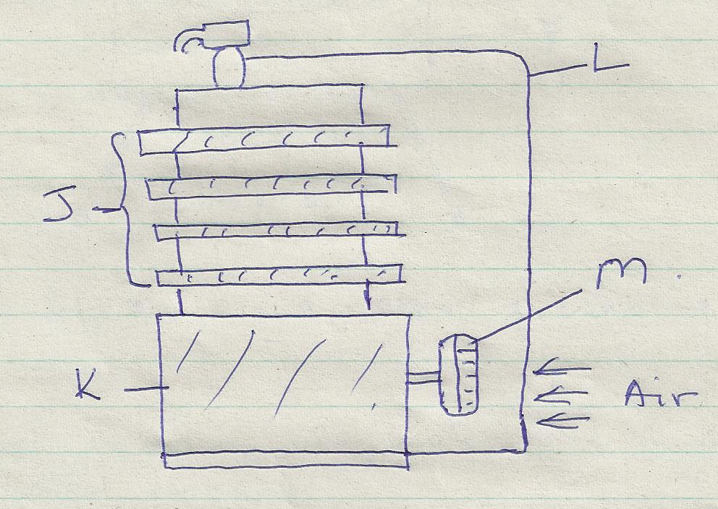
- Identify the type of cooling system illustrated (1mrk
........................................................................................................................................................................................................................................................................................................................

b . Name parts labelled J, K , L and M (2mrks)
................................................................................................................................................................................................................................................................................................................................................
................................................................................................................................................................................................................................................................................................................................................
c. Name two problems associated with the type of cooling system illustrated above(2mrks)
(i)

(ii)
18. Below is an illustration of a method of extracting honey from combs .Study the diagram and answer the question that follow .
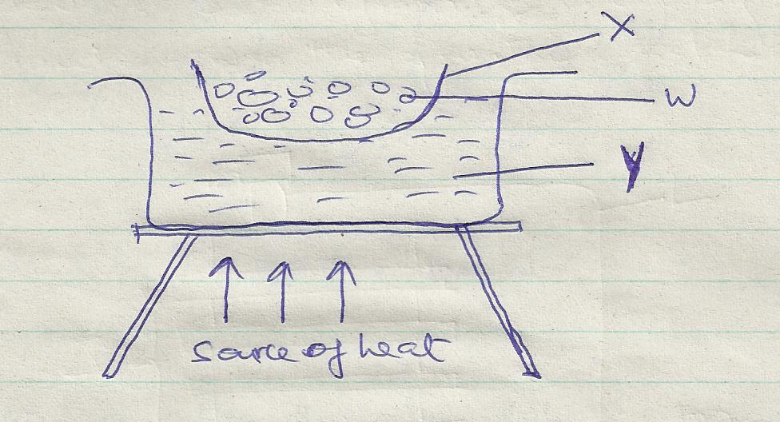
- Indentify the above method of extracting honey (1mrk)
........................................................................................................................................................................................................................................................................................................................
- Give a reason why container x should not be heated directly (1mrk
........................................................................................................................................................................................................................................................................................................................

- Name the parts labeled w and y(2mrks)
w
y

- Besides the above method ,State one other method of extracting honey (1mrk)
........................................................................................................................................................................................................................................................................................................................

19The diagram below shows a certain practice carried out on pig
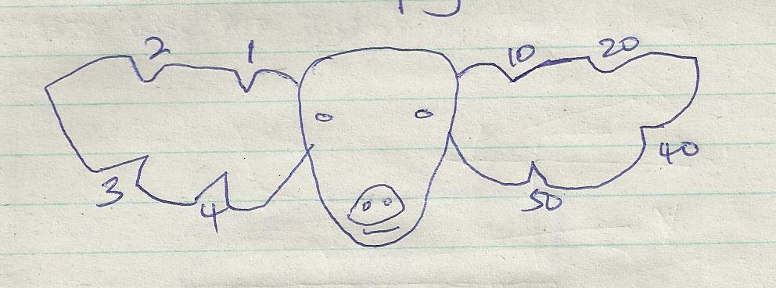
- Identify the practice illustrated above (1mrk)
........................................................................................................................................................................................................................................................................................................................
- Draw another illustration depicting pig number 37(1mrk)

- Name the tool used to carry out the practice illustrated above (1mrk)
........................................................................................................................................................................................................................................................................................................................
- State two other method of indentifying piglet (2mrks)
i)
ii)
20 .Below an illustration of a farm operation .Study it carefully and answer the question that follow.
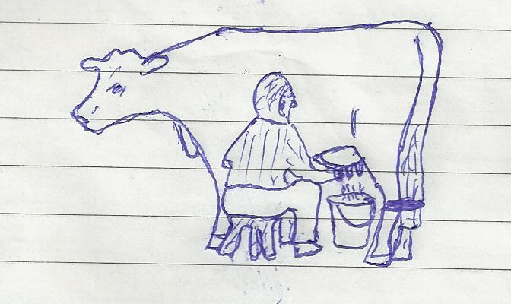

- Identify the activity being carried out (1mrk)
......................................................................................................................................................................................................................................................................................................................................................

- Give one other activity carried on the animal before the above operation is carried out (1mrk)
......................................................................................................................................................................................................................................................................................................................................................
- Outline the procedure of carrying out the above operation (3mrks)
......................................................................................................................................................................................................................................................................................................................................................
......................................................................................................................................................................................................................................................................................................................................................
......................................................................................................................................................................................................................................................................................................................................................
SECTION C
Answer any two questions in the space provided
21. Outline management practice carried out in a fish pond to ensure maximum harvest of fish (7mrlk)
................................................................................................................................................................................................................................................................................................................................................................................
................................................................................................................................................................................................................................................................................................................................................................................
................................................................................................................................................................................................................................................................................................................................................................................
................................................................................................................................................................................................................................................................................................................................................................................
b) Discuss the importance of farm mechanization (6mrks
................................................................................................................................................................................................................................................................................................................................................................................
................................................................................................................................................................................................................................................................................................................................................................................
................................................................................................................................................................................................................................................................................................................................................................................
c) Discuss the short term maintenance practices carried out on a tractor (7 marks)
................................................................................................................................................................................................................................................................................................................................................................................
................................................................................................................................................................................................................................................................................................................................................................................
................................................................................................................................................................................................................................................................................................................................................................................
................................................................................................................................................................................................................................................................................................................................................................................
................................................................................................................................................................................................................................................................................................................................................................................
22. (a) Explain the feature of a piggery unit (10mrks)
................................................................................................................................................................................................................................................................................................................................................................................
................................................................................................................................................................................................................................................................................................................................................................................
................................................................................................................................................................................................................................................................................................................................................................................
................................................................................................................................................................................................................................................................................................................................................................................
................................................................................................................................................................................................................................................................................................................................................................................
................................................................................................................................................................................................................................................................................................................................................................................
................................................................................................................................................................................................................................................................................................................................................................................ ................................................................................................................................................................................................................................................................................................................................................................................
................................................................................................................................................................................................................................................................................................................................................................................

- Explain the factor that influence the work output of a draught animal(10mrks)
......................................................................................................................................................................................................................................................................................................................................................
......................................................................................................................................................................................................................................................................................................................................................
......................................................................................................................................................................................................................................................................................................................................................
...........................................................................................................................................................................
................................................................................................................................................................................................................................................................................................................................................................................................................................................................................................................................. ........................................................................................................................................................................................................................................................................................................................................................................................................................................................................................................................................................................................................................................................................................................................................................................................................................................................................................................................................................................................................................................................................................................................................................................................................................................................................................................................................................................................................................
23. a)Outline various method of controlling ticks(10 mrks) ................................................................................................................................................................................................................................................................................................................................................................................
................................................................................................................................................................................................................................................................................................................................................................................
........................................................................................................................................................................................
................................................................................................................................................................................................................................................................................................................................................................................
................................................................................................................................................................................................................................................................................................................................................................................
................................................................................................................................................................................................................................................................................................................................................................................
................................................................................................................................................................................................................................................................................................................................................................................
- Describe the management of growers up to the point of lay (10mrks)
................................................................................................................................................................................................................................................................................................................................................................................
................................................................................................................................................................................................................................................................................................................................................................................
................................................................................................................................................................................................................................................................................................................................................................................
................................................................................................................................................................................................................................................................................................................................................................................
................................................................................................................................................................................................................................................................................................................................................................................
................................................................................................................................................................................................................................................................................................................................................................................ ................................................................................................................................................................................................................................................................................................................................................................................
................................................................................................................................................................................................................................................................................................................................................................................
................................................................................................................................................................................................................................................................................................................................................................................
................................................................................................................................................................................................................................................................................................................................................................................

