AGRICULTURE PAPER 2
MARKING SCHEME
SECTION A (30MRKS)
1. Appropriate tools for
a)removing metal chipping s in the files
-wire brush (1x1) (1mrk)
b) Cutting wood along grains
-rip saw 1x1(1mrk)
c) Branding
- Branding iron 1x1=1mrk
2. Characteristic of boran cattle
-Compact, deep and wide body
- Long, wide, dropping rump
-Large hump and dewlap
-Usually white in colour hence radiates heats
-Slow growth rate and late maturity
-Resistant to high temperature
-Cows weigh 410-450kg, bulls 550-650 kg (4x1/2 =2mrks
Used to improve zebu
3. Function of useful bacteria in livestock production
-Digestive of grass and fibre in the rumen
-Fermentation of yoghurt/milk products
2x ½ =1mrk

4. Function of lipids
-Consistuent of body cell/part of body cell
-carries far soluble vitamins A,D,E, K
-Insulate body /prevent body heat loss
-Provide energy stored in reserves 4x ½ (2mrks
5. Ways of reducing friction in moving parts of farm tools
-oiling
-Greasing
2x ½ =(1mrk)
6. Types of fences used n mixed farm
-Electric
-plain wire
-Barbed wires
-Wooden fence
-Woven wire fence/chain link
-Stone /brick fence/block fence
7. Method of out breeding
-out crossing
-Cross breeding
- Grading up /Up grading 3x1/2=1 ½ mrK
8. Reason for tailing in sheep production
-Prevent blowfly infection
-Prevent sailing of wool with urine and feces
- Facilitate even distribution of fat in the body
2x ½ =(1mrk)

9. Parts of cow s udder
- Lobule
- alveolus
-lobe
- teat cisterm
-teat canal
-gland cistern
-teat sphiricter muscles
-annular fold
10. Ways of transmitting livestock diseases
-open wounds
- Body contact with affected animals
-Inhalation of pathogens
-Insect vectors
-Ingestion of contaminated food and water
-Contaminated surgical instruments
5x ½ =2mrks
11. Features of improved grain bin
-Raised above ground
-Have rat guard on supporting posts
-Have impermeable wall to guard against rain water .
-Proper ventilation to control variations.
-Have proper roofing to protect grain from sunlight and rain 4x1/2=(2mrks)
12. Types of calving complications (3x1/2 =1 1/2mrks)
-Breech presentation
-One or both forelegs bent backward
-head twisted backward to either side
-Whole reproductive trait twisted
13. Advantages of zero grazing
-high milk yield
-quick accumulation of manure
-easy control of parasite and diseases
-less wastage of feed
-Large number of animals reared in a small area/allow high stocking rate .
4x1/2=(2mrks)
14. Function of queen bee
-lay eggs
-Production of pheromone which keeps colony together
2x ½ =(1mrk)
15 Symptoms of anaplasmosis
-constipation/hard dung
-fever
-paleness of gum eye lips --Fast breathing and heart beat
-yellow urine, animal do not chew cud
-No milk flow from udder
4x1/2=(2mrk)
16 Terms
a) Caponisation -sterilizing male bird
b)bullock –mature castrated male cattle
c)Epislasis-a combination of inferior gene which individually could express themselves

SECTION B
A)Type of cooling system
-Air cooled system 1x1=1mrk
b) parts
J-Finned cylinder
K-crank case
L-metal cowling
M-fly wheel(blower)
4x ½ =(2mrk)
c) Problem associated
-uses heavy lubricating oil which are expensive
-get hot quickly
- Cooling not adequate when carrying heavy load
2x1(2mrks)
18. Method of extracting honey
a) heat method
b) Why x should not be heated directly
-To prevent destroying honey by heat 1x1=(1mrk)
c) Parts
W-Honey combs
Y-water
2x1=(2mrks)
d) Other method of honey extraction
-Crushing and straining
-Centrifugal method 1x1=1mrk
1x1=(1mrk)
19 a) practice illustrated
-Ear notching 1x1=1mrk
b)Illustration for number 37
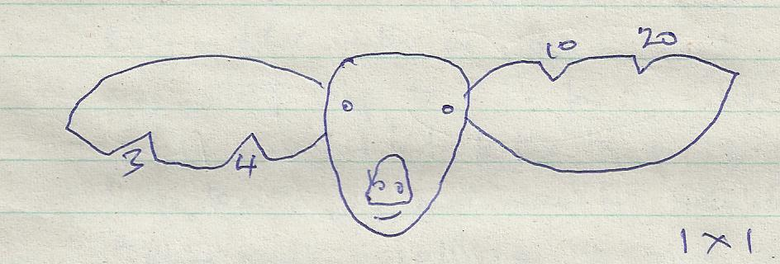
c) Other method of identifying piglet
-Ear tagging
-Ear tattooing
2x1=(2mrks)
20a) activity shown
-Hand milking
1x1=(1mrk)
b) Activity carried out before the operation
-Restraining animal
-Providing food
-Washing udder of animal
-wiping udder dry
-Testing for mastitis
1x1=(1mrk)
c)Procedure of carrying out practice
(i) -Assemble milking equipments
(ii)- Provide food
(iii) -Put cow in milking shed and restrain it
(iv)-Wash udder using warm water
(v)-dry the udder with clean towel
(vi)-Use strip cup to test mastitis
(vii)-Milk animal /strip the teat dry
(viii)-Dip teats in antimastitis solution
(ix)-apply milking jelly /milk salve on teats
(x)-Release cow
3x1=(3mrks)mark as whole
Stop marking where procedure is broken
SECTION C (40 MRKS)
21. a)Management practice on a fish pond to ensure maximum fish harvest
-Control stocking rate
-Control water pollution
-Supply adequate food regularly
-Provide appropriate feed
-Ensure constant in flow and out flow of water /aerate water
-Control predators
-Harvest fish at the correct maturity age .
-Maintain appropriate water level always
7x1=7mrks
b)Importance of farm mechanization
-Farm operation are achieved on time
-Large areas can be covered within short time
-Reduce drudgery /makes work easier and enjoyable
-Increased efficiency /better job done mechanically
-High yield due to timely operation
-Pest and disease outbreak controlled in a shorter time
-Encourage farmer to consolidate land
-Farmer benefit from economic of scale
-Uses less labour
6x1=6mrks
c) Short term maintenance practice on a tractor7x1=(7mrks)
-Check level of engine oil using a dip stick
-Check fuel tank to ensure there is enough fuel
-Check level of electrolyte in battery and adjust accordingly
-Check level of water in radiator and top if necessary .
-Grease /oil moving parts
- Check for belt tension and condition and adjust accordingly
-Check the air cleaner to ensure there is no dirt /check level of oil
-Check the tyre pressure before work and adjust accordingly
-Tighten loose nuts ,bolt and pins
-Remove dirt from sediment bowl
22a)Features of a piggery unit
-Farrowing pen; to ensure safe farrowing and safety of piglet; hence should be provided with farrowing crates and heat source;
-Gilt pen; for keeping young female up to service age
-Boars pen; for breeding boar should be spacious for exercise
-Weaners pen; to house piglet after weaning
-In pig pen; for pregnant sow awaiting farrowing
-Running yard; for sunbathing and dunging
-Feed store for storing pig feed
-Water tough; for watering pigs
-Record room; for keeping feed and weight records
-Roofing; for their protection against extreme weather conditions.
- Feed troughs; for feeding pigs.
-10x1=(10mrks)
b)Factors that influences the work of the output of a draught animal
-Age of the animal –very young and very old have lower out put compared to mature animal
-Level of training –Well trained animals are more efficient than poorly trained ones –They are able to follow simple instructions
-Method or harnessing –Well harnessed animal are more efficient than poorly harnessed animal
Body condition – A well fed draught animal is strong and healthy hence it has a higher work output compared to one that is poorly fed
-Weather condition –Adverse temperature (very high ,very low reduces the work output of draught animal .The animal work best under suitable weather condition
-Duration/ hours of work –Overworked animals tend to have a low work output ,draught animal should be given sufficient time to rest
-Condition of working implement, well maintained Implement are easy to work with and this improves the work output of the animal
Any 5x2=(10mrks)
23a)Methods of controlling tick (10x1=(10mrks)
-Use of natural enemies e.g. ants and birds
-self licking to dislodge ticks
--Burning infected pastures land to expose eggs to the sun
-Top dressing pastures with lime
-Fencing off pasture land.
- Keeping animals away from infected pasture to stave ticks .
--Rotational grazing help to break life cycle .
-Deticking from livestock and killing them .
-Spraying with acaricides or dipping in acaricides
-Hand dressing using pye-grease.

b)The management of grower up to the point of lay
-Feed the grower on adequate growers mash per bird per day .
- Supplement the grower s mash with grains and greens .
-Introduce soluble grit /oyster shells at 20th week
-Provide adequate clean water and libitum.
-Adjust floor space; allowance; as the bird age appropriately
-Give a booster vaccine against new castle disease at 20 weeks of age at the 18th week ,vaccinate against fool pox
- Drench the birds regularly against internal parasites.
-Dust the bird with the appropriate pesticides against external pests .
-Control predator such as rat /cats .
-Feeders and waterier should be cleaned and disinfected daily .
-Maintain foot bath at the entrance of the poultry house .
-Keep the litter as dry as possible /turning it regularly .
-Introduce the layer mash from the 18th week and increase gradually .
-Provide roosts /perches for the birds to perch on from the 9th week .
-Birds start laying at 18-21 weeks of age depending on the breed .
Any 12x1=12mrks)

