Name: .......................................................................................... Index Number ……...………

School: ................................................................... Candidate’s Signature ……………………

Date…………………………
443/1
AGRICULTURE PAPER 1

March/April, 2020
Time: 2 hours

AGRICULTURE PAPER 443/1
ARISE AND SHINE TRIAL 1 EXAM

Instructions to Candidates
- Write your name, index number, school and admission number in the spaces provided.
- Sign and write the date in the spaces provided above.
- Answer all the questions ins section A and B
- Answer any two questions in section C
- Answers should be written in the spaces provided in this booklet.

For Examiner’s Use Only

SECTION | QUESTIONS | MAXIMUM  SCORE | CANDIDATE’S  SCORE
A | 1 – 18 | 30
B | 19-25 | 20
C |  | 20
 |  | 20
 | Total Score | 90
This paper consists of 13 printed pages. Candidates should check to ascertain that all pages are printed as indicated and that no questions are missing.

SECTION A (30 MARKS)

Answer all the questions in this section in the spaces provided

- Give two ways that can be used to assess soil fertility (1 mark)

(i) …………………………………………………………………………………………………
(ii) ………………………………………………………………………………………………….

- List four methods that can be used to reclaim a water-logged land (2 marks)

(i) …………………………………………………………………………………………………
(ii) ………………………………………………………………………………………………….
(iii) …………………………………………………………………………………………………
(iv)………………………………………………………………………………………………….
- State four reasons why subsoiling is important as an operation of land preparation. (2 marks)
(i) …………………………………………………………………………………………………
(ii) ………………………………………………………………………………………………….
(iii) …………………………………………………………………………………………………
(iv)………………………………………………………………………………………………….
- Give two factors that influence the quality of farmyard manure. (1 mark)

(i) …………………………………………………………………………………………………
(ii) ………………………………………………………………………………………………….
- State four advantages of applying lime as a measure of improving soil condition (2 marks)

(i) …………………………………………………………………………………………………
(ii) ………………………………………………………………………………………………….
(iii) …………………………………………………………………………………………………
(iv)………………………………………………………………………………………………….

- State three functions of Nitrogen in crops. (1 ½ marks)

(i) …………………………………………………………………………………………………
(ii) ………………………………………………………………………………………………….
(iii) …………………………………………………………………………………………………
- Give four factors that can increase seed rate in crop production. (2 marks)

(i) …………………………………………………………………………………………………
(ii) ………………………………………………………………………………………………….
(iii) …………………………………………………………………………………………………
(iv)………………………………………………………………………………………………….
8. State four uses of organic mulch in crop production. (2 marks)
(i) …………………………………………………………………………………………………
(ii) ………………………………………………………………………………………………….
(iii) …………………………………………………………………………………………………
(iv)………………………………………………………………………………………………….
9. List four characteristics of crops grown for green manure. (2 marks)

(i) …………………………………………………………………………………………………
(ii) ………………………………………………………………………………………………….
(iii) …………………………………………………………………………………………………
(iv)………………………………………………………………………………………………….
10. List four advantages of timely harvesting of crops. (2 marks)
(i) …………………………………………………………………………………………………
(ii) ………………………………………………………………………………………………….
(iii) …………………………………………………………………………………………………
(iv)………………………………………………………………………………………………….

11. State two advantages of intercropping (1 mark)
(i) …………………………………………………………………………………………………
(ii) ………………………………………………………………………………………………….
12. State two conditions under which the opportunity cost is zero in a farming enterprise.
(1 mark)
(i) …………………………………………………………………………………………………
(ii) ………………………………………………………………………………………………….
(iii) …………………………………………………………………………………………………
(iv)………………………………………………………………………………………………….
13. Give four advantages of sprinkler irrigation. (2 marks)
(i) …………………………………………………………………………………………………
(ii) ………………………………………………………………………………………………….
(iii) …………………………………………………………………………………………………
(iv)………………………………………………………………………………………………….
14. State four disadvantages of weeds in crop production (2 marks)
(i) …………………………………………………………………………………………………
(ii) ………………………………………………………………………………………………….
(iii) …………………………………………………………………………………………………
(iv)………………………………………………………………………………………………….
15. Give three reasons for the success of settlement schemes in Kenya after independence
(i) …………………………………………………………………………………………………
(ii) ………………………………………………………………………………………………….
(iii) …………………………………………………………………………………………………
(1½ marks)
16. State four factors affecting the efficiency of pesticides. (2 marks)
(i) …………………………………………………………………………………………………
(ii) ………………………………………………………………………………………………….
(iii) …………………………………………………………………………………………………
(iv)………………………………………………………………………………………………….

17. State four factors that influence solifluction. (2 marks)
(i) …………………………………………………………………………………………………
(ii) ………………………………………………………………………………………………….
(iii) …………………………………………………………………………………………………
(iv)………………………………………………………………………………………………….
18. Give a reason for carrying out the following practice
(a). topdressing established crops. (1 mark)

............................................................................................................................................................

............................................................................................................................................................

............................................................................................................................................................

............................................................................................................................................................

SECTION B (20 MARKS)

Answer all the questions in the spaces provided

19. Below is a diagram of a type of oil structure. Study it and answer the questions that follow.
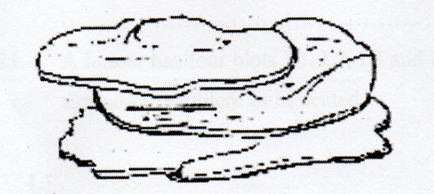

- Identify the soil structure illustrated above. (1 mark)

...............................................................................................................................................

- Give one way in which the structure illustrated above limit crop production.
(1 mark)

20. Study the illustration given below and use it to answer the questions that follow.
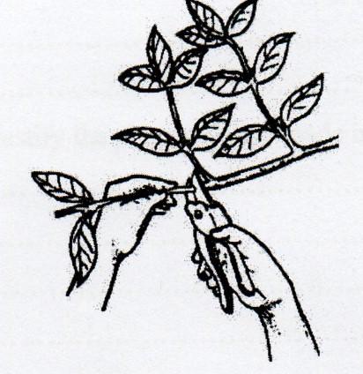
- Identify the operation illustrated above. (1 mark)

.........................................................................................................................................................

- State four reasons for carrying out the operation named in (a) above (2 marks)
(i) …………………………………………………………………………………………………
(ii) ………………………………………………………………………………………………….
(iii) …………………………………………………………………………………………………
(iv)………………………………………………………………………………………………….
21. A farmer has four plots L1, L2, L3 and L4 as shown in the table below. Each plot has an agronomic problem as indicated.

L1 L2 L3 L4
Infected with witch Infected with Deficient in Prone to soil
Weed bacterial Nitrogen erosion
(striga spp) wilt

Plan a crop rotation programme for the first year in the four plots using the following crops maize, Irish potatoes, Rhodes grass and Beans (2 marks)
L1………………………………………….
L2………………………………………….
L3…………………………………………..
L4…………………………………………..

(b). Give reasons to justify the plan you have made in plots L2, L3 and L4. (3marks)
L2……………………………………………………………………..……………………………………………………………………………………………………………………
L3…………………………………………………………………………..………………………………………………………………………………………………………………
L4…………………………………………………………………………………………………………………………………………………………………………………………
22. Mr. Mulamba was advised to apply 150kgCAN/ha, while topdressing his maize crop. CAN contains 21%N. Calculate the amount of nitrogen applied/ha (4 marks)
............................................................................................................................................................

............................................................................................................................................................

............................................................................................................................................................

...........................................................................................................................................................
............................................................................................................................................................

............................................................................................................................................................

............................................................................................................................................................

...........................................................................................................................................................

23. Observe the diagram below and answer the questions that follow.

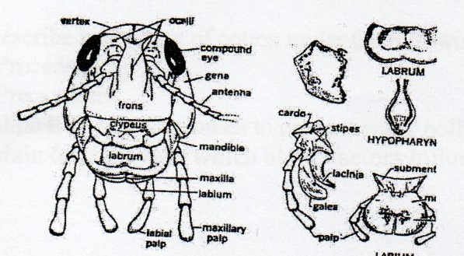

(a). Identify the mode of feeding exhibited by a pest having such features. (1 mark)

............................................................................................................................................................

(b). Name any two pests with the above feeding habits. (2 marks)

............................................................................................................................................................

............................................................................................................................................................

- (a) The diagram below shows a nursery management practice carried out on a tree seedling. Study it and answer the questions that follow.

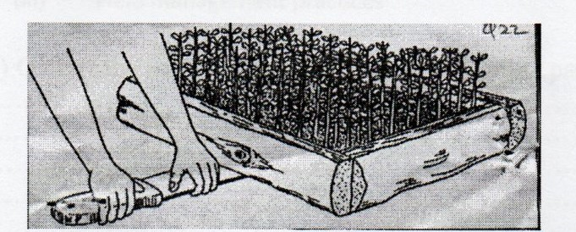

(a) Identify the management practice. (1 mark)
............................................................................................................................................................
(b). Give two reasons for carrying out the practice above. (2 marks)
(i)……………………………………………………………………………………………………
(ii). ………………………………………………………………………………………………..

SECTION C (40 MARKS)

Answer any two questions from this section in the spaces provided after questions.

25. (a) Describe harvesting of cotton under the following sub-headings
i. Procedure (3 marks)
ii. Precautions (4 marks)
(b). Outline five measures taken to prevent water pollution. (5 marks)
(c). Explain four ways in which biotic factors influence crop production in Agriculture
(8 marks)
26. (a). Explain five farming activities which may encourage soil erosion. (10 marks)
(b). Explain the importance of a nursery in crop propagation. (5 marks)
(c). Give the contributions of settlement schemes to agricultural development. (5 marks)

27. Describe the production of beans under the following subheadings:
(i). Field preparation (4 marks)
(ii). Planting (3 marks)
(iii). Field management practices. (5 marks)

(b). Outline the advantages of a mixed grass legume pasture over pure grass. (8 marks)
……………………………………………………………………………………

………………………………………………………………………………………

………………………………………………………………………………………

………………………………………………………………………………………

………………………………………………………………………………………

………………………………………………………………………………………

………………………………………………………………………………………

………………………………………………………………………………………

………………………………………………………………………………………

………………………………………………………………………………………

………………………………………………………………………………………

………………………………………………………………………………………

………………………………………………………………………………………

………………………………………………………………………………………

………………………………………………………………………………………

………………………………………………………………………………………

……………………………………………………………………………………….

………………………………………………………………………………………………………

………………………………………………………………………………………………………

………………………………………………………………………………………

……………………………………………………………………………………

………………………………………………………………………………………

………………………………………………………………………………………

………………………………………………………………………………………

………………………………………………………………………………………

………………………………………………………………………………………

………………………………………………………………………………………

………………………………………………………………………………………

………………………………………………………………………………………

………………………………………………………………………………………

………………………………………………………………………………………

………………………………………………………………………………………

………………………………………………………………………………………

………………………………………………………………………………………

………………………………………………………………………………………

………………………………………………………………………………………

……………………………………………………………………………………….

………………………………………………………………………………………………………

………………………………………………………………………………………………………

………………………………………………………………………………………
……………………………………………………………………………………

………………………………………………………………………………………

………………………………………………………………………………………

………………………………………………………………………………………

………………………………………………………………………………………

………………………………………………………………………………………

………………………………………………………………………………………

………………………………………………………………………………………

………………………………………………………………………………………

………………………………………………………………………………………

………………………………………………………………………………………

………………………………………………………………………………………

………………………………………………………………………………………

………………………………………………………………………………………

………………………………………………………………………………………

………………………………………………………………………………………

……………………………………………………………………………………….

………………………………………………………………………………………………………

………………………………………………………………………………………………………

……………………………………………………………………………………

………………………………………………………………………………………

………………………………………………………………………………………

………………………………………………………………………………………

………………………………………………………………………………………

………………………………………………………………………………………

………………………………………………………………………………………

………………………………………………………………………………………

………………………………………………………………………………………

………………………………………………………………………………………

………………………………………………………………………………………

………………………………………………………………………………………

………………………………………………………………………………………

………………………………………………………………………………………

………………………………………………………………………………………

………………………………………………………………………………………

……………………………………………………………………………………….

………………………………………………………………………………………………………

………………………………………………………………………………………………………

………………………………………………………………………………………

……………………………………………………………………………………

………………………………………………………………………………………

………………………………………………………………………………………

………………………………………………………………………………………

………………………………………………………………………………………

………………………………………………………………………………………

………………………………………………………………………………………

………………………………………………………………………………………

………………………………………………………………………………………

………………………………………………………………………………………

………………………………………………………………………………………

………………………………………………………………………………………

………………………………………………………………………………………

………………………………………………………………………………………

………………………………………………………………………………………

………………………………………………………………………………………

……………………………………………………………………………………….

………………………………………………………………………………………………………

………………………………………………………………………………………………………

………………………………………………………………………………………

……………………………………………………………………………………

………………………………………………………………………………………

………………………………………………………………………………………

………………………………………………………………………………………

………………………………………………………………………………………

………………………………………………………………………………………

………………………………………………………………………………………

………………………………………………………………………………………

………………………………………………………………………………………

………………………………………………………………………………………

………………………………………………………………………………………

………………………………………………………………………………………

………………………………………………………………………………………

………………………………………………………………………………………

………………………………………………………………………………………

………………………………………………………………………………………

……………………………………………………………………………………….

………………………………………………………………………………………………………

………………………………………………………………………………………………………

………………………………………………………………………………………

