2020 FORM 4 TERM 1 ENRTY EXAMS
MARKING SCHEME
FORM 4 AGRICULTURE PAPER 2
Section A (30MKS).
1.Name four methods of dehorning in cattle (2mks)
-Use of caustic potash stick
-Use of disbudding iron
-Use of dehorning saw/wire
-Use of rubber ring and elastrator
-Use of dehorning collodion
2. State the function of the following parts of a poultry digestive system(1mk)
Crop-store food temporarily and moisten it with water
Gizzard-crush and grind food into paste
3. State two functions of protein in animal nutrition (1mk)
Growth repair and replacement of worn out body tissues
Production of antibiotics which protect the animals from diseases
Production of digestive enzymes to break food particles
Production of certain hormones in the body
Production of such products like meat milk eggs and wool.
4.Name four bacterial diseases 2mks
Mastitis
-foot rot
-brucellosis
-scours
-black quarter
-anthrax
-pneumonia
5. Name two meat goats …1mks
-galla
-boer

6.Give four characteristics of a large white breed of pig (2mks)
-white in colour
-long and large
-skin may have a few blue spots
-ears are straight and erect
-has broad dished snout
-has strong hind legs

7. State four ways of restraining cattle during routine management (2mks)
-Use of ropes /halters/casting
-Use of bull stick and bull ring
-Use of crash
-Use of head yoke
- Use of holding/isolation pen/yard (4x ½ =2mks

8. What is meant by the following terms as used in livestock health?
(a) Incubation period
The duration between a disease causing organism infests /enters an animal and the time the first disease symptoms show (1mk)
(b) Mortality rate
The likelihood of death occurring in case of disease outbreak which is expressed as a percentage of the affected animals that dies (1mk)
9. Define the following terms as used in livestock rearing (2mks)
(a)pullet -young female bird from eight week to point of laying
B.cockrel-young male bird from eight week up to maturity
C.piglet-young one of a pig
c.sow -a mature female pig after first parturition
10. What is creep feeding (1mk)
It is the feeding of young animals from birth to weaning
11. State two meat breeds of sheep (2 mks)
-dorper
-black head persians
-red maasai sheep
12. Give microbial activities that take place in the rumen. ( 2mks)
-fermentation of food
-synthesis of vitamin B complex that is vitamin B1(thiamine)vitamB2,vitaminB6 and vitamin K
-Synthesis of amino acids from ammonia gas
-break down of protein to peptides, amino acid and ammonia
-breakdown of carbohydrate and cellulose to carbon dioxide and volatile fatty acids which includes acetic, formic acid etc
13.(a) State 4 functions of cabalt in animal’s body (2mks)
-synthesis of vitamin B12
-increases appetite of ruminant
(b)Name two classes of feedstuff
-roughages
-concentrates
14. Give 4 mechanical method of tick control ( 2mks)
-burning the invested pasture
-starving ticks to death
-fencing off the pasture land and farm
-hand picking and killing
-interfering with or alter the ticks environment
15. State structural requirements of a pig house (2mks)
-it should have concrete floor for easy cleaning
-it should be free from draught as pigs easily get pneumonia
-it should have adequate space for the pigs
-it should have a well drained floor
16. State 4 disadvantages of using spray race over cattle dip (2mks)
It has high operational cost
-it requires highly skilled labour to operate and maintain
-it is only economical with large herd
-in wet weather nozzles tend to clog with dirt in the wash
17. Give the uses of the following farm tools and equipments (2mks)
i) strip cup - test if a cow has mastitis
ii) milk strainer – used for removing sediments and hairs from milk
Iii) Hacksaw- used for cutting metal rods and plates
iv) Centre punch- marking points of drilling

Section B 20mks
18. Diagram G,H and J illustrates some livestock parasites
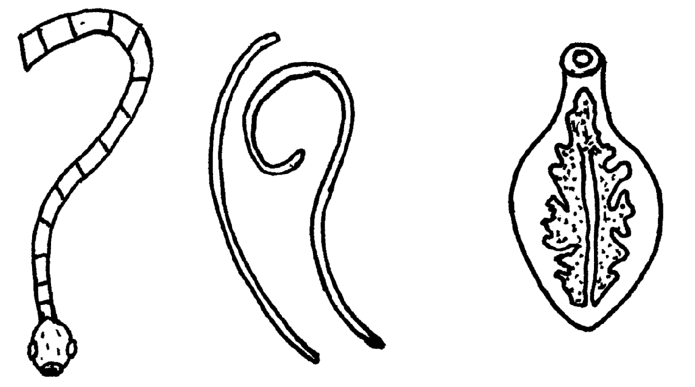

G
H
J

(a) Identify parasites G,H and J (3 mk
G-mature liver fluke
H-round worm
J-tape worm
(b) Name the parts of the host body where parasites G and J are found (1mk)
G- Bile duct, gall bladder, liver
J- Walls of the intestine
.
(c) Name the intermediate host of parasites G and J (2mk)
(G)- Water/ mud snail
(J)- Cattle, pigs
(d) Outline four symptoms of attack in livestock by parasite J (2mks)
- Rough coat
-Presence of parasite segments in faeces
-Excessive appetite
-Emaciation
-Constipation
-Pot belly
-Anemia
-Obstruction/blockage and intestines

19. The diagram below illustrates a hoof of a sheep. Study it carefully and answer the questions that follow
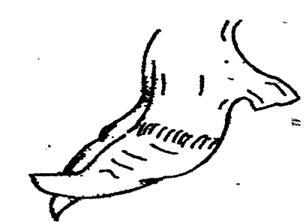

(a) Name the routine management practice that should be carried out on the hoof illustrated above(1mk)
Hoof trimming
(b) State two reasons for carrying out the management practice in (a) above (2mks)
-To prevent lameness/difficulty in walking
-To control foot rot
-To ease mating

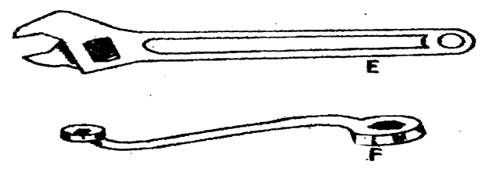
20. Study the diagrams of workshop tools shown below

(a) Identify the tools labeled E and F E-adjustable spanner
F-ring spanner (2x 1/2 =2mks)

(b) What functional advantage does tool E have over tool F? (1mk)
- Tool E can be used for tightening or loosening any size of nuts and bolts but E tighten nut of specific sizes

(c) Below is a diagram of a farm structure for storing grains. Study it carefully and answer the question that follows
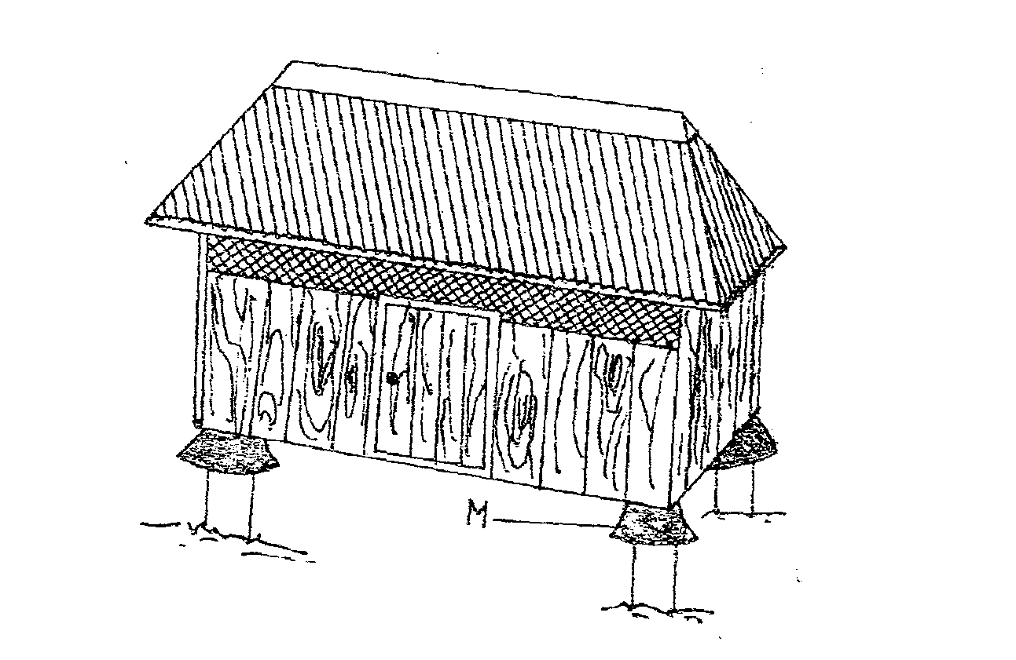

(i) Identify the farm structure illustrated above modern store (1mk)

(ii) State the function of the part labeled M
- prevent rodents from entering the house 1mks

(iii) State two maintenance practices that should be carried out on the farm structure illustrated above in readiness for grain storage
-Cleaning the store
-Dusting with pesticides
-Repair any leakages ( 2mks

21. Give four functions of a worker bee 2mks
-Make honey
-Protect the hive from intruders
-Collect nectars, pollen, tree resins, gums and water
-Build combs and seal the cracks and crevices in the hive
-Clean the hive
-Make honey and beewax

Section c

22(a) i) Describe seven signs of ill-health in livestock (7mks)
- Behavior of the animal- aggressiveness, over excitement or produces abnormal sound
-isolating from others/photophobic
-animal movement-limping/lameness/strained gait
-general appearance: restless, dull, less alert or less response to touch/abnormal posture
-skin/coat: ruffled/starry coat/loss or hair /dull skin/parts peeling off/cracking/ wounds/lesions/swellings
-mucous membrane: dull red/pale/dry/having copious discharge
-production/performance level: Sudden decline in production/performance/loss o weight and condition
-pulse rate: radical change from the normal range
-body temperature: abnormal temperature from the normal range/too high /too low
-urination: abnormal urine colour matter in terms of consistency/smell/colour, difficult urination/less or high frequency

(ii) Outline five uses of a crush in livestock rearing5mks
-Spraying livestock against parasites
-identification of animals
-vaccination
-dehorning
-pregnancy testing
-artificial insemination
-taking body temperature
-hoof riming
-milking
(b) (i) Name the causal organism of coccidiosis in poultry.
Protozoa /Coccidia of Eimeria species (1mk)

(ii) Apart from poultry name two other animals affected by the disease above. (2mks)
-Calves
-young rabbit
-kids
-lambs

(iii) Give five symptoms of the disease in poultry. (5mks)
-Diarrhea
-Dysentery or blood in the dropping.
-Birds have ruffled feathers.
-Birds become dull with drooping wings
-Feeding is affected
-Sudden death in birds

23. (a) Describe the procedure of processing honey wax (8mks

-Put combs whose honey has been extracted in to a basin
-add water to the basin
-heat the mixture till the wax melt
-Strain the mixture through muslin cloth
-Squeeze the residue strongly to force the wax out
-cool the mixture over night
-drain the water and remove any foreign particles
-Re-melt the wax over a water bath and put it in a clean container

(b) Outline five harmful effects of lice in livestock 4MKS

-Lice cause considerable irritation to the skin and this is usually shown by the animal rubbing itself against fixed objects
-Loss of health in case of heavy infestation
-Poor feeding leads to emaciation
-Loss of production in birds
-Restlessness and anemic condition mostly in poultry

(c) Explain five advantages of the top bar beehive 5mks
-the top bar can be removed for inspection of combs and replaced
-honey combs can be removed without disturbing the brood
-Honey of high quality is harvested without brood combs
-More wax is harvested as combs are not returned to the hive
-The hive is cheap to build and does not require expensive equipments to extract honey
-A queen excluder can be used in the centre of the hive to separate honey from the brood this giving quality honey
-It is easy to construct and repair
(d). Give three signs of heat in pigs (3mks)
-Restlessness
-Frequent urination
-Swelling and reddening of the vulva
-Clear / slimy mucous discharge from the vulva
-Frequent mounting on others

24. a) Explain six advantages of artificial insemination (A.I) in livestock breeding. (6mks)
-semen from one superior bull can be used to serve many cows
-It controls the transmission of breeding disease and parasites
-Sires that are unable to serve cows due to heavy weight or injury can produce semen to serve cows
-It prevents large bulls from injuring small cows
-It reduces the expenses of keeping a bull on pasture and veterinary bills semen can be stored for a long time even after the death of a bull
-It is easy to control inbreeding
-It eliminates dangerous bulls from far
-A small –scale farmer who cannot afford to buy a superior bull can have the cows served at a very low cost
(b) Give five categories of farm tools and equipment ( 5mks)
-Garden tools and equipment
-Workshop tools and equipment
-Livestock production tools and equipment
-Masionary tools and equipment
-Plumbing tools and equipment
-

c). outline five characteristics corriedale breed of sheep (5mks)
-has relatively high quality wool and meat
-polled and well covered with coarse wool
-has moderately long legs that are well covered with wool to the hooves
-produces wool of good length and low shrinkage
-The fleece weigh 5-5.5 kg ram weigh 84.2-90.6kg

d) practices carried out on fish before harvesting 4mks
-cleaning the fish to remove mud and any worms
-removing scale and slime
-opening the fish on the side to remove gut and the intestines(gutting)
-cleaning the abdominal carvity thouroughly
-keeping fish in opening containers

