FORM 4 PHYSICS
NAME:……………………………..……………..ADM:………………..DATE:…………..
- Some students wish to determine the focal length of a convex lens of thickness 0.6cm using an optical pin and a plane mirror. Figure 6 shows the experimental set up when there is no parallax between the pin and the image.
Plane mirror
20cm
Image of pin
Pin

Fig. 1
Determine the focal length of the lens (2 marks)

- Figure 2 shows an object O placed in front of a diverging lens whose principal focus is F.
F
O
Figure 2

On the diagram, draw rays diagram to locate the image formed. (3marks)

- A lens forms an image four times the size of an object on a screen. The distance between the object and the screen .is 100cm when the image is sharply focused.
- State with reason what type of lens is used. 1mk

- Calculate the focal length of the lens 3mks

- The figure below shows a stone of mass 450g rotated in a vertical circle at 3 revolutions per second. If the string has a length of 1.5m, determine:
B
A
O

(i) The linear velocity (3mks)

(ii) The tension of the string at position A (3mks)

b) On the same diagram indicate the path that the stone will follow if the string snaps at point B (1 Mk)
(c) A stone is whirled with uniform speed in horizontal circle having radius of 10cm. It takes the stone 10 seconds to describe an arc of length 4cm. Determine:
(i) The angular velocity ω (3mks)

(ii) The period T (3mks)

- a) State Archimede’s principle. (1 mark)

b) The figure below shows a cubic block of sides 4cm and density 800kg/m³ attached to the base of water by means of an inextensible thread. (Take g = 10m/s² and density of water as 1000kg/m³)
Determine;
- The weight of the block. (3 marks)

- Upthrust on the block. (3 marks)

- Tension in the thread. (2 marks)

- A 180w heater is immersed in a copper calorimeter of mass 100g containing 200g of alcohol. When the heater is switch on for 36 seconds the temperature of the calorimeter and its contents raises by 12⁰C. Determine the specific heat capacity of alcohol (Take specific heat capacity of copper = 400Jkg⁻¹K⁻¹). (3mks

- A bubble of air rising from the bottom of a bond doubles its volume just as it reaches the surface of the pond. Explain this observation. (2marks)

- The figure below shows a capacitor network setup.
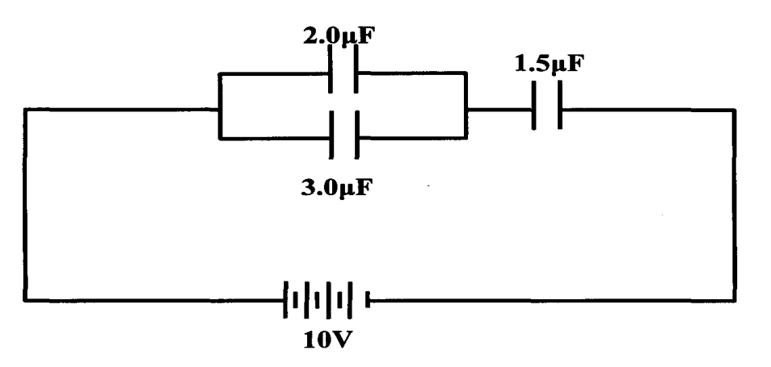
Calculate the charge stored by the 1.5 µ. F capacitor. (3mks)

- A box of mass 300kg is pulled along an inclined plane by a force of 2000N as show in figure 6
Determine the efficiency of the inclined plane. (3mks)

- State one importance of anomalous expansion of water. (1mk)

- Figure 15 below shows graphs of two objects A and B of the same mass dropped from the same height. Object A landed on a foam mattress while B landed on a concrete floor
(i) State which object had a higher force of impact. (1mk)

(ii) What does the area under each curve represent (1mk)

- (i) What is the difference between stationary and progressive waves (1mk)

(ii) State two distinctions between the way sound waves and electromagnetic waves are
transmitted. (2mks)

