**PHYSICS FORM TWO**

**NAME………Marking scheme………………ADM NO….................CLASS…………**

1. Express each of the following volumes in SI unit giving your answer in standard form(2marks)
2. 25000cm3

***2.5×10-2m3***

1. 0.5675cm3

***5.67510-7m3***

1. State the basic law of magnetism . (1mark)

***Like poles repel unlike poles attract.***

1. The figure shows an electromagnet. State the polarities at X and Y.(2 marks)



***X-South***

***Y-North***

1. Dust particles in air appear to move randomly, explain this observation.(1 marks)

***Due to uneven bombardment by invisible air particles or molecules in the air***

1. The diagram below shows a section of a micrometer screw gauge.

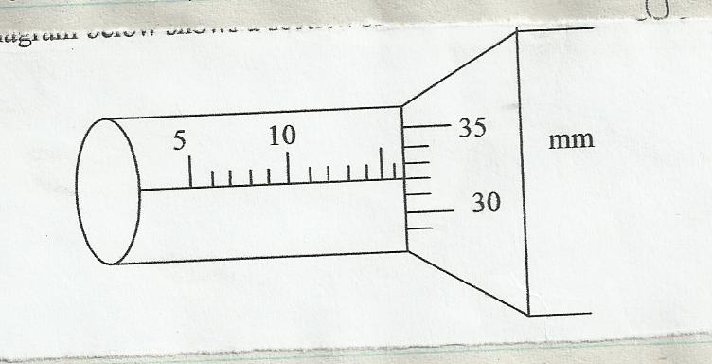

1. State the smallest measurement that can be made by the measurement that can be made by the micrometer screw gauge. (1 mark)

***1/100mmor 0.01mm***

1. (3 marks)

***Initials reading =16.32mm***

***0.25cm=2.5mm***

***Diameter=16.32-2.5=13.82mm***

1. State two properties of magnetic field lines (2marks)

***They originate from North Pole and end at the South Pole.***

***They repel each other side ways and form closed paths never intersecting other lines of forces.***

***They are closer together where the field is strongest***

1. A charge of 180coloumbs flows though a lamp every minute. Calculate- the current flowing through the lamp(3marks)

***Q=It***

***180C = 60I***

***I=3A***

1. The figure below shows part of a vernier caliper when the jaws are closed without an object between the jaws

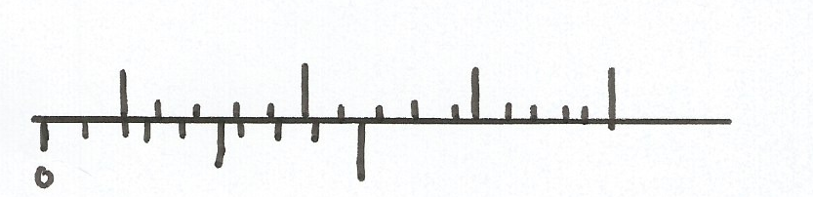

1. What is the value of the zero error of the calipers?(1mark)

**-0.02mm**

1. A student used the same vernier calipers in (a) above to measure the diameter of a test tube whose actual diameter is 2.15cm. What was the reading shown by the calipers(3marks)

***2.15=reading – error***

***2-15=reading + 0.02***

***Reading = 2.13mm***

1. Explain why repulsion is then sure test for polarity of a magnet(1mark)

***The polarity of a magnet can be tested by bringing both its poles, in turn, adjacent to the known poles of a suspended magnet. Repulsion only occurs between the like poles of a magnet. Attraction might occur between unlike poles and a magnetic material thus repulsion is the only sure way to test for polarity.***

1. Explain why a gold leaf is electroscope casing is made up of metal(1mark)

***Metal casing is for protecting the leaf from the effects of draught.***

1. explain the difference between magnetic and non magnetic materials (2marks)

***magnetic materials are those attracted by a magnet e.g iron***

***non magnetic materials are those not attracted by a magnet e.g plastic***

1. On the graph provided, sketch a graph of density against Temperature of a given mass of water(2 marks)

Densitynsity

Temperature

1. State two properties of a good thermometric fluid(2marks)

***Be easily seen (visible).***

***Expand or contract uniformly and by a large amount over a small range of temperature.***

***Not stick to the inside of the tube. (Should not wet the inside of the tube.***

***Have a wide range of temperature.***

1. State one application of magnets.(1mark)

***Magnets have a wide application in real life. For example in hospitals, they are used to remove a piece of iron from the eye.***

***They are used in making compasses, loudspeakers, telephone receivers, bicycle dynamos, generators and electric motors.***

1. I) angle of incidence=angle of reflection

ii) at the point of incidence, the incident ray,reflected ray and the normal line all lie on the same plane.