**FORM THREE MARKING SCHEME**

1. ***3/5 x 60 – 8/3 x 3/2  M1 simplification of***

***45/8 x 16/9 – 5/4 x 24/5 + 14/5 x 10/7 numerator***

***36 – 4 M1 simplification of***

***10 – 6 + 4 denominator***

***32/8 = 4***

1. ***33x x 3 (2x – 2) = 3 2(x + 2 )  M1 expressing in index form***

***3x + 2x – 2 = 2x + 4 M1 relating index***

***3x = 6***

***x = 2***

1. ***Exterior ∠ = 360***

***n***

***Interior ∠ = 180 - 360***

***n***

***180 – 360 = 5 ( 360/n ) M1***

***n***

***180n – 360 = 1800***

***n n M1***

***180n = 2160***

***n = 12 A1***

1. The dimensions of a brick are 2cm x 3.4cm x 6.42cm. Find the percentage error in the calculation of its area. (3 mks)

***Relative error = 0.5/2 + 0.05/3.4 + 0.005/6.42 = 0.26548 .......m1***

***Working Product = 2 x 3.4 x 6.42 =43.656.............m1***

***Percentage error = 0.26548/43.656 x 100 = 0.608%............A1***

1. Masses of three babies was stated as a=12.7kg, b=9.8 kg and c=3.20kg. find the relative error in the following expressions:
2. a+b-c (3mks)

***Absolute error = 0.05 + 0.05 + 0.005 = 0.105.......m1***

***Working (a+b-c)= 12.7+9.8-3.2 = 19.3.............m1***

***Relative error = 0.105/19.3 = 0.005440..............A1***

1. c÷ab (3mks)

***Relative error = 0.05/12.7 + 0.05/9.8 + 0.005/3.2 = 0.01060***

1. Find the relative error in using 0.3 as the estimate of 1/3. (2mks)

***Absolute error = 1/3 – 3/10 =1/30..................m1***

***Relative error = 1/30 ÷ 1/3 = 1/10...................m1***

1. Find the length of **AC** of triangle **ABC** in which **AB**=5cm, <**ABC**=1510 and <**BCA**=130. (3mks)

**1510**

**130**

**5/ Sin 13= AC/ Sin 151 m1**

**AC = 5Sin 151/Sin 13 m1**

**=10.78cm A1**

**A**

**B C**

1. In a triangle **LMN**, <**L**=810, **n**=4.3cm and **m**=3.5cm. Calculate
2. Length ***l*** (2marks)
3. Angles **M** and **N** (3marks)

**M**

**N**

**L**

**3.5cm**

**4.3cm**

810

1. ***L2 = 4.32 + 3.52 – 2 x 4.3 x 3.5Cos810 M2***

***L = 5.10 cm***

***5.1/ Sin 81 = 4.3/Sin N***

***Sin N = 4.3Sin81/5.1***

***Sin N = 0.8328 M2***

***N = 56.380***

***M = 180 – (81+56.38) =42.620 A1***

1. In triangle **ABC**, <**B**=610, and **b** = 5.3cm. find the radius of the circle passing through the vertices **A**,**B** and **C** (3marks)

***5.3/Sin 61 =2R***

***R = 5.3/2 Sin 610***

***R = 3.03 cm***

1. ***(a) Modal class 150 – 154 B1***

***Class f cf***

***140 – 144 3 3 B1 C.F***

***145 – 149 16 19***

***150 – 154 20 39***

***155 - 159 10 49***

***160 – 164 1 50***

***M = L + n/2 – c x i***

***f***

***= 149.5 + 25 – 19 x 5***

***20 M1***

***= 151***

1. Use completing square method to solve for X in.

½ x2 – 5/2x + 1 =0 (3marks)

***x2 – 5x + 2 =0***

***x2 – 5x + C =-2 + C***

***x2 – 5x + (5/2)2 =-2 + 6.25***

***(x – 5/2)2 = 4.25***

***X – 2.5 = ±2.061***

***X = ±2.061 + 2.5***

***X= 2.561 or 0.439***

22. x -4 -3 -2 -1 0 1 2 3 4 5

y -14 -6 0 4 6 6 4 0 -6 -14 B2 b1 for 4 √ values

1. Graph 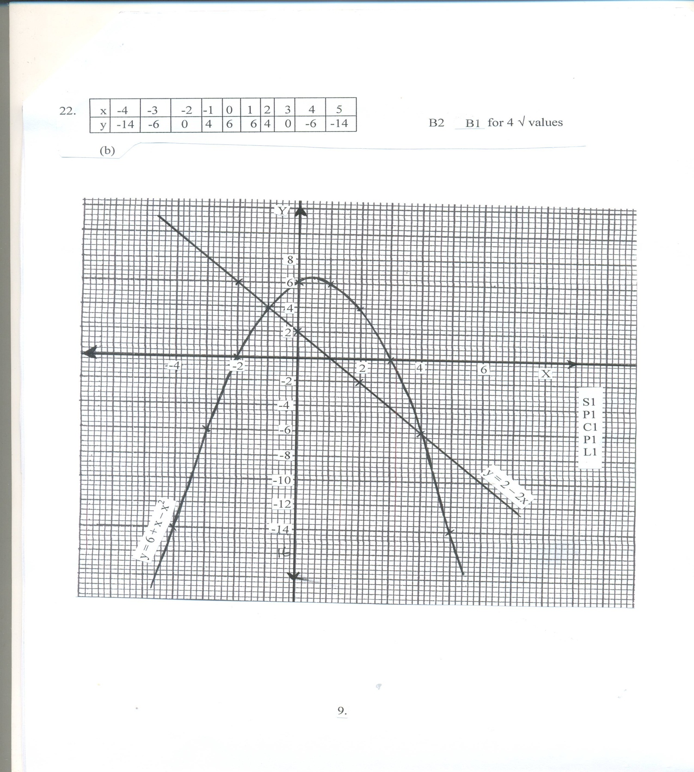

8

(d) x =-1 or x = 4 B1

(e) (x + 1 ) ( x – 4) = 0 M1

x2 – 4x + x – 4 = 0

x2 – 3x -4 =0 A1

10