FORM TWO GEOGRAPHY

NAME…………………………………………CLASS……ADM NO……….
- (a) What are earth movements? ( 1marks)
...............................................................................................................................................................................................................................................................................................................................................................................................................................................
(b) Outline four causes of earth movements (4marks)
……………………………………………………………………………………………………………………………………………………………………………………………………………………………………………………………………………………………………………………………………………………………………………………………………………………………………………………………………………………………………………………………………………………………………………………………………………..
(c) Differentiate between horizontal and vertical earth movements (2marks)
……………………………………………………………………………………………………………………………………………………………………………………………………………………………………………………………………………………………………………………………………………………………………………………………………………………………………………………………………………………………………………………………………………………………………………………………………………………………………………………………………………………………………………..
- Describe the theory of continental drift (5marks)
................................................................................................................................................................................................................................................................................................................................................................................................................................................................................................................................................................................................................................................................................................................................................................................................................................................................................................................................................................................................................................................................................................................................................................................................................................................................................................................................................................................................................................................................................................................................................................................................................................................................................................................................................................................................................................................................................................................................................................................................................................................................................................................................................................................................................................................................................................................................................................................................................................................................................................................................................................................................................................................................................................................................................................................................................................................................................................................................................
- The diagram below represents a tectonic plate boundary
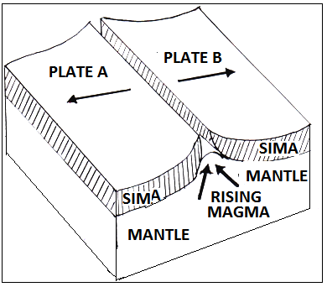
- Identify the type of tectonic plate boundary represented (1mark)
………………………………………………………………………………………………………………………………………………………………………………………………….
- Name three featured formed along the tectonic plate boundary represented by the diagram
(3marks)
……………………………………………………………………………………………………………………………………………………………………………………………………………………………………………………………………………………………………………………………………………………………………………………………………..

- (a) Define the term folding. (2marks)
......................................................................................................................................................................................................................................................................................................................................................................................................................................................................................................................................................................................................
(b) Give two factors that determine the extent of folding (2marks)
………………………………………………………………………………………………………………………………………………………………………………………………………………………………………………………………………………………………………………………………………………………………………………………………………..
(c) State two differences between symmetrical and asymmetrical folds. (4marks)
………………………………………………………………………………………………………………………………………………………………………………………………………………………………………………………………………………………………………………………………………………………………………………………………………………………………………………………………………………………………………………………………………………………………………………………………………………………………………………………………………………………………………………………………………………………………………………………………………………………………………………………………………………………………………………………
- Explain three problems facing gold mining in south Africa (6marks)
………………………………………………………………………………………………………………………………………………………………………………………………………………………………………………………………………………………………………………………………………………………………………………………………………………………………………………………………………………………………………………………………………………………………………………………………………………………………………………………………………………………………………………………………………………………………………………………………………………………………………………………………………………………………………………………………………………………………………………………………………………………………………………………………………………………………………………………………………………………………………………………………………………………………………………………………………………………………………………………………..

