MARKING SCHEME
- (a) What are earth movements? (1marks)
- Earth movements are motions that occur within rocks of the crust due to tectonic forces
(b) Outline four causes of earth movements (4marks)
- Magma movement within crustal rocks
- Convection currents within the mantle
- Isostastic adjustment of crustal rocks
- Collapsing of crustal rocks due to gravitative pressure.
(c)Differentiate between horizontal and vertical earth movements (2mrks)
- Horizontal earth movements are motions that operate along a lateral plane within crustal rocks causing them to shorten ,stretch or shear whereas vertical earth movements operate along the earth’s radius either towards the interior or towards the earth surface
- Describe the theory of continental drift (5marks)
- According to Wegener, the earth was initially a single landmass called pangaea.
- Pangaea was surrounded by a sima floored ocean called panthalassa
- During the late pre-cambrian, Pangaea split to form two super continents called laurasia and Gondwanaland.
- The two were separated by a narrow ocean called tethy’s
- Laurasia split during the Mesozoic era to form Eurasia and North America.
- Gondwanaland split later to form Africa, south America, Australia, Antarctica Arabia and India.
- Africa and India drifted Northwards to their present day location Australia drifted Eastwards the Americas westwards while Antarctica and Eurasia remained relatively static

- The diagram below represents a tectonic plate boundary
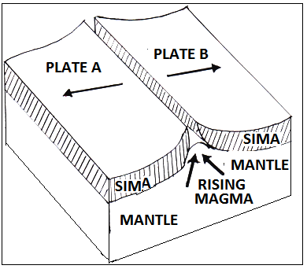
- Identify the type of tectonic plate boundary represented (1mark)
Extensional boundary
- Name three features formed along the tectonic plate boundary represented by the diagram (3marks)
- Rift valleys
- Mid-ocean ridges
- Sub-marine volcanoes
- Volcanic islands
- ( a) Define the term folding (2marks)
- Folding is the process through which young sedimentary rocks bend upwards or downwards due to compressional forces
- Folding is a process of crustal distortion which causes crustal rocks to bend upwards or down wards.

(b) Give to factors that determine the extent of folding (2marks)
- The strength of the compressional forces
- The amount of nature of rocks (rock resistance)
(c) State two differences between symmetrical and asymmetrical folds (4marks)
- Symmetrical folds form due to compression forces of equal magnitude while asymmetrical folds occur due to compressional forces of unequal magnitudes.
- In symmetrical folds, both limbs slope uniformly from the axis whereas in asymmetrical folds, one limb is steeper while the other is gentle.
- Explain three problems facing gold mining in south Africa (6marks)
- Shortage of water
- high cost of mining
- Decreasing quality of gold
- Exhaustion of gold in some mines
- Increasing depth of mines
- Shortage of skilled labour (to be well explained)

