NAME: …………………………………………………….CLASS: …….. ADM.NO. : ………..

CHEMISTRY FORM TWO

- Fractional distillation of liquid air is usually used to separate various gaseous mixtures in air. Explain how to;
- Remove carbon (IV) oxide. (1mk)

- Remove water. (1mk)

- Obtain nitrogen. (1mk)

- The diagrams below represent two iron nails with some parts covered tightly with zinc and tin respectively. What observations would be made at the exposed points R and Z if the wrapped nails are left in the open for several days? Explain.
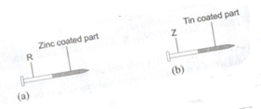
- The Diagram below is set-up for the laboratory preparation of oxygen gas.
Hydrogen peroxide
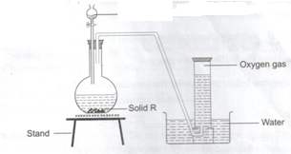

- Name solid R

- Write an equation for the reaction that takes place in the flask. (2mks)

- Give one commercial use of oxygen. (1mk)

- An element y has an electron arrangement of 2.8.5
- State the period and group which the element belongs. (2mks)

- Write the formula of the most stable ion formed when the element Y ionizes (1mk)

- Explain the difference between the atomic radius of element Y and its ionic radius (2mks)

- Lithium has two isotopes with mass numbers 6 and 7. If the R.A.M (relative atomic mass) of Lithium is 6.94, determine the percentage abundance of such isotope.

- Other than their location in the atom, name two other differences between an electron and a proton.(2mks)

- Write down the electronic configuration of the atoms with the following atoms with the following atomic numbers(2mks)
- 7
- 9
- 14
- 18
- An atom of an element has the electronic configuration 2.8.2
a) State its atomic numbers

b) To which group of the periodic table does it belong? Explain.

c) Is the element a metal or a non-metal? Explain (1mk)

d) If the atom has 14 neutrons in its nucleus state its mass number. (1mk)

- Rubidium (Rb) is a member of the alkali metals. Predict how the element reacts with: (3mks)
- Water

- Air

- Chlorine

- Briefly explain the following observations.
- Noble gases are generally unreactive. (1mk)

- Alkaline earth metals are generally less reactive than alkali metals in the same period. (2mks)

