FORM FOUR BIOLOGY
1.Distinguish between transcription and translation as used in genetics (2mks)
Transcription:synthesis of RNA using a DNA template
Translation:transfer of genetic information from m-RNA to the sequence of amino acids in proteins
2.a)Using one example in each case distinguish between continuous and discontinuous variation (2mks)
A type of variation that exhibits a wide range of differences for the same characteristic e.g height, skin colour ,IQ , leaves among others.
Discontinuous variation :a type of variation with definite distinct groups of individuals with no intermediate form e.g sex,tongue rolling abo blood group among others
b)-meiosis
independent assortment of homologous chromosomes
crossing over ; fertilization ; mutations
non-disjunction;
c)Parental Phenotype:
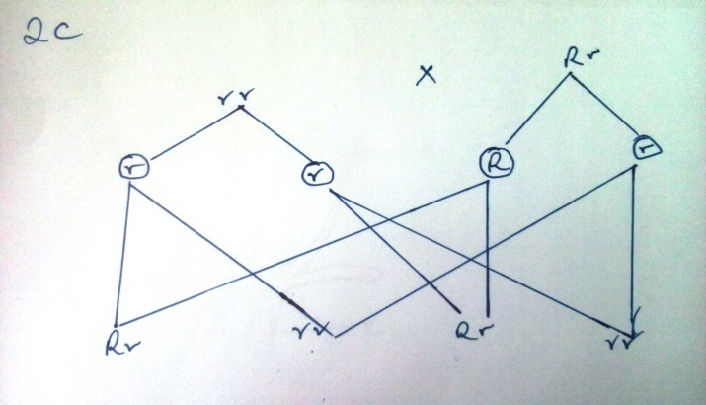
Chance for non-roller child 50% or 1/2

3. State three causes of variations (3mks)
-meiosis/gamete formation
-Independent assortment of homologous chromosomes
-Crossing over; fertilization; mutations
-Non disjunction; environmental conditions
c) If a woman who cannot roll her tongue marries a man who is a tongue roller but is the son of a non roller father what would be the chance of them producing a non roller child?(Ability to roll the tongue id dominant to non roller) (5mks)
parental phenotypes; non roller female roller man
incomplete :its where the body form changes gradually
complete :Its whereby change in body form is radical i.e a very different body result
b) Outline the stages of metamorphosis in:(2mks)
- Coakroach:egg-nymph-adult
- Housefly:egg-larva(maggot)-pupa-adult
c) What is meant by the term apical dorminance?(1mk)
inhibitory influence of the apical bud on the lateral buds below the apex
4 For each of the following traits state whether it is continuous or discontinuous (5mks)
Characteristic type of variation
- Size of the breast continuous
- Blood groups in man discontinuous
- Finger prints discontinuous
- Size of cobs in maize continuous
- Ability to taste phenythiourea discontinuous
Explain the meaning of the following terms in human reproduction (3mks)
- Implantation-attachment of the young embryo (blastocyst) to the wall of the uterus(endomentrium)

- Ovulation
Release of mature ovum from the ovary
- Parturition
Expulsion of the mature foetus out of the uterus (giving birth)
In a certain species of plants ,the gene for red flowers in codominant to the gene for white flowers. In one experiment of such plants all F1 plants had pink flowers.
a)using appropriate letter symbols work out the genotypes of the F1 off springs(4mks)
parental phenotypes: RR-red flowers WW- white flowers
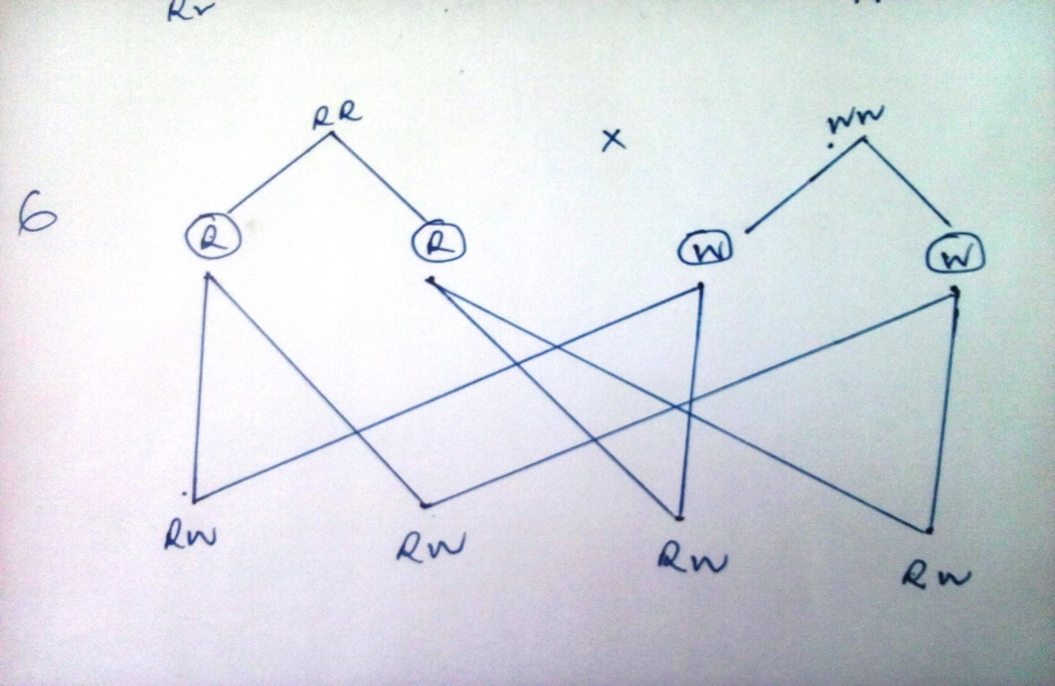
b)if one of the F1 offspring who crossed with a white parent, what would be the phenotypic ratio of their offspring (3mks)

c)what type of cross shown by the set up in (b) (1mk)
back cross - reject test cross
7 the diagram below represents a mixture of bread mould
Name the structures A,B and C (3ks)
A- SPORE
B-SPORANGIUM
C-RHIZOID
b)what is the physiological significance of having testes outside the body of the human male?(2mks)
The process of sperm formation requires a lower temperature than the usual body temperature
c) What do you understand by the term double fertilization in plants? (2mks)
it is a phenomenon in flowering plants where two male nucleus enter the embryo sac.one fuses with the egg cell to form a zygote while the other fuses with the polar nuclei to form a triploid primary endosperm.
a)What are the possible genotype of
- the manX^{h}Y (1mk)
- the womanX^{H}X^{h} .(1mk)
b) Showing your working find out the possible genotypes of their F1(4mks)
c) what is the probability that their first born son is haemophilic (1mk)

½ or 50%

what is the probability that their first born child is normal?(1mk)

¼ or 25%

d)describe how a breeder can know the genotype of F1 showing dominant phenotype (2mks)
by undertaking a test cross using homozygous recessive of the trait

