NAME: ……………………………….. ADM NO: …………. CLASS: …………….

FORM FOUR BIOLOGY

- Distinguish between transcription and translation as used in genetics (2mks)

- Using one example in each case distinguish between continuous and discontinuous variation (2mks)

- State three causes of variations (3mks)

- A woman who cannot roll her tongue marries a man who is a tongue roller but is the son of a non roller father what would be the chance of them producing a non roller child?(Ability to roll the tongue id dominant to non roller) (5mks)

- a) Explain the difference between incomplete and complete metamorphosis(2mks)

b) Outline the stages of metamorphosis in:(2mks)
(i). Cockroach

(ii). Housefly

c) What is meant by the term apical dominance? (1mk)

- For each of the following traits state whether it is continuous or discontinuous (5mks)
Characteristic type of variation
- Size of the breast …………………………….
- Blood groups in man …………………………….
- Finger prints ……………………………
- Size of cobs in maize …………………………..
- Ability to taste phenythiourea …………………………..
Explain the meaning of the following terms in human reproduction (3mks)
- Implantation.

- Ovulation.

- Parturition.

7. In a certain species of plants, the gene for red flowers in codominant to the gene for white flowers. In one experiment of such plants all F1 plants had pink flowers.
a) Using appropriate letter symbols work out the genotypes of the F1 off springs(4mks)

b)If one of the F1 offspring was crossed with a white parent, what would be the phenotypic ratio of their offspring (3mks)

c)what type of cross is shown by the set up in (b) (1mk)

- The diagram below represents a mature bread mould
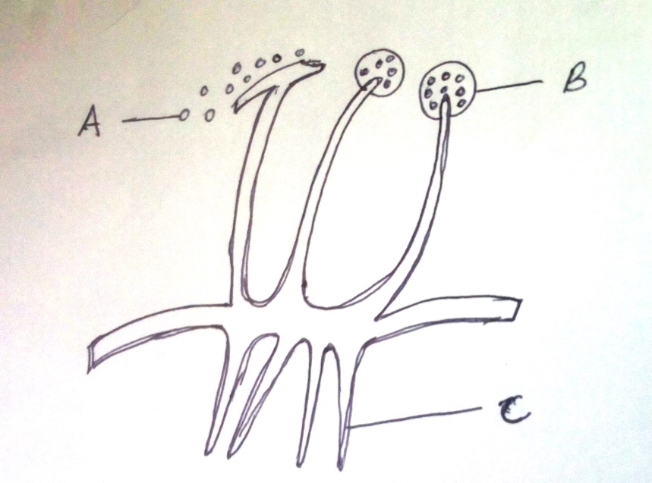
Name the structures A,B and C (3Mks)
A……………………….
B…………………………
C…………………………..

b)what is the physiological significance of having testes outside the body of the human male?(2mks)

c) What do you understand by the term double fertilization in plants? (2mks)

8). In human haemophilia, is a sex linked ,caused by recessive gene which exerts its effect when in homozygous state.A man whose mother was haemophilic marries a normal woman whose father was haemophilic. H represents non haemophilic , h represents haemophilia
a)What are the possible genotype of
- The man…………………(1mk)

- The woman………………….(1mk)

b) Showing your working, find out the possible genotypes of their F1. (4mks)

c)(i) what is the probability that their first born son is haemophilic (1mk)

(ii)what is the probability that their first born child is normal?(1mk)

d) Describe how a breeder can know the genotype of F1 showing dominant phenotype (2mks)

