NAME: ……………………………….. ADM NO: …………. CLASS: …………….
FORM TWO BIOLOGY

Answer all the questions in the spaces provided.

1. The diagram below represents these pathways of water from the soil into the plant.

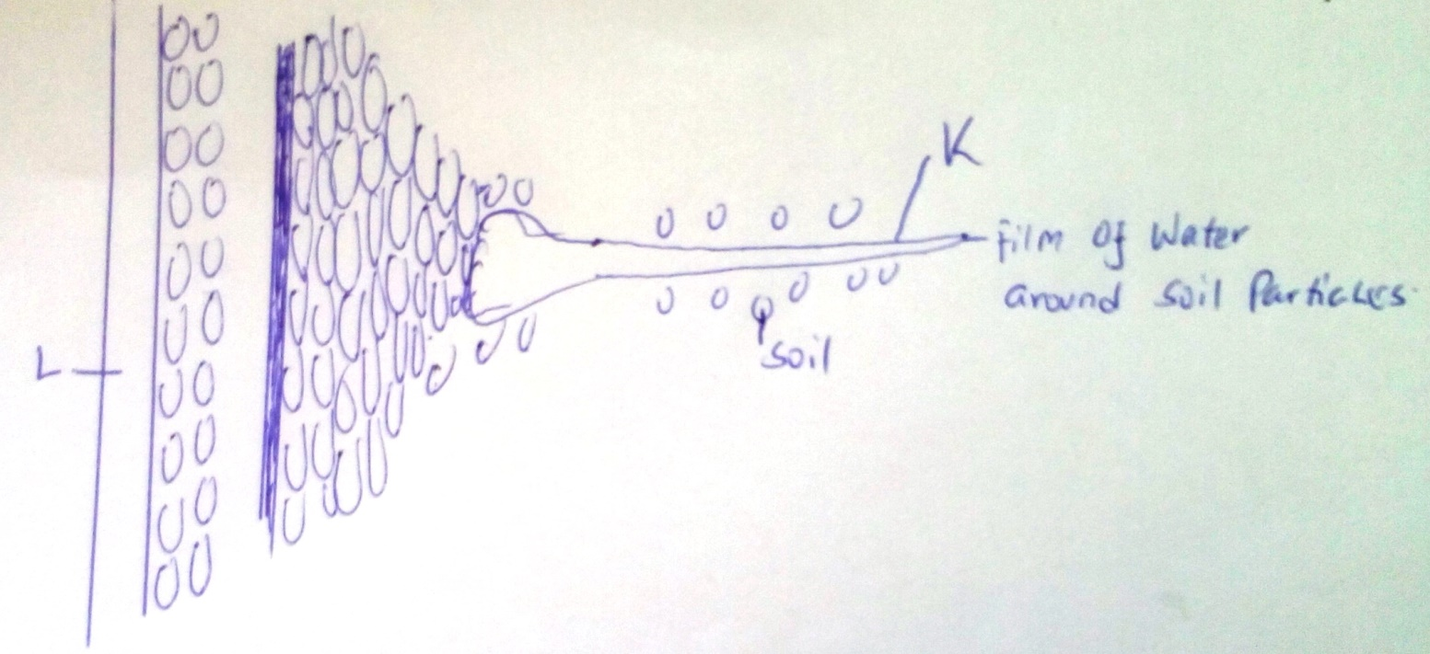

(a) Name the structures labeled K and L. (2 mks)

(b) Explain how water from the soil reaches the structure labeled L. (5 mks)

(c) Name the process by which mineral salts enter into the plant. (1 mk)

2. State four ways in which xylem vessels are adapted to their functions. (4 mks)

3. Name two processes that bring about the translocation of manufactured food. (2 mks)

4. Name three significance of transpiration. (3 mks)

5. State three structural factors affection affecting the rate of transpiration in plants. (3 mks)

6. The diagram below shows a cross section of a dicotyledonous plant. Use it to answer the questions
that follow.

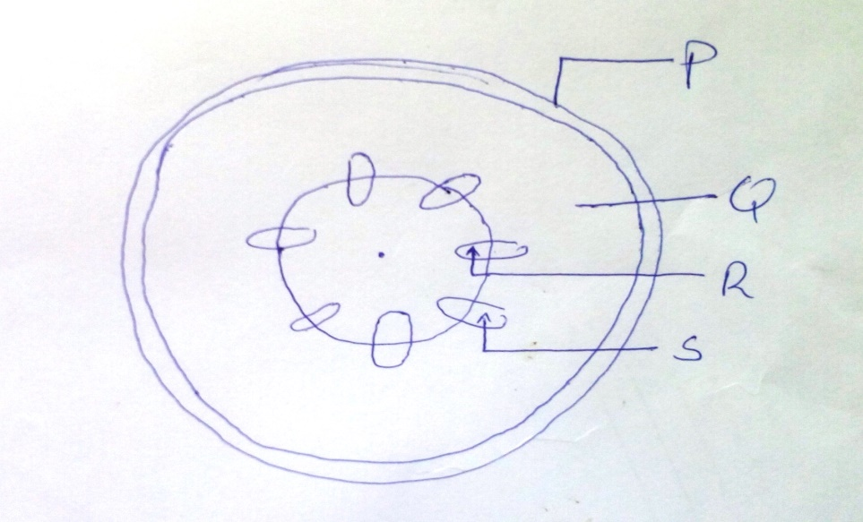

(a) Identify three parts labeled P, Q, R and S. (4 mks)

(b) State the functions of the parts labeled R and S. (3 mks)

7. What is the function of carnassials teeth. (2 mks)

8. Distinguish between the term homodont and heterodont. (3 mks)

9. State two functions of bile juice in the digestion of food. (2 mks)

10. Plant cell do not burst when immersed in distilled water. Explain. (2 mks)

11. Describe what happens during the light stage of photosynthesis. (3 mks)

12. State and explain three factors that affect enzymatic activities. (6 mks)

13. State the functions of the following organelles:
(i) Ribosomes (1 mk)

(ii) Lysosomes (1 mk)

14. Name two dental diseases. (2 mks)

15. Give three characteristics of a cell membrane. (3 mks)

