AGRICULTURE
FORM 3
NAME………………………………………………………….ADM………CLASS…… DATE………
- Define the following terms as used in livestock breeding (2mks)
- Hybrid Vigour (Heterosis)

- Epistasis

- Outbreeding

- Close breeding

- Outline four factors to consider when selecting a breeding stock (4mks)

- State any two disadvantages of inbreeding (1mk)

- List any four signs of heat in cattle (2mks)

- Just before birth, a farmer noticed that the hind legs and the tail of a calf were showing at the vulva.
- What name is given to this type of presentation? (1mk)

- Suggest a precaution the farmer should take under such conditions (1mk)

- State the common signs of parturition in Sows (2mks)

- Differentiate between the following Livestock management practices (2mks)
- Crutching and Ringing

- Flushing and steaming-up

- State four methods of identification in livestock production.( 2mks)

9. a) Name two types of castration (1mk)

b) Name any two kinds of livestock where a rubber ring can be used for castration (1mk)

9. Highlight any five general methods of disease control (5mks)

10. The diagram below shows the reproductive system of a hen.
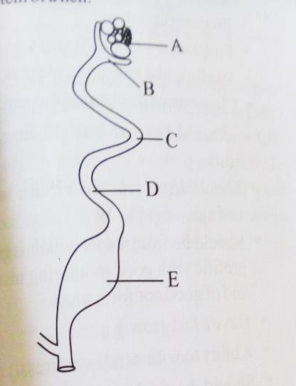
- Name the parts labeled B, C , D and E (2mks)

- In which part does fertilization of the ova take place ( 1mk)

- State the roles of C and E in egg formation (2mk)

10. State the gestation period for each of the following animals (2mks)
a.) Cow

b.) Sow

c.) Ewe

d.) Rabbit

11. State the advantages of using organic mulch in farming (4mks)

12. Give four reasons that would cause swarming of bees (4mks)

13. Calculate the amount of K₂O that would be contained in 600kg of a compound fertilizer, 30:20:10(N: P₂O₅: K₂O respectively) (3mks)

14. Name two common methods of preserving fish (1mk)

15. Below is a method of identifying a cow
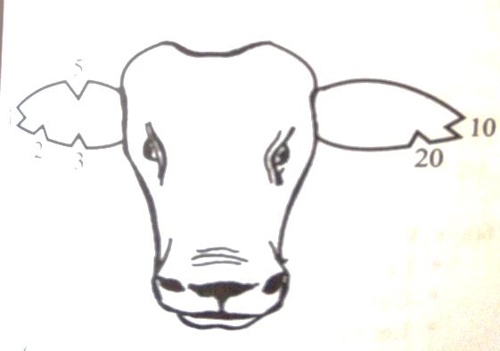
- Name the method of identification illustrated above (1mk)

b. name the tool used to carry out the practice ( 1mk)

c. From the diagram state the number of the animal (1mk)

d. Using the diagram, illustrate how you would identify an animal number 18

e. State any four reasons for carrying out identification of animals. (2mks)

15.Name four predisposing factors of animal diseases within an animal’s body.( 2mks)

16. Why is the use of manure discouraged in carrot production? (1mk)

17. Name two types of bees kept by the farmers (1mk)

