AGRICULTURE
FORM 3
- Define the following terms as used in livestock breeding (2mks)
- Hybrid Vigour (Heterosis)
This refers to increased vigour and performance resulting from crossing two unrelated superior breeds.

- Epistasis
This is the combination of genes which could have otherwise been inferior or undesirable
- Outbreeding
Mating of animals which are not related
- Close breeding
Breeding of very closely related animals

- Outline four factors to consider when selecting a breeding stock (4mks)
Age- young animals that have not given birth more than three times
Level of performance- select highly productive animals
Physical fitness- select animals free from physical defect
Health- select only healthy animals
Behavior- cull animals with bad behaviors
Good mothering ability
Well adapted to environment
Highly prolific
Select animals producing high quality products
- State any two disadvantages of inbreeding (1mk)

Loss of hybrid vigour
Decline in fertility
Reduction in performance
High pre-natal mortality

- List any four signs of heat in cattle (2mks)
Mounting on others and standing still when mounted
Slight rise in body temperature
Drop in milk yield
Swelling and reddening of the vulva
Slimy discharge from the vulva
Mooing frequently

- Just before birth, a farmer noticed that the hind legs and the tail of a calf were showing at the vulva.
- What name is given to this type of presentation? (1mk)
Breech Presentation/ malpresentation
- Suggest a precaution the farmer should take under such conditions (1mk)
Assist the cow by repositioning to normal presentation
Consult or seek the services of a qualified veterinary office

- State the common signs of parturition in Sows (2mks)
Restlessness
Vulva turns red and swells
The udder becomes full with milky fluid
Sow builds a nest

- Differentiate between the following Livestock management practices (2mks)
- Crutching and Ringing
Crutching is the cutting of wool around the reproductive system of the ewe while ringing is the shearing of wool around the sheath of the ram around the service
- Flushing steaming-up
Flushing – giving animal high nutritive feed before service while steaming up is the practice of giving an animal extra feed of high nutritive value during the last weeks of gestation.
- State four methods of identification in livestock production.( 2mks)
Branding
Tattooing
Neck strap / chain
Ear tagging
Ear notching
9. a) Name two types of castration (1mk)
Open
Closed
b)Name any two kinds of livestock where a rubber ring can be used for castration (1mk)
Bull, ram, Buck
9. Highlight any five general methods of disease control (5mks)
Proper selection and breeding
Proper housing
Parasite control
Proper disposal of carcass
Imposition of quarantine
Observing high degree of hygiene
Isolation
Proper feeding and nutrition
Treatment, prophylaxis and vaccination
10. The diagram below shows the reproductive system of a hen.
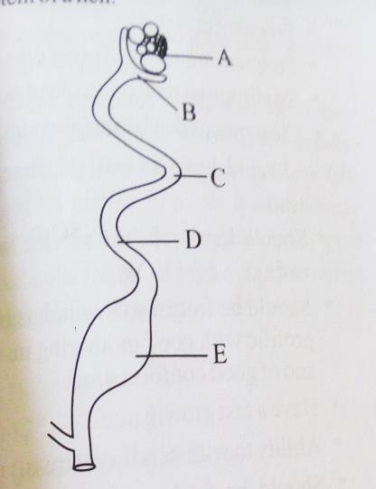
- Name the parts labeled B, C , D and E (2mks)
B-Funnel/ infundibulum
C- Magnum
D- Isthmus
E- Uterus/ shell gland
- In which part does fertilization of the ova take place ( 1mk)
B
- State the roles of C and E in egg formation (2mk)
C- Addition of thick albumen
E- Addition of the shell and shell pigments and more albumen
10) State the gestation period for each of the following (2mks)
a. Cow
270-285 days
b. Sow
113-117 days
c. Ewe
150 days
d. Rabbit
28-32 days
11. state the advantages of using organic mulch in farming( 4mks)
Reduces loss of moisture
Improves soil fertility after decomposition
Reduces splash erosion
Regulates soil temperature
Improves soil humus
Improves water infiltration
Helps to control pests
Improves soil structure
12. Give four reasons that would cause swarming of bees (4mks)
Overcrowding
Sick / infertile queen
Dampness
Lack of adequate ventilation
Shortage of food and water
Outbreak of parasites and diseases
13. Calculate the amount of K₂O that would be contained in 600kg of a compound fertilizer, 30:20:10(N: P₂O₅: K₂O respectively) ( 3mks)
10kg K₂O is contained in 100kg of the fertilizer;
600kg fertilizer=10/100 *600
=60 Kg K₂O
14. Name two common methods of preserving fish (1mk)
Sun drying
Smoking
Salting
Freezing/ refrigeration
15. Below is a method of identifying a cow
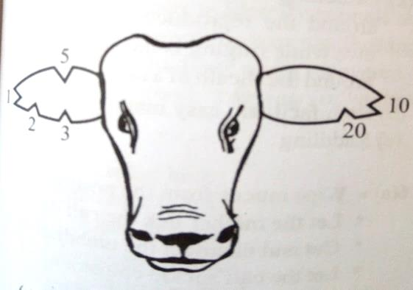
A0 Name the method of identification illustrated above (1mk)
Ear notching
b. name the tool used to carry out the practice ( 1mk)
Ear notcher
c. From the diagram state the number of the animal (1mk)
41
d. Using the diagram, illustrate how you would identify an animal number 18
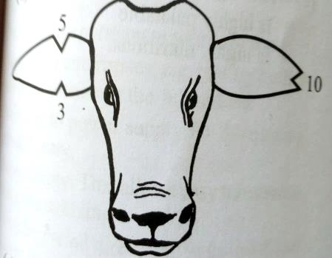
e. State any four reasons for carrying out identification of animals. (2mks)
Allows selection of breeding purposes
Enables culling of low producing animals
Facilitates appropriate treatment of animals
Stolen animals are easily recovered
Enhances good record keeping
Enhance proper feeding
15.Name four predisposing factors of animal diseases within an animal’s body.( 2mks)
Age of the animal
Color of the animal
Sex of the animal
Breed of the animal
Presence of wounds
Body conformation
Physiological conditions
16. Why is the use of manure discouraged in carrot production? (1mk)
It induces forking of carrots hence reducing the quality of the produce
17. Name two types of bees kept by the farmers (1mk)
African bee
European bee

