AGRICULTURE
FORM 4
Answer all questions
- Define egg candling as used in poultry production (1mk)
Method of examining the internal conditions of an egg for abnormalities by looking at it against a strong light in a dark room
- State four conditions necessary for artificial incubation (2mks)
Temperature
Fresh air/ ventilation
Relative humidity
Egg turning
- Highlight any five advantages of battery cage system in poultry production (5mks)
Higher egg production
Accurate egg records can be kept
Cannibalism and egg eating is minimized
Clean eggs
System can be mechanized
No food and water contamination
No bullying during feeding
Many birds can be kept in a small space
- State any two causes of stress in poultry and for each give a control measures (2mks)
Sudden change in routine; enhance gradual routine change programme
Sudden noise i.e from tractors ; build poultry house away from road or where people pass
Lack of feed and water; provides enough feed and water
Infestation of diseases and paraises; control parasites and diseases
- State the different ways of controlling cannibalism among layers in deep litter system (4mks)
Keeping the birds easy
Keeping the birds easy
Ensure poultry house is dimly lit
Control external parasites
Isolating and trweating birds with injuries
Debeaking
Provider a balanced ration
Cull cannibals
- What qualities should eggs meant for incubation meet in poultry production? (3mks)
Medium size
Free from cracks
Ova;l shaped
Fresh
Clean with open pores
Smooth shells
Fertilised
- a) What is colostrum(¹/₂mk)
It is the thick, yellow milk secreted by mammary glands during the first week after parturition
b) Give four qualities of colostrum that make it suitable for new born calves (2mks)
Has a laxative effect
Highly nutritious
It has many antibodies
Highly digestible
Highly palatable
c) State the components of artificial colostrum (2mks)
Fresh egg
Half litre of warm water
Teaspoonful of cod liver oil
Tablespoonful of castor oil
- State the characteristics of clean and high quality milk(2mks)
Free from disease causing organisms
Has no hair, dirt or dust
Has good flavor
High chemical composition
High keeping quality
- State four factors that determine the quality of hay ( 2mks)
Storage conditions
Forage species used
Weather conditions during drying
Level of additives
Presence of foreign materials in hay
Stage of cutting the forage
Length of drying period
Leaf; stem ratio
Degree of damage during handling
- The diagram below shows the structure of the udder, study it and answer the questions that follow
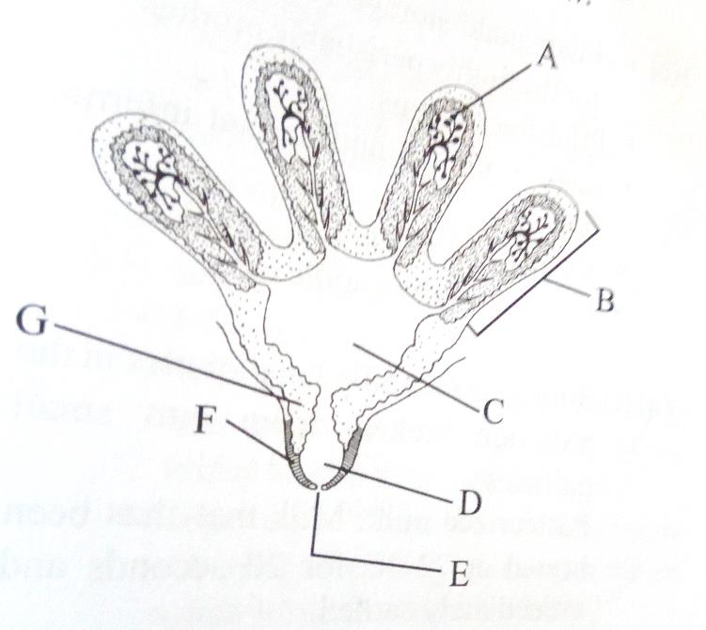
- State the parts labeled A, B, C, D, E, F (3mks)
- Alveolus
- Lobe
- Gland Cistern
- Teat Cistern
- Teat orifice
- Teat sphincter muscle

- In which of the labeled parts does secretion take place ( 1mk)
A
- Name the two hormones that control milk secretion (1mk)
Oestogen
Prolactin
- For how long should milking process take? (1mk)
5-8 minutes
- Give a reason for your answer in (d) above (1mk)
Because this is the duration of the effect of hormone oxytocin

- State two precautions observed in harvesting of tea (2mks)
Use woven baskets
Avoid compacting tea leaves
Spread plucked tea under shade
Take plucked tea to factory on the same day
Pluck two leaves and a bud
- State two ways of weed control in rice production (1mk)
Flooding
Uprooting
Use of herbicides
- Name three methods of conserving silage( 1¹/₂mks)
Silage
Hay
Standing forage
- State any four bacterial diseases affecting livestock (2mks)
Anthrax
Blackquater
Mastitis
Brucellosis
Foot rot

- Explain five requirements of a good calf pen (5mks)
Cleanliness- concrete floors easy to clean to prevent contamination
Dryness and warmth- Dry litter to be changed when wet to prevent infection by pneumonia
Adequate space- To allow exercise
Proper lighting- To enhance synthesis of vitamin D
Proper drainage to prevent dampness
Draughts free- construct solid walls; prevent cold winds which encourage infection
Proper ventilation for fresh air circulation
Single housing- prevent licking each other which encourage formation of balls in their rumen and infection with parasites
- a) Define layering in crop production (1mk)
This is the practice of inducing a plant to produce roots while still attached to the mother plant

- Name four methods of layering (2mks)
Tip layering
Trench
Aerial/ marcotting
Compound layering

- A dairy farmer wanted to prepare 1000kg of a calf ration containing 20% DCP. The feedstuffs available were maize (10% DCP) and Sunflower (35% DCP). Using Pearson Square method, calculate the amount of each of the rearing ration ( 3mks)

Check square drawn and labeled

Amount of Maize =15/25 * 1000= 600 kg
Amount of sunflower= 10/25* 1000= 400 kg

